C00407916

Contents

Introduction 1

Features Extraction 1

Favorable (good) Features 1

Non-favorable (Bad) Features 1

Normal Features 2

Target Vector 2

Assumptions 2

Output 2

# Introduction

We have trained a classifier to suggest the user that he/she should visit or not the place visited by his/her Facebook friend based on the number of comments, likes, heart, hate, normal reaction positivity in post caption. One more important feature we have considered here is if the user has already visited the place or not. Unfortunately, there is no API currently available, which can get the listed information from the user account. So have created dummy data, which contains 10000 records. Date set contains the following columns.

**Name:** Column contains the name of the friend who has visited a place and made a check-in activity on Facebook.

**Place:** Name of the place visited by the friends or name of the place mention in the check-in activity.

**Comments:** Number of comment in on the post.

**Likes:** Number of likes on the post.

**Heart:** Number heart emoji on the post.

**Hate:** Number of angry emoji on the post.

**Normal:** number of sad emoji on the post.

**Caption_positivity:** Contains percentage positivity of post caption.

**Already_visited:** Indicated if the user has already visited the place or not.

**Should_visit:** Indicated if the user should visit the place or not which our target.

# Features Extraction

## Favorable (good) Features

1. Number of likes.
2. Number of comments.
3. Number of heart emoji.

## Non-favorable (Bad) Features

1. Number of angry emoji
2. Already visited

## Normal Features

1. Number of sad emoji
2. Caption positivity

## Target Vector

1. Should visit.

# Assumptions

1. The user is never intended to visit a place twice.
2. If the average of good features is greater than average of bad features and positivity in the caption is greater than 60 percent then user always intends to visit the place.
3. If the average of good features is less than average of bad features and positivity in the caption is greater than 80 percent then the choice of the user is random mean it’s up to him/her that he/she wants to visit the place or not.
4. If the average of good features is equal than average of bad features then the choice of the user is random mean it’s up to him/her that he/she wants to visit the place or not.

# Output

Testing and classification report

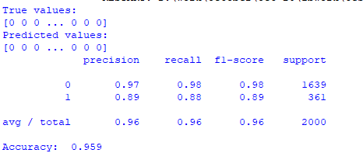

Testing

