INDEX

Sr No. | Date | Practical Name | Pg.  No. | Sign
1. |  | Generate regression model and interpret the result for a given data set.
2. |  | Generate forecasting model and interpret the result for a given data set.
3. |  | Write a map-reduce program to count the number of occurrences of each alphabetic character in the given dataset. The count for each letter should be case-insensitive (i.e., include both upper-case and lower-case versions of the letter; Ignore non-alphabetic characters).
4. |  | Write a map-reduce program to count the number of occurrences of each word in the given dataset. (A word is defined as any string of alphabetic characters appearing between non-alphabetic characters like nature's is two words. The count should be case-insensitive. If a word occurs multiple times in a line, all should be counted)
.7. |  | Write a program to construct different types of k-shingles for given document.
8. |  | Write a program for measuring similarity among documents and detecting passages which have been reused.
9. |  | Write a program to compute the n- moment for a given stream where n is given.
10. |  | Write a program to demonstrate the Alon-Matias-Szegedy Algorithm for second moments.

Practical No. 1

Aim : Generate Regression model and interpret the result for a given data set.

Step 1: Open Weka then open file h.arff in Weka Explorer.
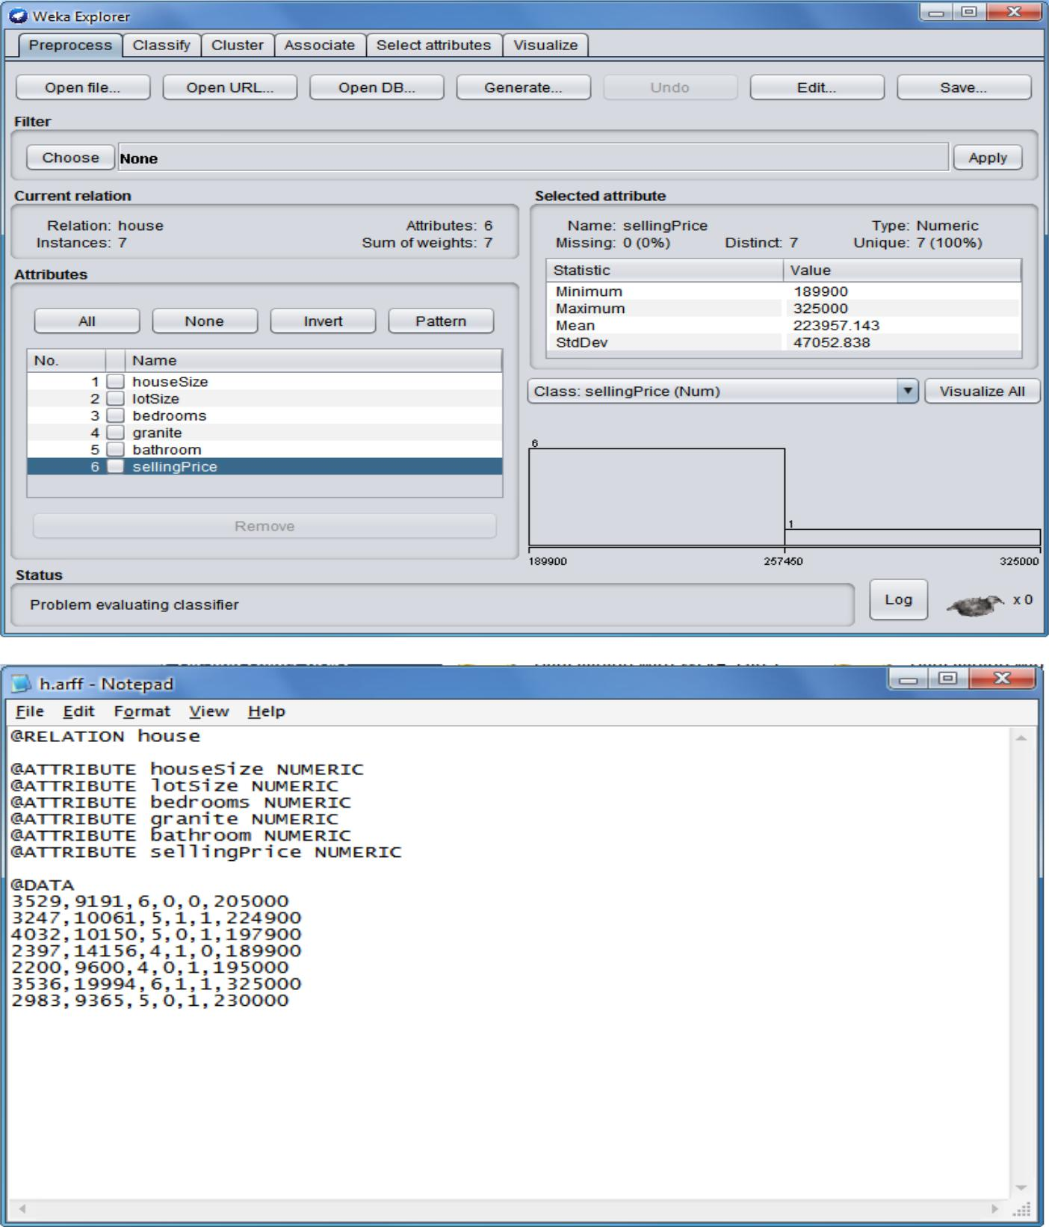

Step 2: Click on Classify, choose weka classifier function LinearRegression -S 0 -R 1.0E-8 -num-decimal-places 4.
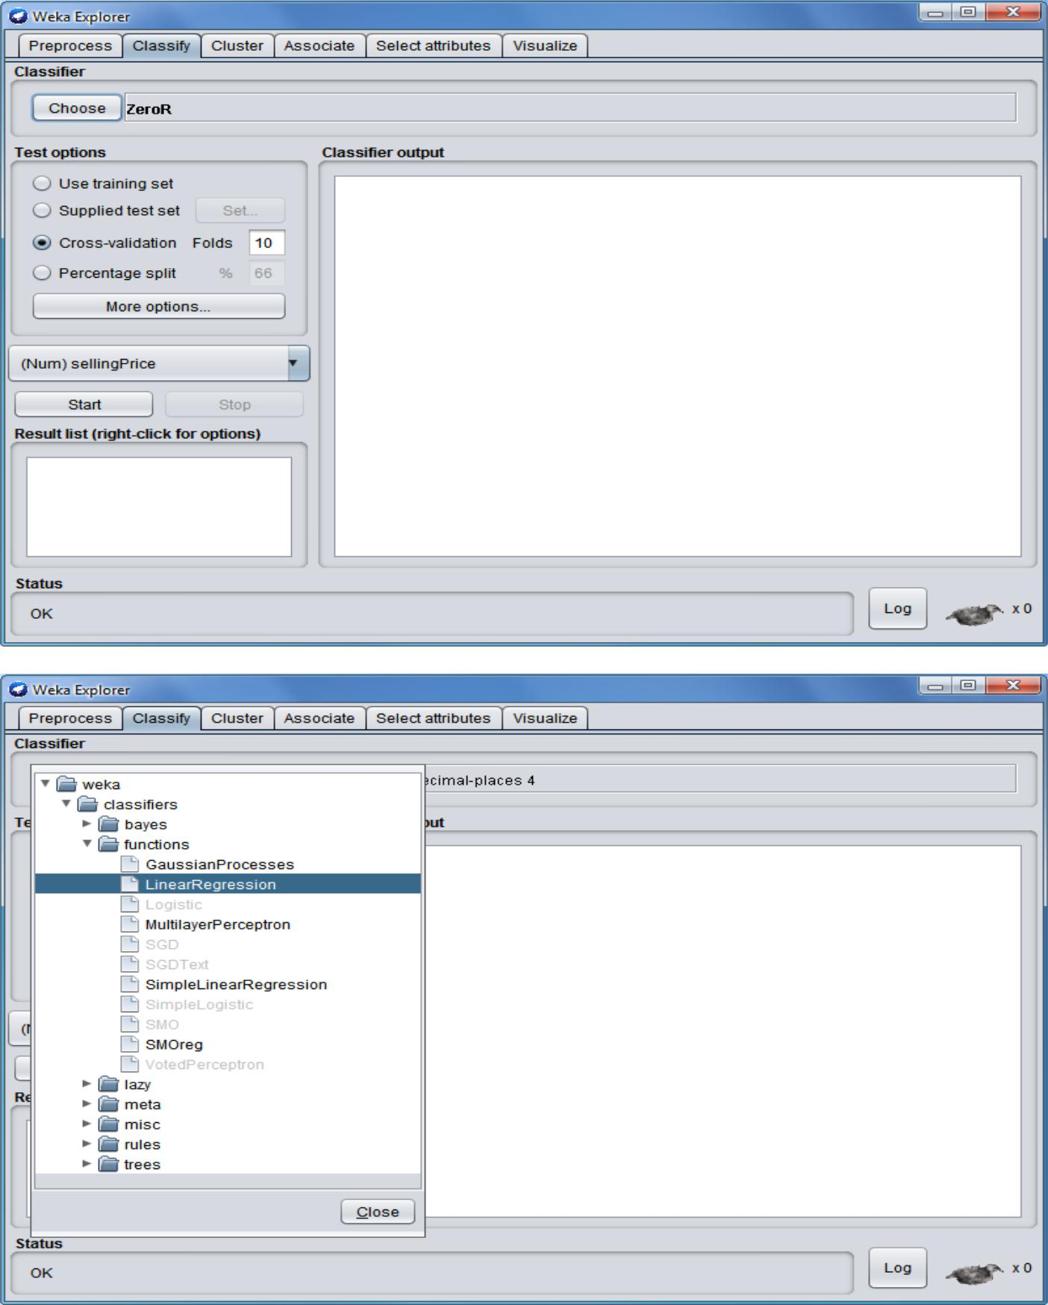
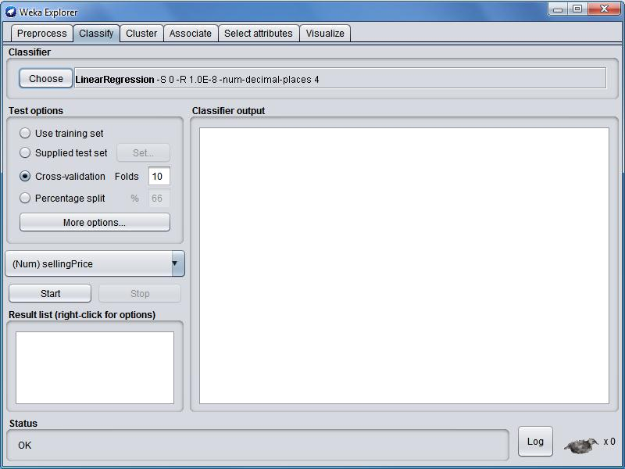

Step 3: Click on Start. You can see the linear regression on the input file.
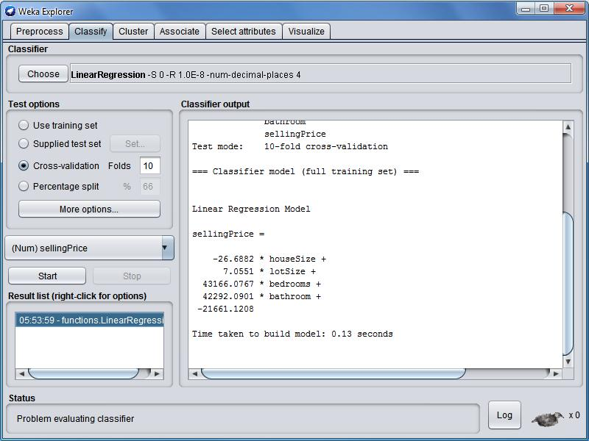
Practical No. 2

Aim : Generate forecasting model and interpret the result for a given data set.

Step 1: Open Weka then open file Weather.arff in Weka Explorer.
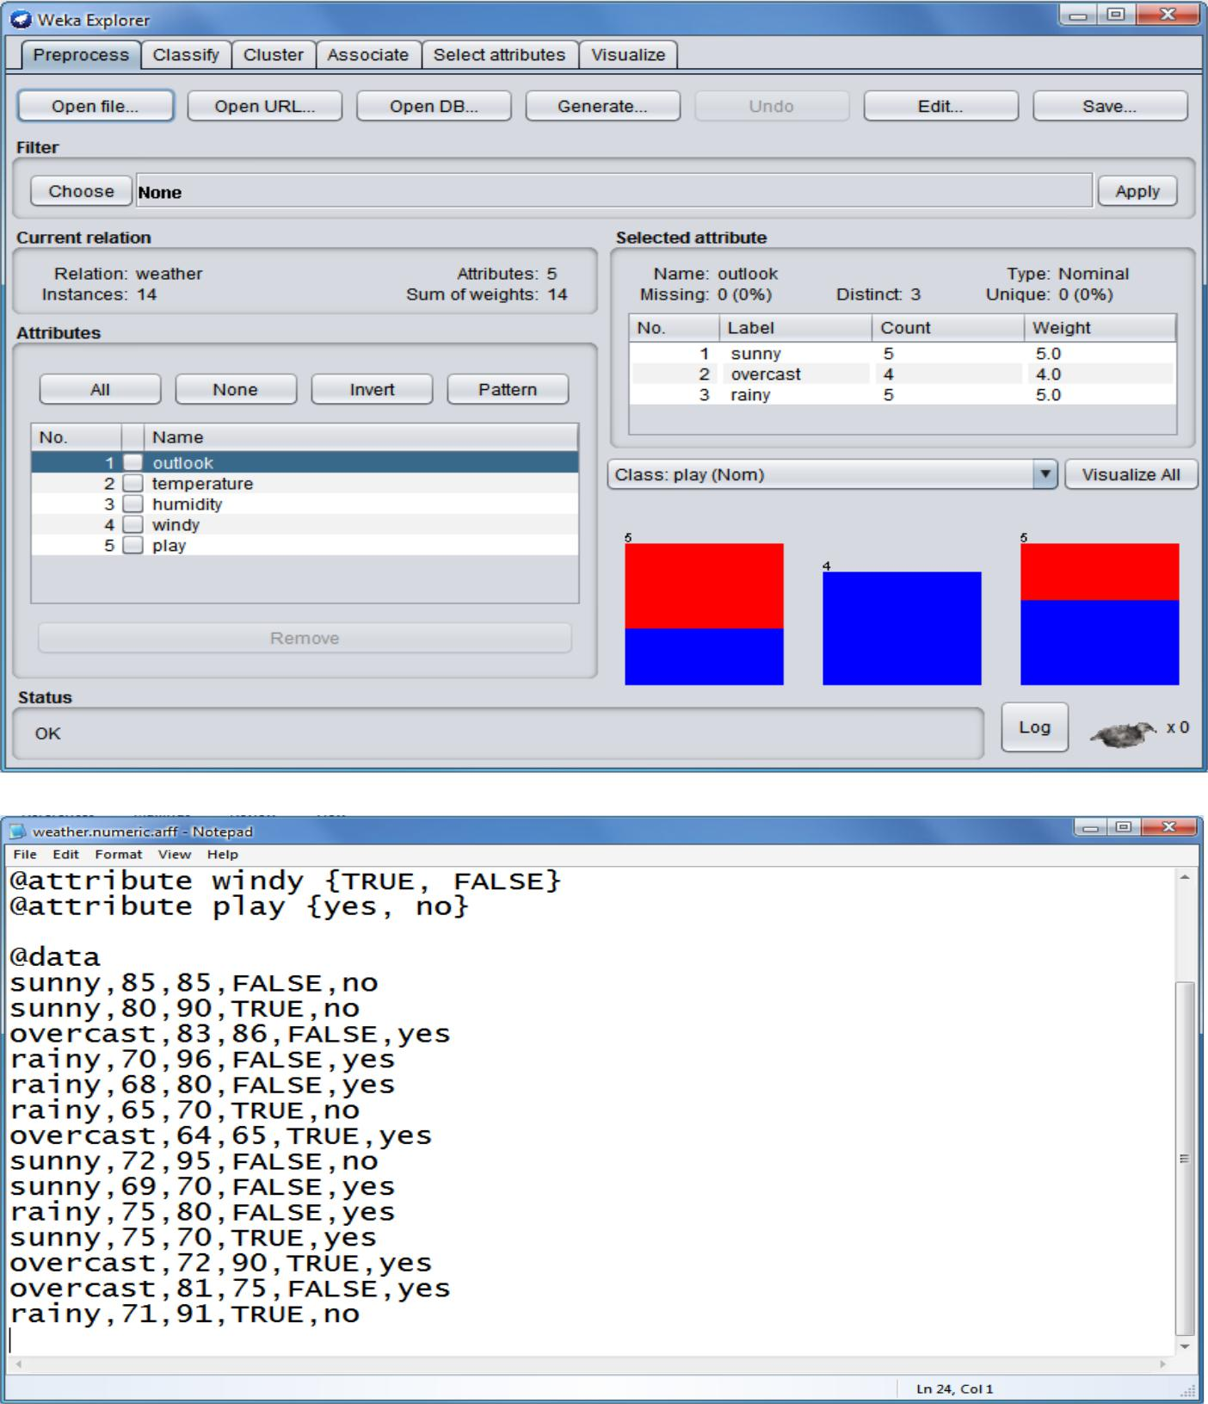

Step 2: click on Cluster, choose weka forcasting function SimpleKMean.
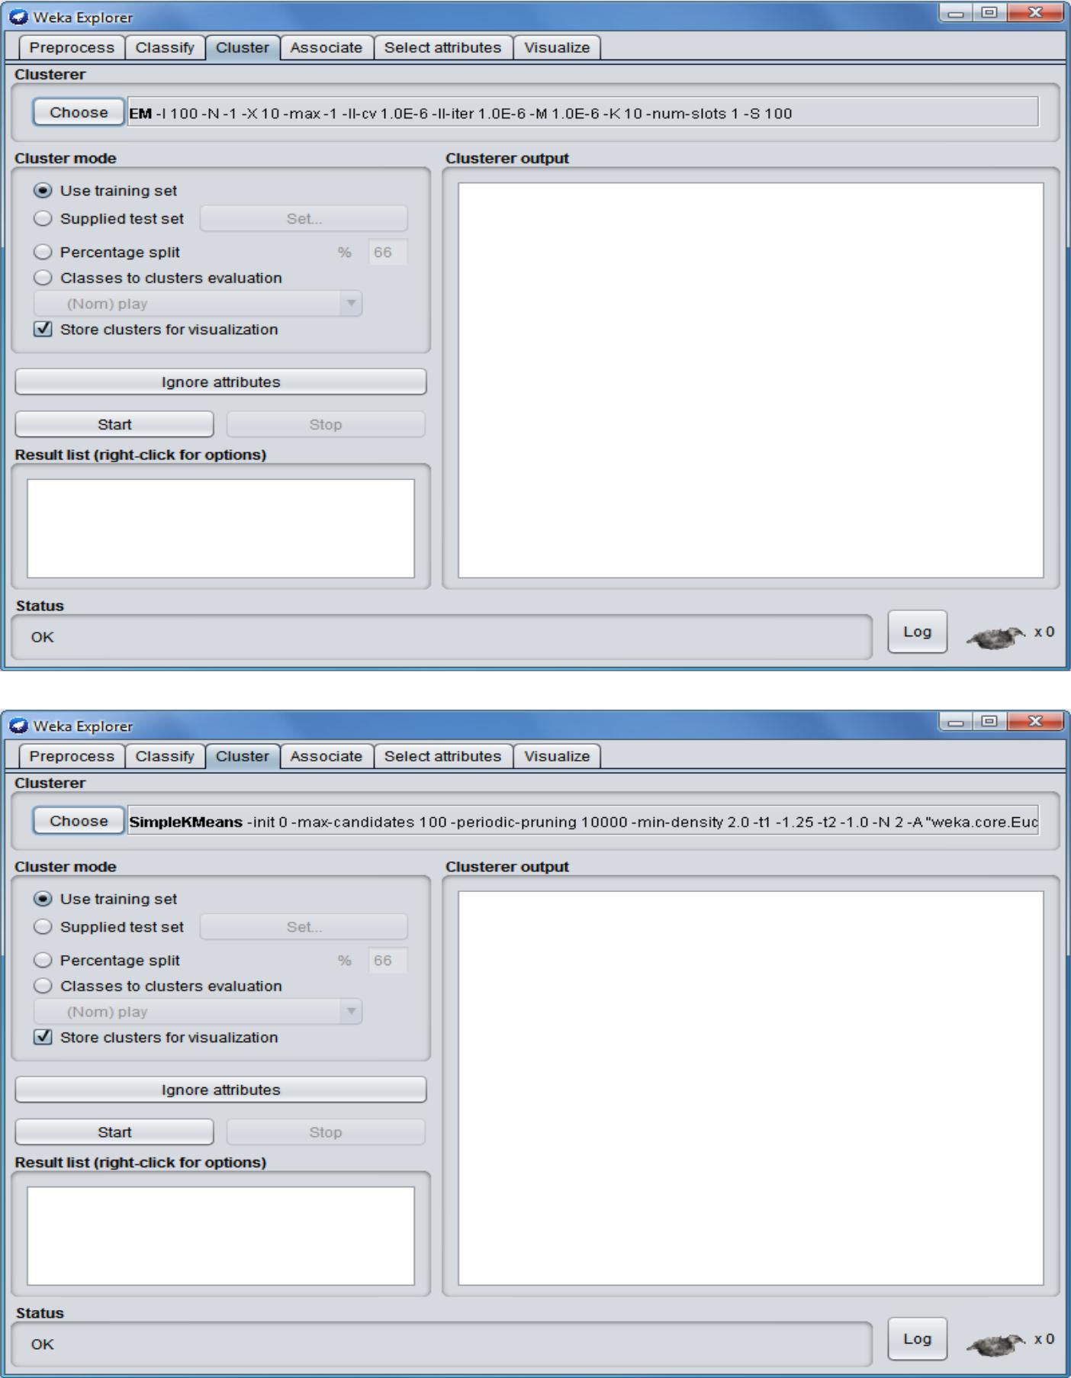
Step 3: Click on Start. You can see the SimpleKMean on the input file.
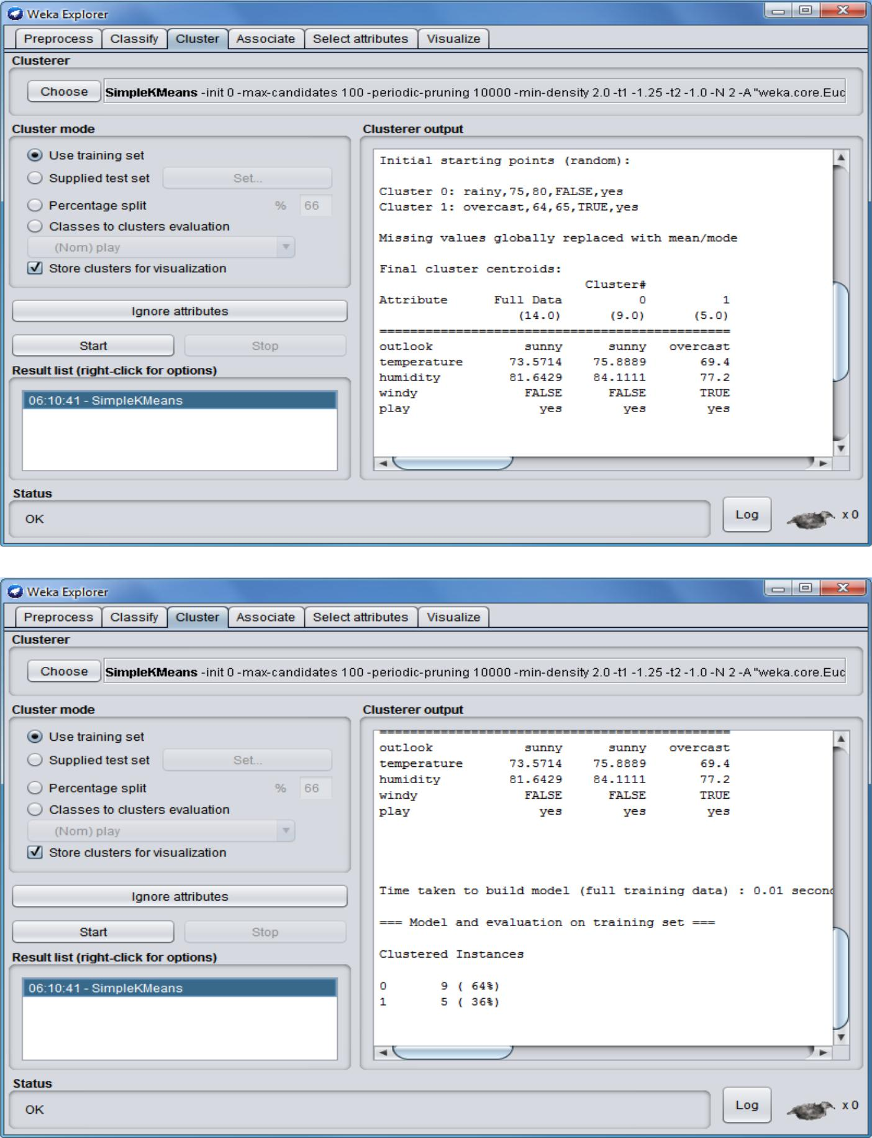
Practical No. 3

Aim : Write a map-reduce program to count the number of occurrences of each alphabetic character in the given dataset. The count for each should be case-insensitive(i.e include both upper-case and lower-case versions of the letter, ignore non-alphabetic characters).
Source Code:
Charcount.java(Driver Class)

import org.apache.hadoop.conf.Configuration; import org.apache.hadoop.fs.Path; import org.apache.hadoop.io.IntWritable;

import org.apache.hadoop.io.Text;
import org.apache.hadoop.mapreduce.Job;

import org.apache.hadoop.mapreduce.lib.input.FileInputFormat; import org.apache.hadoop.mapreduce.lib.input.TextInputFormat; import org.apache.hadoop.mapreduce.lib.output.FileOutputFormat; import org.apache.hadoop.mapreduce.lib.output.TextOutputFormat;

public class Charcount {

public static void main(String[] args) throws Exception {

- TODO Auto-generated method stub Configuration conf = new Configuration(); Job job = new Job(conf, "Charcount"); job.setJarByClass(Charcount.class); job.setMapperClass(Charmap.class); job.setReducerClass(Charreduce.class); job.setInputFormatClass(TextInputFormat.class); job.setOutputFormatClass(TextOutputFormat.class); job.setMapOutputKeyClass(Text.class); job.setMapOutputValueClass(IntWritable.class); job.setOutputKeyClass(Text.class); job.setOutputValueClass(IntWritable.class); FileInputFormat.addInputPath(job, new Path(args[0]));
FileOutputFormat.setOutputPath(job, new Path(args[1])); System.exit(job.waitForCompletion(true) ? 0 : 1);

}

}

Charmap.java(Mapper Class)

import java.io.IOException;
import java.util.StringTokenizer;

import org.apache.hadoop.io.IntWritable;
import org.apache.hadoop.io.LongWritable;
import org.apache.hadoop.io.Text;

import org.apache.hadoop.mapreduce.Mapper;

public class Charmap extends Mapper<LongWritable, Text, Text, IntWritable> { public void map(LongWritable key, Text value, Context context)

throws IOException, InterruptedException {

String line = value.toString();
char[] carr = line.toCharArray();

for (char c : carr) {
System.out.println(c);
context.write(new Text(String.valueOf(c)), new IntWritable(1));
}

}

}
Charreduce.java(Reducer Class)

import java.io.IOException;

import org.apache.hadoop.io.IntWritable;
import org.apache.hadoop.io.Text;
import org.apache.hadoop.mapreduce.Reducer;

public class Charreduce extends Reducer<Text, IntWritable, Text, IntWritable> { public void reduce(Text key,Iterable<IntWritable> values,Context context)throws
IOException,InterruptedException{
int count = 0;

IntWritable result = new IntWritable();
for (IntWritable val : values) {
count +=val.get();
result.set(count);

}
String found = key.toString();
if (found.equals("a") || found.equals("t") || found.equals("c") || found.equals("g"))
{

context.write(key, result);
}

}
}
Practical No. 4
Aim : Write a map-reduce program to count the number of occurrences of each word in the given dataset.(A word is defined as any string of alphabetic characters appearing between non-alphabetic characters like nature’s is two words. The count should be case-insensitive. If a word occurs multiple times in a line, all should be counted).

WordCount.java(Driver Class)

import org.apache.hadoop.fs.Path;
import org.apache.hadoop.conf.*;
import org.apache.hadoop.io.*;
import org.apache.hadoop.mapred.*;
import org.apache.hadoop.util.*;

public class WordCount extends Configured implements Tool{ public int run(String[] args) throws Exception

{

//creating a JobConf object and assigning a job name for identification purposes

JobConf conf = new JobConf(getConf(), WordCount.class); conf.setJobName("WordCount");

//Setting configuration object with the Data Type of output Key and Value
conf.setOutputKeyClass(Text.class);
conf.setOutputValueClass(IntWritable.class);

//Providing the mapper and reducer class names conf.setMapperClass(WordCountMapper.class); conf.setReducerClass(WordCountReducer.class);

//We wil give 2 arguments at the run time, one in input path and other is output

path
Path inp = new Path(args[0]);
Path out = new Path(args[1]);

//the hdfs input and output directory to be fetched from the command line FileInputFormat.addInputPath(conf, inp); FileOutputFormat.setOutputPath(conf, out);
JobClient.runJob(conf);
return 0;
}

public static void main(String[] args) throws Exception
{
// this main function will call run method defined above.

int res = ToolRunner.run(new Configuration(), new WordCount(),args); System.exit(res);

}
}

WordCountMapper.java(Mapper Class)

import java.io.IOException;
import java.util.StringTokenizer;

import org.apache.hadoop.io.*;
import org.apache.hadoop.mapred.*;

public class WordCountMapper extends MapReduceBase implements Mapper<LongWritable, Text, Text, IntWritable> {

//hadoop supported data types

private final static IntWritable one = new IntWritable(1); private Text word = new Text();

//map method that performs the tokenizer job and framing the initial key value pairs

// after all lines are converted into key-value pairs, reducer is called.

public void map(LongWritable key, Text value, OutputCollector<Text, IntWritable> output, Reporter reporter) throws IOException

{

//taking one line at a time from input file and tokenizing the same String line = value.toString();

StringTokenizer tokenizer = new StringTokenizer(line);

//iterating through all the words available in that line and forming the key value

pair
while (tokenizer.hasMoreTokens())
{
word.set(tokenizer.nextToken());

//sending to output collector which inturn passes the same to reducer output.collect(word, one);

}
}
}

WordCountReducer.java(Reducer Class)

import java.io.IOException;
import java.util.Iterator;

import org.apache.hadoop.io.*;
import org.apache.hadoop.mapred.*;

public class WordCountReducer extends MapReduceBase implements Reducer<Text,

IntWritable, Text, IntWritable>
{

//reduce method accepts the Key Value pairs from mappers, do the aggregation based on keys and produce the final out put

public void reduce(Text key, Iterator<IntWritable> values, OutputCollector<Text, IntWritable> output, Reporter reporter) throws IOException

{
int sum = 0;

/*iterates through all the values available with a key and add them together and give the

final result as the key and sum of its values*/ while (values.hasNext()) {

sum += values.next().get();

}
output.collect(key, new IntWritable(sum));
}
}
Practical No. 7

Aim :Write a program to construct different types of k-shingles for given document.
Installation of required packages before executing program:-

install.packages("tm")
require("tm")
install.packages("devtools")

readinteger <- function()

{

- <- readline(prompt="Enter value of k-1: ") k<-as.integer(n)

u1 <- readLines(E:/BA/Hadoop.txt”) Shingle<-0

i <-0 while(i<nchar(u1)-k+1)
{

Shingle[i] <- substr(u1, start=i, stop=i+k) print(Shingle[i])

i=i+1
}

}
if(interactive()) readinteger()
OutPut:-

- if(interactive()) readinteger() Enter value of k-1: 2 character(0)
[1] "thi"
[1] "his"
[1] "is "
[1] "s i"
[1] " is"
[1] "is "
[1] "s a"
[1] " a "
[1] "a t"
[1] " te"
[1] "tex"
[1] "ext"
[1] "xt."

OutPut:-

- if(interactive()) readinteger() Enter value of k-1: 3 character(0)
[1] "this"
[1] "his "
[1] "is i"
[1] "s is"
[1] " is "

[1] "is a"
[1] "s a "
[1] " a t"
[1] "a te"

OutPut:-

- if(interactive()) readinteger() Enter value of k-1: 4 character(0)
[1] "this "
[1] "his i"
[1] "is is"
[1] "s is "
[1] " is a"
[1] "is a "
[1] "s a t"
[1] " a te"
[1] "a tex"
[1] " text"
[1] "text."
[1] "ext. "
Practical No. 8
Aim : Write a program for measuring similarity among documents and detecting passages which have been reused.

Installation of required packages before executing program:-

install.packages("tm")
require("tm")

install.packages("ggplot2")
install.packages("textreuse")
install.packages("devtools")

Source Code 1:-

my.corpus <- Corpus(DirSource("c:/msc/r-corpus"))

my.corpus <- tm_map(my.corpus, removeWords, stopwords("english"))
my.tdm <- TermDocumentMatrix(my.corpus)
#inspect(my.tdm)
my.dtm <- DocumentTermMatrix(my.corpus, control = list(weighting =

weightTfIdf, stopwords = TRUE))
#inspect(my.dtm)
my.df <- as.data.frame(inspect(my.tdm))
my.df.scale <- scale(my.df)

- <- dist(my.df.scale,method="euclidean") fit <- hclust(d, method="ward") plot(fit)
OutPut:-

<<TermDocumentMatrix (terms: 69, documents: 6)>>
Non-/sparse entries: 97/317
Sparsity : 77%
Maximal term length: 12
Weighting : term frequency (tf)
Docs
Terms | File1.txt File2.txt File3.txt File4.txt File5.txt File6.txt
also | 0 | 1 | 1 | 1 | 0 | 0
bed | 0 | 0 | 0 | 1 | 0 | 0
better | 0 | 0 | 0 | 1 | 0 | 0
call | 0 | 1 | 0 | 0 | 0 | 0
can | 0 | 0 | 1 | 1 | 0 | 0
cat | 0 | 0 | 0 | 1 | 0 | 0
cats | 0 | 0 | 0 | 1 | 0 | 0
couch. | 0 | 0 | 0 | 1 | 0 | 0

- barplot(as.matrix(my.tdm))
- my.df.scale <- scale(my.df)
- d <- dist(my.df.scale,method="euclidean")
- fit <- hclust(d, method="ward")

The "ward" method has been renamed to "ward.D"; note new "ward.D2" > plot(fit)
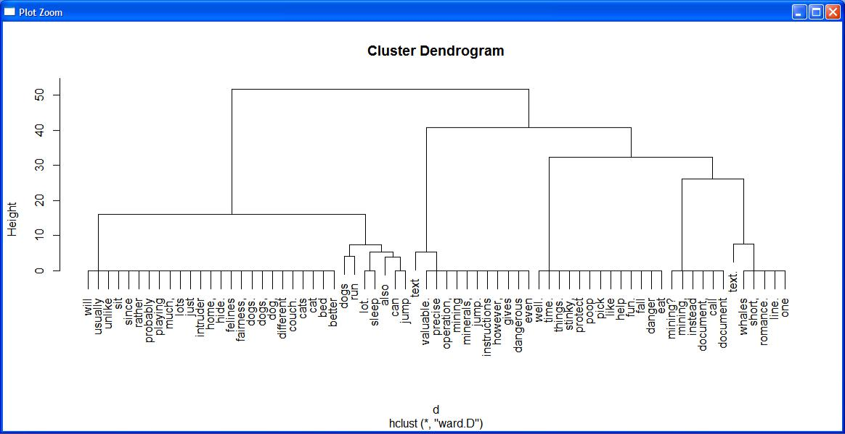

Sourec code 2 (using bar plot with and without color):-

my.corpus <- Corpus(DirSource("c:/msc/r-corpus"))

my.corpus <- tm_map(my.corpus, removeWords, stopwords("english"))
my.tdm <- TermDocumentMatrix(my.corpus)

inspect(my.tdm)
my.df <- as.data.frame(inspect(my.tdm))
barplot(as.matrix(my.tdm))
#barplot(as.matrix(my.tdm),col = color)

OutPut:-
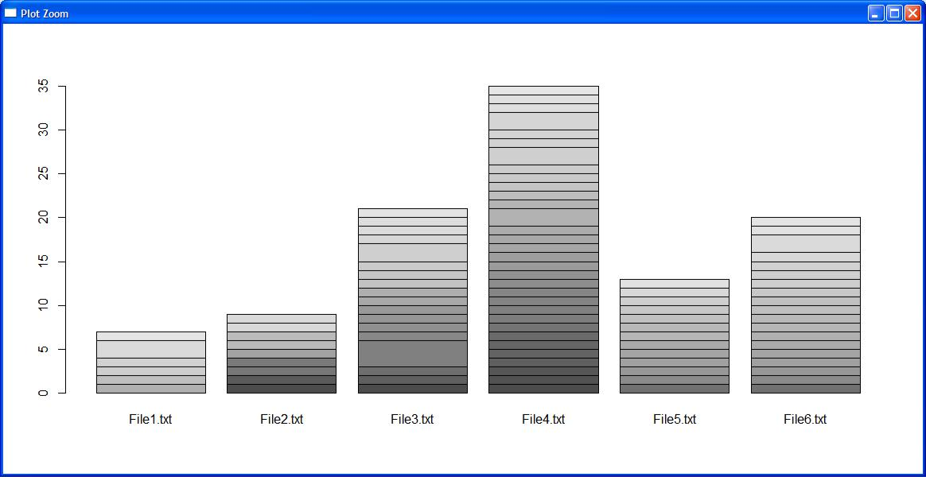

barplot(as.matrix(my.tdm),col = color)
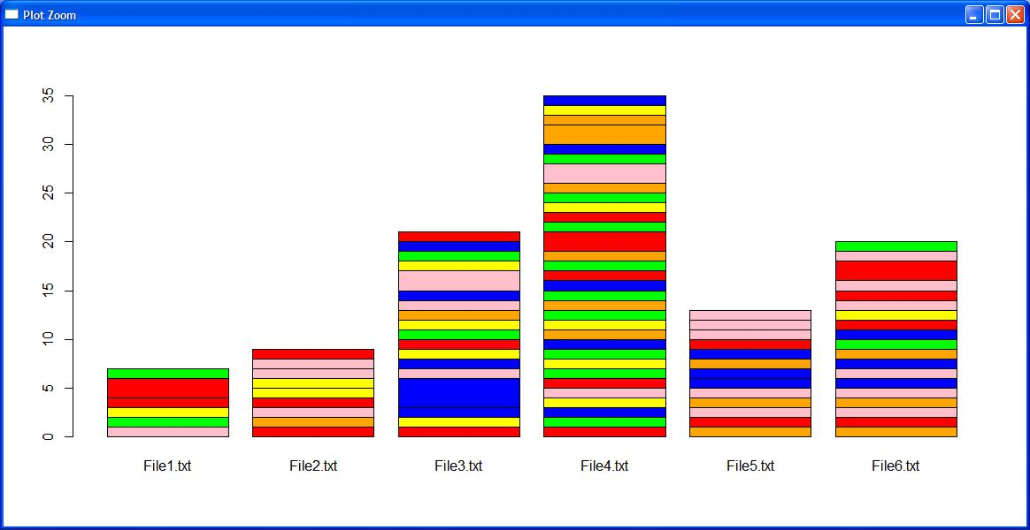

Jaccard similarity

Similarity of asymmetric binary attributes[edit]

Given two objects, A and B, each with n binary attributes, the Jaccard coefficient is a useful measure of the overlap that A and Bshare with their attributes. Each attribute of A and B can either be 0 or 1. The total number of each combination of attributes for both A and B are specified as follows:

represents the total number of attributes where A and B both have a value of 1.

represents the total number of attributes where the attribute of A is 0 and the attribute of B is 1.

represents the total number of attributes where the attribute of A is 1 and the attribute of B is 0.

represents the total number of attributes where A and B both have a value of 0.
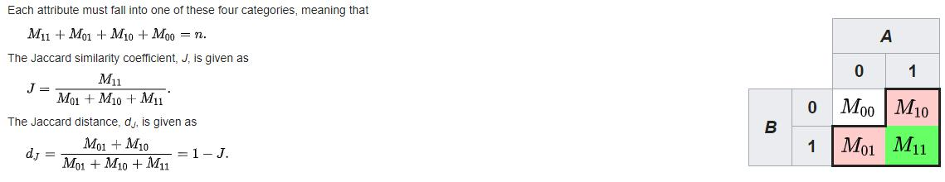

Sourec code 3 (using minhash and jaccard similarity):-

library(textreuse)

Source Code:-

minhash <- minhash_generator(200, seed = 235)

ats <- TextReuseCorpus(dir = "c:/msc/r-corpus", tokenizer = tokenize_ngrams, n = 5, minhash_func = minhash)

buckets <- lsh(ats, bands = 50, progress = interactive())
candidates <- lsh_candidates(buckets)
scores <- lsh_compare(candidates, ats, jaccard_similarity, progress = FALSE) scores

color <- c("red","green","blue","orange","yellow","pink")

barplot(as.matrix(scores),col = color)

Output:
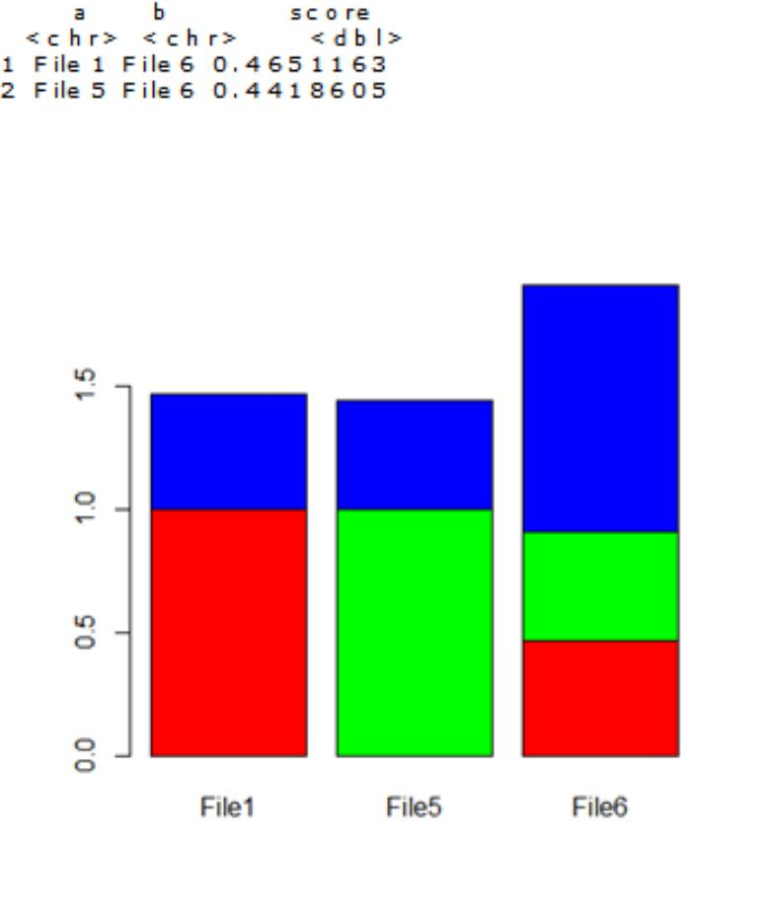

Practical No. 9

Aim : Write a program to compute the n-moment for a given stream where n is given.

Source Code:

import java.io.*;
import java.util.*;

class n_moment2
{
public static void main(String args[])
{

int n=15;
String stream[]={"a","b","c","b","d","a","c","d","a","b","d","c","a","a","b"};

int zero_moment=0,first_moment=0,second_moment=0,count=1,flag=0; ArrayList<Integer> arrlist=new ArrayList();;

System.out.println("Arraylist elements are :: ");

for(int i=0;i<15;i++)
{
System.out.print(stream[i]+" ");
}

Arrays.sort(stream);

//Calculate Zeroth moment(calculates unique elements-raised to zero)
for(int i=1;i<n;i++)
{

if(stream[i]==stream[i-1])
{
count++;
}

else
{
arrlist.add(count);
count=1;

}
}
arrlist.add(count);

zero_moment=arrlist.size();
System.out.println("\n\n\nValue of Zeroth moment for given stream ::"+zero_moment);

//Calculate First moment(Calculate length of the stream-raised to one)

for(int i=0;i<arrlist.size();i++)
{
first_moment+=arrlist.get(i);
}
System.out.println("\n\nValue of First moment for given stream ::"+first_moment);

//Calculate Second moment(raised to two)
for(int i=0;i<arrlist.size();i++)
{

int j=arrlist.get(i);
second_moment+=(j*j);
}
System.out.println("\n\nValue of Second moment for given stream ::"+second_moment);

}
}

Output :

Arraylist elements are ::
a b c b d a c d a b d c a a b

Value of Zeroth moment for given stream ::4

Value of First moment for given stream ::15

Value of Second moment for given stream ::59

Practical No. 10

Aim : Write a program to demonstrate the Alon-Matias-Szegedy Algorithm for second moments.

Source Code:

import java.io.*;

import java.util.*;
class AMSA
{

public static int findCharCount(String stream,char XE,int random,int n)

{

int countOccurance=0;

for(int i=random;i<n;i++)

{

if(stream.charAt(i)==XE)

{

countOccurance++;//System.out.println(countOccurance+" "+i);

}

}

return countOccurance;

}

public static int estimateValue(int XV1,int n)

{

int ExpValue;

ExpValue=n*(2*XV1-1);

return ExpValue;

}

public static void main(String args[])

{

int n=15;

String stream="abcbdacdabdcaab";

int random1=3,random2=8,random3=13;

char XE1,XE2,XE3;

int XV1,XV2,XV3;

int ExpValuXE1, ExpValuXE2, ExpValuXE3;

int apprSecondMomentValue;
XE1=stream.charAt(random1-1);
XE2=stream.charAt(random2-1);

XE3=stream.charAt(random3-1);

//System.out.println(XE1+" "+XE2+" "+XE3);

XV1=findCharCount(stream,XE1,random1-1,n);

XV2=findCharCount(stream,XE2,random2-1,n);

XV3=findCharCount(stream,XE3,random3-1,n);

System.out.println(XE1+"="+XV1+" "+XE2+"="+XV2+" "+XE3+"="+XV3);

ExpValuXE1=estimateValue(XV1,n);

ExpValuXE2=estimateValue(XV2,n);

ExpValuXE3=estimateValue(XV3,n);

System.out.println("Expected value for "+XE1+" is :: "+ExpValuXE1);

System.out.println("Expected value for "+XE2+" is :: "+ExpValuXE2);

System.out.println("Expected value for "+XE3+" is :: "+ExpValuXE3);

apprSecondMomentValue=(ExpValuXE1+ExpValuXE2+ExpValuXE3)/3;

System.out.println("Approximate Second moment value using Alon-Matias-Szegedy is :: "+apprSecondMomentValue);

}

}

Output:

c=3 d=2 a=2

Expected value for c is :: 75

Expected value for d is :: 45

Expected value for a is :: 45

Approximate Second moment value using Alon-Matias-Szegedy is :: 55

