Software Requirements Specification

for

Cab Rental and Sharing System with GPS Tracking

Version 1.0 approved

Prepared by:  
  
Prateek Mishra (U101114FCS105)

NIIT University

20-September-2016

Table of Contents

1. Introduction 1

1.1 Purpose 1

1.2 Document Conventions 1

1.3 Intended Audience and Reading Suggestions 1

1.4 Product Scope 1

1.5 References 1

2. Overall Description 2

2.1 Product Perspective 2

2.2 Product Functions 2

2.3 User Classes and Characteristics 2

2.4 Operating Environment 2

2.5 Design and Implementation Constraints 2

2.6 User Documentation 2

2.7 Assumptions and Dependencies 3

3. External Interface Requirements 3

3.1 User Interfaces 3

3.2 Hardware Interfaces 3

3.3 Software Interfaces 3

3.4 Communications Interfaces 3

4. System Features 4

4.1 System Feature 1 4

4.2 System Feature 2 (and so on) 4

5. Other Nonfunctional Requirements 4

5.1 Performance Requirements 4

5.2 Safety Requirements 5

5.3 Security Requirements 5

5.4 Software Quality Attributes 5

6. Other Requirements 5

1. Introduction
   1. Purpose

Many students and faculty use cabs in our university. Faculty uses the cabs so as to go home. Many students are often willing to share cabs so as to make the cost of travelling less due to sharing. So the purpose of our app is to simplify the process of booking and sharing cabs within our university,

And to make the cabs easily accessible to the users of our app (Faculty and students of the university) and letting the users choose the type of cab based on their requirements. By using GPS tracking we are providing user an added functionality of getting the exact location of the cab they have booked. Cancellation of booking is also available.

* 1. Product Scope

This android base application is helpful not only to those students who go out with their friend on weekends and visit Railway/Bus station on vacations but also to those faculties and staff who need cab to go home on regular basis. NIIT University can know the distance travelled by each faculty and thus they can pay cabs based on this information. Students can share cabs when lots of students are going to same Station during vacation.

* 1. Intended Audience And Reading Suggestions

With this app we are targeting the university people as the main Audience , and to anybody who needs to visit our university from the nearby areas like NCR, Rajasthan etc. This is a user-friendly and an easy to use app which the user will understand easily, after first use.

* 1. Document Conventions

The format of this SRS is very simple and main focus will be on general topics of our software or a specific kind of interest and issue were user faces the problem.

* 1. References
* <http://www.cse.chalmers.se/~feldt/courses/reqeng/examples/srs_example_2010_group2.pdf>
* IEEE. IEEE Std 830-1998 IEEE Recommended Practice for Software Requirements Specifications. IEEE Computer Society, 1998.
* <https://www.scribd.com/doc/113753725/Cab-Booking-System>
* <https://www.scribd.com/doc/146558587/GPS-TRACKING-SYSTEM>

1. Overall Description
   1. Product Perspective

This product is based on the structure of established cab booking applications. This app is being developed so as to replace the traditional cab booking methods, making the process of booking/sharing cabs done through this app in a more automated way. This software requires a cab with GPS facility so that once booked, the cab driver and user both can know where each of their respective current location is. Upon booking software lets cab driver know that their cab has been booked through SMS automation feature and GPS tracking. Similarly User also receives the required information through same features.

* 1. Product Functions

In today’s world a user books the cab through conventional methods like phone call etc. This app wants to eradicate these conventional methods, and replace it by letting the general user complete this task in a more automated way.

Some of the Functions are as follows -

* It enables user to book/share cabs and track the location of the cab.
* GPS Tracking – Through this feature the user keeps track of where the cab is, soon after placing the booking.
* Cab Sharing- This feature searches for two or more users who are going to the same destination. Through this feature the overall fare will be considerably less.
* Pop-up Notification- This app also sends a pop-up notification asking a particular user asking whether they want to share the cab or not.
* SMS Automation – This feature lets the driver, know that his cab is booked, plus it is also send to the guard to make him aware that this particular driver’s cab has been booked.
  1. User Class and Characteristics

**Faculty** –The faculty are frequent users take cabs to travel everyday between home and the university, so firstly they have to call the cab driver then have to wait for the cab to arrive, and on exiting the university they have to sign at the main gate entrance, so for their convenience this app makes the this process less complex and more automated.

They just have to book the cab before 30 mins and it will reach at their destination at the right time.  Moreover they just have to enter the kilometers of the car before starting and after ending on the app manually. Thus, they’ll be signed out of the university automatically and will get summarized details of the ride they had just ridden. The fares of the ride however, will be predefined according to various locations.

**Students** – This app most convenient for the students on vacations when they are going to or coming back from home  or even when they want to go the market or any other place. Students also can book the cab 30 mins before for the cab to arrive in time.

* 1. Operating Environment

Minimum System requirements for Cab booking app –

* GPRS Data plan is essential for the working of this app.
* Hardware Requirement- GPS Enabled Smartphone.
* Operating System – Android (4.0 or higher).
  1. Design and Implementation Constraints

Synchronization – Works with USB (2.0) charging port only, and connects to only Android (4.0 or above).

Internal Memory – The device should have at least 2GB of internal memory with 200mb of free space available

The app requires the device to have at least 1GB of RAM for proper functioning.

No external memory (like SD Card slot) is required as the app will have all of its data on the internal memory.

* 1. Assumption and Dependencies

It is assumed that the app will work with other maps alternatives such as HERE Maps from Microsoft, Apple Maps or any other third party maps. Although Google Maps is **recommended**.

It may also work with devices with 512mb of RAM on Android Kitkat (4.4) or below upto Android 4.0.

* 1. User Documentation

TBD

1. External Interface Requirements
   1. User Interfaces
   * If a cab gets delayed due to some reason and is not able to reach in assigned time then a cab delay alert pop up will appear.
   * Notification is sent to every user if someone want to share a cab.
   * Voice messages can be send easily to guard and the driver simply by pressing and holding the mic icon while speaking and releasing to send.
   * In the GPS tracking feature users can simply click on GPS icon and see the position of the cab they have booked.
   1. Software Interfaces

The voice message sent by user will go to the server and server will sent that message to driver and guard. For GPS feature we will take help of Google maps. If someone wants to share a cab a notification will go to server and server will forward the notification to every other user. The location log will be stored on server until admin chooses to delete it.

* 1. Communication Interfaces

User need to have an email account while making account on this app. Users will be informed about any special offers (if any) or important information through email. Voice message sent by users can be assessed only by guards and drivers. Users and driver must turn on GPS and allow notification for this app.

* 1. Hardware Interfaces

This app is meant for Smart Phone users with working GPRS data plan. For using GPS tracking feature user need to have working GPS in their phone. Voice message feature makes use of internal microphone present inside the smart phones. For getting Notification for sharing every user has to allow this app to push notification on their respective phones.

1. System Features

This system should allow user to book or share a cab.

This system should allow user to enter the number of kilometer he has travelled.

The system should provide current location of the cab being tracked at request.

The system should log position of the cab being tracked at a fixed interval of time.

The system should let admin to delete or edit location log.

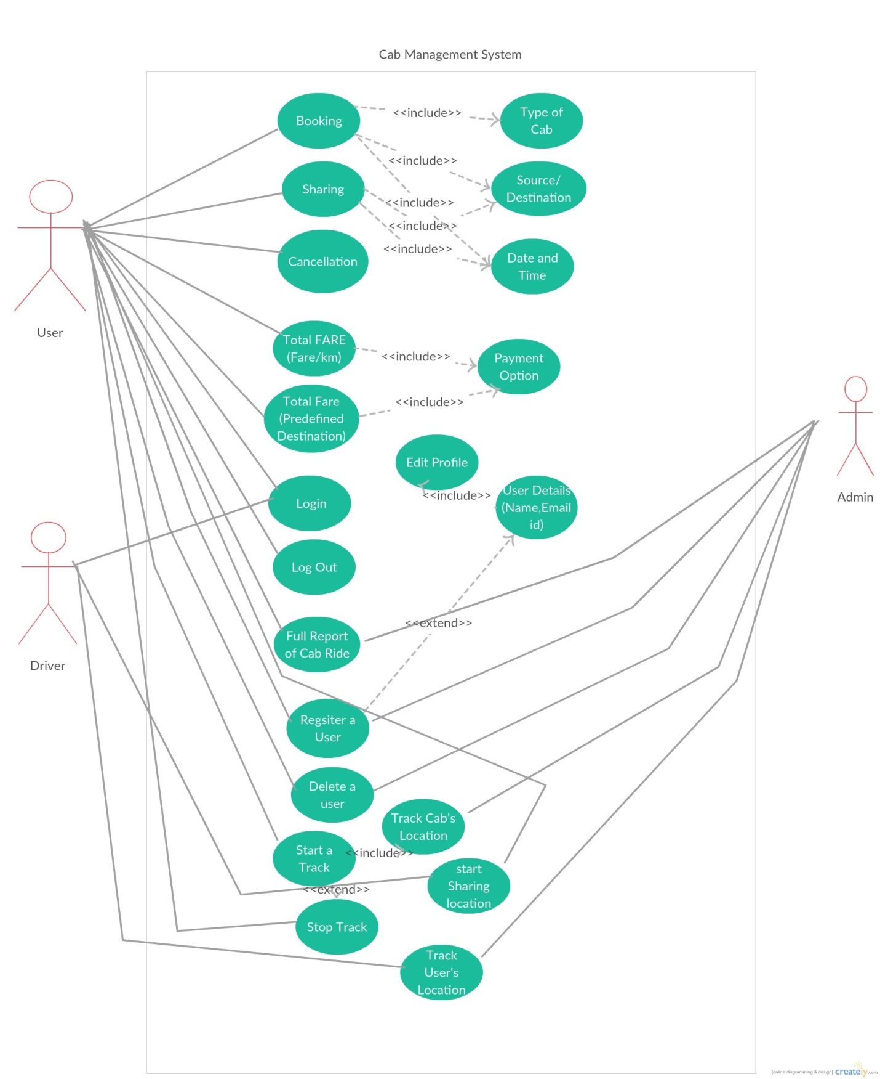

**USE CASE DIAGRAM OF CAB MANAGEMENT SYSTEM APP**

* 1. Functions:

**4.1.1 Booking (Id-1):**

After checking the availability of cabs, Customers can book a cab or number of cabs according to their requirements.

**4.1.2 Sharing (Id-2):**

If a user want to share a cab with other students/faculty they can provide their details (time of departure, location, type of cab) and a notification will be sent to other app users. If others want to share the cab they will reply by contacting the user who initiated the process.

**4.1.3 Type of Cab(Id-3):**

A user can book a cab according to his/her requirements, for example, on selecting sharing option the number of user’s can be more than 4 or 5, in that case a bigger cab is provided, otherwise for individual cases smaller cabs are provided . Basically Different cabs are provide according to different needs.

**4.1.4 Source/Destination (Id-4):**Faculty have input their destination on the app manually on starting point and ending point, this distance is kept note of and later the university pays for the charges of faculty through this application.

There are also some predefined destinations where the fare rate is fixed.

**4.1.5 Date/Time (Id-5):**if user wants to book a cab in advance they have to provide date and time (when they would like their cab to arrive). In an ideal world placing of booking should be done before 30 mins so the cab will reach on time. Instant booking can also be done but it will delay the cab arrival.

**4.1.6 Cancellation (Id-6):**

If the customer wants to cancel the cab then 10% of the amount per person is deducted if the booking is cancelled before 30 mins of the service time.

**4.1.7 Total Fare (Id-7):**

Total cost for a location can be calculated by providing current location and destination. Also for some destinations the total fare is fixed so in that case fare/km concept doesn’t apply.

**4.1.8 Payment (Id-8):**

Customer can pay via debit/credit cards, Net Banking or even cash. Although upon reserving of a required cab, the customer will have to pay the amount in advance (optional).

**4.1.9 Register a User (Id-9):**

Admin has authority to accept the registration of user. Driver will also have to input user name before providing cab service.

**4.1.10 User Detail (Id-10):**

App will have to display details such as Name of the user, Email id etc which were provided by the user during the process of registration.

**4.1.11 Edit Profile (Id-11):**

User/driver can edit their profile and update information any time they want.

**4.1.12 Login (Id-12):**

Every user need to login into their account to start booking/sharing cab. Drivers also need to login.

**4.1.13 Log out (Id-13):**

User will have option to log out after completion of his task.

**4.1.14 Full Report of cab ride (Id-14):**

User can give their feedback about their experience with cab. They can also complain to admin about something they didn’t like.

**4.1.15 Delete User (Id-15):**

Driver can choose to delete old document of user from their app. Admin has authority to delete user account, from the server.

**4.1.16 Start Track (Id-16):**

This function will run on the device at every fixed interval of time to read the input from GPS receiver and get the location data. This will allow the users to start tracking the cab which they’ve booked.

**4.1.17 Share Location (Id-17):**

User can share their location with guard/driver. Driver can share their location with guard/user.

**4.1.18 Stop Track (Id-18):**

This function will allow user to stop tracking the location of the cab.

**4.1.19 Track User’s Location (Id-19):**

This function will allow driver and admin to track user’s location.

|  |  |  |
| --- | --- | --- |
| Requirement Id | Short Name | Description |
| RQ1 | Registration Phase | **RQ1.1Register a User:** During the process of registration the user will be asked to enter details such as name, email id etc.Admin has authority to accept the registration of user.  **RQ1.2Delete User:** Admin has authority to delete user account, from the server.  **RQ1.3Registration of Driver:** Drivers(User) also have to register for the first time to use the app. |
| RQ2 | Login Phase | **RQ2.1Login:** Every user need to login into their account to start booking/sharing cab.  **RQ2.2Log out:** User will have option to log out after completion of his task. |
| RQ3 | Profile | **RQ1.1 User Detail:** App users (both drivers and faculty/students) will have to provide their details while making their id.  **RQ1.2 Edit Profile:** User/driver can edit their profile and update information any time they want. |
| RQ4 | Cab Booking | **RQ4.1Booking:** After checking the number of cab available the customers books a cab according to their requirements.  **RQ4.2 Type of Cab:** User can select the type of cab(big/small) they want according to their needs.  **RQ4.3Date/Time:** If user wants to book a cab, they have to provide date and time.  **RQ4.4Source/Destination:** User can input their destination and they can see their distance from current location.  **RQ4.5Cancellation:** If the customer want to cancel the cab then 10% of the amount per person is deducted if the booking is cancelled before 30 mins of the service time. |
| RQ5 | Cab Sharing | **RQ5.1Sharing:** If a user want to share a cab with other students/faculty they will a request. The system will search for any other user wanting to share the cab. A pop up notification will appear on the other users app. If other want to share they will contact user who initiated the request.  **RQ5.2 Type of Cab:**. In the case of sharing this will depend upon how many people are going in the shared cab. According to their needs the cab will be provided.  **RQ5.3Date/Time:** If user wants to book a cab, they have to provide date and time.  **RQ5.4Source/Destination:** User can input their destination and they can see their distance from current location.  **RQ5.5Cancellation:** If the customer want to cancel the cab then 10% of the amount per person is deducted if the booking is cancelled before 30 mins of the service time. |
| RQ6 | Payment Option and Feedback | **RQ6.1Payment:** Customer can pay via debit/credit cards, Net Banking or even cash. Although upon reserving of a required cab, the customer will have to pay the amount in advance.  **RQ6.2Total Fare:** Total cost for a location can be calculated by providing current location and destination. Also for some destinations the total fare is fixed so in that case fare/km concept doesn’t apply.  **RQ6.3Full Report of cab ride:** User can give their feedback about their experience with cab. They can also complain to admin about something they didn’t like. |
| RQ7 | Tracking Phase | **RQ7.1Start Track:** This function will run on the device at every fixed interval of time to read the input from GPS receiver and get the location data. This function will allow user to start tracking cab’s location.  **RQ7.2Share Location:** User can share their location with guard/driver. Driver can share their location with guard/user.  **RQ7.3Stop Track:** This function will allow user to stop tracking.  **RQ7.4Track User’s Location:** This function will allow driver and admin to track user. |

1. Other Non-Functional Requirements
   1. Performance Requirements

It is available during all 24 hours.

Offered through Air conditioned or non-Air conditioned Cabs.

About 20 cabs run daily.

*Types of concerns and complexities:*

Special 10 % discount is given to corporate customers for their advance monthly bookings.

* 1. Safety Requirements

Privacy issue may occur. Only user who has booked the car will be able to track it. The user will send the request to driver for tracking his location. After reaching the location the user won’t be able to track the location of cab.

* 1. Security Requirements

Security attempts to verify protection mechanism built into a system will in fact protect it from improper penetration. Security is provided for each user by giving them login name and password. Security was done, as any other anonymous user can’t log in with a user password if the user is already logged in.

* 1. Software Quality Attributes

This app has an additional feature that allow user to enter the no. of kilometers travelled manually, which will help the organization to get exact number and there will be no case of discrepancy.

**6.) Other Requirements**

We need to maintain a database to store all our records.  
We need to seek the permission of the respective company to use their GPS services.