Software Requirements Specification

For

Cab Rental and Sharing System with GPS Tracking

Prepared by:  
  
Rohan Shrivastava(U101114FCS118)  
NIIT University

1. Introduction
   1. Purpose

Purpose of this project is to design an app to simplify the current process of cab booking and introduce new features like sharing cab and tracking the cab for members of this University. There are lots of cab users in our university like Faculty (regular user) and students (occasional user), thus our team intend to make this process of booking and sharing cab easier and simpler for them. Features like GPS tracking gives user the ability to know the exact location of cab they have booked and thus saves their time.

* 1. Product Scope

Any Android user can use this app. This app is beneficial not only to regular cab users (faculty) but also to students who need to share cab at the time of vacation when they are headed to same station. This app will let NiitUniversity know the total cost which they need to pay for cab uses by faculties.

1.3 Intended Audience and Reading Suggestions

This SRS is meant to help our team, thus intended audience is our team who may need to refer this SRS while coding. This is made very simple and easy to understand by any member.

1.4. Document Conventions

I did not use any special convention and have kept the format simple and easily comprehensible by any member of our group. Some obvious representations are Dependent (D), Related (R) .

1.5. References

One don’t need any reference to understand this document.

I have taken help from

<http://www.cse.chalmers.se/~feldt/courses/reqeng/examples/srs_example_2010_group2.pdf>

IEEE. IEEE Std 830-1998 IEEE Recommended Practice for Software Requirements Specifications. IEEE Computer Society, 1998.

<https://www.scribd.com/doc/113753725/Cab-Booking-System>

<https://www.scribd.com/doc/146558587/GPS-TRACKING-SYSTEM>

2. Overall Description

2.1. Product Perspective

This Software product is based on the structure of traditional cab booking applications. It is being developed to simplify the process of booking and sharing cabs for members of our university. This app requires GPS enabled cab and user need to have GPS service in their phone , so that they can track the cab or send their location to driver. SMS is sent by the server to cab driver and user after cab is booked.

2.2Product Functions

* Advance and instant cab booking.
* Cab Sharing- Notification is sent to other user, if they want to share cab they can contact the person.
* SMS Automation – sends message to user, guard and driver when cab is booked.
* GPS Tracking – user can track the cab they have booked.
* Notification is received if someone wants to share cab.

2.3User Class and Characteristics

**Faculty** – faculty and staff of University are regular user of cab service since they need cab to go home. This app will help them in calculating the total cost easily so that university can for it.

**Students** – students are occasional user of this app but they are large in number , cab sharing feature will help them a lot specially when they are headed for same destination during vacation.

2.4Minimum System requirements for Cab booking app –

* + User must have a GPS Enabled Smartphone.
  + Android (4.0 or higher) is required
  + GPRS Data plan ( 3g is recommended)

2.5Design and Implementation Constraints

Synchronization – Works with the USB (2.0) charging port only, and connects to only Android (4.0 or above).

Internal Memory – The device should have at least 200mb of free space available

This app requires the device to have at least 1GB of RAM for proper functioning.

No external memory (like SD Card slot) is required as long as 200mb spce is available.

2.6Assumption and Dependencies

This app will make use of other mapsapplication such as HERE Maps from Microsoft, Google Maps(Google maps would be best for getting exact location)or any other third party maps.

It might work with devices with 512mb of RAM on Android(4.0 or above)

3. External Interface Requirements

3.1User Interfaces

* + Cab Delay Alert Service.
  + Notification is sent to every user if someone want to share a cab.
  + Voice messages can be sent easily to guard and the driver simply by pressing and holding the mic icon while speaking and releasing to send.
  + In the GPS tracking feature users can simply click on GPS icon and see the position of the cab they have booked.

3.2Software Interfaces

The voice message sent by user will go to the server and server will forward that message to driver /guard. The tracking feature we will take help of Google maps. If someone wants to share a cab a notification will go to server and server will forward that notification to every other user. The admin has right to delete old documents on server.

3.3Communication Interfaces

User must have an email account to register on this app. Users will be informed about any special offers (if any) or important information via email. Driver and user need to enable GPS .

3.4Hardware Interfaces

User must have Smartphone with GPS . For using GPS tracking feature user need enable GPS in their phone. Voice message feature makes use of microphone. To get Notification about cab sharing every user need to allow this app to push notification on their respective phones.

4. System Features

The system should allow user to book and share cab.

The system should provide current location of the cab after booking.

The system should log position of the cab at regular intervals.

The system should let admin to delete old location log.

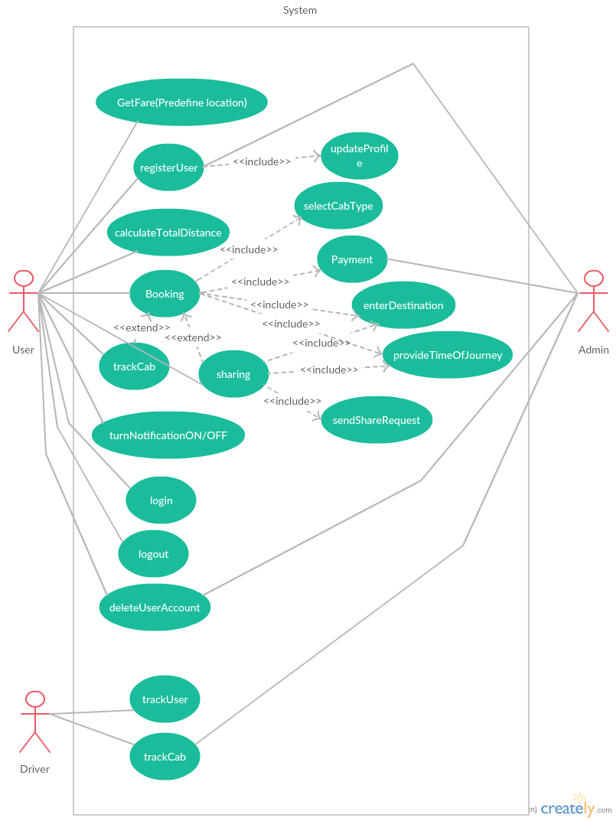

4.1.Functions:

**4.1.11Cab Details (Id-1):**

Customers may view the details of their booking like cab timing at a date their name and the cab they have selected.

**4.1.2Booking (Id-2):**

After checking the availability, the customers can book cab(s) according to their requirements.

**4.1.3 Sharing (Id-3):**

If a user want to share a cab with other students/faculty they can provide their details (time of departure, location, type of cab) and a notification will be sent to other app users. If other wants to share they will contact user. User may choose to send notification to selected people.

**4.1.4 Source/Destination (Id-4):**User can input their destination and they can see their distance from current location. They can also calculate cost to go to that destination.

**4.1.5 Date/Time (Id-5):**If user wants to book a cab in advance they have to provide details like date and time (when they would like their cab to arrive). If they are using instant booking then only time would be necessary.

**4.1.6 Payment (Id-6):**

After reserving the required cab, the customer will have to pay the amount in advance (optional because faculties won’t need to pay if they are going home).

**4.1.8 Cancelation (Id-7):**

Customer can cancel their booking anytime they want but they may be charged some amount depending on time of cancellation.

**4.1.9 Full Report of cab ride (Id-9):**

Users have the facility to give feedback about their experience with cab. They can also write complain to admin about something they didn’t like.

**4.1.10 User Detail (Id-10):**

It is necessary for App user to provide their details while making their account.

**4.1.11 Total Fare (Id-11):**

User can calculate total cost by providing current location and destination.

**4.1.12 Edit Profile (Id-12):**

User/driver can edit their profile and update their information any time they want.

**4.1.13 Login (Id-13):**

User will need to login to their account to be able to book/share cabs. Drivers also need to login.

**4.1.14 Register a User (Id-14):**

Admin has the authority to accept the registration of users. Drivers will also have to provide user name before providing cab services.

**4.1.15 Start Track (Id-15):**

User can start tracking location of cab as soon as they finish booking.

**4.1.16 Share Location (Id-16):**

User can share their location with guard/driver. Driver can share their location with guard and user.

**4.1.17 Delete User (Id-17):**

Driver can choose to delete old document of user from their app. Admin has authority to delete old data and user account, from the server.

**4.1.18Log out (Id-18):**

User will have option to log out of their account anytime they want .

**4.1.19Delete Log (Id-19):**

Admin has authority to delete logged entry.

**4.1.20 Stop Track (Id-20):**

Users wont be able to track the cab after end of their journey they can stop tracking in between their journey if they want.

**4.1.21 Track Cab (Id-21):**

User,driver and admin can track the cab .

**4.1.22 Track User (Id-22):**

This function will allow driver to track the user.

|  |  |  |  |
| --- | --- | --- | --- |
| Requirement Id | Short Name | | Description |
| RQ1 | User Profile | | **RQ1.1User Detail:** App user will have to provide their details while making their id.  **RQ1.2 Edit Profile:** User/driver can edit their profile and update their information any time they want. |
| RQ2 | Sign Up Phase | | **RQ2.1Register a User:** Admin has authority to accept/reject the registration of users.  **RQ2.2Delete User:** Admin has authority to delete user account, permanently from the server. |
| RQ3 | Login Phase | | **RQ3.1Login:**Every user need to login into their account to start using services.  **RQ3.2Log out:** User will have option to log out of their account after completion of his task. |
| RQ4 | Cab Booking | | **RQ4.1Booking:** After checking the number of cab available the customer can book a cab according to their requirements.  **RQ4.2Cancelation:** If the customer want to cancel the cab then 10% of the amount is deducted if the booking is cancelled before 30 mins of the service time.  **RQ4.3Date/Time:** If user wants to book a cab, they will have to provide date and time of journey.  **RQ4.4Cab Details:** Customers may check their booking details.  **RQ4.5Source/Destination:** User can input their destination to see the distance from current location. |
| RQ5 | Cab Sharing | **RQ5.1Sharing:** If a user want to share a cab with other students/faculty they can provide their details (time of departure, location, type of cab) and a notification will be sent to other app users. If other wants to share they will contact user. User may choose to send notification to selected people.  **RQ5.2Date/Time:** If user wants to book a cab, they have to provide date and time of journey.  **RQ5.3Cancelation:** If the customer want to cancel the cab then 10% of the amount per person is deducted if the booking is cancelled before 30 mins of the service time.  **RQ5.4Source/Destination:** User can input their destination and they can see their distance from current location. | |
| RQ6 | Payment Option | | **RQ6.1Payment:** After reserving the required cab, the customer pays the amount in advance (optional).  **RQ6.2Total Fare:** Total cost for a location can be calculated by providing current location and destination. **RQ6.3Full Report of cab ride:**User can give their feedback about their experience with cab. They can also complain to admin about something they didn’t like. |
| RQ7 | Tracking Phase | | **RQ7.1Start Track:** This function will run on the device at every fixed interval of time to read the input from GPS receiver and get the location data.  **RQ7.2Share Location:** User can share their location with guard/driver. Driver can share their location with guard/user.  **RQ7.3Stop Track:** This function will allow user to stop tracking.  **RQ7.4 Track Cab:** This function will allow user and admin to track cab.  **RQ7.5Track User:** This function will allow driver and admin to track user.  **RQ7.6Delete Log:** Allow admin to delete logged entry. |

5. Other Non-Functional Requirements

5.1Performance Requirements

Service is available 24 hours.

Offered through Air conditioned or non-Air conditioned Cabs.

About 20 cabs run daily.

*Types of concerns and complexities:*

Special 10 % discount will be given to corporate customers for their advance monthly bookings.

5.2Safety Requirements

Privacy issue may occur. So, only user who has booked the car will be able to track it. The user will send the request for tracking cabs location.

5.3Security Requirements

Security attempts to verify protection mechanism built into a system will in fact protect it from improper penetration. Security is provided for each user by giving them unique login name and password. Security was taken care of, as any other anonymous user can’t log in with a user password if the user is already logged in.

5.4Software Quality Attributes

This app has an additional feature that allow users to enter the no. of kilometers travelled manually, which will help the organization to get exact number and there will be no case of discrepancy.

6. Other Requirements

We need to maintain a database to store all our records.  
We need to seek the permission of the respective company to use their GPS services.