**The webpage that displays temperature:**

https://node-red-b00123102-cloud.eu-gb.mybluemix.net/temp-data

**The Sigfox Callback Setup**

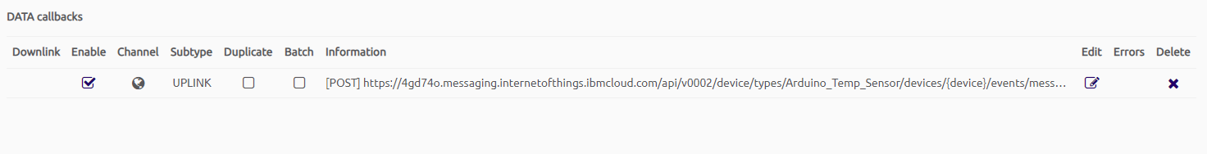

**Sigfox Callback Edit Page:**

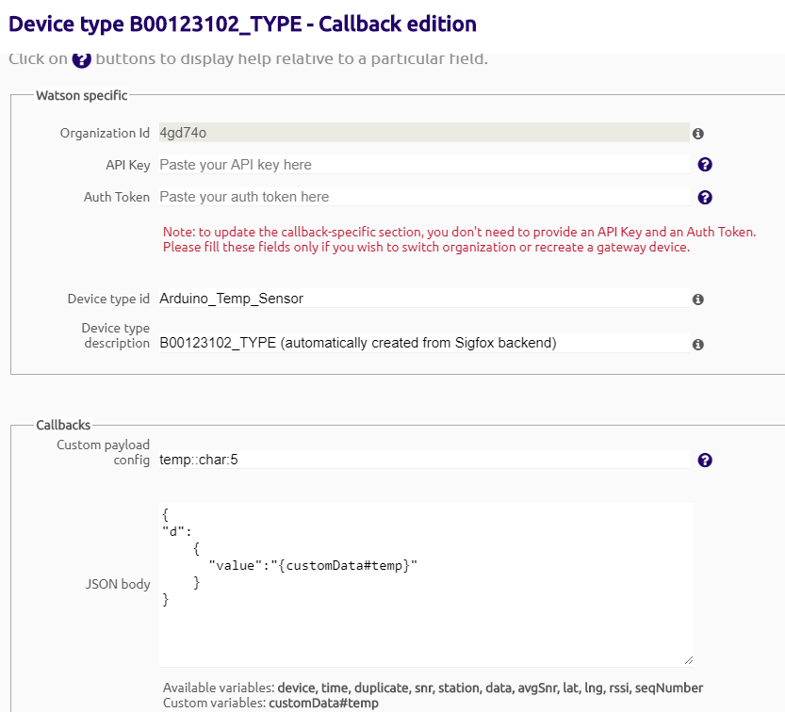

**Watson IoT Devices' Page:**

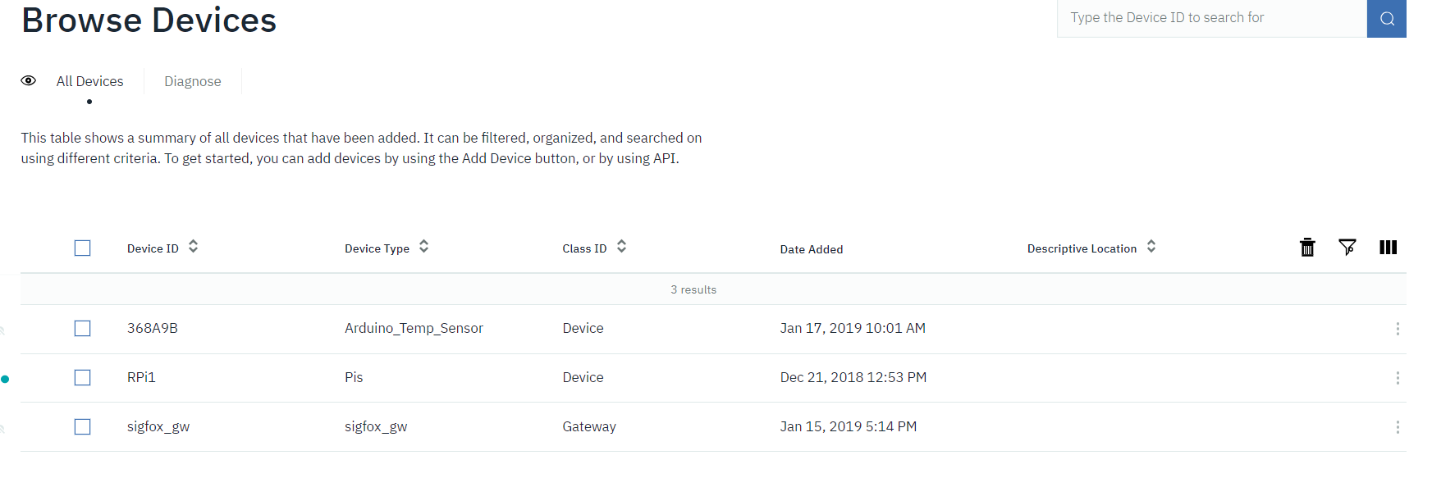

**IBM Cloud Node-Red**

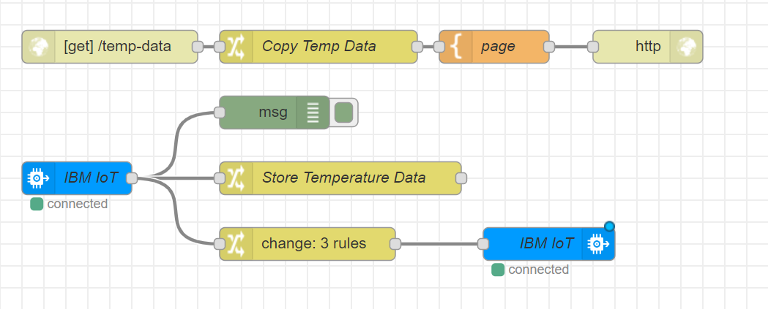

**Raspberry-pi Node-Red**

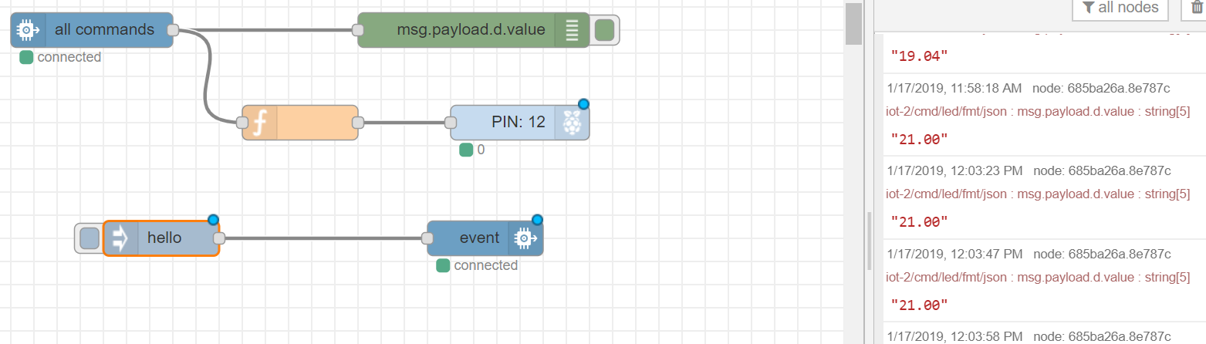

**Messages received in Sigfox**

