RetailPulse AI
  - Solution design and architecture
Hackathon panel submission | 10 October 2026

Solution overview
RetailPulse AI is a proposed retail platform for NovaMart customers and store teams. It combines a shopping experience with an AI assistant that understands product needs, answers questions from approved retail documents and supports controlled business workflows.
The application will use React for the frontend, Node.js and Express for the backend, PostgreSQL for storage and Prisma for database access. JWT authentication will identify users, while role and store permissions will control their access. Document retrieval will use PostgreSQL with pgvector.

Problem being addressed
Customers struggle to find suitable products, understand return and delivery policies, verify stock availability and obtain timely support. Store managers need visibility into inventory and a coordinated way to handle low stock, orders and customer issues. The solution connects these activities through a shared source of retail information.

Expected outcome
A customer can sign in, select a store, describe a product requirement, receive relevant suggestions with reasons, check a policy with a source citation and place a simulated order. A manager can view the resulting stock position and review a replenishment proposal. An administrator maintains products, access and approved knowledge.

Document guide
Page | Coverage
1 | Solution overview and business problem
2 | Scope and implementation assumptions
3 | MVP architecture and technology choices
4 | Roles and membership tiers
5 | Shopping and order workflows
6 | Retail knowledge assistant
7 | AI coordination and store operations
8 | Authentication and data design
9 | Implementation, validation and demonstration
10 | System context and core data flow diagrams

This document describes the proposed design. Implementation status and measured results will be presented separately in the final demonstration.
01 / SOLUTION DESIGN

Scope and implementation assumptions
The use case specifies shopping and document-grounded assistance, along with specialized agents for inventory, promotions, orders and support. JWT authentication is an additional panel requirement. The team has selected the technology stack stated in this document.

Included capabilities
Area | Planned scope
Shopping | Catalogue, categories, brands, search, filters, sorting, pagination, product details, cart, preferences and availability by store.
Access | Customer registration and JWT login, role-based navigation and backend permission checks.
Knowledge | PDF, Markdown, text, CSV and JSON ingestion; retrieval; grounded answers; versioned source citations.
AI assistance | Product recommendations and focused workflows for inventory, promotions, orders and support.
Operations | Inventory views, low-stock identification, replenishment approval, order updates and support tickets.

Implementation assumptions
Assumption | Design consequence
Sample retail data | Use a manageable catalogue with multiple stores and a warehouse to demonstrate different stock situations.
Authentication is built within the app | No existing login service is assumed. Public registration creates customer accounts; staff access is controlled.
Single region and currency for the demo | Use India and INR, while retaining region metadata for policy applicability.
Simulated external operations | Payment, delivery updates and replenishment receipt are simulated. No real financial transaction is performed.
Explicit membership rules | Define sample tier benefits and matching policy documents; tier names alone do not establish benefits.
Approved document lifecycle | An administrator reviews and activates successfully processed documents before use.
Text-based document extraction | All listed file formats are supported; scanned PDFs requiring OCR are outside the initial scope.

Scope boundary
Real payment settlement, courier integration, supplier purchasing and advanced demand forecasting are outside the initial implementation. Stock and operational changes remain validated, persisted and visible even when the external process is simulated.
02 / SOLUTION DESIGN

MVP architecture and technology
The MVP uses one React frontend, a modular Node.js and Express backend, and a document ingestion worker. PostgreSQL is the primary database, accessed through Prisma; pgvector stores document embeddings. The diagram shows the components required for the initial build.
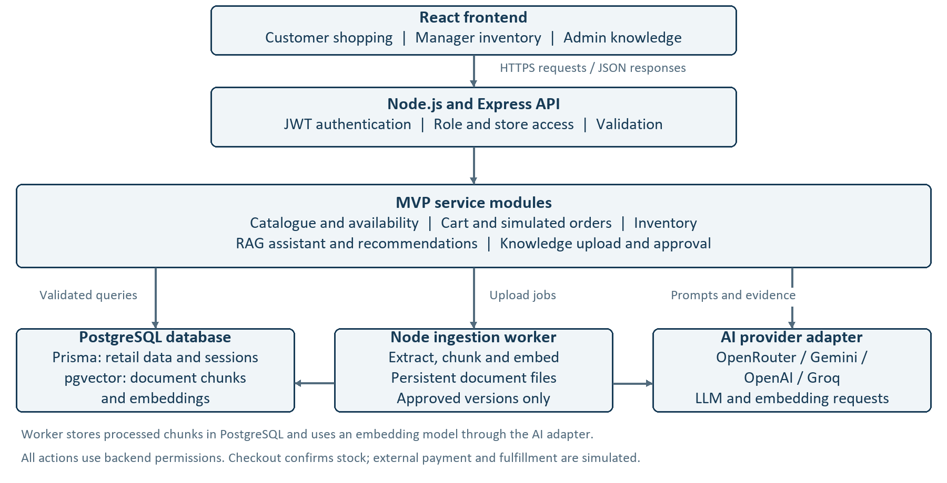

Technology responsibilities
Technology | Purpose
React | Customer shopping, assistant and staff interfaces.
Node.js and Express | APIs, JWT authentication, business logic and AI coordination.
PostgreSQL and Prisma | Retail records, relationships, database access and migrations.
pgvector | Document embeddings and similarity retrieval within PostgreSQL.

LLM integration
We can use models through OpenRouter, Gemini, OpenAI or Groq, depending on development needs. The provider and model will be selected during implementation. The AI layer supports intent interpretation, recommendation explanations and document-grounded answers; an embedding model supports retrieval.
MVP priorities are JWT login, shopping and stock-safe simulated checkout, document-grounded answers, recommendations, and basic store inventory views. Business services enforce prices, permissions and stock. Advanced forecasting, real payments and external delivery integrations remain outside the MVP.
03 / SOLUTION DESIGN

Roles and membership tiers
Roles control authority; membership tiers control customer benefits. The brief requires role-based navigation and names four membership tiers, but does not define an exact permission or benefit matrix. The following is the proposed application design.

Role based features
Role | Main features | Access boundary
Customer | Shopping, recommendations, policy questions, preferences, cart, orders and support tickets. | Own profile, orders and tickets; eligible customer documents.
Store manager | Inventory dashboard, store orders, low-stock items, replenishment approvals and scoped support. | Assigned stores and authorized internal procedures.
Administrator | Products, locations, user roles, membership rules, promotions, knowledge documents and audit oversight. | Privileged operations validated and recorded by the backend.

Proposed demo tier benefits
All tiers receive the core shopping and assistant features. The benefits below are demo business choices and must be represented consistently in application rules and sample policies.
Benefit | Standard | Silver | Gold | Platinum
Standard delivery | INR 99 | Free from INR 1999; else 99 | Free | Free
Express delivery | INR 199 | INR 199 | INR 99 | Free
Eligible offers | Public | Public + Silver | Public + Silver + Gold | All tier levels
Support priority | Normal | Normal | High | Urgent

Pickup is free for every tier. Delivery thresholds use the merchandise subtotal after discounts; express delivery is offered only where supported. One best eligible merchandise promotion applies per order. Support priority affects queue ordering and does not imply a guaranteed response time.

Navigation and enforcement
Customers see shopping and personal account screens. Managers see store operations and approvals. Administrators see configuration and knowledge management. Membership changes the benefits displayed, not staff access. Backend checks enforce permissions independently of menus or browser requests.
04 / SOLUTION DESIGN

Shopping and order workflows

Product discovery
Customers browse by category and brand, search products, filter by price and specifications, sort results and navigate paginated listings. Product details show price, specifications, images, ratings and availability at the selected store. Preferences can inform recommendations without replacing explicit customer requirements.

AI assisted recommendations
The customer describes a need, such as a laptop for development within a budget. The assistant converts the request into structured requirements, retrieves matching products and checks availability. It returns product identifiers and clear reasons tied to the actual catalogue. If a necessary detail is missing, it asks a clarifying question.
Price and stock come from the database. Mandatory constraints are applied by backend logic, while AI helps interpret needs and explain suitable options. This reduces the chance of recommending an invented product or an unavailable option as in stock.

Cart and checkout
Step | Behavior
Select fulfillment | Choose store pickup or home delivery. Pickup uses the selected store; the demo delivery flow uses a warehouse.
Prepare cart | Add or update quantities and show the applicable membership offers and delivery charge.
Review quote | Recalculate totals on the server and present the order for explicit confirmation.
Submit order | Recheck stock and prices, simulate successful payment and update the order and inventory consistently.
Handle changes | If stock or totals changed, show the revised result and request confirmation where required.

Order visibility and consistency
Customers see only their own orders. Managers handle fulfillment for assigned locations. Pickup orders move from placed to ready and collected; delivery orders move through processing, shipped and delivered. These are simulated status updates in the demo.
Items in a cart do not reserve stock. Checkout must prevent overselling and duplicate order creation when requests are retried. Purchased item prices are saved with the order so later catalogue updates do not change purchase history.
05 / SOLUTION DESIGN

Retail knowledge assistant
The knowledge assistant answers questions using approved retail documents rather than relying on general model knowledge. Sources include return policies, warranty policies, delivery rules, membership benefits, product manuals and store procedures.

Document ingestion
Stage | Purpose
Upload and metadata | Accept supported files and record title, type, version, region, category, effective dates and intended audience.
Extraction and chunking | Extract readable content and divide it into passages while preserving headings or record context.
Embeddings and storage | Generate embeddings and store passages with source metadata in PostgreSQL using pgvector.
Activation | An administrator activates a successfully processed version for retrieval.

Answering workflow
For each question, identify the relevant context and retrieve applicable passages. Filter by country, product category, effective date, document type and customer membership. Generate an answer from the retrieved evidence and display the document title, section and version.
When an order-specific question depends on the purchase context, use the relevant order information and policy basis. Ask for clarification when essential context is missing. When supporting evidence is unavailable or conflicting, explain the limitation and offer support escalation.

Access and grounding
Customer policies and internal procedures have separate access audiences. A customer must not receive staff-only passages through the assistant. Source links open only content that the current user is allowed to view. The backend derives identity and membership from the authenticated account.
Citations must refer to retrieved passages. A source reference alone is not sufficient evidence of correctness, so validation includes whether the answer is supported by the cited content. Recommendations use catalogue facts; policy answers use approved documents.

Example demonstration questions
- Can I return an opened mobile phone purchased online?
- Do I receive free express delivery with my membership?
- What warranty applies to this refrigerator?
- Which manual section explains how to reset this device?
06 / SOLUTION DESIGN

AI coordination and store operations
Specialized agents are implemented as focused workflows within the backend. A coordinator routes each request to the appropriate workflow and provides only the permitted tools. This keeps the behavior understandable and avoids unnecessary service complexity.
Workflow | Responsibility | Controlled outcome
Shopping | Interpret requirements, search products and check availability. | Explained recommendations and proposed cart changes.
Knowledge | Retrieve applicable approved passages. | Grounded answers with source citations.
Inventory | Inspect stock and identify low-stock items. | Replenishment proposal for an authorized manager.
Promotions | Check active offers and membership eligibility. | Applicable offer explanation; proposed changes reviewed by an admin.
Orders | Read authorized orders and prepare checkout. | Order placement after customer confirmation.
Support | Understand the issue and collect relevant context. | Ticket creation after an explicit request or confirmation.

Inventory and replenishment
Managers view stock for assigned stores and see products at or below configured reorder levels. A replenishment suggestion identifies the product, location, proposed quantity and reason. The manager approves or rejects it. Approval creates the simulated request; stock increases only when receipt is recorded.
Low-stock detection is rule-based in the initial implementation. AI explains the observed condition and proposed action. This supports a clear demonstration without claiming advanced demand prediction.

Support and promotions
Customer tickets remain linked to their account and, where relevant, an order or store. Managers handle tickets within their scope, while administrators oversee assignment. Membership determines the configured queue priority. Promotions are checked by backend eligibility rules so displayed offers match checkout behavior.

Action control and traceability
AI cannot assign roles, bypass store restrictions or modify records without the relevant permission. Proposed business actions are shown with their parameters before confirmation or approval. Execution rechecks the action and records the actor, action, result and relevant references. Repeated execution must not create duplicate changes.
07 / SOLUTION DESIGN

Authentication and data design

JWT authentication
Customers register and sign in through the application. Passwords are stored as secure hashes. Successful login issues a signed, expiring access JWT; a refresh mechanism maintains the session. The backend verifies tokens and session validity before protected requests. Logout revokes the session.
Public registration creates a customer account. Staff roles and store assignments are managed through authorized administration. The browser and AI assistant cannot supply trusted role or membership values. Role changes and account disabling must affect subsequent authorization checks.

Authorization rules
Request | Required check
Customer order or ticket | The authenticated customer owns the record.
Manager inventory or fulfillment | The manager is assigned to the affected store.
Policy publication or role change | The current user has administrator permission.
AI tool execution | Apply the same role, ownership and store checks as a normal API action, plus any required approval.

Main data groups
Group | Principal entities
Identity | Users, authentication sessions and store assignments.
Catalogue and inventory | Products, categories, brands, images, locations, inventory and stock movements.
Shopping and benefits | Carts, orders, order items, promotions and membership benefit rules.
Knowledge | Documents, versions, chunks, embeddings and ingestion jobs.
Support and control | Tickets, conversations, action approvals and audit records.

Data design choices
Prisma manages relational data and migrations. A dedicated knowledge repository handles vector retrieval. Foreign keys preserve relationships; unique constraints protect identifiers such as email and SKU. Monetary values use decimal storage, and order lines preserve purchased prices. Related stock and order updates run together in a database transaction.
Validation applies to user requests, uploaded metadata, model responses and tool arguments. Secrets remain on the server, while logs and AI context include only the information necessary for the current task.
08 / SOLUTION DESIGN

Implementation and validation

Implementation sequence
Phase | Deliverable
1 Foundation | Database schema, sample data, JWT authentication, role permissions and navigation.
2 Shopping | Catalogue, selected-store availability, preferences, cart, pricing and simulated checkout.
3 Knowledge | Document ingestion, metadata filters, retrieval, source citations and safe fallback.
4 AI and operations | Recommendations, specialized workflows, inventory dashboard, approvals and support tickets.
5 Submission | End-to-end validation, setup instructions, architecture overview and demonstration rehearsal.

Essential validation
Area | Expected behavior
Access | Customers cannot use admin functions or read another customer's orders; managers cannot modify another store.
Orders | Concurrent purchases do not oversell stock; repeated checkout requests do not create duplicate orders.
Membership | Displayed offers and delivery charges agree with configured tier rules.
Knowledge | Answers cite applicable versions and exclude unauthorized documents; missing evidence produces a safe fallback.
Agent actions | Unapproved or unauthorized changes are rejected; successful actions are traceable.
Failure handling | Invalid files, stock changes and unavailable AI services produce clear messages.

Demonstration flow
Sign in as a customer, select a store, request a suitable product and inspect the recommendation reasons. Ask a policy question and open its citation. Review tier-aware checkout and confirm a simulated order. Sign in as a manager to inspect stock and approve a replenishment proposal. Show an administrator activating knowledge and demonstrate one denied unauthorized action.

Submission package
Provide the working application, source code, setup instructions, schema and migrations, architecture overview and demo access instructions. Clearly identify simulated integrations and the features implemented in the final build.

Design basis
Business scope follows the supplied RetailPulse AI hackathon use case. React, Node.js, Express, PostgreSQL and Prisma are the team-selected stack; JWT is a panel requirement. Role definitions, membership benefits and simulated workflow rules in this document are explicit proposed implementation choices.
09 / SOLUTION DESIGN

System data flows
These diagrams show what information enters the platform, how it is processed and where it is stored. External participants are rectangles, processes are rounded boxes and data stores have horizontal boundaries. Arrows show the direction of data movement.

System context
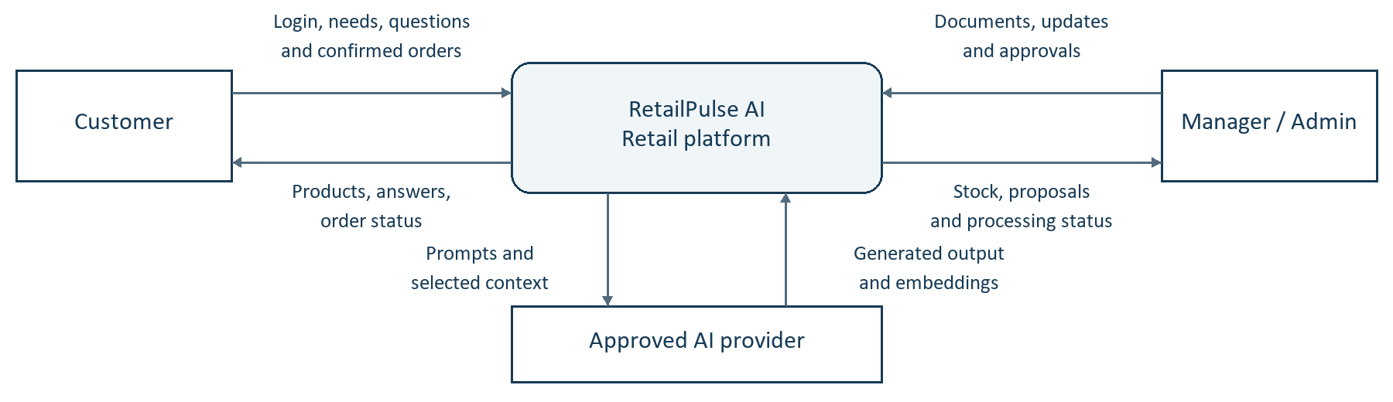

Shopping and knowledge data flows
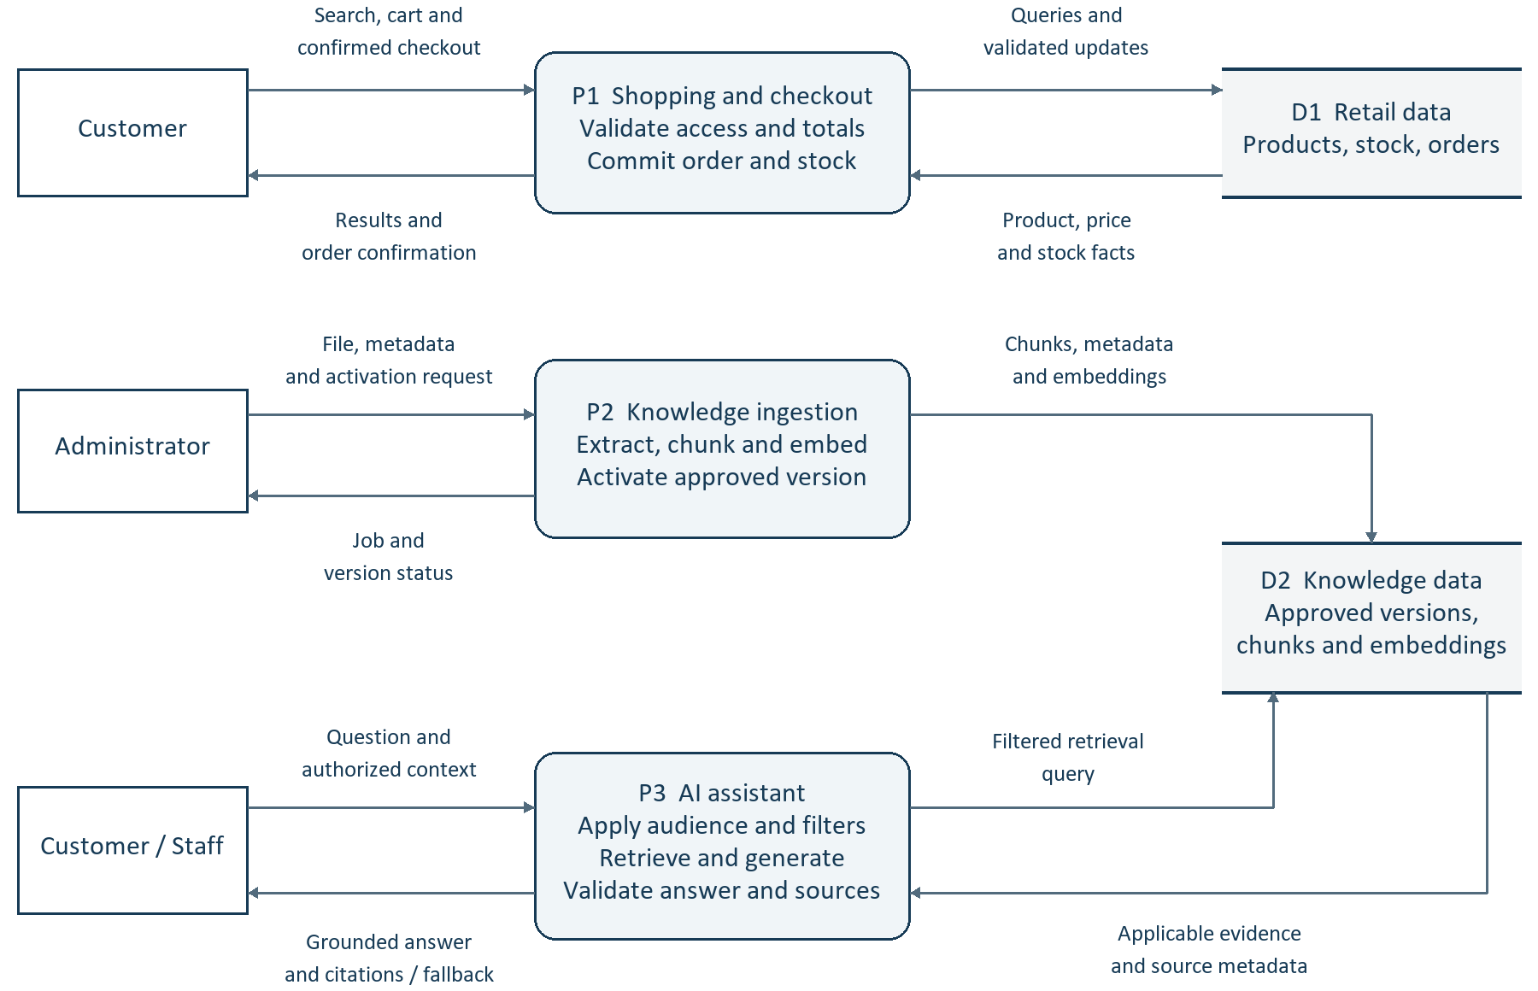
P1 uses Prisma and a transaction for order and stock updates. P2 uses the ingestion worker and stores original files separately. P2 and P3 use the approved AI provider shown above. Every process enforces the caller's permissions; operational actions follow the approval flow described earlier.

