

**Table Of Content:**

|  |  |
| --- | --- |
| Executive Summary | 3 |
| Proposal-Design Diagram | 4 |
| Internet Connectivity | 5-7 |
| Bill Of Materials | 7 |
| Purpose Of Each Materials | 8 |
| Reason for Selection of Material | 9 |
| Security Details | 10 |
| Monitoring Details | 10-11 |

**Executive Summary**

* Project Overview

This document will explain the framework of the Imaginary College’s fundamental network infrastructure. The key objective of this network design is to provide the college with a strong and a

dependable as well as cost effective network system that supports the college’s day to day tasks and

future expansion.

* Objective

Our main objective is to boost connection for strengthening the imaginary college’s network system. We

want to make sure that the network is reliable and works smoothly among all the departments and the

remotes offices with its peak performance. We will assure that the network structure of the imaginary

college is fully dependable and it will help the users of the network to accomplish their day to day tasks.

We will assure that the security of this network system will help protect all files and all computer

components from any type or virus, hazardous file or even any miscellaneous files. We will ensuring this

design with scalability that simply means that there will be space available for the future expansion as

well as advancements in technological terms without any complication.

**Proposal**

**Design Diagram:**

**Internet Connectivity**

**Network requirements**:

* Based on the physical topology of the imaginary college. The network is divided into two areas (Building A & building B). Both buildings have a separation distance of 200 meters. This is an important key factor when designing the network infrastructure.

1. **Building A** **(Staff Room & Administration Office)**

* The staff room is 576m2 and the Administration office is 96m2. This helps us understand the devices that can be installed in a room without congestion.

1. **Building B** **(Computer Lab)**

* The computer lab is the largest room compared to the rooms in building A. Therefore, it has room for more devices.

**Devices used in the network:**

|  |  |
| --- | --- |
| **Devices** | **Quantity** |
| Computers | 30 |
| Switch(2960 IOS15) | 3 |
| Multilayer Switch(3650-24ps) | 1 |
| Projector | 1 |
| Printer | 5 |
| Wireless Display Gateway | 1 |

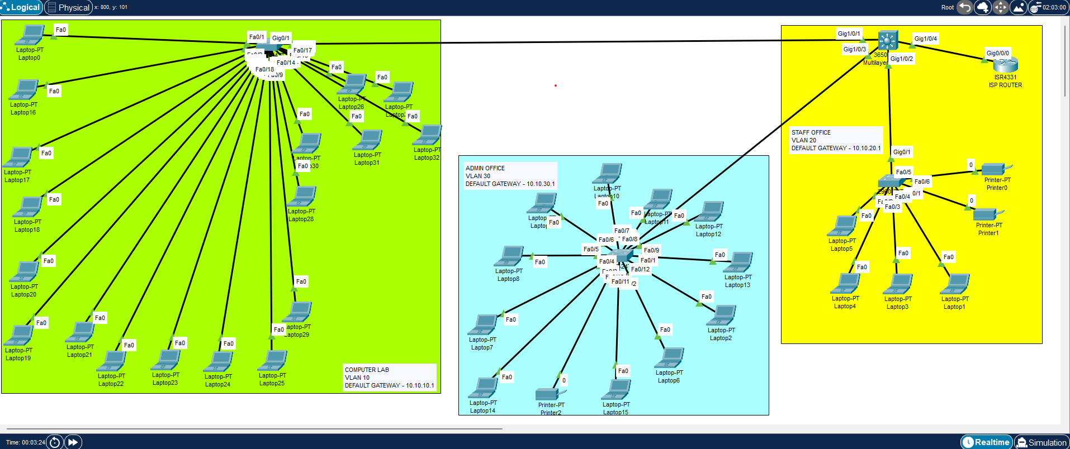**Diagram from packet tracer:**

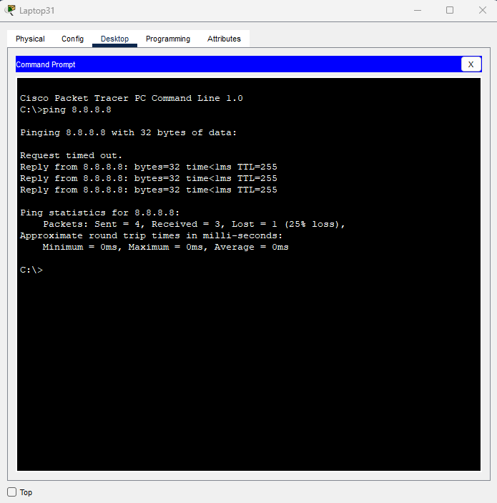

-To check the internet connection, I used command prompt to ping to the Google DNS server (8.8.8.8).

-Also the VLANs were pinged to ISP.

**Implementation:**

Each room had a dedicated access layer switch configured with VLANs that in turn connected to a core multilayer switch with switch virtual interfaces configured. The multilayer switch then connected to an ISP router responsible for routing traffic to the internet.

**Bill of materials:**

|  |  |  |  |
| --- | --- | --- | --- |
| Material | Model | Cost Per Unit | Shipping Cost |
| Computers | Dell OptiPlex 3000 | $789.00 x 30 | $232.20 |
| Switch | Cisco Catalyst 3650 Switch | $6,989.21 X 3 | - |
| Multilayer Switch | Cisco Catalyst 2960-X Switch | $3,589.22 | - |
| Projector | Optoma LED Projector ML 1050ST+ | $769.95 | $211.22 |
| Printer | BROAGE HP Laser-Jet Pro 4001 DW | $369.00 x 5 | $190.68 |
| Wireless Display Gateway | Wepresent WICS-2100 | $595.00 | $168.95 |
| Ethernet Cables | RJ45 Cat-6 Ethernet Patch Cable | $6.29 per 7.6m x 1000 | $31.02 |
| Fiber Optics Cable | SFP+ DAC Twinax Cable | $199.99/300m | $86.79 |
|  | Total Cost+Shipping | | ≈ $58,847.65 |

**Purpose of each material**

|  |  |
| --- | --- |
| Material | Purpose |
| Computers | This will provide an interactive interface to the users (students, staffs & instructors) to carry out their tasks. Also helps the users to store information and access the internet. |
| Switch | A switch allows connection between multiple devices (Computers, Projectors, Printers). Packets are sent and received through multiple devices. |
| Multilayer Switch | A multilayer switch combines the functions of a traditional switch, router, and other network devices. |
| Projector | A projector is used to cast the instructor’s computer screen to the front of the room for all the students to see. |
| Printer | Prints and scans important documents; also allows users to print documents from their computers via LAN (Local Area Network) connection. |
| Wireless Display Gateway | Is a wireless display adapter that allows instructors to mirror their screen to the projectors |
| Ethernet Cables | Ethernet devices are used to connect devices to the LAN. Supports connection distance up to 100 meters. |
| Fiber Optics Cable | Allows data transfers in the form of light at a much greater distance (40km-100km) and much faster speeds (up to 10Gbs depending on your connection). |

**Reason for selection of material:**

|  |  |
| --- | --- |
| Material | Reason for selection |
| Computers | This will provide an interactive interface to the users (students, staffs & instructors) to carry out their tasks. Also helps the users to store information and access the internet. |
| Switch | A switch allows connection between multiple devices (Computers, Projectors, Printers). Packets are sent and received through multiple devices. |
| Multilayer Switch | A multilayer switch combines the functions of a traditional switch, router, and other network devices. |
| Projector | A projector is used to cast the instructor’s computer screen to the front of the room for all the students to see. |
| Printer | Prints and scans important documents; also allows users to print documents from their computers via LAN (Local Area Network) connection. |
| Wireless Display Gateway | Is a wireless display adapter that allows instructors to mirror their screen to the projectors |
| Ethernet Cables | Ethernet devices are used to connect devices to the LAN. Supports connection distance up to 100 meters. |
| Fiber Optics Cable | Allows data transfers in the form of light at a much greater distance (40km-100km) and much faster speeds (up to 10Gbs depending on your connection). |

**Security Details**

Security is one of the essential factors of network designing it is a security system that helps to protect

the computer and the network system as well as the data in it. It also protects the computers from

unauthorized access, different types of security threats and cyber-attacks as well. The firewall manages

the ingoing and the outgoing of the traffic to see whether the traffic involves any miscellaneous files. It

is extremely important to have a security system for the networking system in order to keep the communication safe and secure**. For security purposes managed Cisco catalyst switches were used which were configured with VLANs for traffic segregation and collision detection and avoidance. Since the ports for the managed switches were in their own collision domains they were no chances of a network loop occurring in the network that would cause disruptions to the business operation.**

**Monitoring Details**

* Before Network Configuration

Before we setup the network structure, there must be an evaluation carried out so that we have a fair

idea of the cost and the requirements. We should plan the network as such that it gives out the best

expected results. A site is also required where the network structure will be set up. The layout plan will

be made, cabling infrastructure will be added in the network diagram. After completing the network

diagram and the costing there will be a proposal made to the organization so that the organization

decide if the design will meet the demand and then appropriate tools, hardware, software will be

chosen to begin with set up.

* During Network Configuration

Many monitoring is done during the setup. Real-time monitoring procedures will be carried out so that

the installation process can be tracked. Simultaneous equipment test is carried out to check whether the

equipment are functioning properly and give the best and accurate results such as speed tests. If there is

a fault seen there will be fixing done as soon as possible to eliminate the issues. Then there will be

security mechanisms added to the network structure as it is one of the essential part of the network

configuration system. Security elements such as firewall and intrusion detection system will be added to

the system for a safer and secure network system which protects the computer system from hazardous

and miscellaneous files. Then elements like IP addresses, serial numbers network setting will be done so

that the devices are able to communicate and fully functional.

* After Network Configuration

After completing with the network structure, several tests are carried out to check for errors and to

check to see if all the components in the structure functions accurately. Security auditing will be done to

act again any risk arousing to damage or affect the network system and the data in it. There will also be

expansion slots available for future expansions. Troubleshooting tools will also be used to detect

component breakdowns and the connection difficulties. Frequent backup is also done for data safety

and one of the major one is the maintenance of the network system so that the system continues to

function properly and give its best results.

**Drawbacks & Limitations**

During the completion of this project, the following limitations were encountered:

1. Due to the use of the simulation tool for designing the network architecture few bugs were noticed during the configuration of the devices whereby certain modules used in the devices were giving errors.
2. The simulation tool did not support some of the modules that were required to connect a fiber optic SFP to the network switches.

**Conclusion**

In conclusion, this assignment helped me in understanding the basic fundamental of networking and also gave me a fair idea of how it works in a real world scenario. Using notes from the lectures; my own knowledge & help from my peers we were able to successfully complete this assignment.