Job Market Analysis
REPORT
SUBMITTED BY : VISHANTH M S

Summary
This report analyzes 742 data-science-related job postings scraped from Glassdoor, covering job titles, salaries, company details, and required skills across 42 features. The goal is to identify where the jobs are, what they pay, and what skills and qualifications employers expect, in order to guide job seekers and inform employer hiring strategy.
- California and Massachusetts dominate both job volume and pay for data science roles.
- Python, Excel, and SQL are the three most universally demanded skills, ahead of specialized tools like AWS or Spark.
- Seniority level has a larger effect on salary (~$50K spread) than formal degree requirements (~$21K spread).
- Biotech & Pharmaceuticals is the single largest hiring industry for these roles.

Methodology
Data was extracted from the provided MySQL database and cleaned as follows:
- Removed an empty stray column (FIELD4) present in the raw export.
- Company names were stripped of a trailing Glassdoor rating artifact (e.g. "Company\n3.8").
- Placeholder -1 values in Rating, Founded, and Age were treated as missing and imputed with the column median.
- A data-entry corruption in Size ("Jan-50") was corrected to "1-50" employees.
- Job title and seniority text was normalized for consistent casing and "na" values relabeled as "Not specified".

1. States with Most Number of Jobs.

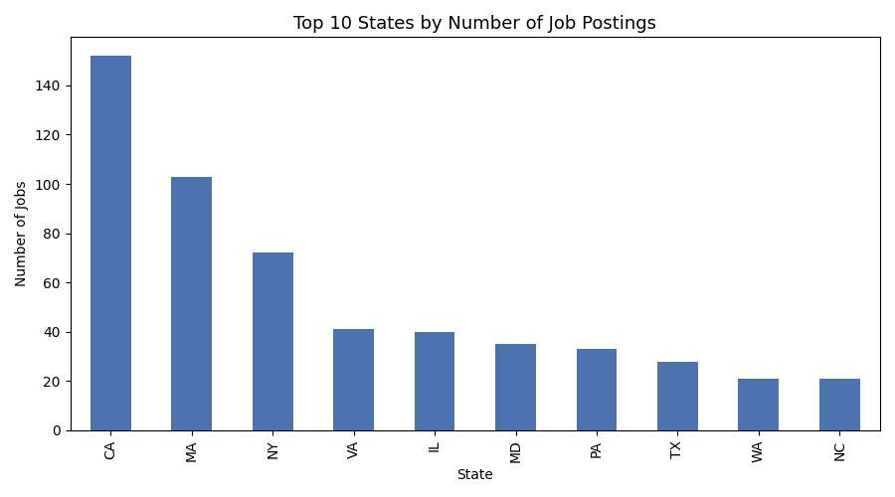

California leads decisively with 152 postings, more than 45% ahead of second-place Massachusetts (103). New York (72), Virginia (41), and Illinois (40) round out the top five. Job seekers targeting data science roles will find the deepest markets on the coasts, with California alone accounting for roughly 1 in 5 postings in the dataset.

2. Average Minimum and Maximum Salary by State
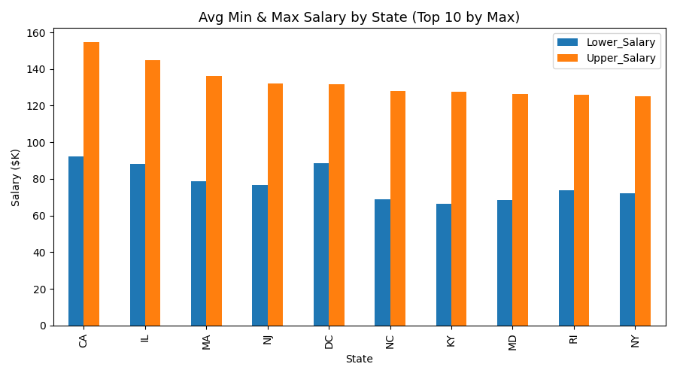

California posts both the highest average minimum ($92.4K) and maximum ($154.6K) salary bounds, followed by Illinois and Massachusetts. Notably, the spread between minimum and maximum offers is wide and fairly consistent (roughly $50-65K) across the top-paying states, suggesting negotiation range rather than fixed-rate offers is standard for these roles.

3. Average Salary by State
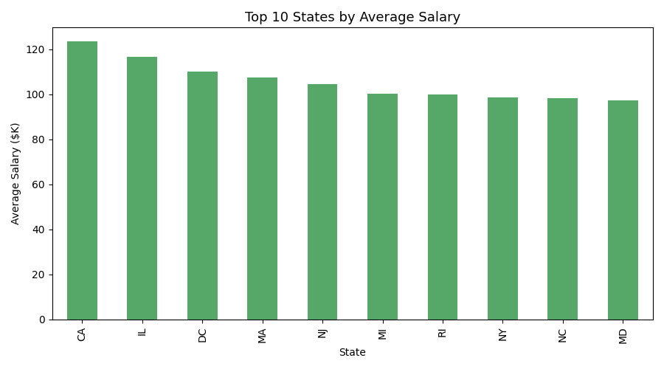

California again leads with an average salary of $123.5K, followed by Illinois ($116.7K) and Washington DC ($110.2K). Because California also has the most job postings, it offers job seekers the rare combination of high volume and high pay.

4. Top 5 Industries by Data Science Job Postings
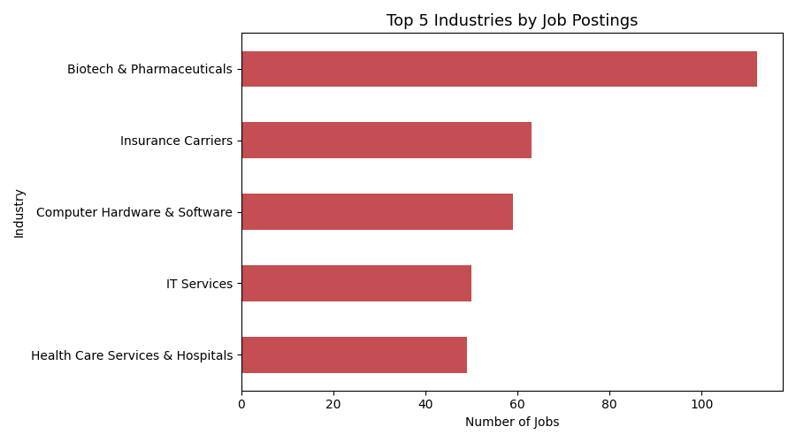

Biotech & Pharmaceuticals is by far the top hiring industry (112 postings), nearly double the second-place Insurance Carriers (63). Computer Hardware & Software (59), IT Services (50), and Health Care Services & Hospitals (49) complete the top five. This suggests data science hiring is heavily concentrated in life sciences and traditional insurance/tech sectors rather than pure-play tech startups.

5. Companies With the Most Job Openings
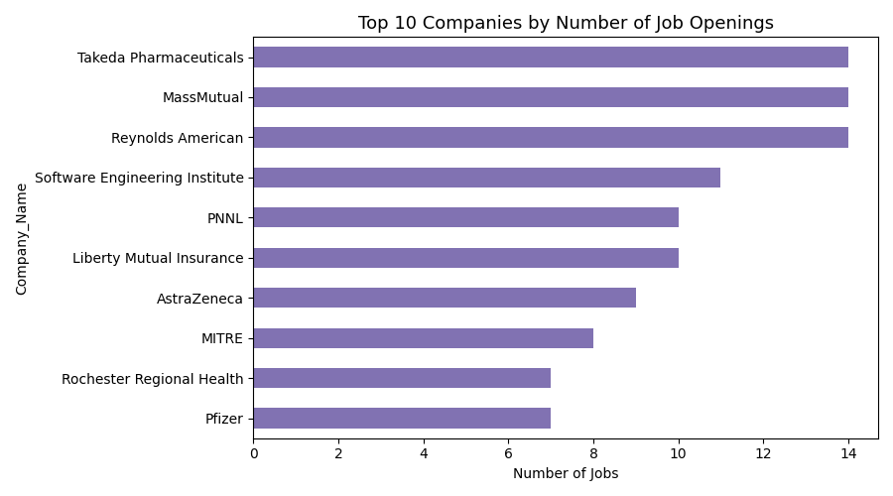

Takeda Pharmaceuticals, MassMutual, and Reynolds American are tied for the most postings (14 each), reinforcing the biotech/insurance concentration seen industry-wide. No single employer dominates the market — the top 10 companies together account for well under 20% of all postings, indicating a fragmented rather than employer-concentrated hiring landscape.

6-7. Most Common Job Titles and Their Salaries
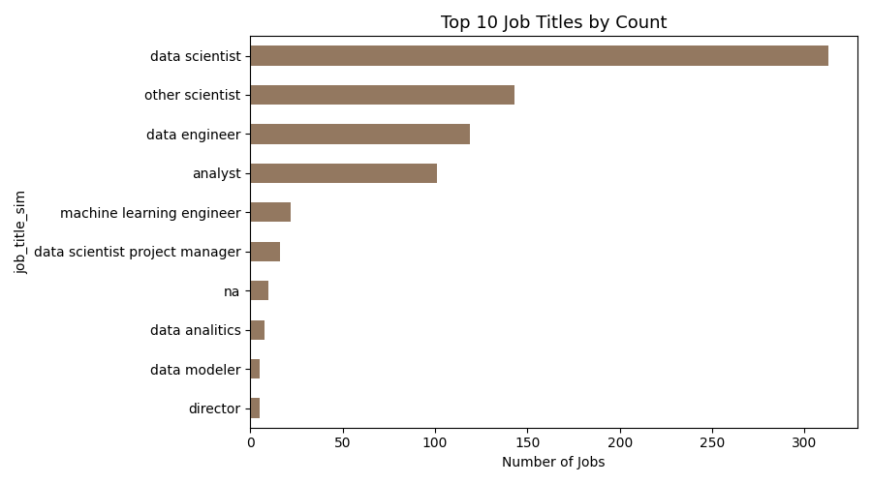

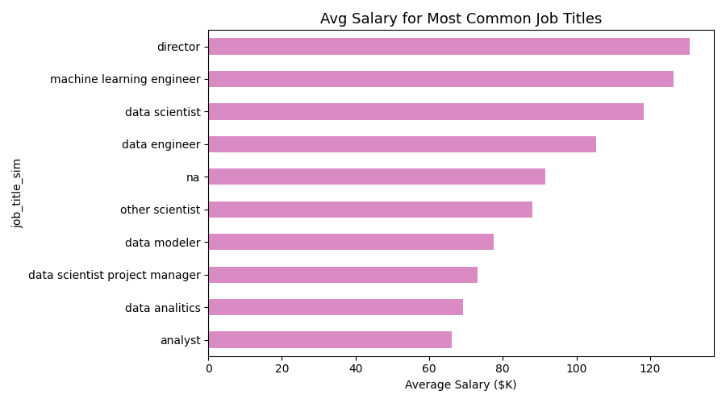

"Data Scientist" is the single most common title (313 postings, 42% of the dataset) and pays well above average at $118.3K. "Analyst" roles are also common (101 postings) but pay considerably less ($66.1K) — less than half of what Director-level roles command ($130.8K). Machine Learning Engineer, while rarer (22 postings), is the second-highest-paying title ($126.4K), suggesting specialization pays a premium over generalist analyst work.

8. Skills Required by Job Title
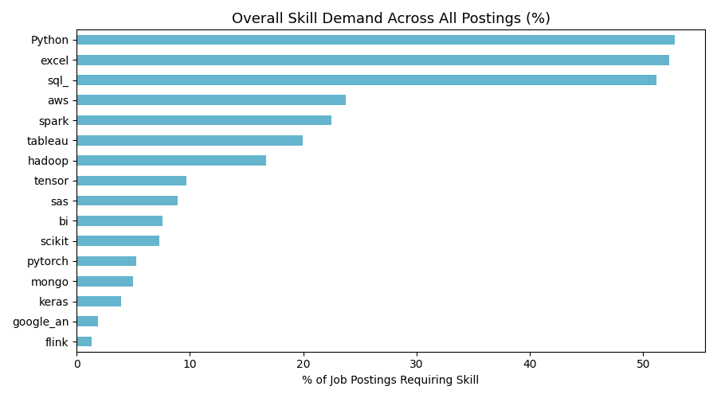

Across all postings, Python (53%), Excel (52%), and SQL (51%) are required at roughly equal, very high rates — these are the baseline toolkit for the field. Cloud/big-data skills (AWS 24%, Spark 22%, Tableau 20%, Hadoop 17%) form a clear second tier. Deep learning frameworks (TensorFlow, PyTorch, Keras, scikit-learn) are far less common overall but cluster heavily within Machine Learning Engineer and Data Scientist postings specifically, reflecting their specialized, role-specific nature rather than general demand.

9. Relationship Between Average Salary and Education
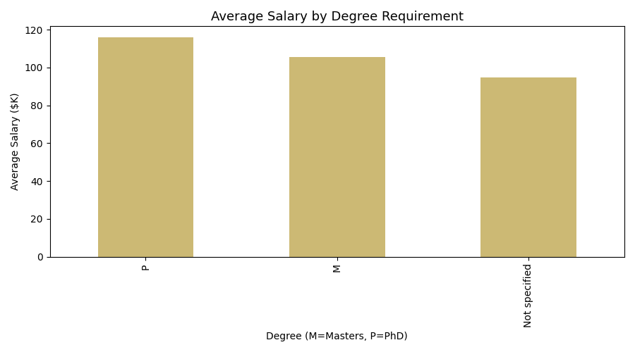

Postings that mention a PhD preference pay the most on average ($116.0K), followed by Master's-preferring postings ($105.6K), with postings that don't specify a degree preference paying the least ($94.7K). The roughly $21K gap between PhD- and no-preference postings confirms that advanced credentials are rewarded in this market, though the effect is smaller than the seniority effect discussed below.

10. Additional Insights

Seniority Matters More Than Degree
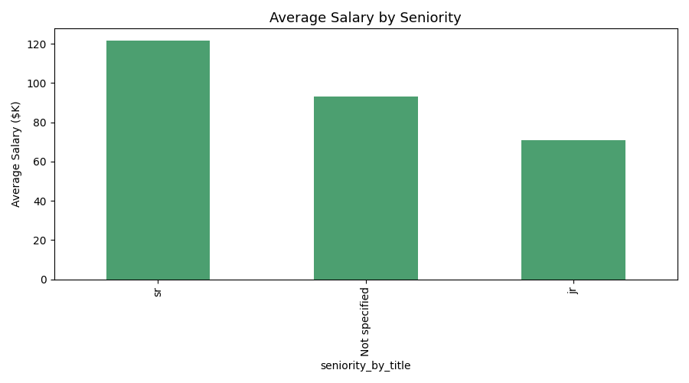

Senior-tagged roles average $121.7K versus $71.0K for junior roles — a ~$50.7K gap, more than double the salary spread attributable to degree requirements. This suggests experience and career progression are the strongest salary levers in this market, more so than formal education.

Feature Correlations
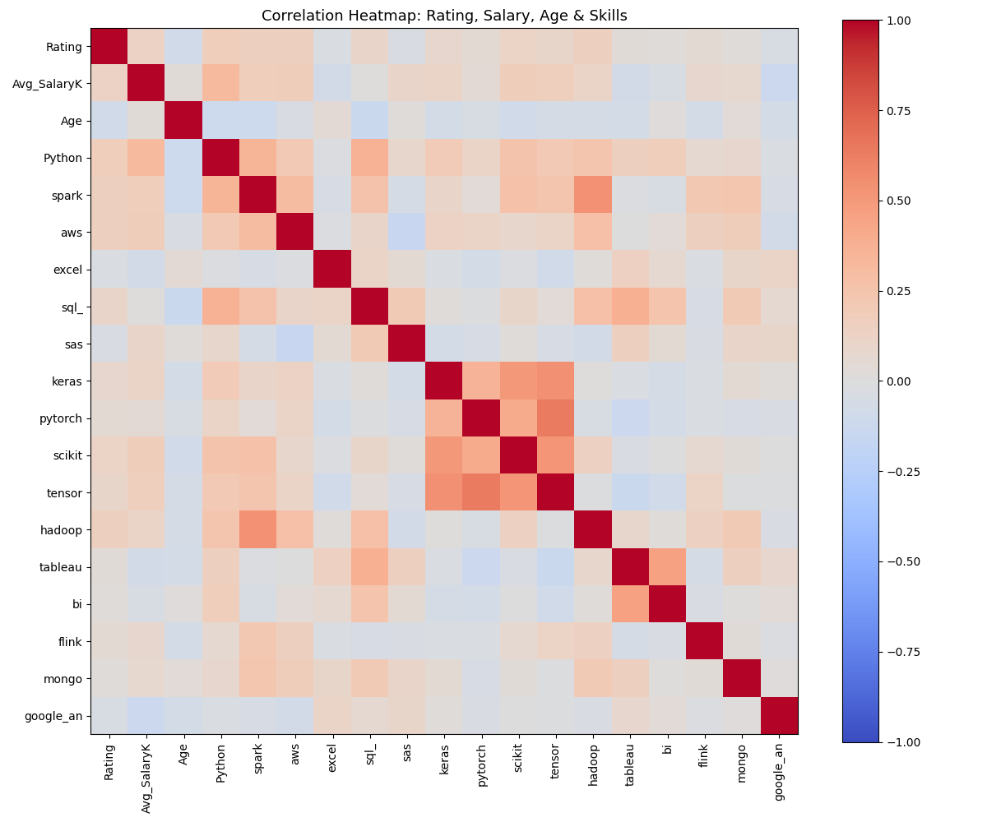
Figure 11: Correlation heatmap of rating, salary, age, and skill flags
No single skill flag correlates strongly with salary in isolation, reinforcing that pay is driven more by role/title and seniority than by any one tool. Company rating shows little relationship with salary or skill requirements, suggesting employee satisfaction and compensation are largely independent in this dataset.

Recommendations

For Job Seekers
- Prioritize Python, SQL, and Excel fluency — these are non-negotiable baseline skills across nearly all postings.
- Target California, Massachusetts, or New York for the deepest and best-paying markets, but expect higher cost of living to offset some of the premium.
- Consider specializing toward Machine Learning Engineer or Director-track roles for above-average pay, and treat a Master's/PhD as a differentiator rather than a requirement.

For Employers
- Since baseline technical skills are near-universal among candidates, differentiate job postings by clearly stating growth path, seniority level, and specialized tool requirements to attract the right applicants.
- Given the fragmented hiring landscape (no dominant employer), competitive compensation and clear role definitions are likely more effective for attracting talent than brand recognition alone.
- Biotech/pharma and insurance employers should benchmark pay against the state-level averages in Section 3, since these industries compete for the same national talent pool as tech-sector employers.

