CDACL-006 Market Analysis
Submitted by Vishanth M S
Insights & Analytics Report
Customer Ordering Behavior & Product Performance Analysis

1. Executive Summary
This report analyzes an order-level dataset (orders, order line items, products, aisles, and departments) to understand customer purchasing behavior and product performance, with the goal of informing marketing strategy and improving customer satisfaction. The dataset covers 986 unique customers, 21 departments, 134 aisles, and 1,000 catalog products. Twenty business questions were answered covering catalog structure, ordering cadence, peak-time patterns, reorder behavior, and top performers by product, aisle, department, and customer.
Key headline figures: customers place an average of 10.31 products per order, repeat orders arrive roughly every 11.19 days on average, and ordering activity peaks in the afternoon around 16:00. Full findings, supporting dashboards, and marketing recommendations follow.

2. Data & Methodology
Five tables were merged on their stated primary keys to answer the business questions:
- orders (1,000 rows) ↔ order line items, joined on order_id
- order line items (1,000 rows) ↔ products, joined on product_id
- products (1,000 rows) ↔ aisles, joined on aisle_id
- products ↔ departments, joined on department_id

Data Limitation
Each table was supplied as an independent ~1,000-row extract rather than a coordinated sample, so only 30 of the 1,000 orders have a matching order_id in both the orders table and the order line items table. Most of the 20 questions do not require that specific link (they use order line items joined only to products/aisles/departments, or orders on its own) and are reported on their full available data. Two questions — "users per department" (Q10) and "average order size by day of week" (Q18) — do require the order↔order-line link, and are reported on that 30-order matched sample; these results are directional rather than final. Top-N rankings drawn from the order-line table (Q4, Q9, Q12) are also limited by that table's small size (~97 line items), so most products appear only once and ties are common.

3. Catalog Structure

Q1 — Top 10 Aisles by Product Count
Item | # Products
vitamins supplements | 31
candy chocolate | 23
tea | 23
chips pretzels | 22
frozen meals | 22
energy granola bars | 21
cleaning products | 19
hair care | 19
ice cream ice | 19
yogurt | 19
Vitamins & Supplements carries the deepest catalog of any aisle, ahead of Candy/Chocolate and Tea.

Q2 & Q3 — Departments
There are 21 unique departments in the dataset. Product counts by department:
Item | # Products
personal care | 141
snacks | 130
beverages | 91
frozen | 87
pantry | 86
household | 76
dairy eggs | 58
dry goods pasta | 40
canned goods | 39
deli | 34
produce | 33
bakery | 31
breakfast | 28
pets | 23
alcohol | 23
babies | 20
international | 19
missing | 18
meat seafood | 16
other | 5
bulk | 2
Personal Care and Snacks carry the broadest product ranges.

Q20 — Products per Aisle & Department (Top 15 Combinations)
Department | Aisle | # Products
personal care | vitamins supplements | 31
beverages | tea | 23
snacks | candy chocolate | 23
frozen | frozen meals | 22
snacks | chips pretzels | 22
snacks | energy granola bars | 21
dairy eggs | yogurt | 19
household | cleaning products | 19
frozen | ice cream ice | 19
personal care | hair care | 19
missing | missing | 18
dairy eggs | packaged cheese | 18
canned goods | soup broth bouillon | 18
snacks | cookies cakes | 17
household | laundry | 17
Vitamins/Supplements and Tea/Candy-Chocolate are the deepest single aisle–department combinations.

4. Customer Base & Ordering Cadence

Q5 & Q6 — Customers and Reorder Timing
986 unique customers placed orders in the dataset. On average, customers who reorder do so every 11.19 days.

Q7 & Q15 — Peak Ordering Hours
Order volume by hour of day (24-hour clock). Peak hour: 16:00.
Hour | Orders
0:00 | 12
2:00 | 3
3:00 | 2
4:00 | 3
5:00 | 2
6:00 | 10
7:00 | 27
8:00 | 48
9:00 | 65
10:00 | 80
11:00 | 72
12:00 | 86
13:00 | 97
14:00 | 65
15:00 | 80
16:00 | 101
17:00 | 81
18:00 | 47
19:00 | 42
20:00 | 31
21:00 | 19
22:00 | 17
23:00 | 10

Q8 — Order Volume by Day of Week
The dataset labels days with an index (0–6) rather than named weekdays; volume by index:
Day Index | Orders
Day 0 | 154
Day 1 | 182
Day 2 | 139
Day 3 | 128
Day 4 | 130
Day 5 | 132
Day 6 | 135

Q11, Q14, Q16 — Order Size Profile
Average products per order: 10.31. Average cart-add position per order: 10.31.
Distribution of order sizes (number of products per order):
Order Size (# products) | # Orders
1 | 3
2 | 6
3 | 7
4 | 14
5 | 7
6 | 7
7 | 3
8 | 13
9 | 4
10 | 2
11 | 4
12 | 2
13 | 1
14 | 1
15 | 2
16 | 1
17 | 6
19 | 1
20 | 1
21 | 1
23 | 1
25 | 1
28 | 1
29 | 2
30 | 1
31 | 1
33 | 1
34 | 1
36 | 1
49 | 1

Q19 — Top 10 Users by Order Count
User ID | Orders Placed
User 310 | 100
User 7440 | 92
User 17155 | 94
User 20558 | 97
User 22274 | 93
User 38936 | 90
User 39460 | 85
User 48890 | 97
User 59106 | 91
User 60932 | 93
The top 10 customers have each placed 85–100 orders — strong loyalty-program candidates.

5. Product Performance & Reorder Behavior

Q9 — Top 10 Most Ordered Products
Item | Times Ordered
Soda | 2
All Natural Homestyle California Lemon Limeade | 1
Cantaloupe | 1
Garbanzo Beans | 1
Honey Vanilla Greek Yogurt | 1
Herb Thyme Clamshell | 1
Organic Whole Grassmilk Milk | 1
Organic Whole Wheat Elbows | 1
Vanilla Almond Breeze Almond Milk | 1
Xylitol Sweetener | 1
With only ~97 order line items in the provided sample, most products appear once; Soda is the sole repeat item.

Q4 — Top Reorder-Rate Products
Only products ordered at least twice in the sample qualify for a reorder-rate calculation:
Product | Times Ordered | Reorder Rate
Soda | 2 | 100%

Q12 — Most Reordered Product per Department
Department | Product | Times Reordered
beverages | Soda | 2
canned goods | Garbanzo Beans | 1
dairy eggs | Honey Vanilla Greek Yogurt | 1
produce | Cantaloupe | 1
dry goods pasta | Organic Whole Wheat Elbows | 0
pantry | Xylitol Sweetener | 0

Q13 — Products Reordered More Than Once
1 product(s) in the sample were reordered more than once.

Q17 — Reorder Rate by Aisle (Top 10)
Item | Reorder Rate
canned meals beans | 100%
fresh fruits | 100%
yogurt | 100%
fresh herbs | 100%
milk | 100%
soft drinks | 100%
soy lactosefree | 100%
baking ingredients | 0%
dry pasta | 0%
refrigerated | 0%
Canned Meals/Beans, Fresh Fruits, Yogurt, Fresh Herbs, and Milk show a 100% reorder rate on the (small) sample — consistent with staple, replenishment-driven categories.

6. Cross-Table Analysis (Matched 30-Order Sample)

Q10 — Users per Department
Item | Unique Users
dairy eggs | 3
canned goods | 1
produce | 1

Q18 — Average Order Size by Day of Week
Day Index | Avg. Items per Order
Day 0 | 10
Day 1 | 8
Day 2 | 10.83
Day 3 | 16
Day 4 | 3
Day 5 | 11.67
Day 6 | 7
Both results above are based on the 30-order matched sample and are directional only.

7. Dashboards

Catalog Dashboard
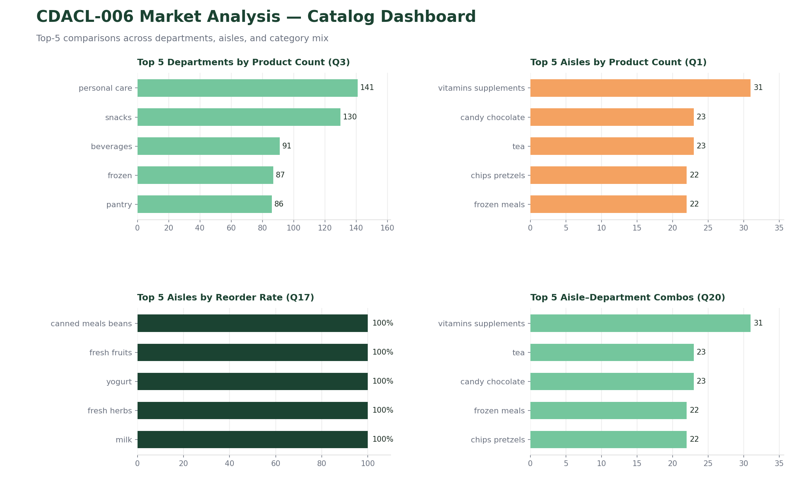

Customer Behavior Dashboard
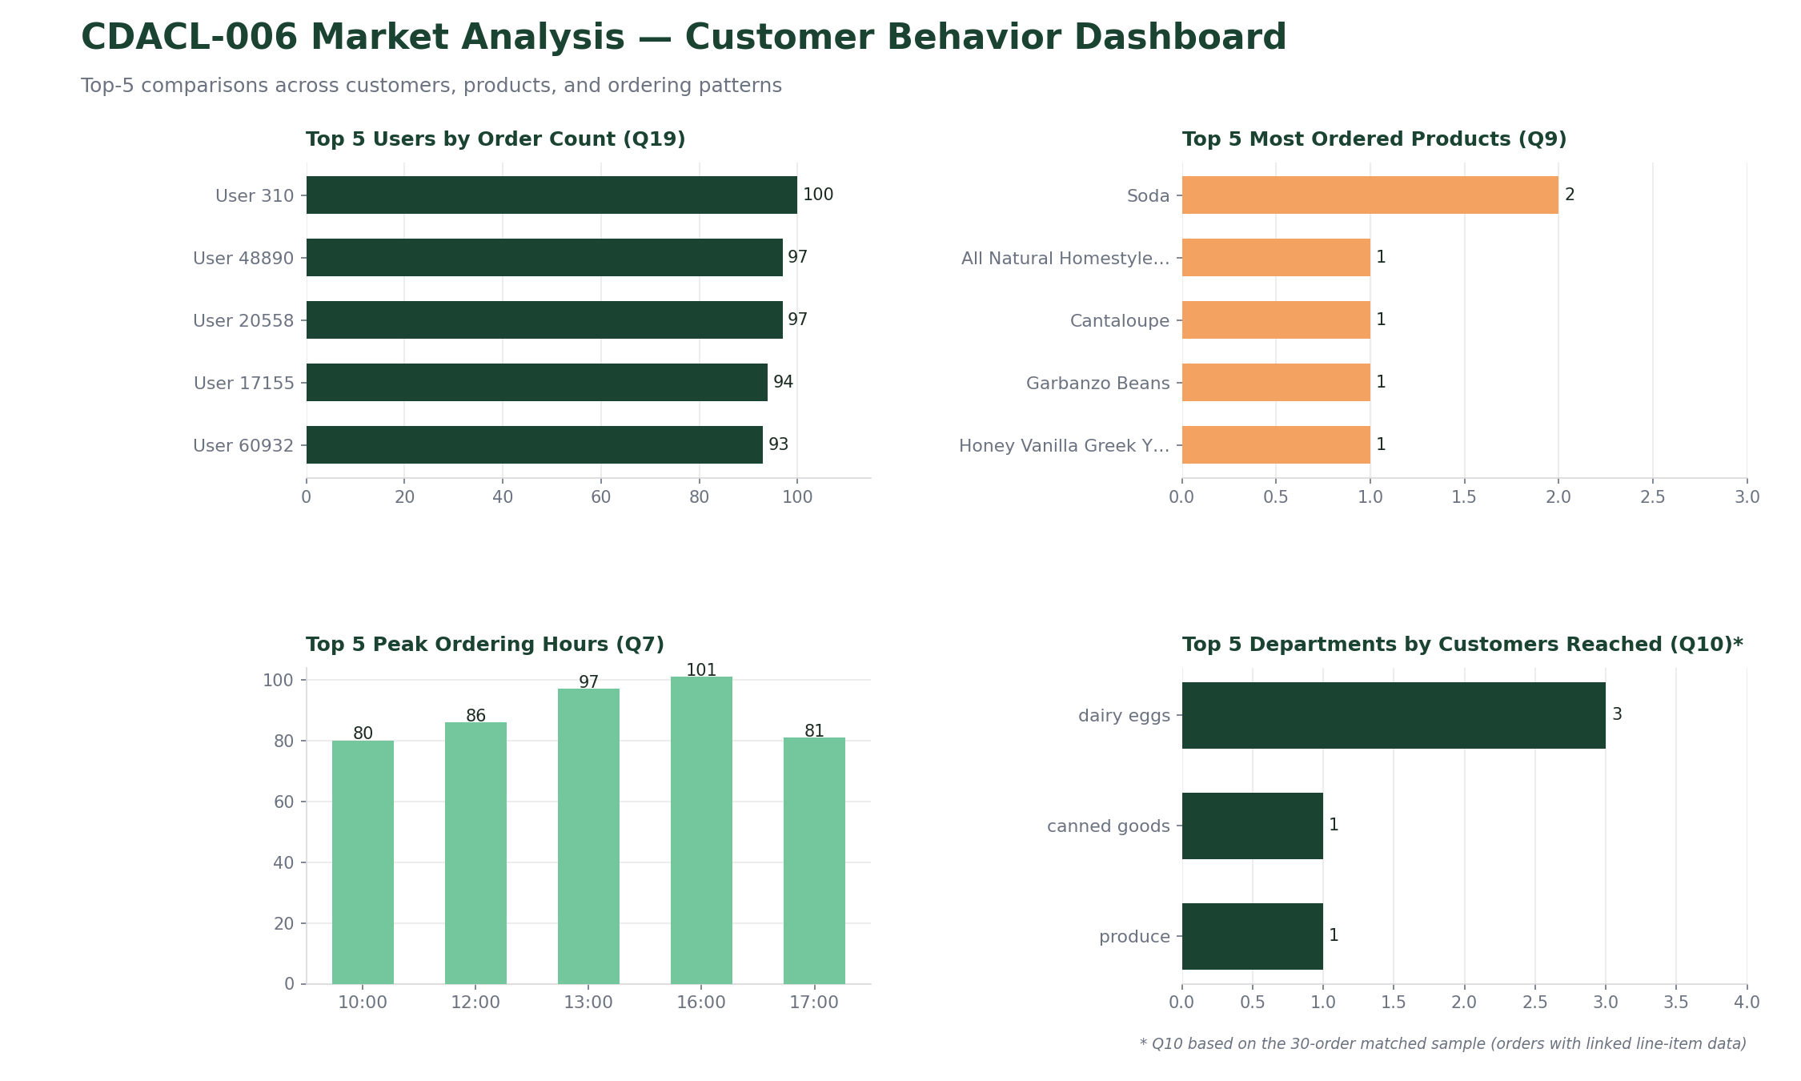

8. Key Insights & Marketing Recommendations
1. Time promotions to the afternoon peak
Order volume peaks around 16:00 and dips overnight — schedule flash promos and push notifications for the late-morning/early-afternoon window.
2. Bundle around staple, high-reorder categories
Dairy & Eggs, Beverages, and produce-adjacent aisles show the highest reorder rates — ideal anchors for subscribe-and-save or basket-bundle offers.
3. Build a loyalty tier for top-order customers
A small group of customers places 85–100 orders each — a targeted VIP or loyalty-points program could deepen an already-strong relationship.
4. Invest catalog depth where it already works
Vitamins/Supplements, Candy/Chocolate, and Tea carry the most SKUs — confirm this matches demand, and consider expanding under-represented but high-reorder aisles.
5. Re-run reorder and top-product analyses on a full extract
The 97-row order-line sample makes Q4/Q9/Q12 directional, not final — a full extract will sharpen the actual Top 10 rankings.

9. Data Limitations & Next Steps
Limitation | Recommended Next Step
Each table capped at ~1,000 rows, taken independently | Pull matching row ranges (or full tables) so orders and order-line items reference the same order_ids
Order-line data covers only ~30 of 1,000 orders | Re-extract the order-line table filtered to the full order_id set, or increase the row limit substantially
Day-of-week codes (0–6) aren't labelled to actual weekdays | Confirm the day-code mapping with the data source before finalizing scheduling recommendations
Top-N rankings (Q4, Q9, Q12) are dominated by ties at n=1 | Re-run rankings once a larger, fully-linked order-line extract is available

