**Objective:**

Design a device that analyze the Luminosity of the overhead light in the room and keep it within specific threshold. An LED should be turned ON if system needs maintenance.

**Tools:**

* 9 V power supply (reliable)
* Arduino Nano Board
* Photoreceptor (Light Dependent Resistor)
* 2 Resistors (k, k)
* LED
* Jumper wires
* Bread Board

**How it Works:**

As shown in the figure, Analog voltage is measured on pin A2 and we have to convert the variable resistance from LDR into voltage at A2. We are using Voltage Divider Circuit to do that. Now, LDR and R1 both are in series and they are connected to +5V and GND. Common point of both resistors connection is connected to A0. Light Dependent Resistor (LDR) sense the light intensity and accordingly vary the resistance.

As both resistors are in series, current flowing through them must be the same and according to ohm’s law I=V/R. So, when LDR Resistance drops with light , voltage across LDR and non-LDR resistor will increase and so as voltage at A0 will too. We will set the threshold value of light intensity or luminosity that LDR value can reach and beyond that threshold value it will turn on the LED which shows maintenance requirement.

**Calculations**:

Curr_A0 = V/R = 5 V/ R1 + R_LDR

= 5/ 10000+ 6000 (Assume R1 is 10k and LDR is VT90N1 with min 6k)

Volt_A0 = Curr_A0 * R1

= 5 * 10000 / (16000)

= 3.12v (at A0)

So when light is not present at all in the room, LDR has its highest value 6k. As the light intensity increase the resistance of LDR will drop and make the voltage at A0 increase to 3.12 v.

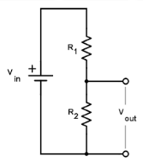

Fig: Voltage Diveder Circuit

**Circuit Diagram:**

R1 = 10 k

R2 = 220 k

R_LDR = 6k

9V power supply to board which converted to 5v automatically

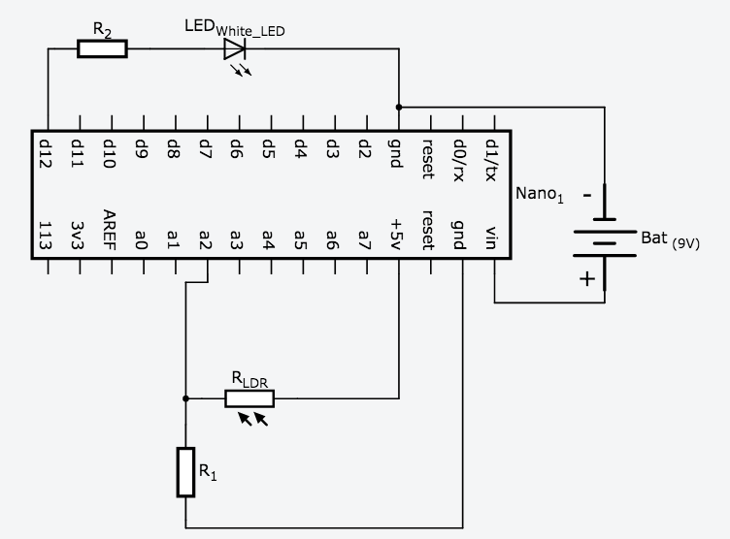

Fig 1: LDR circuit with Arduino Nano board to measure the light intensity

**Code:**

int LDR = A0;// Declare voltage reading at pin A0

int LED = 13;// define LED output at pin no. 13

int value = 0;

int light_intensity = 500; // set threshold value of luminance

void setup()

{

pinMode(LDR,INPUT); // set the analog input to read

Serial.begin(9600); // serial communication at 9600 baudrate

pinMode(LED,OUTPUT); // set output pin for LED

}

void loop()

{

value= analogRead(LDR); // analog reading of pin A0 voltage

Serial.println(value); // serially print the value

delay(500);

if(value <= light_intensity) //chech the threshold

{

digitalWrite(LED,HIGH)

}

else

{

digitalWrite(LED,LOW)

}

}