**E-Pharma.com**

**Abstract:**

Nowadays, medicines are needed more than ever and are available to everyone. Our project helps get medications from a pharmacy in a much easier way. It is to help both customers and pharmacies. Using the concepts learned, we created a platform wherein the database in the pharmacy consisting of different tables each corresponding to unique entity can be accessed to know the status of available medicines, then they are provided to the customers accordingly. This database also helps in keeping the records of the incoming supplies to the pharmacy and also those of which that are sold. This helps ease to search and reduces time consumption and also helps in accessing any required data more feasibly. We have used a few Tables in our project, each table having its primary key and different functions. ER diagrams , Relational Schema, and snapshots of queries regarding the formation of this database and our project are listed below.

**ER Diagram**

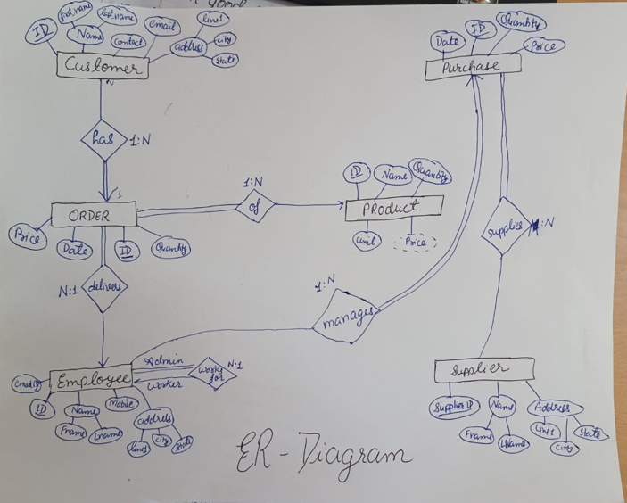

**Relational Table**

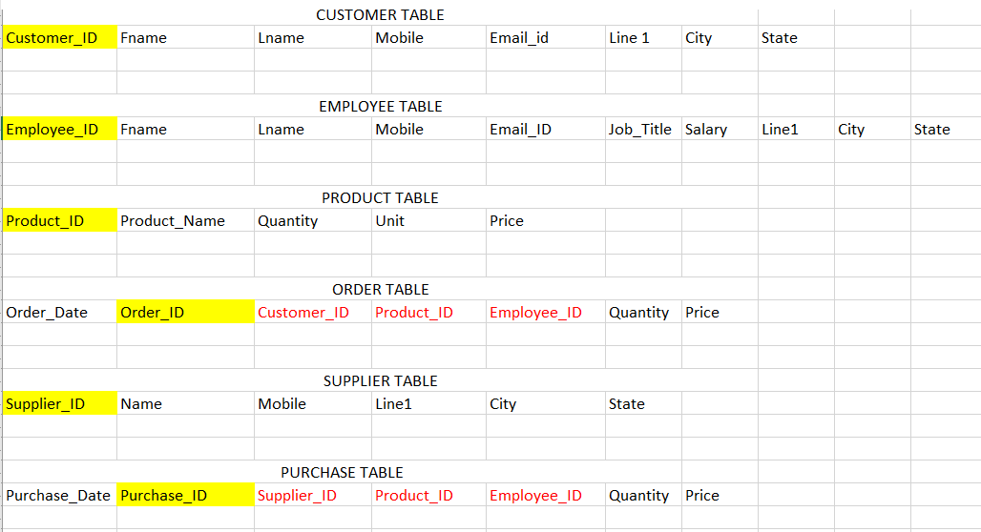

**Screenshots capturing tables data through select queries.**