REAL GAS PROPERTY CALCULATOR
PVT Behaviour and Thermodynamic Properties Using Cubic Equations of State
PROJECT REPORT
Submitted by: Dhruv Garg (2025CH12072) & Vishesh Agrawal (2025CH71978)
Course/Department: Chemical Engineering

ABSTRACT
This project involves the development of a Python-based application for studying the PVT behaviour and thermodynamic properties of pure real gases. Four cubic equations of state, namely Peng–Robinson, Soave–Redlich–Kwong, Redlich–Kwong and Van der Waals, have been implemented. The application calculates compressibility factor, molar volume, enthalpy, entropy, fugacity coefficient and fugacity for five selected gases. It also analyses the real roots of the cubic equations to identify liquid-like and vapour-like solutions. A phase-selection option, individual P–V plots and a comparison of all four EOS models are included. The results can also be exported in CSV format. The application uses Python and Streamlit to provide an interactive interface. It is intended mainly as a learning tool for understanding and comparing real-gas models.

1. INTRODUCTION
This is a Python application which predicts the PVT behaviour of a pure real gas and a number of associated thermodynamic properties. It implements four cubic equations of state (Peng-Robinson, Soave–Redlich-Kwong, Redlich–Kwong and Van der Waals). For a given gas, temperature and pressure the application will calculate the compressibility factor, molar volume, enthalpy, entropy, fugacity coefficient and fugacity. It will also identify any possible liquid-like and vapour-like roots and provide a simple phase selection option. The interface is built using Streamlit, with NumPy for the calculations, Matplotlib for the plots and Pandas for the tables. The current database contains methane, ethane, propane, CO2 and nitrogen. It's primarily an educational tool and for initial calculations.

1.1 Objectives
The main objectives are to: (i) implement PR, SRK, RK and VDW equations; (ii) compute compressibility factor and molar volume; (iii) compute enthalpy and entropy using ideal-gas and departure contributions; (iv) compute pure-component fugacity coefficient and fugacity; (v) identify liquid-like and vapour-like roots; (vi) produce individual P–V isotherms and four-EOS comparison plots.

2. THEORETICAL BACKGROUND
Real gases deviate from ideal gas behaviour, especially at high pressures and low temperatures, due to intermolecular forces and the finite volume of molecules. Cubic equations of state (EOS) are used to account for these effects and predict the PVT behaviour of gases.
This software uses four EOS models: Peng–Robinson (PR), Soave–Redlich–Kwong (SRK), Redlich–Kwong (RK) and Van der Waals (VDW). These models use two main parameters: a, which accounts for molecular attraction, and b, which accounts for molecular size. Their values depend on the properties of the gas.
The compressibility factor is used to measure deviation from ideal behaviour:
Z = PVₘ/(RT) ; Vₘ = ZRT/P
For an ideal gas, (Z=1), while real gases may have values above or below one.
The cubic EOS can give one or three real roots. When three valid roots exist, the smallest is treated as liquid-like and the largest as vapour-like. The software's Auto option compares their fugacity coefficients to select a phase.
Fugacity represents the effective pressure of a real gas and is calculated as (f=\phi P), where φ is the fugacity coefficient. Enthalpy and entropy are calculated by adding ideal-gas contributions and departure functions, which account for non-ideal behaviour. The software assumes constant ideal-gas heat capacity and uses 298.15 K and 1 bar as the reference state.

3. EQUATIONS AND PROPERTY CALCULATIONS
EOS | Attraction term / alpha function | Co-volume parameter b
PR | ac = 0.45724R²Tc²/Pc; α = [1 + κ(1−√Tr)]²; κ = 0.37464 + 1.54226ω − 0.26992ω² | 0.07780RTc/Pc
SRK | ac = 0.42748R²Tc²/Pc; α = [1 + κ(1−√Tr)]²; κ = 0.480 + 1.574ω − 0.176ω² | 0.08664RTc/Pc
RK | a(T) = acTr⁻¹ᐟ²; ac = 0.42748R²Tc²/Pc | 0.08664RTc/Pc
VDW | a = 27R²Tc²/(64Pc) | RTc/(8Pc)

3.1 Compressibility Roots and Phase Selection
The EOS is rearranged into a cubic polynomial in Z using A = aP/(R²T²) and B = bP/(RT). The roots are calculated using NumPy. Roots are kept if they are real enough and satisfy Z > B. In the case of several valid roots, the smallest is taken as liquid-like and the largest as vapour-like; the intermediate root is not selected. In Auto mode the fugacity coefficients are used to compare the available liquid-like and vapour-like roots. This is a simplified phase-screening method, not a vapour-liquid equilibrium calculation.

3.2 Fugacity
φ = f/P ; f = φP
The fugacity coefficient is calculated from the selected EOS and compressibility-factor root. Fugacity is then obtained by multiplying the coefficient by system pressure. For the generalized cubic form, the implemented expression is based on:
ln φ = Z − 1 − ln(Z − B) − [A/{B(δ₁−δ₂)}] ln[(Z+δ₁B)/(Z+δ₂B)]

3.3 Enthalpy and Entropy
H = Hᶦᵍ + Hᵈᵉᵖ ; S = Sᶦᵍ + Sᵈᵉᵖ
Hᶦᵍ = Href + Cp,ig(T−Tref)
Sᶦᵍ = Sref + Cp,ig ln(T/Tref) − R ln(P/Pref)
The departure terms account for the difference between real-gas and ideal-gas properties at the same temperature and pressure. In the current implementation, ideal-gas heat capacity is treated as constant. The reference state is 298.15 K and 1 bar, with reference enthalpy and entropy set to zero. Reported H and S are therefore relative to this chosen reference basis.

4. SOFTWARE DESIGN
Module | Function
gas_data.py | Stores critical properties, acentric factors, molecular weights, heat capacities and reference conditions for five gases.
eos.py | Implements four EOS models, calculates parameters and solves for physically admissible Z roots.
enthalpy.py / entropy.py | Calculate ideal-gas, departure and total enthalpy and entropy.
fugacity.py | Calculates fugacity coefficient and pure-component fugacity.
graphs.py | Generates individual P–V isotherms and four-EOS comparison plots.
main.py | Streamlit interface; accepts inputs, calls calculation modules and displays/export results.
requirements.txt | Lists required packages: Streamlit, NumPy, Matplotlib and Pandas.

CSV Export: The application allows users to download calculated property results in CSV format. It also provides CSV export for the comparison of all four EOS models, making it possible to examine the numerical results separately or use them for further analysis.

4.1 Calculation Workflow
The user selects a gas, EOS, temperature, pressure and phase option. The program validates the inputs, calculates EOS parameters, solves the cubic equation, filters physical roots and selects a root. The selected root is then used to calculate molar volume, enthalpy, entropy and fugacity. Results and graphs are displayed in the interface.

5. GAS DATABASE, UNITS AND RESULTS
Gas | Formula | Tc (K) | Pc (bar) | ω | Cp,ig (J/mol·K)
Methane | CH₄ | 190.564 | 45.99 | 0.01142 | 35.69
Ethane | C₂H₆ | 305.32 | 48.72 | 0.0995 | 52.49
Propane | C₃H₈ | 369.83 | 42.48 | 0.1523 | 73.60
Carbon dioxide | CO₂ | 304.13 | 73.77 | 0.22394 | 37.13
Nitrogen | N₂ | 126.192 | 33.958 | 0.0372 | 29.12

Units: T in K; P in bar; molar volume in L/mol; H in J/mol; S in J/(mol·K); fugacity in bar. The EOS gas constant is R = 0.08314462618 L·bar/(mol·K).

5.1 Sample Calculation: Methane with PR EOS
Input conditions: methane, Peng–Robinson EOS, T = 300 K, P = 50 bar, vapour root.
Calculated property | Value | Unit
Compressibility factor, Z | 0.901827 | —
Molar volume | 0.449892 | L/mol
Ideal-gas enthalpy | 66.0265 | J/mol
Enthalpy departure | −902.3924 | J/mol
Total enthalpy | −836.3659 | J/mol
Ideal-gas entropy | −32.3056 | J/(mol·K)
Entropy departure | −2.1446 | J/(mol·K)
Total entropy | −34.4502 | J/(mol·K)
Fugacity coefficient | 0.901369 | —
Fugacity | 45.068470 | bar

Z and φ are below unity, indicating non-ideal behaviour at the stated conditions. Fugacity is consequently below pressure.

5.2 Compressibility-Factor Root Comparison
EOS | Smallest root | Intermediate root | Largest root
PR | 0.035508 | 0.325325 | 0.612075
SRK | 0.040167 | 0.338037 | 0.621796
RK | 0.040913 | 0.299444 | 0.659643
VDW | 0.059624 | 0.203248 | 0.780657

These results correspond to propane at 250 K and 10 bar. The different roots demonstrate that the selected EOS affects predicted PVT behaviour.

6. APPLICATION OUTPUT
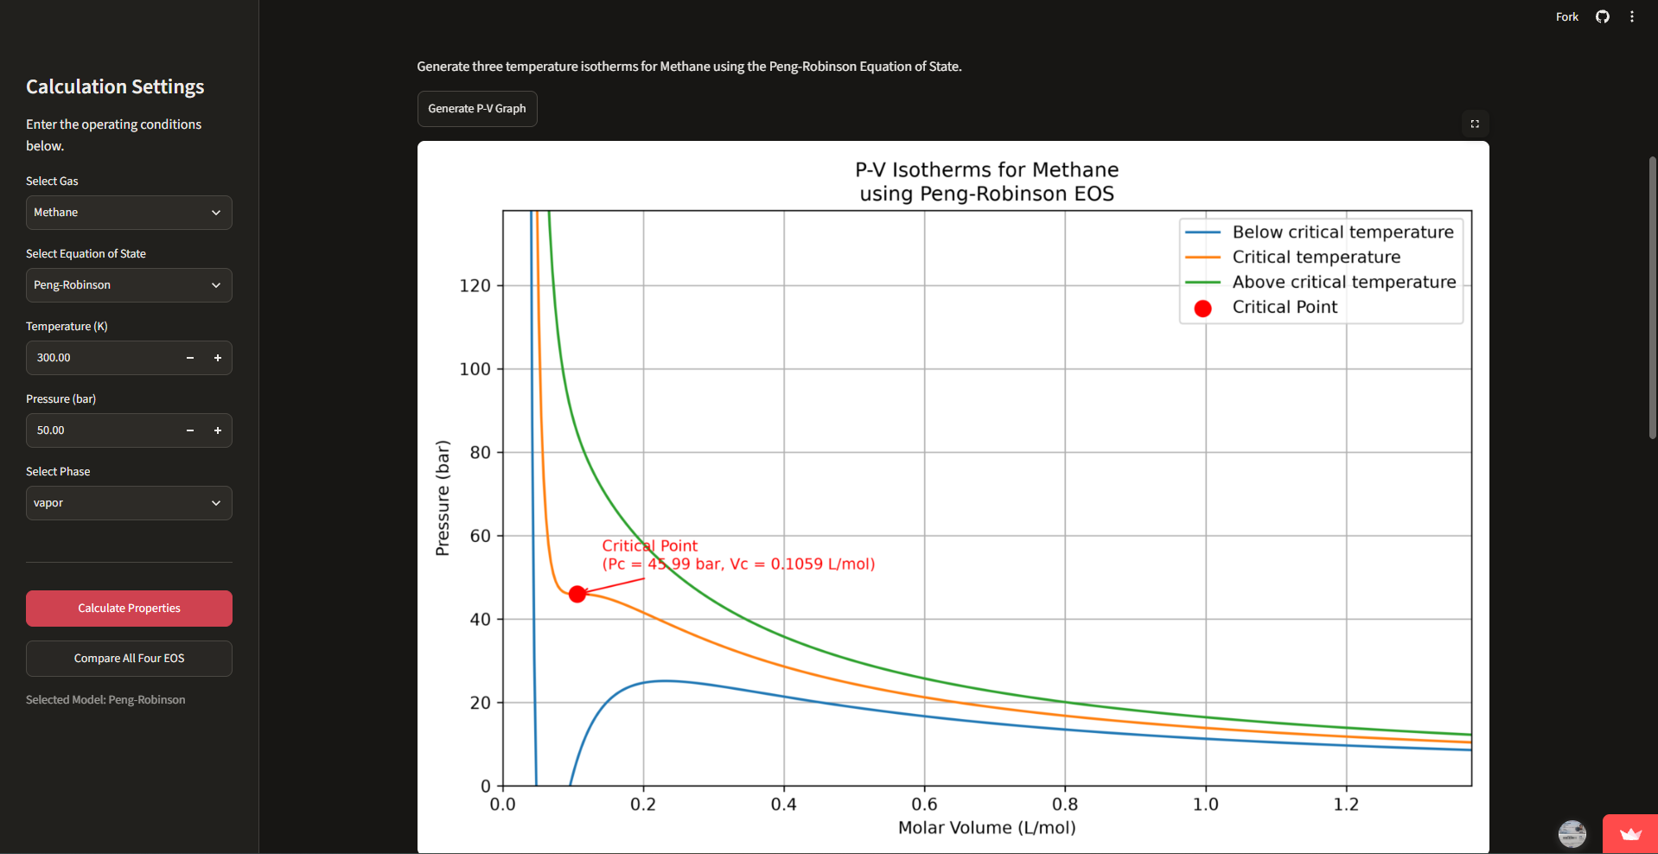
Figure 1. Main Streamlit interface showing input selection and calculated properties.
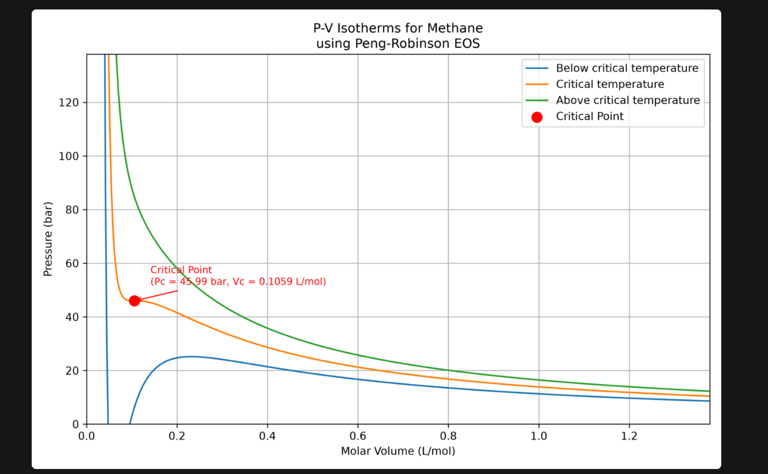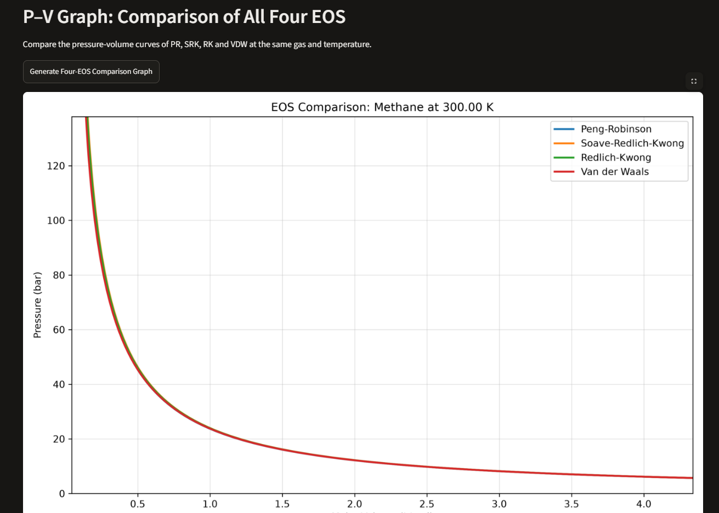
Figure 2. P–V isotherm and comparison of the four cubic equations of state.
The application provides individual P–V isotherms and a comparison plot for PR, SRK, RK and VDW. Subcritical cubic EOS curves may contain loop-shaped regions; these should not automatically be interpreted as stable equilibrium paths.

7. ASSUMPTIONS AND LIMITATIONS
The current software supports pure components only. Ideal-gas heat capacity is assumed constant. Enthalpy and entropy are relative to the selected reference state. The Auto phase option is a simplified comparison of fugacity coefficients and does not constitute a complete VLE or flash calculation. Cubic EOS models are approximations and may be less accurate near critical conditions or for strongly associating fluids. The database is limited to five gases. Design-critical use requires independent validation against reliable data.

8. INSTALLATION AND EXECUTION
git clone https://github.com/visheshagrawal1506-ops/real-gas-property-calculator.git
cd real-gas-property-calculator
pip install -r requirements.txt
py -m streamlit run src/main.py

9. FUTURE SCOPE
Possible extensions include adding more gases and user-defined critical properties, temperature-dependent heat-capacity correlations, mixture calculations with mixing rules, saturation and flash calculations, rigorous phase-equilibrium analysis, systematic validation against reference data, and additional Excel/PDF export options.

10. CONCLUSION
A Real Gas Property Calculator has been developed in Python for the study of PVT behavior and selected thermodynamic properties using PR, SRK, RK and VDW equations of state. The software calculates compressibility factor, molar volume, enthalpy, entropy, fugacity coefficient and fugacity for five pure gases. It also finds the possible liquid-like and vapour-like roots and generates P-V diagrams for single EOS models and their comparison. The application is useful for learning real-gas thermodynamics because it has a modular design and an interactive interface. The present assumptions and limitations of the interpretation of results should be taken into account.

REFERENCES
[1] Peng, D.-Y. and Robinson, D. B. (1976). A New Two-Constant Equation of State. Industrial & Engineering Chemistry Fundamentals, 15(1), 59–64.
[2] Soave, G. (1972). Equilibrium constants from a modified Redlich–Kwong equation of state. Chemical Engineering Science, 27(6), 1197–1203.
[3] Redlich, O. and Kwong, J. N. S. (1949). On the Thermodynamics of Solutions. Chemical Reviews, 44(1), 233–244.
[4] Smith, J. M., Van Ness, H. C., Abbott, M. M. and Swihart, M. T. Introduction to Chemical Engineering Thermodynamics.
[5] Project repository: https://github.com/visheshagrawal1506-ops/real-gas-property-calculator

