STEP1:  
here we are going to collect the data set using opencv library and we will form a dataset of images which .jpg format

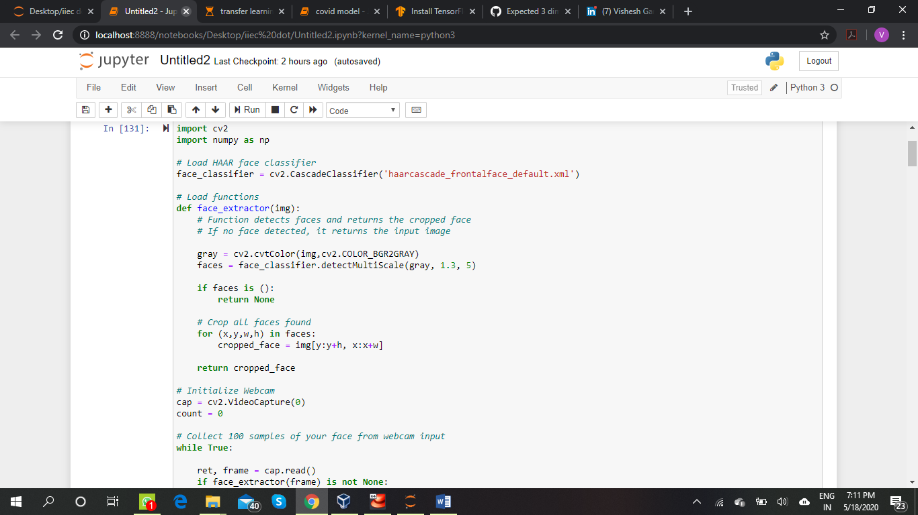

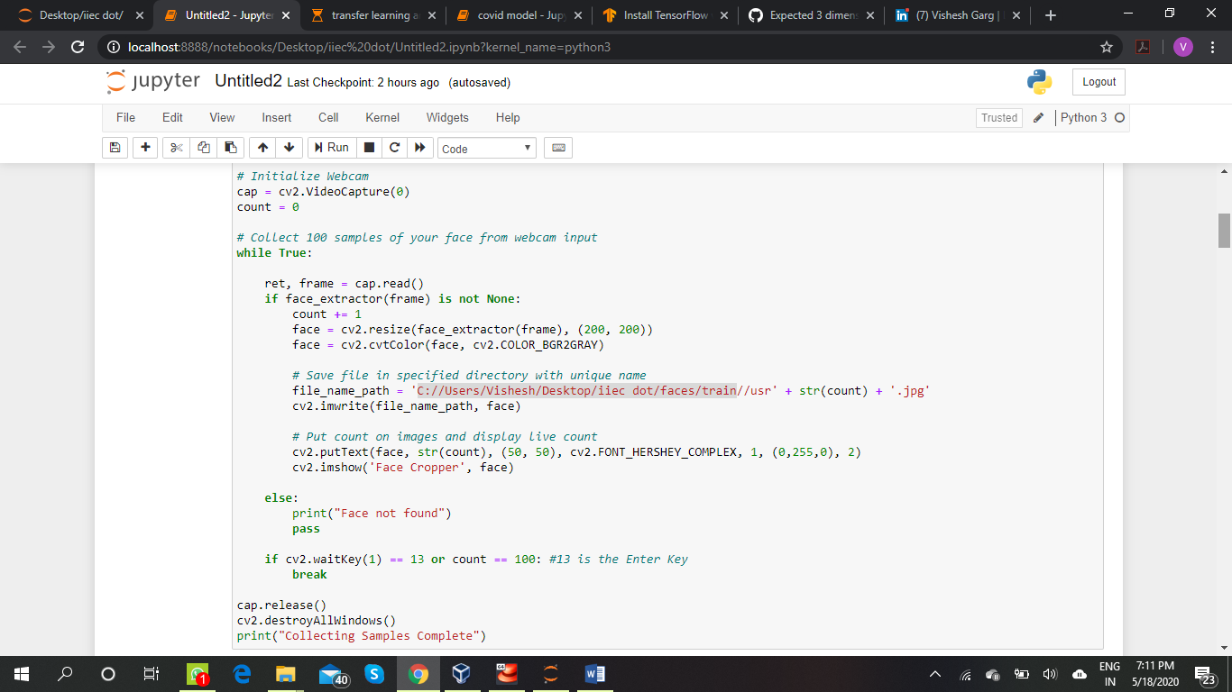

# here u can use ur own dataset by assembling the images here I just want to integrate my captured dataset and trained and predict it

STEP2: In this we will generate a test dataset u can change your background or hairstyle it will help us as a test dataset

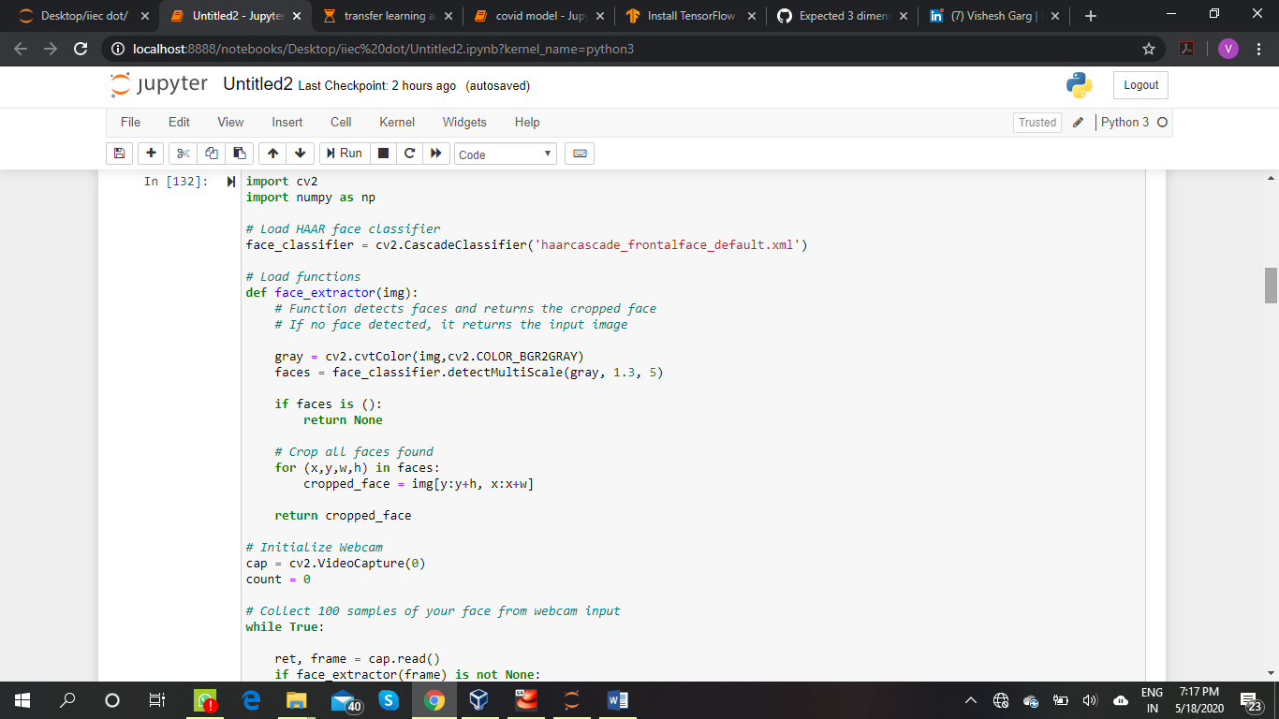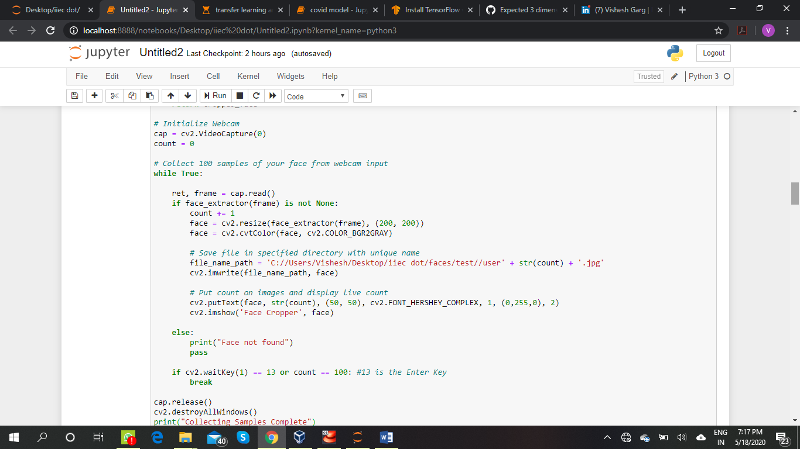

STEP3:

Here we will use the pre-trained model and pre-trained weight I am using IMAGENET u can use resnet vgg16 etc

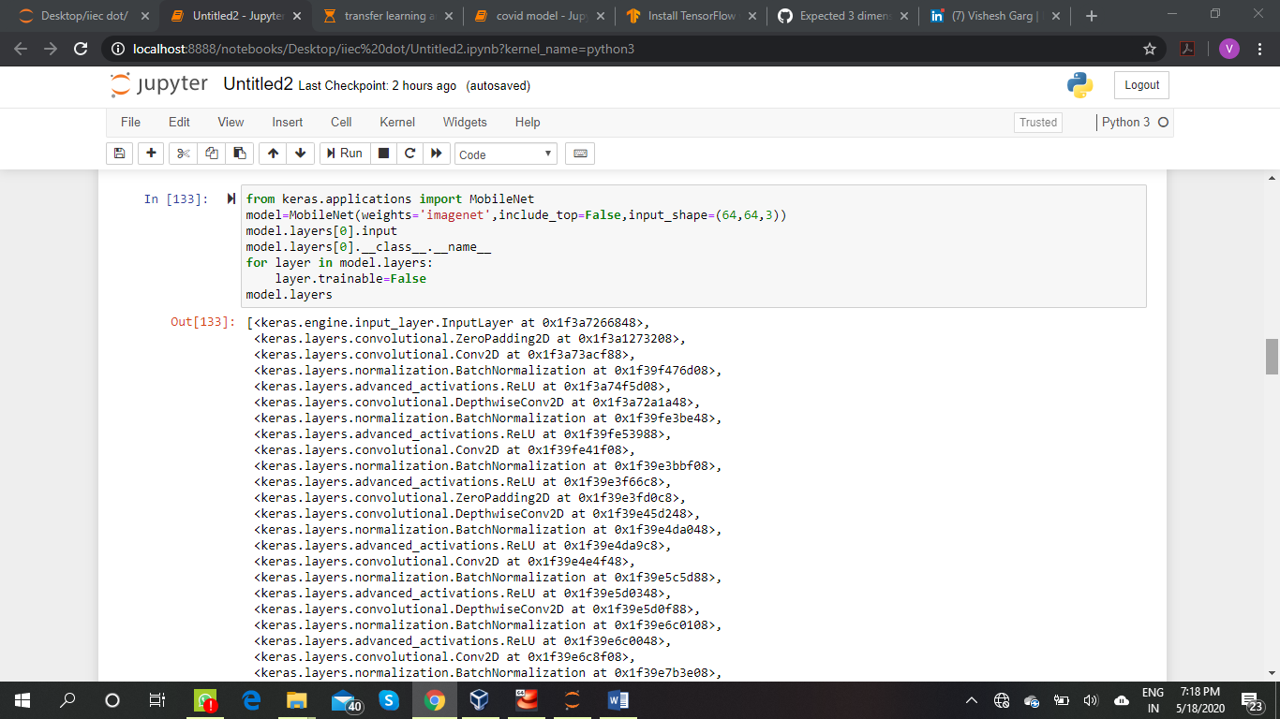

STEP4:

Now we will import layers and model,then we will add flatten and dense layers and get the model summary

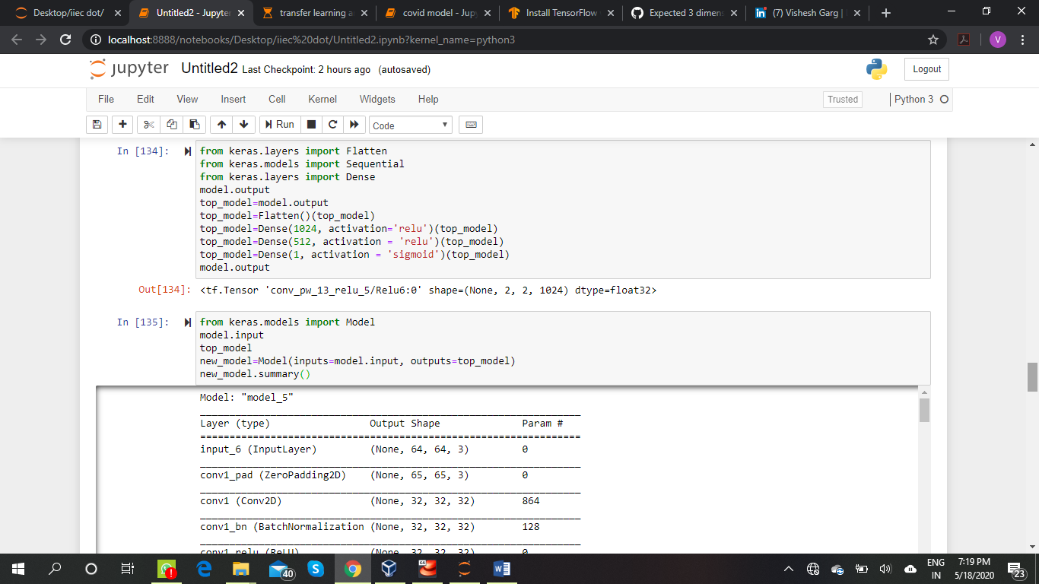

STEP5:

Now we will add a compile layer and add a generator to compiler our program

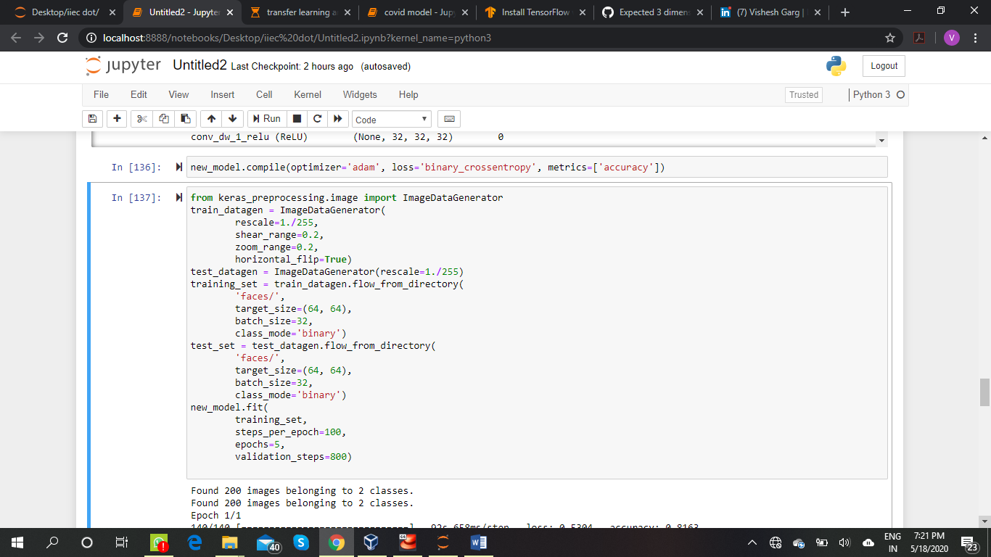

STEP6:

Now we will see the output and will predict whether the trained model is working or not

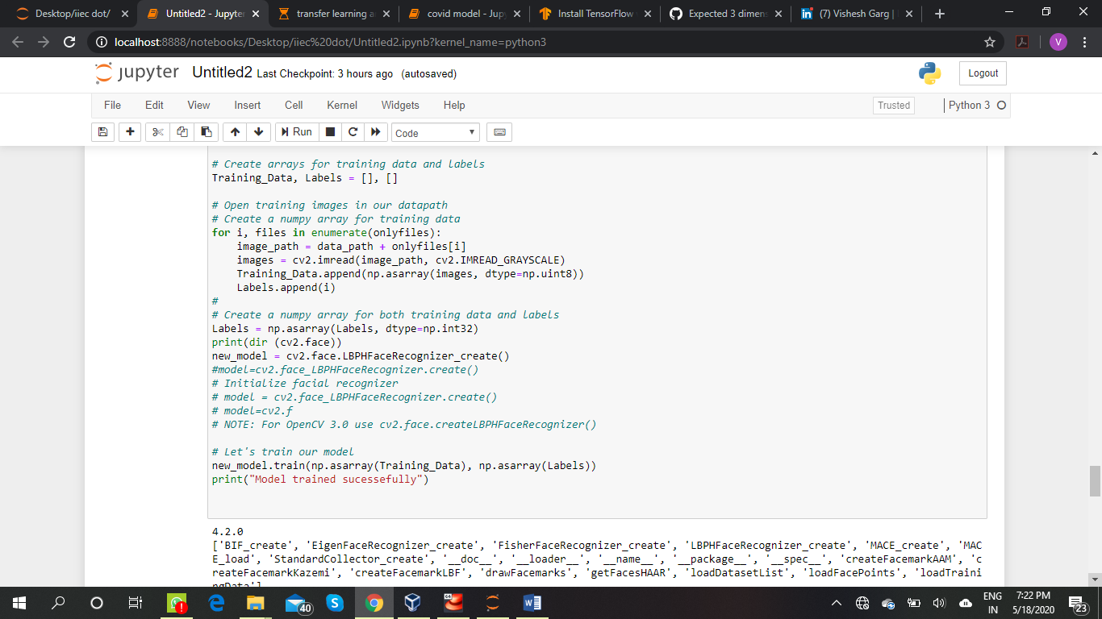

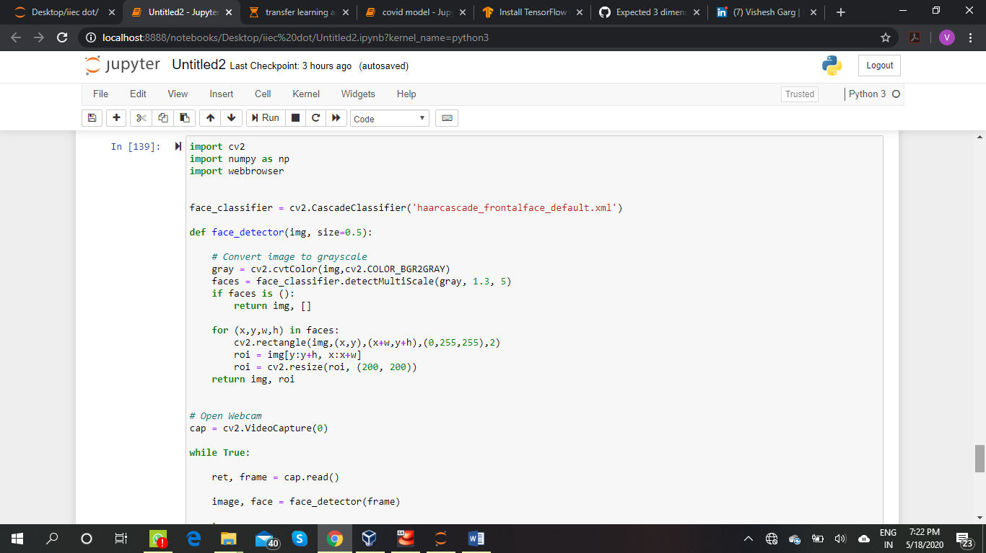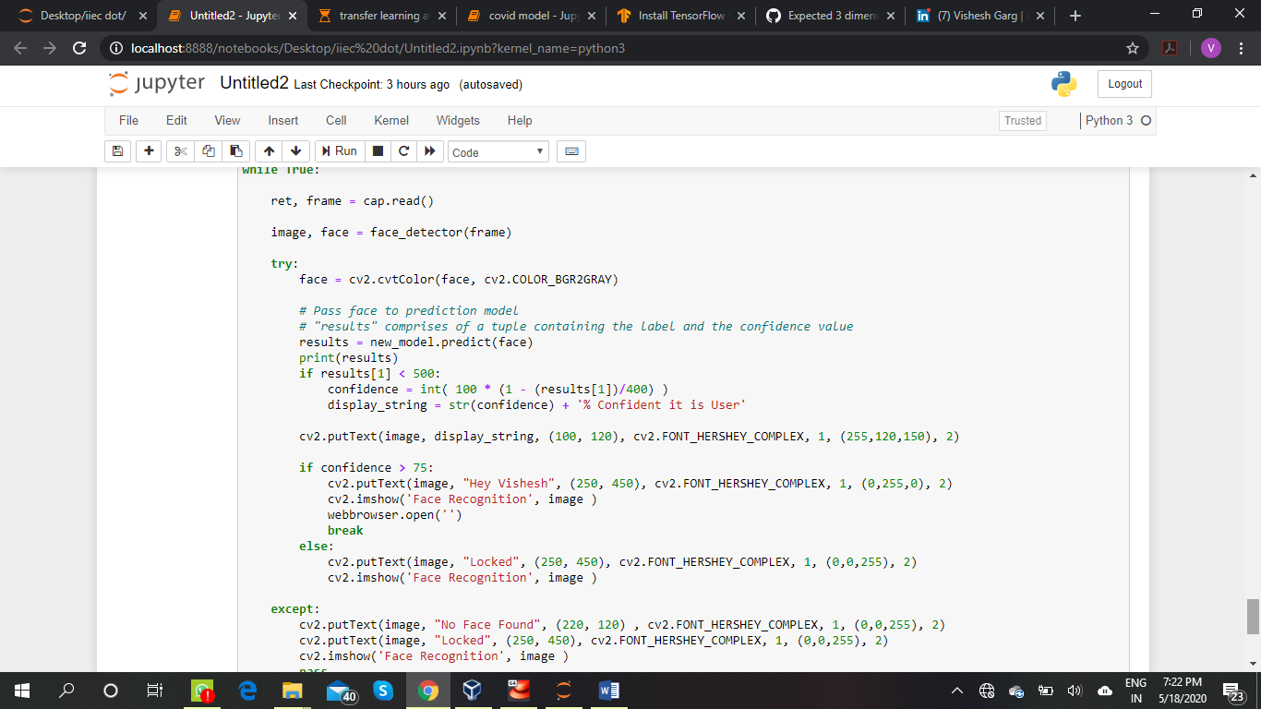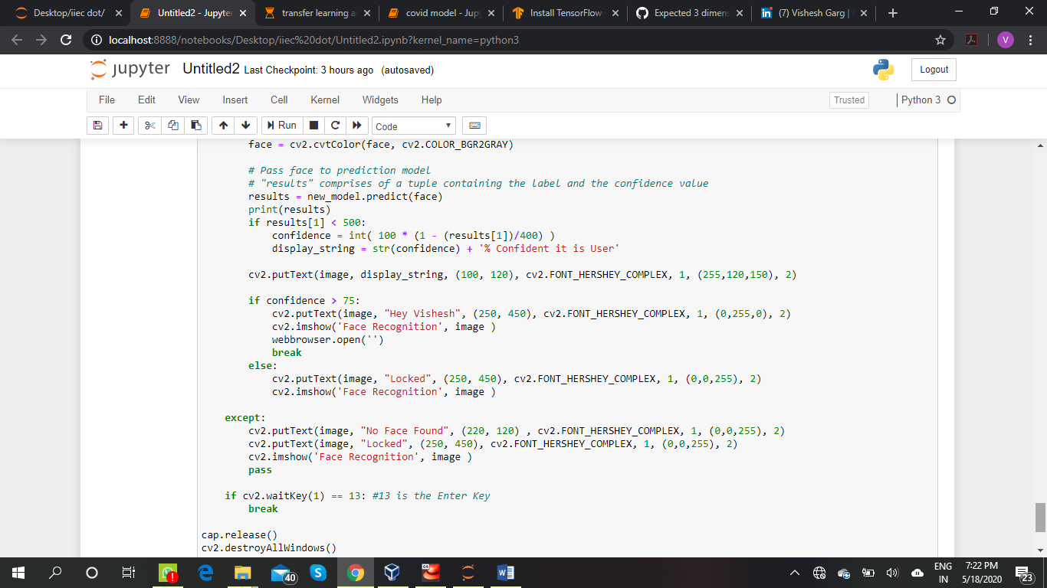

Or else u can also predict manually

