**ARGUMENTATIVE ESSAY**

**on**

**"Is systems engineering actually engineering?"**

Systems engineering and engineering are related. Systems engineering has an in-depth concept including [1] complex systems, solution-neutral functions, decomposition in complexity, decision-making process, and optimizing problems. Systems engineering is an interdisciplinary field of engineering and engineering management that focuses on designing, integrating, and managing complex systems over their life cycles [2]. At its core, systems engineering utilizes systems thinking principles to organize this body of knowledge. The individual outcome of such efforts, an engineered system, can be defined as a combination of components that collectively perform the function.

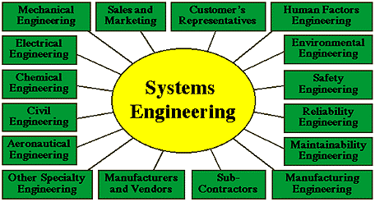

Source: <https://www.incose.org/about-systems-engineering/careers-in-se>

In engineering, a big picture is under consideration that consists of various fields and aspects to it. It is more about [3] the application of science and math to solve problems. Engineers figure out how things work and find practical uses for scientific discoveries. On the other hand, systems engineering mostly considers the system, subsystem, and components. As a system engineer, a part of the problem is considered and efforts are made to resolve it. The approach varies where systems engineering is a part of engineering. It works on sub-components for the problem considered.

At [4] NASA, systems engineering is defined as a methodical, multi-disciplinary approach for the design, realization, technical management, operations, and retirement of a system. A system combines elements that function together to produce the capability required to meet a need. They include all hardware, software, equipment, facilities, personnel, processes, and procedures needed for this purpose; that is, all things required to produce system-level results. Systems engineering seeks a safe and balanced design in the face of opposing interests and multiple, sometimes conflicting constraints. The systems engineer should develop the skill for identifying and focusing efforts on assessments to optimize the overall design and not favor one system/subsystem at the expense of another while constantly validating the goals of the operational system. The art is in knowing when and where to probe. Personnel with these skills are usually tagged as “systems engineers”.

Systems engineering empowers fabricating, breaking down, and dealing with a system be it electrical, mechanical, substance, natural, or one including business cycles and logistics. In general, the design disciplines through actual characteristics: electrical architects work with circuits and semiconductors, aeronautical specialists with planes and rockets. Frameworks designing rises above what is planned or managed if 'it' comprises of different associating parts filling a role that can't be accomplished solitarily, then, at that point, it is a system, and frameworks specialists can attempt to comprehend and further develop it.

References: -

[1] Cameron, Bruce, Edward Crawley, and Daniel Selva. *Systems Architecture. Strategy and product development for complex systems*. Pearson Education, 2016.

[2] [https://en.wikipedia.org/wiki/Systems engineering](https://en.wikipedia.org/wiki/Systems%20engineering)

[3] <https://www.livescience.com/47499-what-is-engineering.html>

[4] <https://www.nasa.gov/seh/2-fundamentals>

[5] Thurner, Stefan, Rudolf Hanel, and Peter Klimek. *Introduction to the theory of complex systems*. Oxford University Press, 2018.