Project Report On
TIMESHEET APPLICATION


Submitted in the partial fulfillment of the requirement for the Award of degree of
MASTER OF COMPUTER APPLICATIONS
[Semester 6]

Submitted by
Keenjal K. Modi [135020693047]

Under the guidance
Mr. Pushkaraj Shelke [External]
Mr. Vishesh Jindal [External]
Dr. Hetal Thaker [Internal]

Department Head
Mr. Parag C. Shukla



Submitted to
ATMIYA Institute of Technology & Science Kalawad Road, Yogidham Campus,
Rajkot

COLLEGE CERTIFICATE

COMPANY CERTIFICATE

ACKNOWLEDGEMENT

The project training at the last semester of Master of Computer Applications indicates the integration of the student’s theory knowledge with the practical world. The utmost satisfaction and happiness accompanied with the successful completion of the training will be incomplete without expressing my gratitude to the following entities.

I am very grateful to Hartley Lab Pvt. Ltd(HL) Company for giving me an opportunity to serve their esteemed company. I am also thankful to the interviewers for recognizing me as an apt candidate for the Training period in Hartley Lab Pvt. Ltd(HL).

I am also grateful to Mr. Pushkaraj Shelke (CEO), to provide me an
opportunity to serve his respectful Department (P.D). I am grateful to him for providing me with all the resources that were needed for the development of the project.

I whole-heartedly express my gratitude to Mr. Vishesh Jindal(External Project Guide) for his dedicated and sincere support during the development of the application. His deep technical knowledge and the way of helping, made me learn the technology at ease. Because of his support, I was along with my team member, able to complete the whole project in allocated time.

I also express my whole-hearted thanks to Dr. Hetal R Thaker (Internal Project Guide) for her help and cooperation.

Keenjal K. Modi

CONTENTS

Chapter 1 Company Profile …...........................................................................7
1.1 Brief History .......................................................................................8
1.2 Vision and Mission...............................................................................8
1.3 Our Values............................................................................................9
1.4 Our Core Expertise...............................................................................9
1.5 Working Technologies..........................................................................10
1.6 Contact Us............................................................................................10
Address: .........................................................................................10
Phone: ............................................................................................10
Fax: …............................................................................................10
Email: …........................................................................................10
1.7 Abstract................................................................................................11
Chapter 2 Project Profile …...............................................................................12
2.1 Project Definition................................................................................13
2.1 Introduction.........................................................................................14
Chapter 3 Analysis ….........................................................................................15
3.1 About Existing System........................................................................16
3.2 Feasibility Study..................................................................................17
3.2.1 Technical...............................................................................17
3.2.2 Economical...........................................................................18
3.2.3 Operational...........................................................................18
3.3 Limitations Of Existing System..........................................................19
3.4 Scope/Features Of The Proposed System...........................................20
3.5 Limitations Of Proposed System........................................................21
3.6 System Requirements.........................................................................22
3.6.1 Hardware Requirements......................................................22
3.6.2 Software Requirements........................................................22
3.7 Project Risk.........................................................................................23
Chapter 4 Design …............................................................................................24
4.1 Entity Relationship Diagram...............................................................25
4.2 Data Flow Diagram.............................................................................26
Level-0..........................................................................................26
Level-1..........................................................................................27
4.3 Data Dictionary...................................................................................28
Chapter 5 TESTING AND IMPLEMENTATION…......................................31
5.1 Test Cases...........................................................................................32
5.2 Implementation Status........................................................................37
5.3 Proposed Extensions...........................................................................38
Sample source Code.................................................................................39
Learning during the Project Work & Work Experience...........................52
Appendix A(Input Screen).......................................................................53
Appendix B..............................................................................................63
Planning and schedule of the project-project management.........64
Time-Line Chart..........................................................................65
Appendix C.............................................................................................66
Source Files................................................................................67
About the Tool........................................................................................68
Glossary..................................................................................................69
Bibliography............................................................................................71

CHAPTER-1 COMPANY PROFILE

1.1 Brief History

Hartley Lab is a professionally managed Agile Product development Company servicing
clients all over the world. Hartley Lab was formed by people with over 12 years' experience
in product development and project management with a clear goal to Make IT Simple. We
have successfully offered our product development services to a wide range of very satisfied
customers all over the world. We are supported by a strong, committed team delivering
quality work. We value our employees' contribution and endeavor to improve their skills
and abilities that ultimately enable a work environment of excellence. Our continuous
development and training programs ensure that we are always positioned to provide our
valued customers a wide range of high quality services, using the latest tools and
technology. We inculcate a culture of development and growth among our employees with a
view to be the most competent Software services provider. We are focused on complete
reliability models of project execution and management. We offer turnaround guarantees for any project we undertake, backed by comprehensive management planning and supervision.

1.2 Vision and Mission

The promoters share a common vision to provide Best-in-Class IT and IT enabled services
to clients all over the world. Since the industry is highly people driven, We believes in
providing equal prospect and exceptional infrastructure and work environment to all
employees, thereby improving the work atmosphere and competence level to serve Clients
better.
Our mission is always to create a web site exceeding in quality every time by providing best
web site design with every single project according to the parameters of Google.

1.3 Our Values

As a company, and as individuals, we value integrity, honesty, openness, personal
excellence, constructive self-criticism, incessant self-improvement, and reciprocated
respect. We are committed to our clients and partners and have a passion for new
technologies. We take on big challenges, and pride ourselves on seeing them through. We
hold ourselves accountable to our customers, shareholders, partners, and employees by
honoring our commitments, providing results, and pushy for the highest quality. Our Motto
is “Provide the big values on time and under budget”. We convey what we promise. Our
Work is based on the belief that your site must be better than all your competitors in order to
produce results.

1.4 Our Core Expertise

Website Design & Development
Web Application Development
E-learning
E-Commerce Solutions
Payment Gateway Services
Search Engine Optimization / SEO
Domain Name Registration
logo design
Android App Development
Corporate Hosting Services

1.5 Working Technologies

PHP,Java,Android,.net and Web Designing

1.6 Contact Us

Address:-
Hartley Lab Pvt. Ltd.,
5th Floor, Galore Tech IT Park,
Behind Maratha Mandir,
Bavdhan, Pune.

Phone:-
+91 99 2343 3599

Fax:-
+91 20 3239 3599

Email:-
hello@hartleylab.com

1.7 ABSTRACT

- Time sheet is an application which is been created for the users that syncs between all of your devices.
- Work everywhere and Stay Productive.
- To-do’s ,Checklists.
- Organize web Articles.

- It also contains features like
- Off line Access
- More Space
- Better Search
- Greater Privacy

CHAPTER-2 PROJECT PROFILE

2.1 Project Description

Project Title : Time-sheet Application

Front-End : Android

Back-End : SQLite database

Operating System : Microsoft Windows , 95, 98, 2000,

Professional, Windows 7 or Higher.

Project Guide : Dr. Hetal R.Thaker

Developed By : Keenjal k. Modi

Submitted To : Atmiya Institute of Technology & Science, Rajkot

2.2Brief and Complete Project Definition

Project making is a one subject of MCA. The student gets a chance to have practical knowledge of the software exposure as to gain control over programming languages. The objective of practical training of MCA levels is to develop among the students a feeling of software making in order to develop a practical bias in them as supplement to the theoreticalstudy of the computer application in general.

I have built project on “Time sheet Application”. My Application gives users to handle all type of data. Data can be easily managed and also can be kept secured with the use of this application.

This system is divided into two part:-

- Admin Side
- User Side

- Admin Side:

- Admin can manage whole data of application.

- User Side:

- User can work everywhere and can stay productive.
- User can also organize their times.
- User can also easily access their timeoff-line.

CHAPTER-3 ANALYSIS

3.1 About Existing System (Manual/Automated)

Manual:

My application in any employee easily to login time management module.

Automated:

Student can get correct answer ,easily show winner name.

3.2 Feasibility Study:-

Feasibility study is a process to check possibilities of application development. It is a method to check various different requirements and availability of financial & technical resources.
Before starting the process various parameters must be checked like:

- Estimated finance is there or not?
- The man power to operate the application is there or not?
- The man power is trained or not?

All the above conditions must be satisfied to start the application. This is why in depth analysis of feasibility is carried out.

There are three different ways feasibility can be tested:

- Technical
- Economical
- Operational
3.2.1 Technical
- It is basically used to see existing computer, hardware and software etc., weather it is sufficient or additional equipment’s are required?

- Minimum System Requirement is such that it can be affordable.

- So system is fully technically feasible.

3.2.2 Economical

- In economic feasibility, analysis of the cost of the system is carried out.

- The system should be only developed if it is going to give return.

- In any educational organization or for parents it is headache to find questions
and generate test which is different each time.

- However developing system will not cost much so economically system is
feasible.

3.2.3 Operational

- Once the system is designed there must be trained and expert operator.

- If they are not trained they should give training according to the needs of the
system.

- From the user’s perspective our system is very easy to use as it just requires

some knowledge of computers. So our system also passes the test of operational feasibility.

3.3 Limitations Of Existing System

- Employee can not select any project in detail.
- Employee can not enter without login.
- Employee can not edit previous tickets.

3.4 Scope/Features Of The Proposed System(Advantage Over Existing
System)

- In this Application every requirement full-fill whatever information require for Customer. Such as information about jobs.

- Features:-
- Master your Working times and track them according to projects and tasks.
- Control your success and manage revenues and budgets.
- Create exact time-sheets for customers and employee.
- Track working times flexibly on your smart-phone or tablet.
- Benefit from the possibility to manage and track working times in a team via time-sheets cloud.
- Assign projects and tasks via web app and create reports for your team.

3.5 Limitations Of Proposed System

- In our Application not provide forgot password option.
- Foremost limitation of application is that it needs internet connection

3.6 System Requirements(Client Side)

- 3.6.1 Hardware Requirements:

Operating System | Windows XP /7 /8 or above
Processor  Recommendation | Dual core/ core2duo/ i3 or above
RAM | 2GB or Higher RAM
HDD | 80 B

- 3.6.2 Software Requirements:

Platform | Android Studio, Dreamviewer, Mysql , Sqllite

3.7 Project Risk

- Here many risk is generate in project:

- Data transfer and retrieve risk

- Connection risk
- Requirement change risk
- Software requirement risk
- Hardware requirement risk
- System requirement risk
- Authentication risk

Chapter-4 Design

4.1 Entity Relationship Diagram

Splash
Name
Logo
Login
Employee
FullName
EmailID
EmpID
Confirmpwd
Password
Phno
SignUp
Dashboard
History
ProjectName
Description
Loggedhrs
Date
Add Description
Projectname
Description
Date
TicketNo
Loggedhrs
Submit

4.2 Data Flow Diagram

Level – 0:

Login

Confirm

Employee
Time-sheet

Level-1:
Getting Visit 1.0 Get Info
Employee
SignUp

Diaplsy Project
Description

Select Project
Dashboard

Registered
Loggedhrs
Login

Get Response Login

2.0

3.0

4.0

5.0

4.3 Data Dictionary
- Splash
- EmpID
- Sign-Up
- Project
- Dashboard
- Logged-Hours
- Description

- Splash:

- It contains information and Logo.

No. | FieldName | DataType | Length | Constraints | Default Value | Description
1 | Name | Varchar | 30 | Not Null | - | Name
2 | Logo | Varchar | 200 | Not Null | - | Logo

- EmpID:

No. | FieldName | DataType | Length | Constraints | Default Value | Description
1 | _id | Varchar | 30 | Not Null | - | ID Display
2 | empID | Varchar | 30 | Not Null | - | Employee ID display

- Sign-Up:

- It contains information of Sign-Up Form:-

No. | Field Name | Data Type | Length | Constraints | Default Value | Description
1 | FullName | Varchar | 20 | Not Null | - | FullName
2 | Email | Varchar | 20 | Not Null | - | Email
3 | PhoneNumber | Number | 12 | Not Null | - | PhoneNumber
4 | EmpID | Varchar | 5 | Not Null | - | EmpID
5 | Password | Varchar | 20 | Not Null | - | Password
6 | Confirm-Password | Varchar | 20 | Not Null | - | Confirm-Password
7 | _id | Varchar | 20 | Not Null | - | ID Display

- Dashboard:

- It contains Project review.

No. | Field Name | Data Type | Length | Constraints | Default Value | Description
1 | Project-Name | Varchar | 30 | latin1_swedish_ci | - | ProjectName
2 | Date | Varchar | 30 | latin1_swedish_ci | - | Date
3 | Logged-Hours | Varchar | 5 | - | - | Logged-Hours
4 | Description | Varchar | 30 | latin1_swedish_ci | - | Description

- Project:

No. | FieldName | DataType | Length | Constraints | Default Value | Description
1 | ProjectName | Varchar | 30 | Not Null | - | Project-Name
2 | ProjectType | Varchar | 30 | Not Null | - | Project-Type

- Logged-Hours:

- It contains standard Logged-Hours.

No. | Field Name | Data Type | Length | Constraints | Default Value | Description
1 | Project-Name | Varchar | 30 | latin1_swedish_ci | - | Project-Name
2 | Date | Varchar | 30 | latin1_swedish_ci | - | Date
3 | Logged-hours | Number | 5 | latin1_swedish_ci | - | Logged-hours
4 | TicketNo | Varchar | 20 | latin1_swedish_ci | - | TicketNo
5 | Description | Varchar | 30 | latin1_swedish_ci | - | Description
6 | EmpID | Varchar | 30 | latin1_swedish_ci | - | EmployeeID

- Description:

- It contains Project Description.

No. | Field Name | Data Type | Length | Constraints | Default Value | Description
1 | Project-Name | Varchar | 30 | latin1_swedish_ci | - | ProjectName
2 | Date | Varchar | 30 | latin1_swedish_ci | - | Date
3 | Logged-Hours | Varchar | 5 | - | - | Logged-Hours
4 | Description | Varchar | 30 | latin1_swedish_ci | - | Description

CHAPTER – 5 TESTING AND IMPLEMENTATION

5.1 Test Cases

- The test cases provide important information to the client or user regarding the quality of their application.
- The test cases also provide information that how many features are provided to user or client.

Project Name: Time-Sheet Application

SignUp Modul

Test Designed Date: 04-Feb-2016 | Test Execution Date: 15-Feb-2016
Test Priority(Low/Med/High): High | Test Performed by: Keenjal Modi
Module Name: SignUp Module
Test Title: The Menu Information Display.
Description: The Dashboard module ProjectList Display

Step | Test Step | Expected  Result | Actual Result | Status  (Pass/Fail)
1 | Login to Time-Sheet  Application | Login Successful | Login Successful | Pass
2 | Registration Form | Reg Login. | Dashboard item  Record | Pass
3 | Submit To Form  information | SignUp Form  Information  Successfully | Dashboard details  Successfully | Pass
4 | Dashboard ProjectList Images | Successfully | Successfully | Pass
5 | Add new project button Images | Add new project button image  Information  Successfully. | Successful Project Button  images and  information | Pass
6 | Login Different users | Test Email id | True Values  Successful. | Pass

Dashboard Module

Test Designed Date: 20-Feb-2016 | Test Execution Date: 25-Feb-2016
Test Priority(Low/Med/High): High | Test Performed by: Keenjal Modi
Module Name: Dashboard Module
Test Title: The Ptoject Information Display.
Description: The Dashboard module Display

Step | Test Step | Expected  Result | Actual Result | Status  (Pass/Fail)
1 | Login to Time-Sheet  Application | Login Successful | Login Successful | Pass
2 | Registration Form | Reg Login. | Dashboard item  Record | Pass
3 | Submit To Form  information | SignUp Form  Information  Successfully | Dashboard details  Successfully | Pass
4 | Dashboard ProjectList Images | Successfully | Successfully | Pass
5 | Add new project button Images | Add new project button image  Information  Successfully. | Successful Project Button  images and  information | Pass
6 | Login Different users | Test Email id | True Values  Successful. | Pass
7 | Select Project pink Button | Project information successfully | Select of Project and any other details | Pass

Logged-hours Module

Test Designed Date: 29-Feb-2016 | Test Execution Date: 13-March-2016
Test Priority(Low/Med/High): High | Test Performed by: Keenjal Modi
Module Name: Logged-hours Module
Test Title: The Ptoject Information Display.
Description: The Logged-hours module Display

Step | Test Step | Expected  Result | Actual Result | Status  (Pass/Fail)
1 | Login to Time-Sheet  Application | Login Successful | Login Successful | Pass
2 | Registration Form | Reg Login. | Dashboard item  Record | Pass
3 | Submit To Form  information | SignUp Form  Information  Successfully | Dashboard details  Successfully | Pass
4 | Dashboard ProjectList Images | Successfully | Successfully | Pass
5 | Add new project button Images | Add new project button image  Information  Successfully. | Successful Project Button  images and  information | Pass
6 | Login Different users | Test Email id | True Values  Successful. | Pass
7 | Select Project Information and add any other details | Project information successfully | Select Project and add any other details. | Pass

Description Module

Test Designed Date: 20-Feb-2016 | Test Execution Date: 24-Feb-2016
Test Priority(Low/Med/High): High | Test Performed by: Keenjal Modi
Module Name: Description Module
Test Title: The Ptoject Information Display.
Description: The Description module Display

Step | Test Step | Expected  Result | Actual Result | Status  (Pass/Fail)
1 | Login to Time-Sheet  Application | Login Successful | Login Successful | Pass
2 | Registration Form | Reg Login. | Dashboard item  Record | Pass
3 | Submit To Form  information | SignUp Form  Information  Successfully | Dashboard details  Successfully | Pass
4 | Dashboard ProjectList Images | Successfully | Successfully | Pass
5 | Add new project button Images | Add new project button image  Information  Successfully. | Successful Project Button  images and  information | Pass
6 | Login Different users | Test Email id | True Values  Successful. | Pass
7 | Display the Project Information | Project information successfully | Display Project and any other details. | Pass

5.2.Implementation Status

Once code has been generated, program testing begins. The testing process focuses on the
logical internals of the Application, ensuring that all statements have been tested, and on the functional externals; that is, conducting tests to uncover errors and ensure that defined input will produce actual results that agree with required results.

A Successful test is one that finds an undiscovered error. If the testing is conducted
successfully,It will uncover errors in the Application. Testing demonstrate that Application function appear to be working according to specification, that behavioral and performance requirements appear to have been met. Testing is conducted provide a good indication of the Application reliability and Application quality. Testing cannot show the absent of errors and defects, it can show only that Application errors and defects are present.

- Save and retrieve objects from storage.
- Validate property values automatically.
- All tests should be traceable to customer requirements
- Test should be planned before the testing begins.
With the project nearing completion, we have taken up the activity of testing the individual forms and making sure that the interaction among the various forms is smooth and without any glitches. Before actually beginning testing, few things should be born in mind. Among others these include.

5.3 Proposed Extensions (Future Enhancements)

- Provide the authentication page before starting application.
- Enhancement in Setting Recurring Priorities .
- Plan & schedule resources easier.
- Integration with Project Server improved.
- Procure services without item creation.
- Post timesheets across multiple projects / legal entities.

Sample Source Code

SignUp Form:-

package com.hartleylab.app.timesheet.activities;
import android.content.Intent;
import android.os.Bundle;
{
private Button btnSingUp;
private EditText etFullName, etEmailID, etPhoneNumber, etPassword, etConfirmPassword;
private AutoCompleteTextView actcEmployeeID;
private ArrayList<String> empIDList = new ArrayList<>();
private AppController appController;
@Override
protected void onCreate(final Bundle savedInstanceState) {
super.onCreate(savedInstanceState);
setContentView(R.layout.activity_sign_up_form);
appController = AppController.getInstance();
Toolbar toolbar = (Toolbar) findViewById(R.id.toolbar);
toolbar.setTitle(R.string.tv_signup);
setSupportActionBar(toolbar);
initViews();
fetchEmpIDs();
btnSingUp.setOnClickListener(new View.OnClickListener() {
@Override
public void onClick(View v) {
onSubmitClick(btnSingUp);
}
});
}
/**
* Function to Fetch Employee IDs
*/
private void fetchEmpIDs() {
if (NetworkUtil.checkNetwork(SignUpFormActivity.this, true)) {
StringRequest stringRequest = new StringRequest(Request.Method.GET, Constants.BASE_URL + Constants.EMPLOYEE_ID_URL,
new Response.Listener<String>() {
@Override
public void onResponse(String response) {
Gson gson = new Gson();
List<EmpID> empIDs = gson.fromJson(response, new TypeToken<List<EmpID>>() {
}.getType());
if (!empIDs.isEmpty()) {
for (int i = 0; i < empIDs.size(); i++) {
empIDList.add(empIDs.get(i).getEmpID());
}
}
}
}, new Response.ErrorListener() {
@Override
public void onErrorResponse(VolleyError error) {
}
}) {
@Override
public Map<String, String> getHeaders() throws AuthFailureError {
Map<String, String> map = new HashMap<>();
map.put(Constants.API_KEY_NAME, Constants.API_KEY);
return map;
}
};
appController.addToRequestQueue(stringRequest);
}
}
private void onSubmitClick(Button btnSingUp) {
String fullName = etFullName.getText().toString();
String email = etEmailID.getText().toString();
String employeeID = actcEmployeeID.getText().toString();
String phoneNumber = etPhoneNumber.getText().toString();
String password = etPassword.getText().toString();
String confirmPassword = etConfirmPassword.getText().toString();
if (TextUtils.isEmpty(fullName) &&
!TextUtils.isEmpty(email) &&
!TextUtils.isEmpty(employeeID) &&
!TextUtils.isEmpty(phoneNumber) &&
!TextUtils.isEmpty(password) &&
!TextUtils.isEmpty(confirmPassword)) {
Snackbar.make(btnSingUp, R.string.err_incomplete_form, Snackbar.LENGTH_LONG).show();
} else if (!CommonUtils.validateFirstName(etFullName.getText().toString())) {
Snackbar.make(btnSingUp, R.string.err_name, Snackbar.LENGTH_LONG).show();
} else if (!CommonUtils.isValidEmail(etEmailID.getText().toString())) {
Snackbar.make(btnSingUp, R.string.err_email, Snackbar.LENGTH_LONG).show();
} else if (!confirmPassword.equals(password)) {
Snackbar.make(btnSingUp, R.string.err_password, Snackbar.LENGTH_LONG).show();
} else {
saveItSharedPreference(fullName, email, employeeID, phoneNumber, password);
}
}
/**
* Function to initiate Views
*/
private void initViews() {
etFullName = (EditText) findViewById(R.id.etFullName);
etEmailID = (EditText) findViewById(R.id.etEmailID);
etPhoneNumber = (EditText) findViewById(R.id.etPhoneNumber);
etPassword = (EditText) findViewById(R.id.etPassword);
etConfirmPassword = (EditText) findViewById(R.id.etConfirmPassword);
actcEmployeeID = (AutoCompleteTextView) findViewById(R.id.actvEmployeeID);
btnSingUp = (Button) findViewById(R.id.btnSingUp);
ArrayAdapter<String> adpt = new ArrayAdapter<String>(this, android.R.layout.simple_list_item_1, empIDList);
actcEmployeeID.setAdapter(adpt);
}
private void saveItSharedPreference(String fullName,
String email, String employeeID, String phoneNumber, String password)
{
Employee employee = new Employee();
employee.setFullName(fullName);
employee.setEmail(email);
employee.setEmpId(employeeID);
employee.setPhoneNumber(phoneNumber);
employee.setPassword(password);
SharedPreferenceManager sharedPreferenceManager = new SharedPreferenceManager(SignUpFormActivity.this);
sharedPreferenceManager.putObject(Constants.KEY_EMPLOYEE, employee);
saveOnServer(employee);
goToDashboard();
}
private void goToDashboard()
{
Intent i = new Intent(getApplicationContext(), DashBoardActivity.class);
startActivity(i);
}
private void saveOnServer(Employee employee){
if (NetworkUtil.checkNetwork(SignUpFormActivity.this, true))
{
HashMap<String,String> params = new HashMap<>();
params.put(getString(R.string.tv_key_fullName), employee.getFullName());
params.put(getString(R.string.tv_key_email),employee.getEmail());
params.put(getString(R.string.tv_key_empID),employee.getEmpId());
params.put(getString(R.string.tv_key_phoneNumber),employee.getPhoneNumber());
params.put(getString(R.string.tv_key_password),employee.getPassword());
JSONObject jsonObject = new JSONObject(params);
JsonObjectRequest stringRequest = new JsonObjectRequest(Request.Method.POST,
Constants.BASE_URL + Constants.EMPLOYEE_PROFILE_URL,jsonObject, new Response.Listener<JSONObject>()
{
@Override
public void onResponse(JSONObject response)
{

}
},new Response.ErrorListener(){
@Override
public void onErrorResponse(VolleyError error)
{
}
})
{
@Override
public Map<String, String> getHeaders() throws AuthFailureError
{
Map<String, String> map = new HashMap<>();
map.put(Constants.API_KEY_NAME, Constants.API_KEY);
return map;
}
};
appController.addToRequestQueue(stringRequest);
}
}
}
Logged-hours Form:-

package com.hartleylab.app.timesheet.activities;
import android.content.Intent;
import android.os.Bundle;
public class LoggedHoursActivity extends AppCompatActivity implements AdapterView.OnItemSelectedListener {
private AppController appController;
private Spinner ProjectName;
private Spinner spDate;
private EditText etLoggedHours, etTicketNo, etDescription;
private Button btnSubmit;
private Employee employee;
@Override
protected void onCreate(Bundle savedInstanceState) {
super.onCreate(savedInstanceState);
setContentView(R.layout.activity_logged_hours);
Toolbar toolbar = (Toolbar) findViewById(R.id.toolbar);
setSupportActionBar(toolbar);
SharedPreferenceManager sharedPreferenceManager = new SharedPreferenceManager(this);
employee = sharedPreferenceManager.getObject(Constants.KEY_EMPLOYEE,Employee.class);
appController = AppController.getInstance();
etLoggedHours = (EditText) findViewById(R.id.etLoggedHours);
etTicketNo = (EditText) findViewById(R.id.etTicketNo);
etDescription = (EditText) findViewById(R.id.etDescription);
ProjectName = (Spinner) findViewById(R.id.spProjectName);
getprojectName();
spDate = (Spinner) findViewById(R.id.spDate);
spDate.setOnItemSelectedListener(this);
List<String> Date = new ArrayList<String>();
Date.add(getString(R.string.tv_today));
Date.add(getString(R.string.tv_yesterday));
ArrayAdapter<String> dateAdapter = new ArrayAdapter<String>(this, android.R.layout.simple_spinner_item, Date);
dateAdapter.setDropDownViewResource(android.R.layout.simple_spinner_dropdown_item);
spDate.setAdapter(dateAdapter);
btnSubmit = (Button) findViewById(R.id.btnSubmit);
btnSubmit.setOnClickListener(new View.OnClickListener() {
@Override
public void onClick(View v) {
Map<String, String> data = new HashMap<String, String>(2);
data = (Map<String, String>) ProjectName.getSelectedItem();
String date = spDate.getSelectedItem().toString();
String loggedHours = etLoggedHours.getText().toString();
String ticketNo = etTicketNo.getText().toString();
String description = etDescription.getText().toString();
if (TextUtils.isEmpty(loggedHours)) {
Toast.makeText(LoggedHoursActivity.this, "Enter Hours First!!", Toast.LENGTH_SHORT).show();
return;
}
if (TextUtils.isEmpty(ticketNo)) {
Toast.makeText(LoggedHoursActivity.this, "Enter TicketNo!!", Toast.LENGTH_SHORT).show();
return;
}
if (TextUtils.isEmpty(description)) {
Toast.makeText(LoggedHoursActivity.this, "Enter Description!!", Toast.LENGTH_SHORT).show();
return;
}
ProjectDescriptionModel logDescription = new ProjectDescriptionModel();
logDescription.setDescription(description);
logDescription.setTicketNo(ticketNo);
logDescription.setLoggedHours(loggedHours);
logDescription.setDate(spDate.getSelectedItem().toString());
if (employee != null) logDescription.setEmpID(employee.getEmpId());
logDescription.setProjectName(data.get(getString(R.string.key_project_name)));
postDescription(logDescription);
}
});
}
@Override
public void onItemSelected(AdapterView<?> parent, View view, int position, long id) {
}
@Override
public void onNothingSelected(AdapterView<?> parent) {
}
private void getprojectName() {
if (NetworkUtil.checkNetwork(LoggedHoursActivity.this, true)) {
StringRequest stringRequest = new StringRequest(Request.Method.GET, Constants.BASE_URL +
Constants.PROJECTNAME_URL, new Response.Listener<String>() {
@Override
public void onResponse(String response) {
Gson gson = new Gson();
ArrayList<Project> projectList = gson.fromJson(response, new TypeToken<List<Project>>() {
}.getType());
initProjectSpinner(projectList);
}
}, new Response.ErrorListener() {
@Override
public void onErrorResponse(VolleyError error) {
}
}) {
@Override
public Map<String, String> getHeaders() throws AuthFailureError {
Map<String, String> map = new HashMap<>();
map.put(Constants.API_KEY_NAME, Constants.API_KEY);
return map;
}
};
appController.addToRequestQueue(stringRequest);
}
}
private void initProjectSpinner(ArrayList<Project> projectList) {
List<Map<String, String>> projects = new ArrayList<Map<String, String>>();
for (int i = 0; i < projectList.size(); i++) {
Map<String, String> data = new HashMap<String, String>(2);
data.put(getString(R.string.key_project_name), projectList.get(i).getProjectName());
data.put(getString(R.string.key_project_type), projectList.get(i).getProjectType());
projects.add(data);
}
SimpleAdapter adapter = new SimpleAdapter(LoggedHoursActivity.this, projects, android.R.layout.two_line_list_item,
new String[]{getString(R.string.key_project_name), getString(R.string.key_project_type)},
new int[]{android.R.id.text1,
android.R.id.text2});
adapter.setDropDownViewResource(android.R.layout.simple_spinner_dropdown_item);
ProjectName.setAdapter(adapter);
}
private void goToDashboard() {
Intent i = new Intent(getApplicationContext(), DashBoardActivity.class);
startActivity(i);
}
private void postDescription(ProjectDescriptionModel projectDescriptionModel) {
if (NetworkUtil.checkNetwork(LoggedHoursActivity.this, true)) {
HashMap<String, String> params = new HashMap<>();
params.put(getString(R.string.sp_key_projectName), projectDescriptionModel.getProjectName());
params.put(getString(R.string.et_key_loggedHours), projectDescriptionModel.getLoggedHours());
params.put(getString(R.string.et_key_ticketNo), projectDescriptionModel.getTicketNo());
params.put(getString(R.string.et_key_description), projectDescriptionModel.getDescription());
params.put(getString(R.string.key_emp_id),employee.getEmpId());
Calendar calendar = Calendar.getInstance();
if (projectDescriptionModel.getDate().equals(getString(R.string.tv_today))){
params.put(getString(R.string.sp_key_date1), calendar.getTime().toString());
}else {
calendar.add(Calendar.DAY_OF_MONTH,-1);
params.put(getString(R.string.sp_key_date1),calendar.getTime().toString());
}
JSONObject jsonObject = new JSONObject(params);
JsonObjectRequest stringRequest = new JsonObjectRequest(Request.Method.POST,
Constants.BASE_URL + Constants.LOGGEDHOURS_URL, jsonObject, new Response.Listener<JSONObject>() {
@Override
public void onResponse(JSONObject response) {
Toast.makeText(getApplicationContext(), response.toString(), Toast.LENGTH_SHORT).show();
goToDashboard();
}
}, new Response.ErrorListener() {
@Override
public void onErrorResponse(VolleyError error) {
Toast.makeText(getApplicationContext(), error.toString(), Toast.LENGTH_SHORT).show();
}
}) {
@Override
public Map<String, String> getHeaders() throws AuthFailureError {
Map<String, String> map = new HashMap<>();
map.put(Constants.API_KEY_NAME, Constants.API_KEY);
return map;
}
};
appController.addToRequestQueue(stringRequest);
}
}
}
Dashboard Code:-

package com.hartleylab.app.timesheet.activities;
import android.app.ProgressDialog;
import android.content.Intent;
import android.os.Bundle;
public class DashBoardActivity extends AppCompatActivity {
private AppController appController;
private RecyclerView rv;
private List<ProjectDescriptionModel> projectDescriptionModelList;
private Employee employee;
@Override
protected void onCreate(Bundle savedInstanceState) {
super.onCreate(savedInstanceState);
setContentView(R.layout.activity_dash_board);
appController = AppController.getInstance();
employee = new SharedPreferenceManager(this).getObject(Constants.KEY_EMPLOYEE,Employee.class);
fetchDescription();
Toolbar toolbar = (Toolbar) findViewById(R.id.toolbar);
setSupportActionBar(toolbar);
rv = (RecyclerView) findViewById(R.id.recyclerview);
FloatingActionButton floatingActionButton = (FloatingActionButton) findViewById(R.id.floatingActionButton2);
floatingActionButton.setOnClickListener(new View.OnClickListener() {
@Override
public void onClick(View v) {
Intent i = new Intent(getApplicationContext(), LoggedHoursActivity.class);
startActivity(i);
}
});
}
private void initRecyclerView(List<ProjectDescriptionModel> list) {
rv.setHasFixedSize(true);
LinearLayoutManager linearLayoutManager = new LinearLayoutManager(this);
linearLayoutManager.setOrientation(VERTICAL);
rv.setLayoutManager(linearLayoutManager);
Adapter adpt = new Adapter(list);
rv.setAdapter(adpt);
rv.setItemAnimator(new DefaultItemAnimator());
adpt.setmOnItemClickListener(new Adapter.OnItemClickListener() {
@Override
public void onClick(View v, int position) {
Intent i = new Intent(DashBoardActivity.this, DescriptionActivity.class);
i.putExtra(getString(R.string.key_project_description),projectDescriptionModelList.get(position));
startActivity(i);
}
});
}
private void fetchDescription()
{
final ProgressDialog progressDialog = ProgressDialog.show(DashBoardActivity.this,"Loading","Fetching...");
if (NetworkUtil.checkNetwork(DashBoardActivity.this, true))
{
StringRequest stringRequest = new StringRequest(Request.Method.GET,
"https://timesheet-161e.restdb.io/rest/logsheet?q={\"empID\":\""+employee.getEmpId()+"\"}",
new Response.Listener<String>()
{
@Override
public void onResponse(String response)
{
progressDialog.dismiss();
Gson gson = new Gson();
projectDescriptionModelList =
gson.fromJson(response, new TypeToken<List<ProjectDescriptionModel>>() {
}.getType());
if (!projectDescriptionModelList.isEmpty()) {
initRecyclerView(projectDescriptionModelList);
}
}
}, new Response.ErrorListener(){
@Override
public void onErrorResponse(VolleyError error) {
progressDialog.dismiss();
}
}){
@Override
public Map<String, String> getHeaders() throws AuthFailureError {
Map<String, String> map = new HashMap<>();
map.put(Constants.API_KEY_NAME, Constants.API_KEY);
return map;
}
};
appController.addToRequestQueue(stringRequest);
}
}
}

Learning during the Project Work & Work Experience

Work-based experiences are paid or unpaid opportunities to practice your skills and prepare you for success in your future career.There are many different kinds of work-based experiences,including part-time or summer jobs, service projects,volunteer work, or internships.

Service projects and volunteer work are unpaid experiences where I use and learn work
skills to benefit my community.

Internships opportunity to learn and gain experience working with an employer over a set
period of time. They can be paid or unpaid and either part time or full time. Most internship is connected to education programs, either during college year, or last between four weeks and a year.

During project development work in my internship I had great experience with my work
and I teach lot many things about to how to handle live project. During internship we have to follow rule of company and also follow step to developed project.

During this time I also met my client and conversation between us and some
questionnaires are there. It was my first experience to meet client and tell about his project in detail and explain what kind of way I am developing application.

I also visit some other company which is IT Company. There are different way and
different step to follow some rule. I also check other application related my application and analysis of it that what kind of reminders provides. I tried my best to keep extra module and provide extra features in my application.

Appendix A

1.Input Screen:-
Logo Screen



The first step is to put together your Time-Sheet application logo design.

Login With User Registration
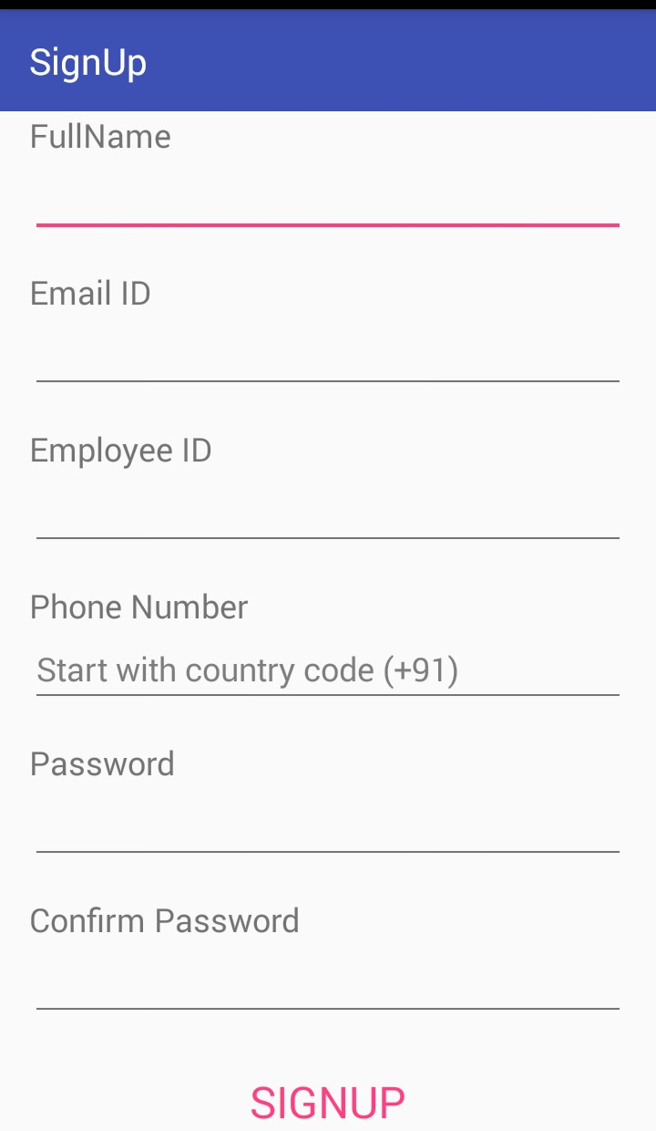

This screen is login users and another is creating a new account to registration.

User Full Fill the Form.
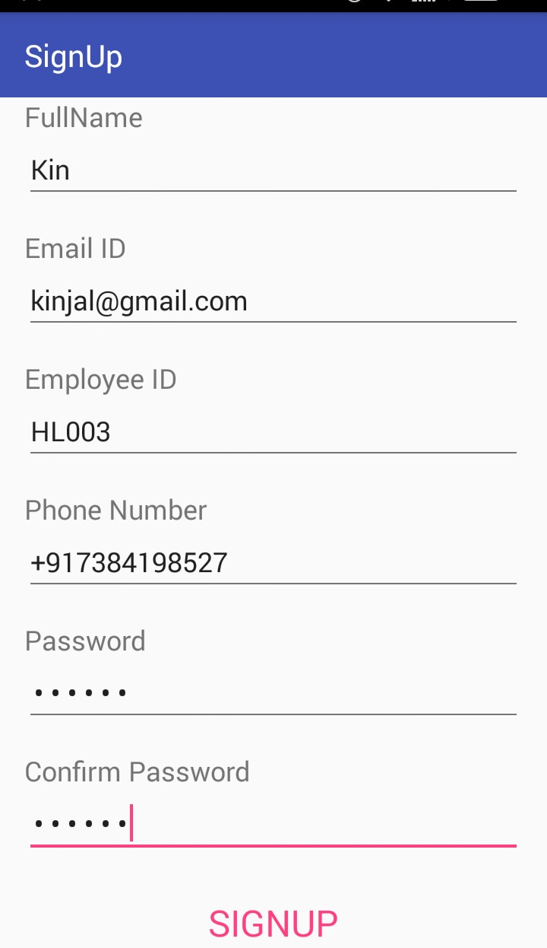
User Details Registration Form.

Password Validation Form.
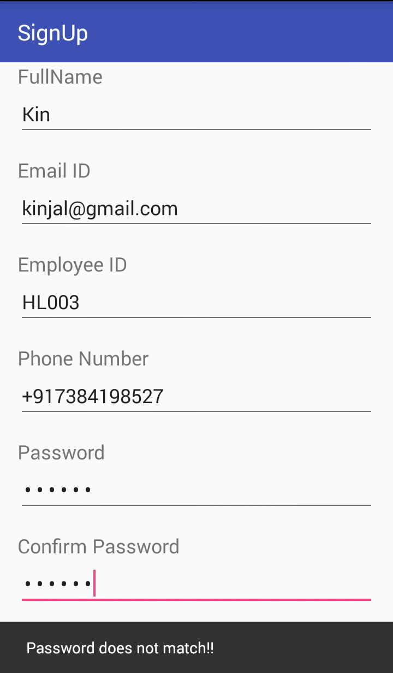
Password and Confirm-Password does not match form.(Validation).

Project list description display.
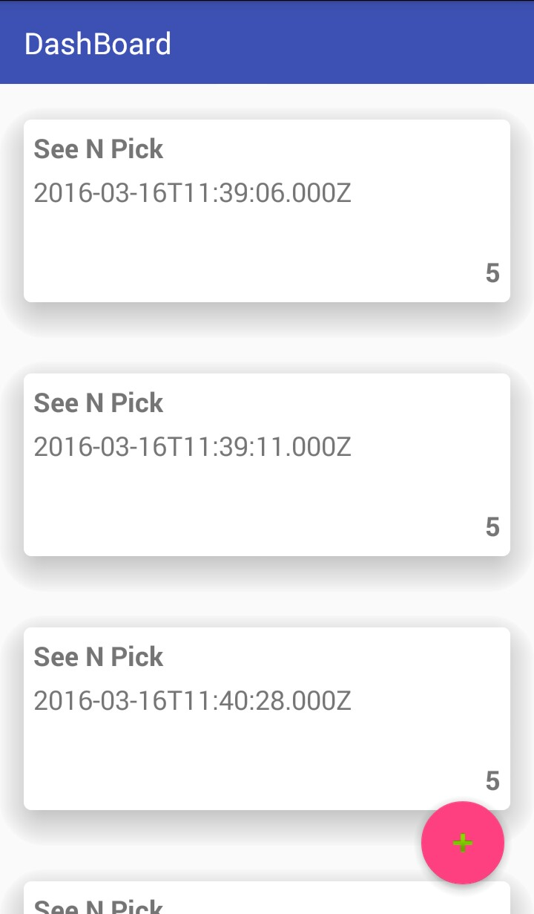

Project list in recyclerview display and all details are also display.(Time and hours).

Logged-hours form.
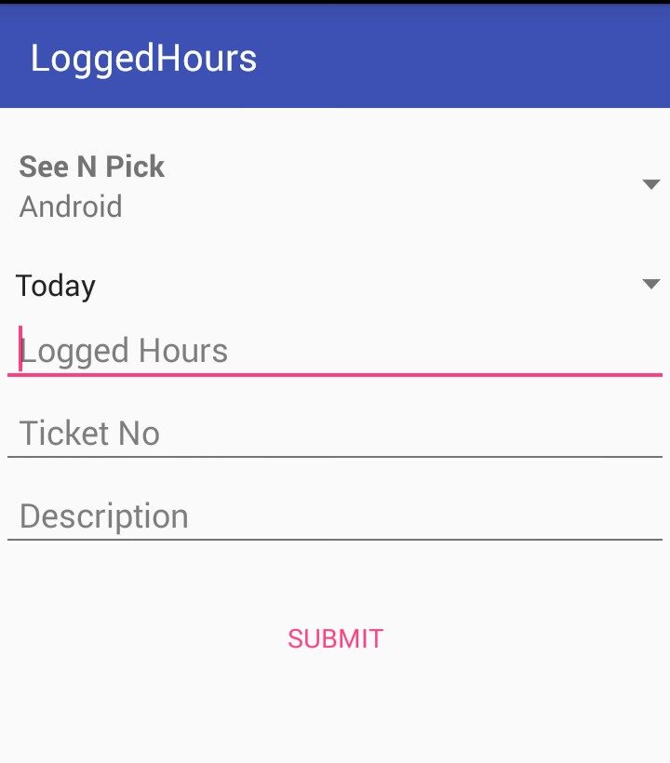
This page are Logged-hours form project description.

Logged-hours form with description.
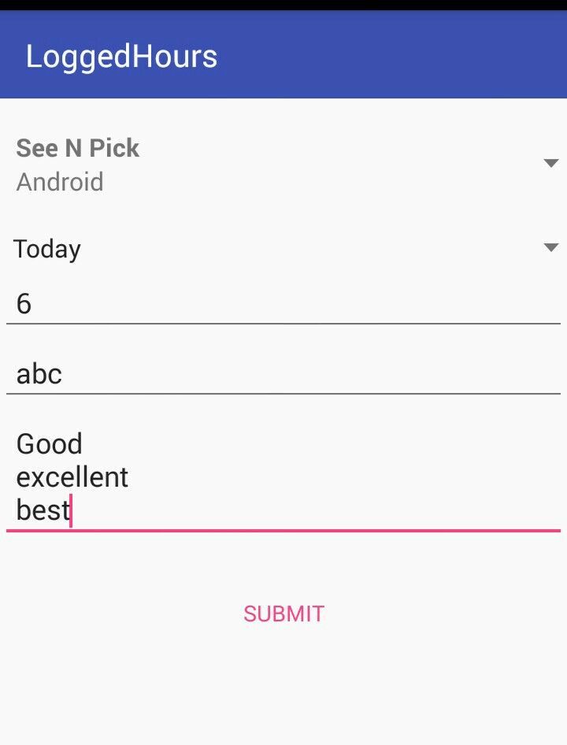

This page are Display the All Project Details Description Display.

TESTING STRATEGY

- Application Test

The Application tests will focus on the behavior of the Application. User scenarios
will be executed giants the Application as well as screen mapping and error message
testing. Overall, the Application tests will test the integrated Application and verify
that it meets their requirements defined in the requirements document.

- Performance Test

Performance test will be conducted to ensure that the Application’s response times
meet the user expectation and do not exceed the specified performance criteria.
During these tests, response times will be measured under heavy stress and/or
volume.

- Security Test

Security tests will determine how secure the Application is the tests will verify that
unauthorized user access to confidential data is prevented.

- Automated Test

A suite of automated tests will be developed to test the basic functionality of the
Application and perform regression testing on areas of the Applications that
previously had critical/major defects. The tool will also assist us by executing user
scenarios thereby emulating several users.

- Stress and Volume Test

We will subject the Time-Sheet Application to high input conditions and a high
volume of data during the peak times. The Application will be stress tested using
twice the number of expected users.

- Documentation Test

Tests will be conducted to check the accuracy of the user documentation. These tests
will ensure that no features are missing, and the contents can be easily understood.

Appendix B

Planning and schedule of the project-project management

We can’t imagine starting a long car trip to an unfamiliar destination without a map or
navigation system. Same here in project management.
The schedule of project is reviewed regularly, and it is often revised while the project is in progress. It continues to develop as the project moves forward, changes arise, risks come and go, and new risks are identified. The schedule essentially transforms the project from a vision to a time-based plan.

Schedules have following tips:
- Realize the importance of the schedule.
- Identify the availability of team members.
- Build the schedule around deliverables.
- Include regular milestones.
- Expect that the schedule will change.
- Have a process for managing change.

Schedules also help in following:

- It provides a basis for you to monitor and control project activities.
- It helps you determine how best to allocate resources so you can achieve the project goal.
- It helps you assess how time delays will impact the project.
- We can figure out where excess resources are available to allocate to other projects.
- It provides a basis to help you track project progress.

Time line chart:

Development  Phases | Week |  |  |  |  |  |  |  |  |  |  |  |  |  |  | Duratin Weeks
Development  Phases | 1 | 2 | 3 | 4 | 5 | 6 | 7 | 8 | 9 | 10 | 11 | 12 | 13 | 14 | 15
Analysis |  |  |  |  |  |  |  |  |  |  |  |  |  |  |  | 4
Design |  |  |  |  |  |  |  |  |  |  |  |  |  |  |  | 5
Coding |  |  |  |  |  |  |  |  |  |  |  |  |  |  |  | 8
Testing |  |  |  |  |  |  |  |  |  |  |  |  |  |  |  | 2
Documentation |  |  |  |  |  |  |  |  |  |  |  |  |  |  |  | 15

Appendix C

Source Files:-

activities
interfaces
model
utilities
webservice

About the Tool

- Android studio
At the core of Android Studio is an intelligent code editor capable of advanced code completion, refactoring, and code analysis. The powerful code editor helps you be a more productive Android app developer.
- SDK Tools
The SDK tools are installed with the SDK starter package and are periodically updated. The SDK tools are required if you are developing Android applications. The most important SDK tools include the Android SDK Manager (android SDK), the AVD Manager (android AVD) the emulator (emulator), and the Dalvik Debug Monitor Server (DDMS). A short summary of some frequently-used SDK tools is provided below.

- Virtual device tools
A QEMU-based device-emulation tool that you can use to debug and test your applications in an actual Android run-time environment.
- SDK manager
The Android SDK separates tools, platforms, and other components into packages you can download using the SDK Manager. For example, when the SDK Tools are updated or a new version of the Android platform is released, you can use the SDK Manager to quickly download them to your environment.

- DDMS
Lets you debug Android applications.

- SQLite
Lets you access the SQLite data files created and used by Android applications.
Glossary

Glossary of project management terms and acronyms used by project managers and
business professionals. Understanding these terms and acronyms is an important first step towards success in project management .

Agile Project Management:

The ideas from agile software development applied to project management. Agile methods
promote a process that encourages development iterations, teamwork, stakeholder involvement,
objective metrics and effective controls.

Assumptions:

Any factors that you are assuming to be in place that will contribute to the successful
outcome of the project.

Baseline:

A baseline is an approved configuration item, for example a project plan that has been
signed off for execution. The baseline records the planned costs, schedule and technical
requirements against which a project is measured.

Earned Value:

An approach where you monitor the project plan, actual work and work-completed value
to see if a project is on track. Earned Value shows how much of the budget and time should have been spent, for work done.

Project Manager:

The person who has the overall responsibility for the successful planning, execution and
closure of a project. Project Managers work in the construction industry, architecture, information technology and many different occupations that produce a product or service.

Scope:

The overall definition of what the project should achieve and a specific description of
what the result should be. A major ingredient of scope is the quality of the final product.

Bibliography
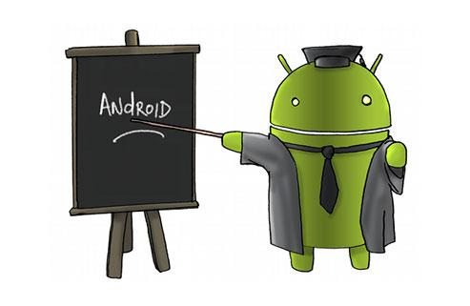

Websites: -

1) https://github.com :


2) www.stackoverflow.com :


3) www.androidhive.com :


4) www.iconarchive.com :


5) www.iconfinder.com :

