VISHESH KUMAR DWIVEDI

You can run my file in google Colaboratory (colab) and spyder 3 IDE (Anaconda 3).

**DATA ENTRY**( as a user):

**For problem 1 part 2** :

**I am entering the number of clusters and initial centers as an input as a user .So After running the code ,it will ask**

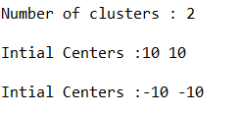

**Please run the code by plugging the data as given above.**

**Enter a space-in between while entering x and y coordinates of the Initial centers.**

**Similarly, For problem 1 part 3:**

* **Similarly for running problem 2 part 3,** Enter the input as given above, For more details,I posted the **outputs (test cases)** in the **report** file

**Enter a space-in between while entering x and y coordinates of the Initial centers.**