Cleya.ai — Bug Report
Website: https://cleya.ai/
Date: 30 March 2026 | Total Bugs: 15

Bug #1: Company Stage Dropdown — Options Not Visible
When the 'Company Stage' dropdown is opened, the options list appears blank. The option texts are not visible (likely white text on white background, or options not rendering at all).
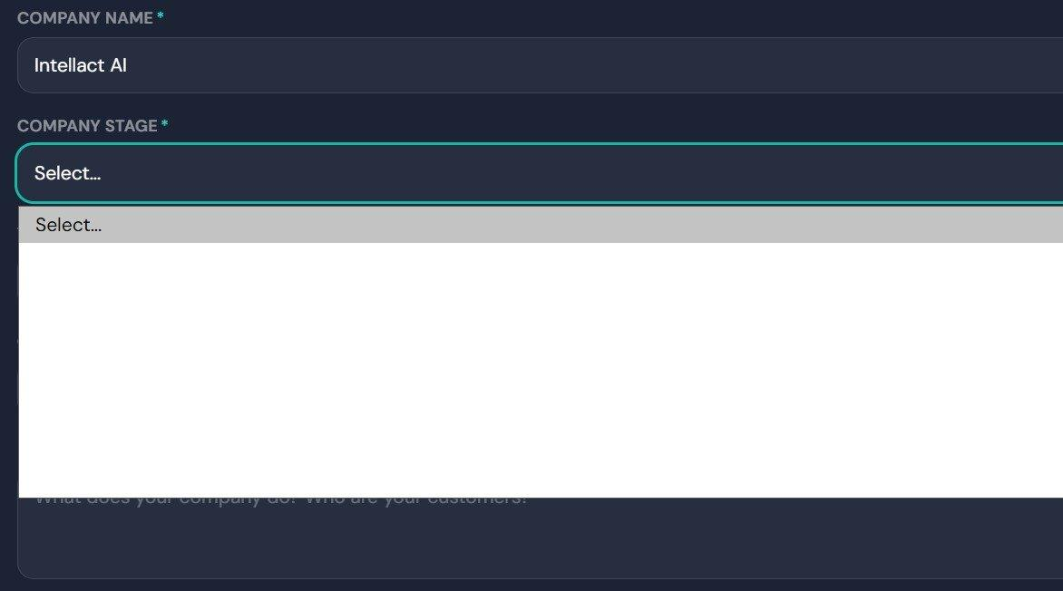
Bug #1 — Dropdown options not visible in Company Stage field

Bug #2: 'Other' Option in Industries — No Popup/Input Appears
In the 'Industries You Work In' section, clicking the 'Other' option does not trigger any popup or text input field. The user should be able to type a custom industry, but nothing happens on click.
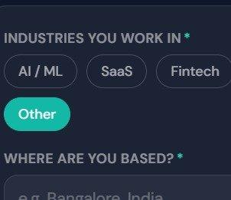
Bug #2 — 'Other' button does not open any input field

Bug #3: Profile Completion Stuck at 88%
The profile completion progress bar is stuck at 88% even after filling in all visible details. It is unclear which fields account for the remaining 12%, suggesting a miscalculation in the progress logic or unmapped required fields.
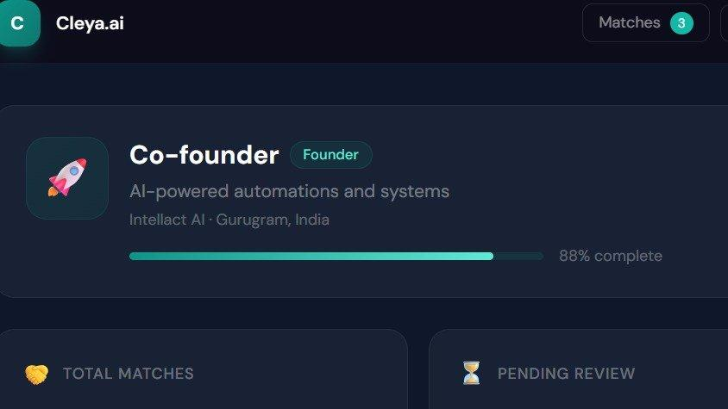
Bug #3 — Profile shows 88% complete with no indication of missing fields

Bug #4: Match Recommendations Not Hyper-Niched / Irrelevant Results
The match recommendations are not relevant to the user's stated needs. When the user selected a preference for someone to help boost marketing, the system recommended partners in the AI space and investors instead. This is likely due to a small dataset or the matching algorithm not filtering accurately based on the user's specific goals.

Bug #5: Matches Not Sorted by Fit Percentage (Descending Order)
The matches are not sorted by fit percentage in descending order. The highest 'Possible Fit' match should appear first, followed by lower ones. Currently the ordering appears random (e.g., 33% appearing after 31% rather than being sorted highest to lowest).
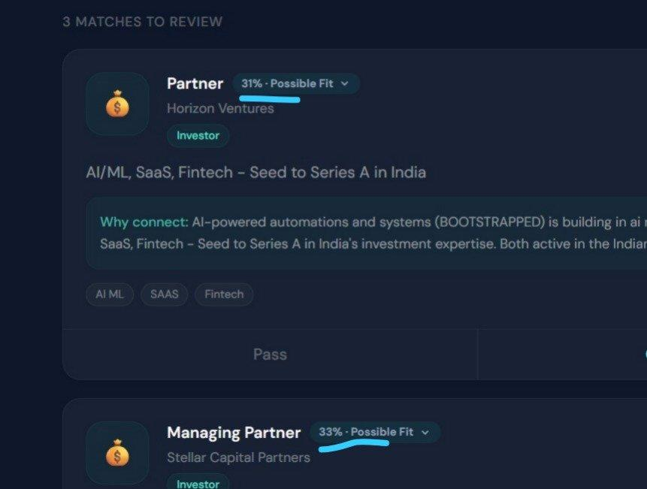
Bug #5 — Match cards not sorted by fit percentage

Bug #6: Pending Count Mismatch & No Request State Tracking
Two issues found on the 'Your Matches' page:
- Counter mismatch: After clicking 'Connect', the Pending count shows 0 on the 'Your Matches' page but the Dashboard shows 3 pending. The count is inconsistent across screens.
- No request state tracking: There is no proper acknowledgement of the request's current status. Suggested stages such as 'Request Sent → Viewed → Accepted/Rejected' are missing, leaving the user with no visibility into where their connection request stands.
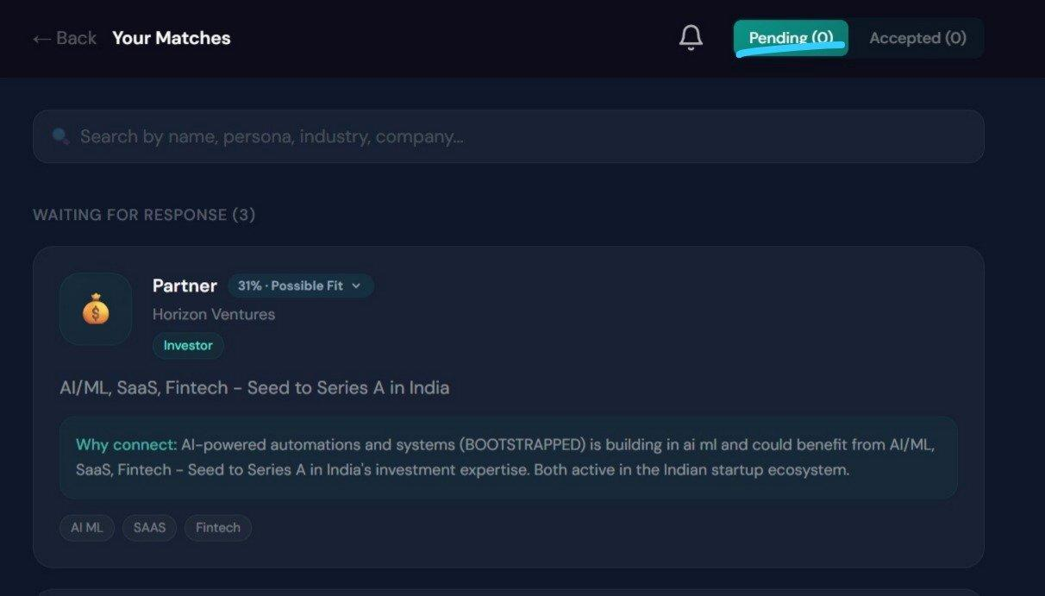
Bug #6 — Pending(0) on Matches page while Dashboard shows 3 pending

Bug #7: 'Why Connect' Description is Vague — Missing Profile Details
The 'Why Connect' description is too generic and does not provide sufficient relevant information about the connection's background. Key details such as companies they have worked at, funded, or been associated with should be visible — ideally auto-scraped from LinkedIn — to help the user make a more informed decision before connecting.

Bug #8: Chat with Cleya — Broken Markdown Formatting
The 'Chat with Cleya' AI assistant response displays raw markdown syntax (e.g., **bold**) as plain text instead of rendering it properly. This makes the response appear cluttered and hard to read.
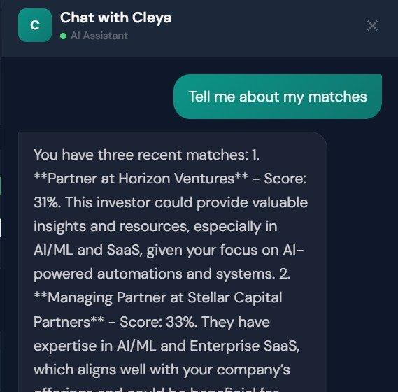
Bug #8 — Raw markdown symbols visible in Cleya chat response

Bug #9: Lengthy Onboarding Forms — No LinkedIn/CV Import Option
Multiple UX and product-level issues identified:
- Lengthy onboarding forms: The forms are too long and tedious. A user who discovered the platform randomly may drop off before completing them.
- No auto-fill from LinkedIn/CV: There is no option to import profile data from LinkedIn or upload a CV to auto-populate form fields, which would significantly reduce friction.
- Low quality leads: Currently unable to connect with high-quality leads, likely due to a small user base. The core value proposition depends on the quality of matches — if that is not strong, retention will suffer.

Bug #10: Match Card Shows Insufficient Information
The information shown on the match card is too minimal to make an informed decision. Just a title, company name, and a one-liner 'Why Connect' description is not enough. Users need more context such as the person's background, experience, past companies, achievements, or portfolio to judge whether it's worth their time to connect.
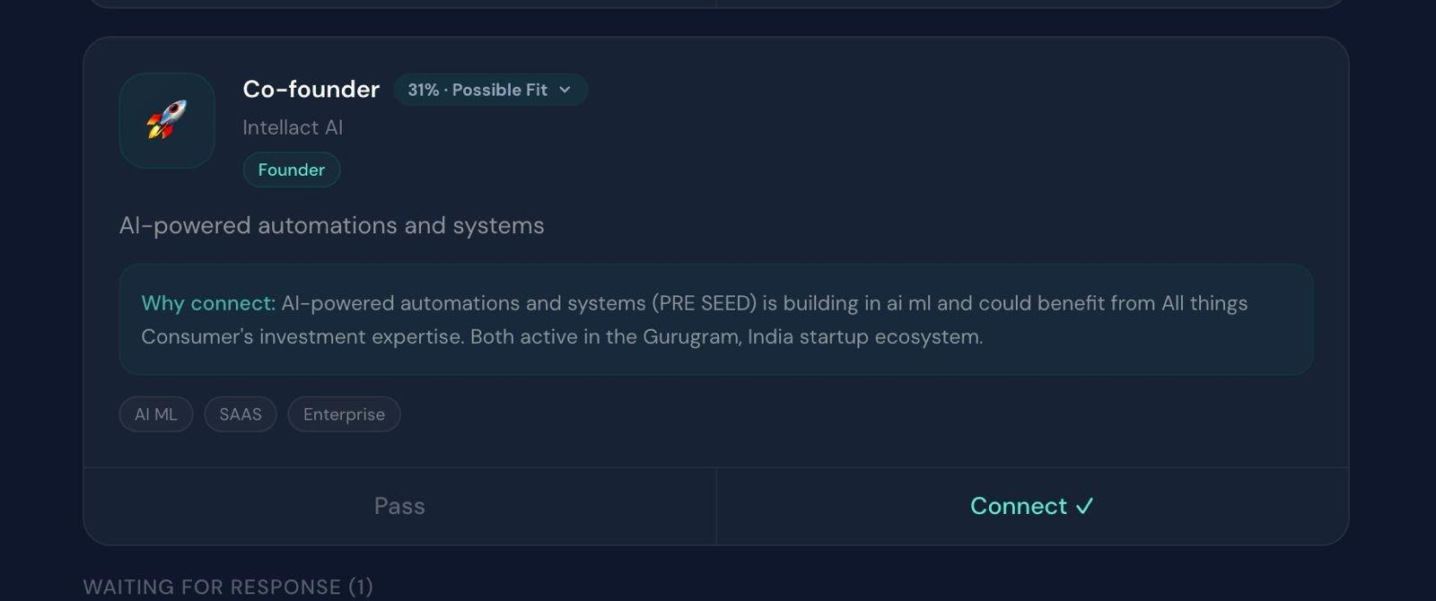
Bug #10 — Match card with insufficient profile information

Bug #11: Generic AI-Generated Design — Lack of Unique Branding
The website has a generic AI-generated visual design. The branding and visual identity lack uniqueness and creativity, making it look similar to countless other AI-built websites. At minimum, the branding (colors, typography, visual language) should be distinctive and tailored, even if the overall layout follows standard conventions.

Bug #12: Onboarding Chat Flow Dead-End After 'How Did You Hear About Cleya?'
The onboarding chat flow gets stuck after the user answers 'How did you hear about Cleya.ai?' — there is no next step, confirmation, or transition to the dashboard or matches page. The user is left with no feedback on what happens next, creating a dead-end experience with no clear call to action or progress indicator.
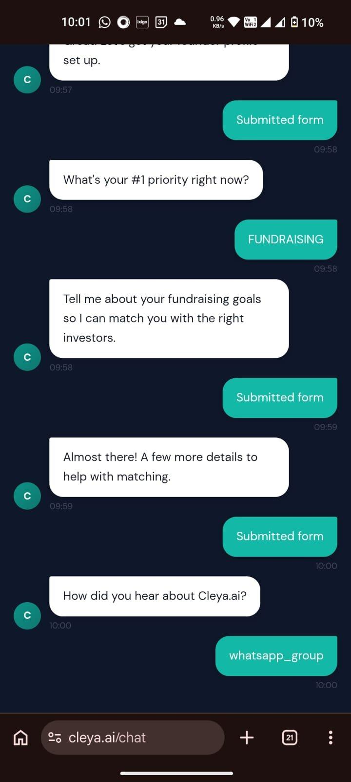
Bug #12 — Chat flow stuck with no next step after referral question

Bug #13: LinkedIn URL Field — 'https://' Not Pre-filled
The LinkedIn URL input field expects the full URL including 'https://' to be typed manually by the user. The 'https://linkedin.com/in/' prefix should be pre-filled in the input field so the user only needs to enter their unique handle — reducing friction and chances of input errors.

Bug #14: Matching Algorithm Relies on Limited Data — Needs LinkedIn Crawling
The matching algorithm relies on limited self-reported data, making truly relevant matches coincidental rather than intentional. A more robust approach would involve LinkedIn crawlers and reasoning-based search (using tools like Olostep or Firecrawl) to proactively source and match relevant profiles — similar to candidate sourcing agents. However, the use case here is more nuanced than hiring, so the crawling logic and matching reasoning would need to be carefully tailored to the platform's purpose.

Bug #15: Multiple UI/Navigation Issues
Several UI and navigation-level issues observed across the platform:
- Incomplete Hindi translation: When the language is toggled to Hindi, some content remains in English and is not properly translated.
- No footer after login: The logged-in view of the site is missing a footer entirely.
- Inconsistent Navbar: The navbar lacks proper arrangement, and several inner pages (e.g., Introductions, Chat) are missing navbar links, leaving users without easy navigation.
- No chat history: The 'Chat with Cleya' feature does not store or display previous conversation history. Each session starts fresh with no context from prior chats.

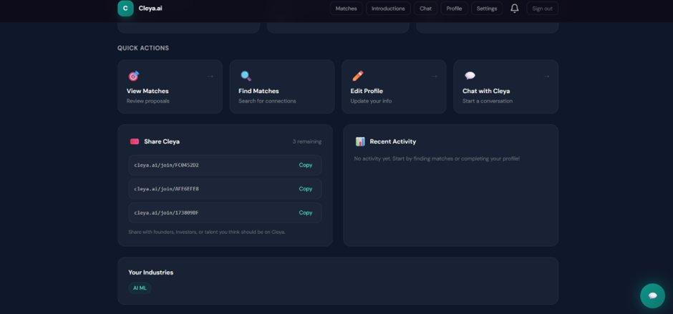
Bug #15 — Dashboard view
Bug #15 — Navbar on inner pages
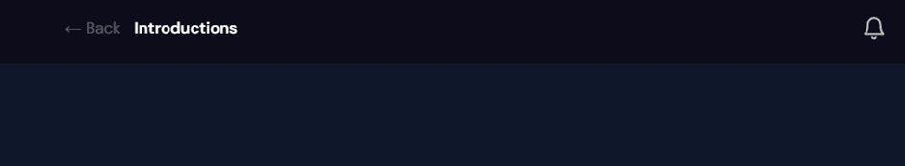
Bug #15 — Introductions page with no content
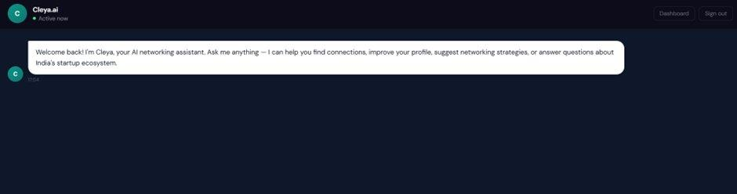
Bug #15 — Chat page (no history)
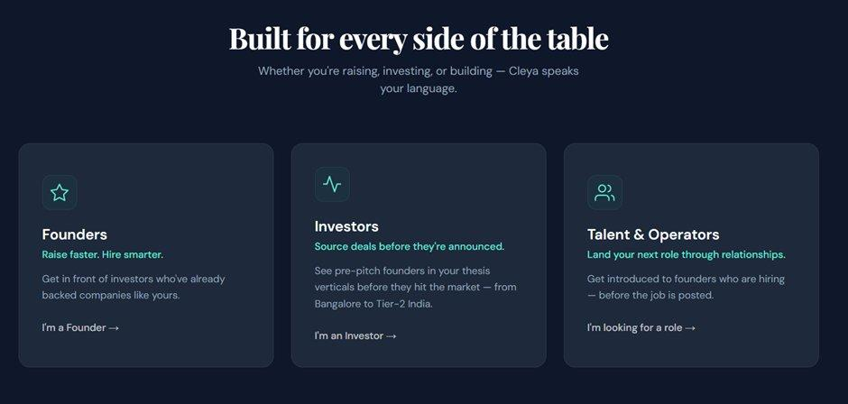
Bug #15 — Landing page sections

End of Bug Report — Cleya.ai

