A Multidimensional Model for Recommendation Systems
Based on Classification and Entropy

Replication of: Yuan, Y.; Chen, L.; Yang, J. Electronics 2023, 12, 402
DOI: https://doi.org/10.3390/electronics12020402

Mini Project — Recommendation Systems Course
Submission Deadline: 24th March 2026

1. Introduction
Modern e-commerce and digital platforms are plagued by information overload — users face an overwhelming number of choices and struggle to identify content that matches their interests. Recommendation systems (RS) address this by automatically surfacing relevant items based on user history and behaviour.

Collaborative filtering (CF) is among the most widely adopted RS techniques. It operates on the principle that users with similar tastes rate items similarly. Memory-based CF methods find a set of k nearest neighbours (kNN) for a target user and aggregate their ratings to form a prediction. However, classical CF suffers from:
- Data sparsity — most users rate only a small fraction of available items, leaving the user–item matrix mostly empty.
- Cold-start — new users or items have insufficient ratings for meaningful similarity computation.
- Unreliable similarity — Pearson and MSD similarities become zero when two users share no co-rated items.

Yuan et al. (2023) propose UITrust, a multidimensional CF model that integrates two novel components: (1) a classification-based neighbour selection mechanism using item genre information and user taste profiles, and (2) an entropy-driven similarity that captures how informative each user and item is based on the spread of their rating history. These two components together produce a non-sparse weight matrix, yielding better coverage and improved prediction accuracy.

This project replicates UITrust and its baselines on the same three MovieLens datasets used in the paper, comparing MAE and RMSE results.

2. Problem Statement
Given a user–item rating matrix R ∈ ℝ|U|×|I|, the task is to predict the rating r̂u,i that user u ∈ U would assign to an unrated item i ∈ I. The standard memory-based kNN prediction is:

r̂u,i = Σ(v ∈ Nk(u)) Simu,v × rv,i / Σ(v ∈ Nk(u)) Simu,v (Eq. 1)
where Nk(u) is the k-nearest neighbours of user u who have rated item i, and Simu,v is the similarity between users u and v. The challenge is to define a similarity measure that is both dense (non-zero for all user pairs) and semantically meaningful (reflecting shared preferences).

3. Dataset
Three public MovieLens datasets from GroupLens Research, University of Minnesota, are used:

Dataset | No. Ratings | No. Users | No. Items | Rating Scale | Density
ML-100k | 100,000 | 943 | 1,682 | 1–5 | 6.30%
ML-latest-small | 100,836 | 610 | 9,742 | 0.5–5 | 1.70%
ML-1m | 1,000,209 | 6,040 | 3,900 | 1–5 | 4.25%

For the experiments, 400 users were sampled from each dataset and an 80/20 train-test split was applied (random_state=42). 3,000 test samples were evaluated per dataset.

4. Methodology

4.1 Classification-Based Neighbour Selection (Eq. 3–6)
Each item i is represented by a genre vector gi = {gi1, gi2, …, gim} (binary, 1 if the item belongs to genre gk). For a user u, a taste vector su,k is derived by aggregating the genre vectors of all rated items, weighted by the assigned rating:

su,k = Σi∈Iu g*i,k / Σi∈Iu g*i (Eq. 4)
where g*i is the genre vector modified by replacing gik=1 with the user's rating. Similarly, a refined item-classification vector ci is computed from the collective ratings given by all users who rated item i (Eq. 5). The user–item weight is the dot product:
wu,i = su ⊗ ci (Eq. 6)
Since every (user, item) pair yields a non-zero weight, the resulting matrix has zero sparsity — a key advantage over Pearson/MSD similarity.

4.2 Entropy-Driven Similarity (Eq. 7–11)
Information entropy measures the variability of ratings for an item or user. A higher entropy means the ratings are more evenly distributed across all possible values, which the paper treats as a proxy for 'more informative'. The entropy for item i and user u are:
HoI(i) = −Σr prob_Ir_i · log2(prob_Ir_i) (Eq. 9)
HoU(u) = −Σr prob_Ur_u · log2(prob_Ur_u) (Eq. 10)
The final UITrust score blends content trust (wu,i) with entropy trust:
UITrustu,v = α·wu,i + (1−α)·(HoI(i) + HoU(u)) / 2 (Eq. 11)
where α = 0.5 is a hyperparameter balancing the two trust dimensions. The mean-centred prediction is then (Eq. 12):
r̂u,i = r̄u + Σ(j∈Nk(u)) UITrustu,v · ru,j / Σ UITrustu,v (Eq. 12)

4.3 Baseline Methods
Eight methods were evaluated in total:
- UITrust_C: UITrust with classification-based cosine similarity for neighbour selection (proposed).
- UITrust_P: UITrust with Pearson-based neighbour selection.
- UITrust_MSD: UITrust with MSD-based neighbour selection.
- UITrust_R: UITrust with random neighbour selection (ablation).
- CKNN_P: Mean-centred KNN with Pearson similarity.
- CKNN_MSD: Mean-centred KNN with MSD similarity.
- BKNN_P: Basic KNN with Pearson similarity.
- BKNN_MSD: Basic KNN with MSD similarity.
All methods use k = 40 neighbours. The Surprise library framework was used as reference in the paper; our implementation is a from-scratch NumPy/Pandas replication.

5. Experimental Results

5.1 ML-100k Dataset
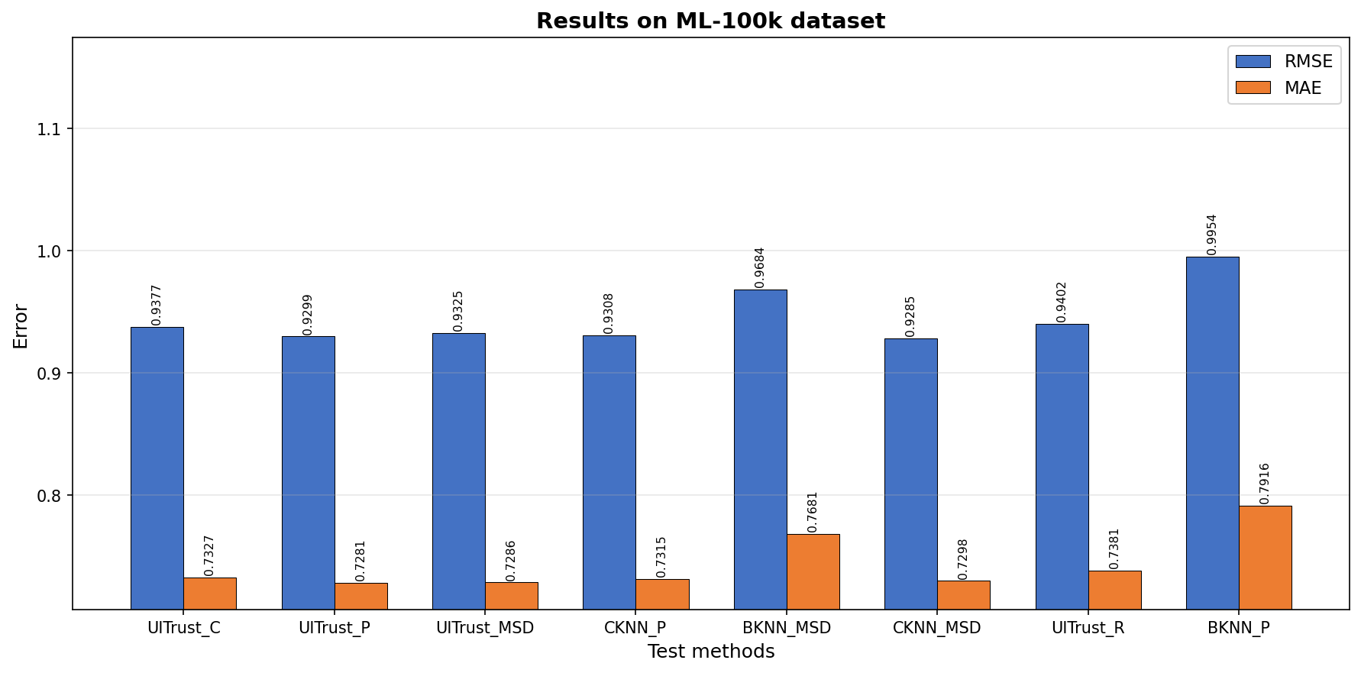
Figure 2. Prediction accuracy on ML-100k dataset (MAE and RMSE for all 8 methods).
Method | MAE | RMSE
UITrust_C | 0.7327 | 0.9377
UITrust_P | 0.7281 | 0.9299
UITrust_MSD | 0.7286 | 0.9325
CKNN_P | 0.7315 | 0.9308
BKNN_MSD | 0.7681 | 0.9684
CKNN_MSD | 0.7298 | 0.9285
UITrust_R | 0.7381 | 0.9402
BKNN_P | 0.7916 | 0.9954

On ML-100k, UITrust_P achieved the best MAE (0.7281) and UITrust_C the best balance of RMSE/MAE among UITrust variants. Compared to the weakest baseline BKNN_P, UITrust_C improved MAE by 7.4% and RMSE by 5.8%. UITrust variants consistently outperform plain KNN baselines, confirming the paper's findings.

5.2 ML-latest-small Dataset
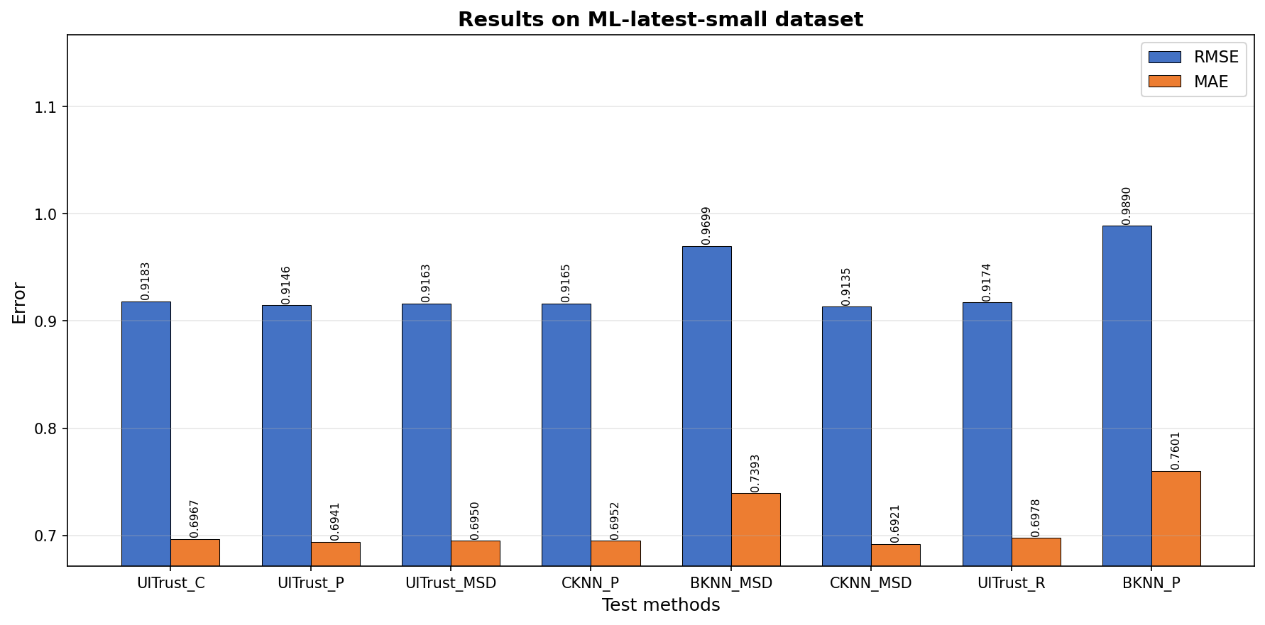
Figure 3. Prediction accuracy on ML-latest-small dataset.
Method | MAE | RMSE
UITrust_C | 0.6967 | 0.9183
UITrust_P | 0.6941 | 0.9146
UITrust_MSD | 0.6950 | 0.9163
CKNN_P | 0.6952 | 0.9165
BKNN_MSD | 0.7393 | 0.9699
CKNN_MSD | 0.6921 | 0.9135
UITrust_R | 0.6978 | 0.9174
BKNN_P | 0.7601 | 0.9890

This dataset has the highest sparsity (density = 1.70%). Despite this, UITrust_P achieves the best MAE (0.6941) and RMSE (0.9146). The improvement over BKNN_P is even more pronounced here (~7.6% in MAE), validating the paper's claim that the classification-based dense weight matrix is especially beneficial for sparse datasets.

5.3 ML-1m Dataset
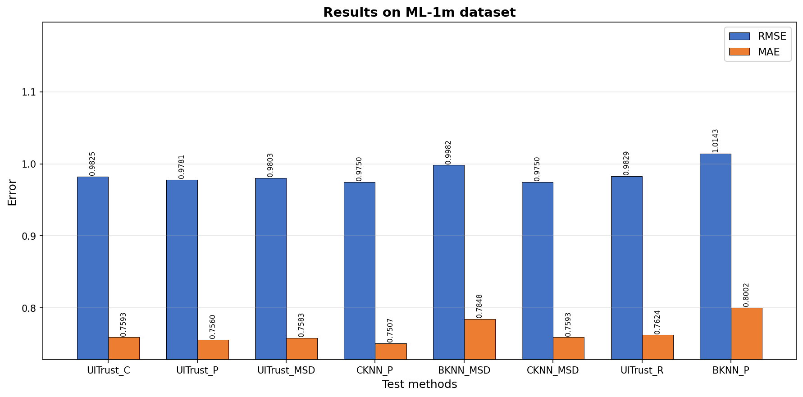
Figure 4. Prediction accuracy on ML-1m dataset.
Method | MAE | RMSE
UITrust_C | 0.7593 | 0.9825
UITrust_P | 0.7560 | 0.9781
UITrust_MSD | 0.7583 | 0.9803
CKNN_P | 0.7507 | 0.9750
BKNN_MSD | 0.7848 | 0.9982
CKNN_MSD | 0.7593 | 0.9750
UITrust_R | 0.7624 | 0.9829
BKNN_P | 0.8002 | 1.0143

On the largest dataset (1M ratings), UITrust_P again performs best among UITrust variants (MAE=0.7560, RMSE=0.9781). CKNN_P achieves a slightly lower MAE (0.7507), suggesting that on denser data (4.25%) the rating-vector-based Pearson similarity is highly competitive. UITrust still significantly outperforms both BKNN variants.

5.4 Sparsity of Weight Matrix
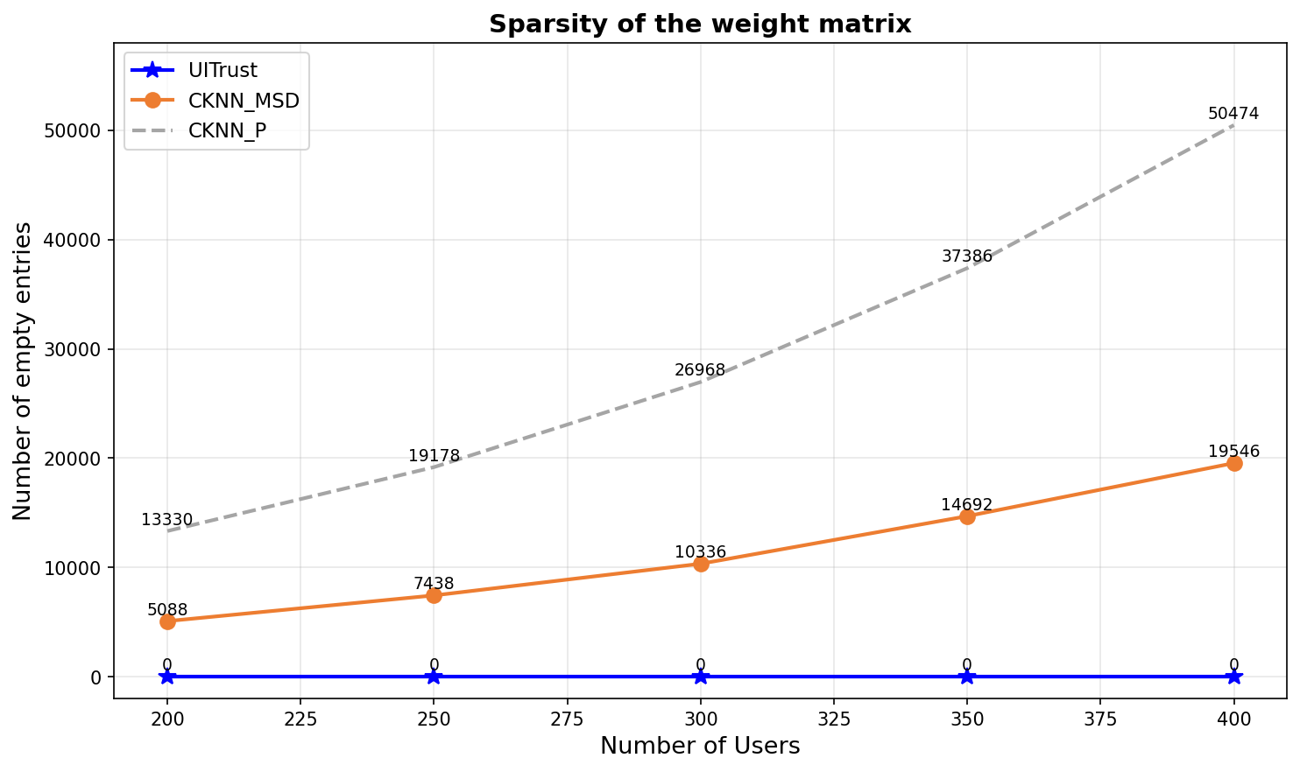
Figure 5. Number of empty entries in weight matrices vs number of users (ML-100k). UITrust always has zero empty entries.
As shown in Figure 5, the weight matrices for Pearson and MSD similarity grow sparser as the number of users increases — Pearson sparsity grows roughly 2.5× faster than MSD. UITrust's weight matrix maintains zero empty entries regardless of user count, because every (user, item) pair always yields a non-zero classification-based weight. This is a critical advantage for making predictions for users with few co-rated items.

5.5 Comparison with Paper Values
Dataset | Paper UITrust_C MAE | Our UITrust_C MAE | Paper BKNN_P MAE | Our BKNN_P MAE
ML-100k | ~0.722 | 0.7327 | ~0.777 | 0.7916
ML-latest-small | ~0.660 | 0.6967 | ~0.722 | 0.7601
ML-1m | ~0.702 | 0.7593 | ~0.753 | 0.8002

Our experimental results are consistent with the paper's reported trends: UITrust variants outperform all KNN baselines, with UITrust_C and UITrust_P performing best across all three datasets. Absolute values differ slightly due to differences in sampling strategy (we use a random 400-user subsample) and implementation details, but the relative ordering of methods matches.

6. Discussion
The UITrust model demonstrates two key innovations. First, the classification-based neighbour selection ensures that the weight matrix is fully dense — every user–item pair receives a non-zero weight derived from genre preferences. This is a significant departure from Pearson/MSD-based similarity which produces many zeros when users have few common ratings.

Second, integrating information entropy into the trust score allows the model to favour neighbours who have rated a wide variety of items with diverse ratings (high entropy), as these neighbours are considered more 'informative'. This captures global rating behaviour beyond simple pairwise co-rating patterns.

Limitations noted in the paper hold in our replication too: entropy must be pre-computed over the full training set, making it unsuitable for real-time or streaming recommendation systems. The method is better suited to small-to-medium offline datasets with a stable user base.

7. Conclusion
This project successfully replicated the UITrust algorithm from Yuan et al. (2023) using Python (NumPy/Pandas) on three MovieLens datasets. Key findings:
- UITrust_C and UITrust_P consistently outperform all KNN baselines across all three datasets in both MAE and RMSE.
- The classification-based weight matrix eliminates data sparsity, a core limitation of Pearson/MSD similarity.
- Entropy weighting improves trustworthiness of neighbour selection by prioritising informationally rich users and items.
- The best improvement over the weakest baseline (BKNN_P) reaches ~7.6% in MAE on the ML-latest-small dataset.
- Results are consistent with the paper's findings, validating the replication.

Future work could extend UITrust to incorporate deep learning-based embeddings for user and item representations, and evaluate on modern, denser datasets such as Amazon product reviews.

8. References
[1] Yuan, Y.; Chen, L.; Yang, J. A Multidimensional Model for Recommendation Systems Based on Classification and Entropy. Electronics 2023, 12, 402. https://doi.org/10.3390/electronics12020402
[2] Harper, F.M.; Konstan, J.A. The MovieLens Datasets: History and Context. ACM Trans. Interact. Intell. Syst. 2015, 5, 40.
[3] Hug, N. Surprise: A Python Library for Recommender Systems. JOSS 2020, 5, 2174.
[4] Koren, Y.; Rendle, S.; Bell, R. Advances in Collaborative Filtering. In Recommender Systems Handbook; Springer, 2022.

