Green Gold Limited – Strategic Action Plan
Consultant Name
Consultant Number (Student Number)
Lecturer:
Date of Report:

1.0 Purpose of the Action Plan
This action plan outlines the actions that Green Gold Limited will take based on the recommendations from this consultancy. The report recognizes that, along with the development of the Rotterdam plant, the project depends on being able to source finance, feedstock, customers, a skilled workforce, regulatory advancements, and stakeholder buy-in to succeed.

2.0 Recommendation One: Establish a Commercial Readiness Board
Green Gold should set up a Commercial Readiness Board, made of senior representatives from finance, operations, engineering, HR, commercial management, and regulatory functions to speed up the process of commercial readiness. There shall be a review by the board to determine if the company is ready to advance its development. This is similar to Hodges' definition of consultancy, which focuses on discovering an organisation's needs, risks and interventions.
Activity | Responsibility | Timing | Measure
Appoint senior sponsor | Senior Management | Q4 2026 | Sponsor appointed
Establish board | Senior Management | Q4 2026 | Board operational
Define readiness criteria | Board | Q1 2027 | Criteria approved
Review finance and regulation | Finance / Regulatory | Quarterly | Progress reported
Review suppliers, customers and workforce | Board | Quarterly | Readiness report
Approve stage progression | Board | Each stage | Decision recorded
The primary advantage will be more effective coordination and investment decisions. Unclear roles and decision-making procedures are risks and can be mitigated by establishing clear roles and reporting. The board should be the main governance structure for the controlled commercial growth.
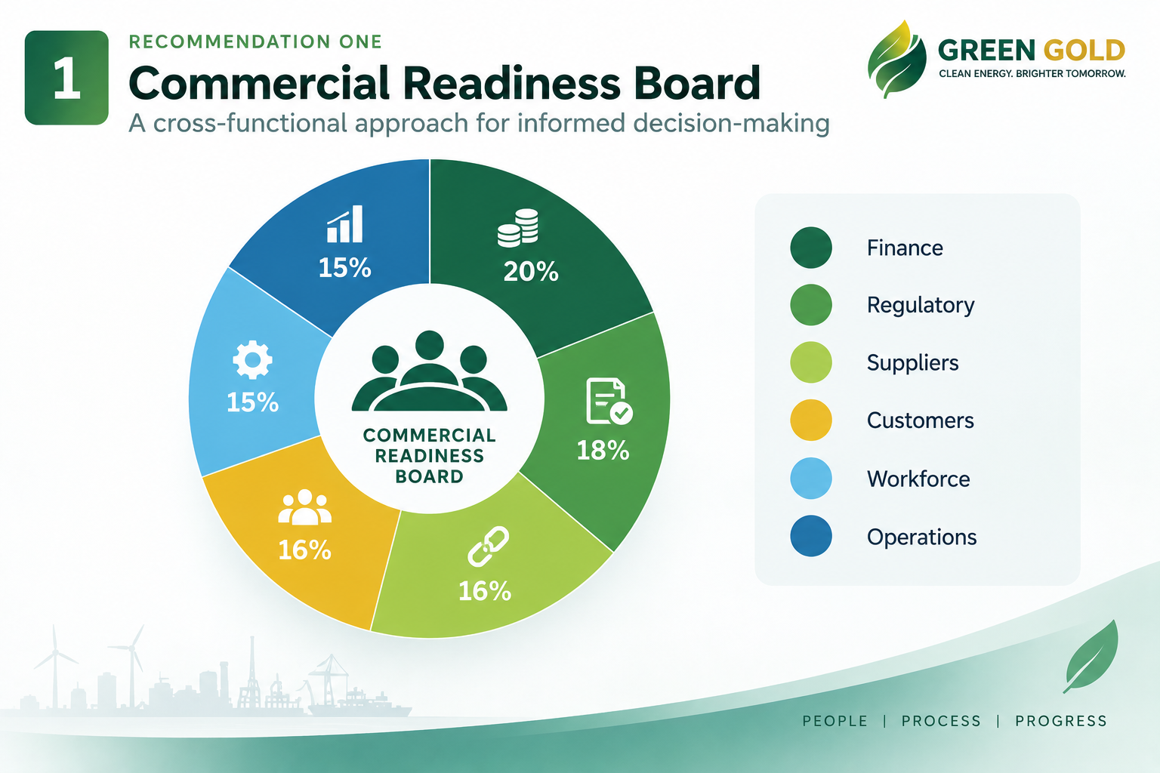

3.0 Recommendation Two: Develop a Multi-Supplier Feedstock Strategy
Green Gold should diversify away from relying on a single feedstock supplier to a portfolio of suppliers. Suppliers should be evaluated from the volume, quality, price and geographical location and reliability. Long-term contracts should be linked with short term purchasing arrangements, so as to ensure flexibility.
The production of rDME requires proper renewable feedstocks and production processes (TNO, 2023).
Activity | Responsibility | Timing
Identify suppliers | Procurement | Q4 2026
Assess capacity, quality and reliability | Procurement / Operations | Q4 2026–Q1 2027
Compare prices and logistics | Finance / Procurement | Q1 2027
Negotiate supply contracts | Procurement | Q1–Q2 2027
Establish contingency suppliers | Procurement | Q2 2027
Review supplier performance | Management | Quarterly
This should minimize reliance on a single supplier and ensure continuity in production. Main risks include lack of quantity, quality, and delivery issues. These risks should be dealt with via multiple suppliers, clear terms, and contingency plans.

4.0 Recommendation Three: Introduce Customer Pilot Agreements
Green Gold should not be too hasty in transitioning from product development to big commercial contracts. Fuel performance, operating requirements, delivery, pricing, reliability and repeat purchase intentions are key characteristics that should be first tested in the laboratory by controlled pilots with industrial customers and distributors.
Activity | Responsibility | Timing
Identify target customers | Commercial Team | Q4 2026–Q1 2027
Conduct technical and commercial discussions | Commercial / Technical | Q1–Q2 2027
Agree pilot conditions | Commercial / Legal | Q2 2027
Conduct controlled pilots | Operations / Commercial | Q2–Q3 2027
Review results and feedback | Commercial | Q3 2027
Convert successful pilots into contracts | Management | Q4 2027
Prior to large-scale production commitments, the pilots should be able to give practical market evidence. Weak customer interest, poor product performance and inappropriate pricing are among risks. These must be planned on a defined basis (pilot criteria) and formally reviewed prior to agreements of a longer term.

5.0 Recommendation Four: Build a Strategic Skills Pipeline
Green Gold needs to develop a workforce programme – recruitment, training and external partnerships. Roles that are critical to commissioning should be identified prior to commissioning and training should include production, safety, digital systems and quality management. The report relates this to the perspective on workforce planning that it should be aligned to organisational needs (Armstrong and Taylor's, 2023).
Activity | Responsibility | Timing
Identify critical roles | HR / Operations | Q4 2026
Complete skills-gap assessment | HR | Q4 2026–Q1 2027
Recruit priority employees | HR | Q1–Q2 2027
Develop training programme | HR / Operations | Q1–Q2 2027
Deliver technical and safety training | Operations | Q2–Q3 2027
Review workforce readiness | Management | Q3–Q4 2027
The primary advantage is that the technical ability is available prior to commercial operation. Key risks are recruitment shortages and training delays; therefore, recruitment should be started at an early stage and external training partnerships considered.

6.0 Overall Implementation and Performance
These recommendations should work together to make up one programme for commercial readiness. The Commercial Readiness Board will take care of coordination and supplier security, customer validation, and workforce preparation and communication to support transition to commercial production.
Development Stage | Main Focus | Decision Required
1. Feasibility | Site and commercial assessment | Proceed / Review
2. Validation | Regulatory, supplier and customer evidence | Proceed / Review
3. Funding | Investment approval | Approve / Review
4. Construction | Facility development | Proceed / Review
5. Commissioning | Workforce and operational readiness | Launch / Delay
6. Commercial production | Customer delivery and operations | Continue / Review
The proposed investment in the facility is around £10m, and forecasted revenue for the facility is £8m in 2027, £12m in 2028 and £15m in 2029. These numbers are not projections, but are merely forecasts for management purposes.
Management should keep an eye on capital expenditure, sales, production output, plant downtime, feedstock availability, product quality, conversion of pilot to contract, recruitment and training, safety and issues with stakeholders.
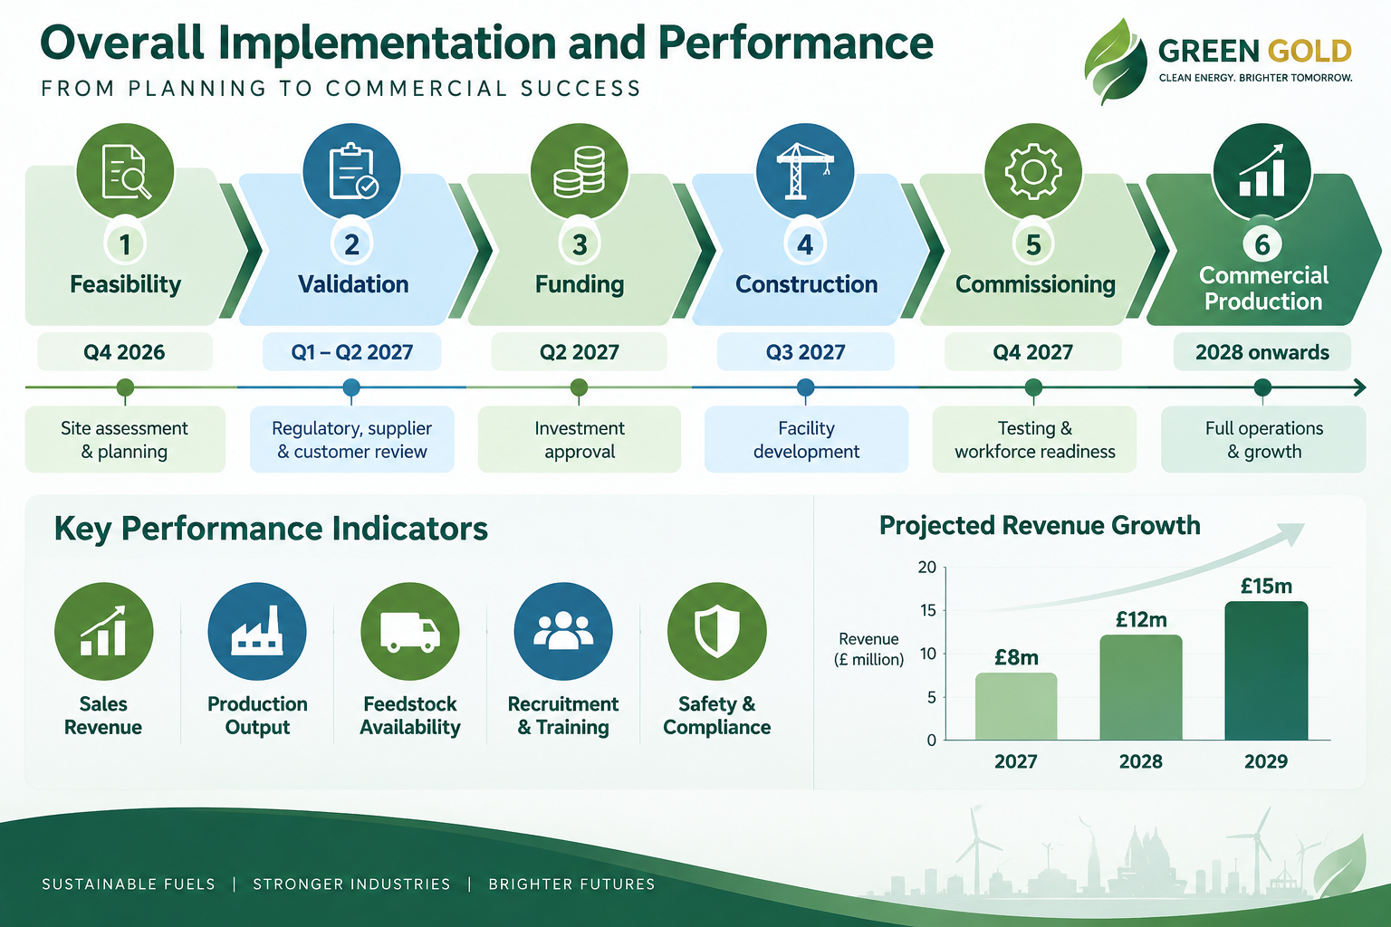

References
Armstrong, M. and Taylor, S. (2023) Armstrong's Handbook of Human Resource Management Practice. 16th edn. London: Kogan Page.
Hodges, J. (2017) Consultancy, Organizational Development and Change: A Practical Guide to Delivering Value. London: Kogan Page.
TNO (2023) ‘Producing renewable DME using renewable energy and CO₂’.

