Strengthening Customer Engagement and Retention at Tesco plc Through Responsible Personalised Digital Loyalty

Programme
Module name
Student Reference Number (SRN)
Report/Assignment Title
Date of Submission

Declaration of Original Work:
- I hereby declare that I have read and understood BPP’s regulations on plagiarism and that this is my original work, and that I have researched, undertaken, completed and submitted in accordance with the requirements of BPP School of Business.
- I declare that where I have used any AI tools, it was for the following reasons (highlight as appropriate):

- To review a draft
- To correct language errors
- Other (please describe) _______________________________________________________

- I have copied & retained for BPP University’s reference, all AI prompts used in the creation of AI content and all AI-generated responses in support of my assignment and attached relevant evidence in the appendices.
- I understand that I may be required to participate in a viva voce, where I will be questioned on any aspect of my assignment, including key concepts, theories, examples used, & any sources included.
- The word count, excluding contents table, bibliography and appendices, is ___ words.

Student Reference Number: Date:

Table of Content

Strengthening Customer Engagement and Retention at Tesco plc Through Responsible Personalised Digital Loyalty 1
Declaration of Original Work: 2
Table of Content 3
1. Executive Summary 4
2. Introduction 6
3. Company/Client Overview 7
4. Problem Definition, Project Aim, Purpose and Consultancy Focus 8
4.1 Problem Statement 8
4.2 Project Aim 8
4.3 Purpose of the Report 8
4.4 Consultancy Focus 9
5. Stakeholder Analysis 10
6. Data Analysis and Framework Application 13
6.1 Analytical approach and framework selection 13
6.2 Secondary data evidence 13
Table 2: Selected Tesco and UK grocery indicators 13
6.3 PESTLE Analysis 14
6.4 Porter’s Five Forces 16
6.5 SWOT analysis 18
6.6 Interpretation of the combined findings 19
6.7 Ethics and sustainability implications 20
7. Recommendations and Conclusion 21
7.1 Summary of findings 21
Recommendation 1: Suggest a more transparent model for a personalised experience for customers on Clubcard 21
Recommendation 2: Shift personalised loyalty from discount targeting towards customer-value journeys 22
Recommendation 3: Establish a Personalisation Performance and Ethics Dashboard 23
Suggested dashboard 23
7.2 Expected benefits 23
7.3 Conclusion 24
8. Employability Reflection 25
References 27

1. Executive Summary
Tesco plc operates in a very competitive grocery market in the UK, and customers are demonstrating a greater tendency to compare the value, convenience, availability, and usefulness of loyalty benefits among grocers. The consultancy project focused on a particular strategic challenge – personalising digital loyalty with customers at the right time and right place without compromising their trust and responsible data usage. The decision was not about the lack of digital resources, but rather the ability to transform those digital resources into long-term customer value (as Tesco already had a large Clubcard ecosystem, with a lot of customer data and starting to develop their own digital skills).
Secondary research conducted through Tesco's 2026 annual reporting, sustainability reporting and corporate announcements, grocery market research and academic literature on personalisation, loyalty, AI and customer trust was used for the project. The decision to use PESTLE, Porter's Five Forces and SWOT was made due to the fact that they covered various aspects of the problem. PESTLE explored the external factors that impact digital loyalty, Porter's analysed how the grocery market in the UK was being influenced by competition, and SWOT related the external factors to Tesco's internal position.
The analysis revealed that Tesco had a robust position when it came into the issue. The UK grocery market share increased by 2.1% to 28.5% in FY2025/26, and UK online sales grew by 11% to over £7 billion. It's also announced that 100% of active Clubcard users' grocery home shopping experiences were personalised on a one-to-one basis at Tesco. Over nine million customers were offered personalised digital coupons and rewards every day, and Clubcard Challenges up to seven million customers (Tesco plc, 2026).
But a strategic conundrum was revealed in the analysis. Loyalty programmes can be more useful when they are personalised, though if they're too targeted, data practices are not transparent, or the type of recommendation isn't relevant to the user, that can spoil the trust. AI personalisation has been shown to boost perceived value, satisfaction and loyalty, and privacy, transparency and customer control have been found to be critical factors for AI personalisation to be successful (Das, Mishra and Mayaluri, 2026). In the area of meal planning and basket building, Tesco's planned AI assistant will leverage previous purchasing history and customer preference to guide customers in creating their meals, highlighting the opportunity and responsibility in extending this model (Tesco plc, 2026).
Three recommendations were thus formulated. Tesco needs to provide a more transparent way for the customer to control their personalised Clubcard experience, so that they know and have control over how their Clubcard is being used. Secondly, Tesco needs to make the tailored incentives more closely linked with actual customer benefits, such as value, convenience, better health and less wasted food. Thirdly, Tesco should establish a personalisation performance framework that will encompass more than sales and engagement, to include the measure of customer trust, relevance, opt-out rate and fairness.

2. Introduction
Today's UK grocery market is highly competitive, with the appetites of consumers also constantly evolving and digital technology playing a growing role in the way groceries are bought and sold. Tesco's market position is strong, having accounted for 28.5% of the UK market during FY2025/26. Meanwhile, the company has revealed that online sales in the UK have hit over £7 billion, highlighting the growing significance of digital channels in its customer proposition (Tesco plc, 2026).
Customer loyalty is more complicated than the provision of lower prices. UK consumers are signing up to multiple grocery loyalty schemes and can switch brands depending on the value and relevance of individual offers. According to Euromonitor (2026), UK grocery loyalty is still high, yet switching is also a major driver of loyalty, as people react to rival offers.
For Tesco, the Clubcard represents a strong strategic asset since it enables them to link purchase behaviours with personalised offers, incentives and digital experiences. Tesco has expanded this capability with AI, such as the upcoming shopping assistant feature, which will take into account previous purchases and preferences to assist in planning and creating personalized meal baskets (Tesco plc, 2026).

3. Company/Client Overview
A leading grocery merchant in the UK, Tesco plc is present in supermarkets, convenience stores, online, as well as wholesale, clothing, pharmacy, financial services, mobile services, and marketplace businesses. Their reach gives them a big customer base, enabling them to build relationships with their customers, rather than just on a transaction-to-transaction basis. In FY2025/26, Tesco achieved a UK market share of 28.5%, with over £7 billion in UK online sales and an online market share of 35.7% (Tesco plc, 2026).
This is at the heart of the company's customer strategy, the Clubcard ecosystem. Tesco said it had over 24 million Clubcard households, and had personalised 100% of the grocery home shopping visits of all active Clubcard customers on a one-to-one basis. Over nine million customers were regularly issued personalised digital coupons and rewards, and Clubcard Challenges extended to up to seven million customers (Tesco plc, 2026).
The grocery market is still very price sensitive. Tesco's share of the UK grocery market was 28.7 per cent for the 12 weeks to 28 December 2025, followed by Sainsbury's (16.3 per cent), Asda (11.4 per cent), Aldi (10.1 per cent), and Lidl (7.8 per cent). Discount stores are thus a major competitor even though Tesco is still the number one store.
Personalisation on digital platforms is also spreading in the industry. In KPMG's research into customer experience excellence (2025/26), personalisation was seen as the most influential of its five customer-experience pillars, making up 20.1% of its overall weighting. As part of this market direction, in 2026 Tesco is to collaborate with Adobe on creating AI-powered personalised content and offers and customer experiences (Adobe, 2026).

4. Problem Definition, Project Aim, Purpose and Consultancy Focus

4.1 Problem Statement
Tesco's sole business challenge is to keep and grow customer engagement and retention as grocery loyalty increasingly relies on a more personalised digital experience. The theme for this year is: Responsible digital personalisation. Tesco already has a lot of tools at its disposal: Clubcard, customer data, digital coupons, online shopping, AI.
But even a big loyal customer base does not guarantee the long-term loyalty of consumers in the UK as they can be members of multiple loyalty programs and switch to another retailer when the other offers more value (Euromonitor, 2026). The challenge is thus strategic, not technological: How to make personalisation more relevant and more useful for customers, while still being trusted by customers and providing customers with control over their data and digital interactions.

4.2 Project Aim
The purpose of the consultancy project is to evaluate Tesco plc's potential to enhance its customer relationship and increase customer retention by implementing responsible personalised digital loyalty. The project assesses Tesco's current strategic environment, competitive pressures on grocery loyalty, and opportunities and threats to improved leveraging of customer information and AI.

4.3 Purpose of the Report
The objective of the report is to provide a digital personalised loyalty strategic assessment based on evidence. This report is using second hand evidences to bring out external pressures, risks, and strengths. It then prioritises and makes three recommendations from these results.
The report is about the connection between personalisation, engagement, retention, and customer trust.

4.4 Consultancy Focus
The consultancy's specialty is digital marketing and customer strategy. This project examines how more meaningful customer interactions can be achieved by leveraging customer insight, customer digital communication, personalisation (based on AI) and customer loyalty. It's not just about the number of transactions, but also the type of relationship with the customer.
This is of paramount importance since recent research has demonstrated that while AI personalisation can have a positive effect on customer loyalty, privacy concerns can have a negative effect on it (Thangaraj et al., 2026). Due to this, the consultancy includes not only the commercial, technological, and ethical aspects but also digital personalisation as a sales mission.

5. Stakeholder Analysis
The proposed project has a number of stakeholder groups as Tesco's personalised loyalty model depends on interactions between customers, colleagues, technology teams, suppliers, management, regulators and external technology partners.
Table 1: Key stakeholder analysis
Stakeholder | Main interest | Influence | Main expectation
Customers | Value, relevance, convenience, privacy | High | Useful and fair personalised benefits
Tesco senior management | Sales, retention, profitability, strategic growth | High | Commercial returns and controlled risk
Marketing and Clubcard teams | Engagement and campaign performance | High | Accurate customer insight
Technology/data teams | AI performance, data quality, security | High | Reliable data and clear governance
Store and customer-service colleagues | Customer experience and operational workload | Medium | Practical digital tools
Suppliers/brands | Sales, targeting and retail-media value | High | Effective customer access
Adobe/technology partners | Technology delivery and innovation | Medium/High | Successful collaboration
Regulators | Privacy, fairness and consumer protection | High | Lawful and transparent data practices
Communities/sustainability stakeholders | Responsible consumption and social value | Medium | Positive wider outcomes
Customers are the most crucial stakeholder group as the loyalty concept is based on their participation. Engagement with personalised benefits has been high, as over nine million customers were regularly sent personalised digital coupons and rewards (Tesco plc, 2026). But there are no one-size-fits-all customers. Certain individuals might appreciate focused offers, some may prefer standard discounts, and others may be worried about data utilisation.
Senior management has a high level of power, with investment decisions making up the resources that are committed to AI, Clubcard, and customer strategy. It is primarily concerned with commercial performance. Additionally, technology and data teams wield significant power due to the importance of data quality, model effectiveness, and system security for personalisation.
Tesco also has an important interest in external suppliers in terms of their use of customer insight via Tesco Media. Over 800 brands leveraged on Tesco Media and AI-powered audience prediction was used to recognise customers who face the risk of leaving a brand, said Tesco (Tesco plc, 2026). This creates the potential for a tension: while supplier targeting can produce revenue for Tesco, too much commercial messaging may cause customers to lose trust if they feel the digital touchpoint they're using is too commercial.
An overview of the Mendelow stakeholder matrix shows that customers and senior management are in the high power/high interest segment. They must be carefully monitored, as a failure to achieve the desired results has a direct impact on the relationship with customers and on the commercial results of Tesco. Close management is also needed for technology teams, data teams and key partners, as they can either positively or negatively impact the ability for the strategy to work. Regulators have high power but less interest in day-to-day operations, but become very important in situations of personalisation that involve profiling or automated decision-making.
The project also relates to SDGs 8, 12, 13 and 17. The sustainable development goals (SDGs) related to the topic of this document are SDG 8 (sustainable economic growth and productivity), SDG 12 (responsible consumption), SDG 13 (climate action) and SDG 17 (partnerships). Tesco's sustainability reporting offers useful connections between personalised customer engagement and better nutrition, food waste and broader sustainability efforts.
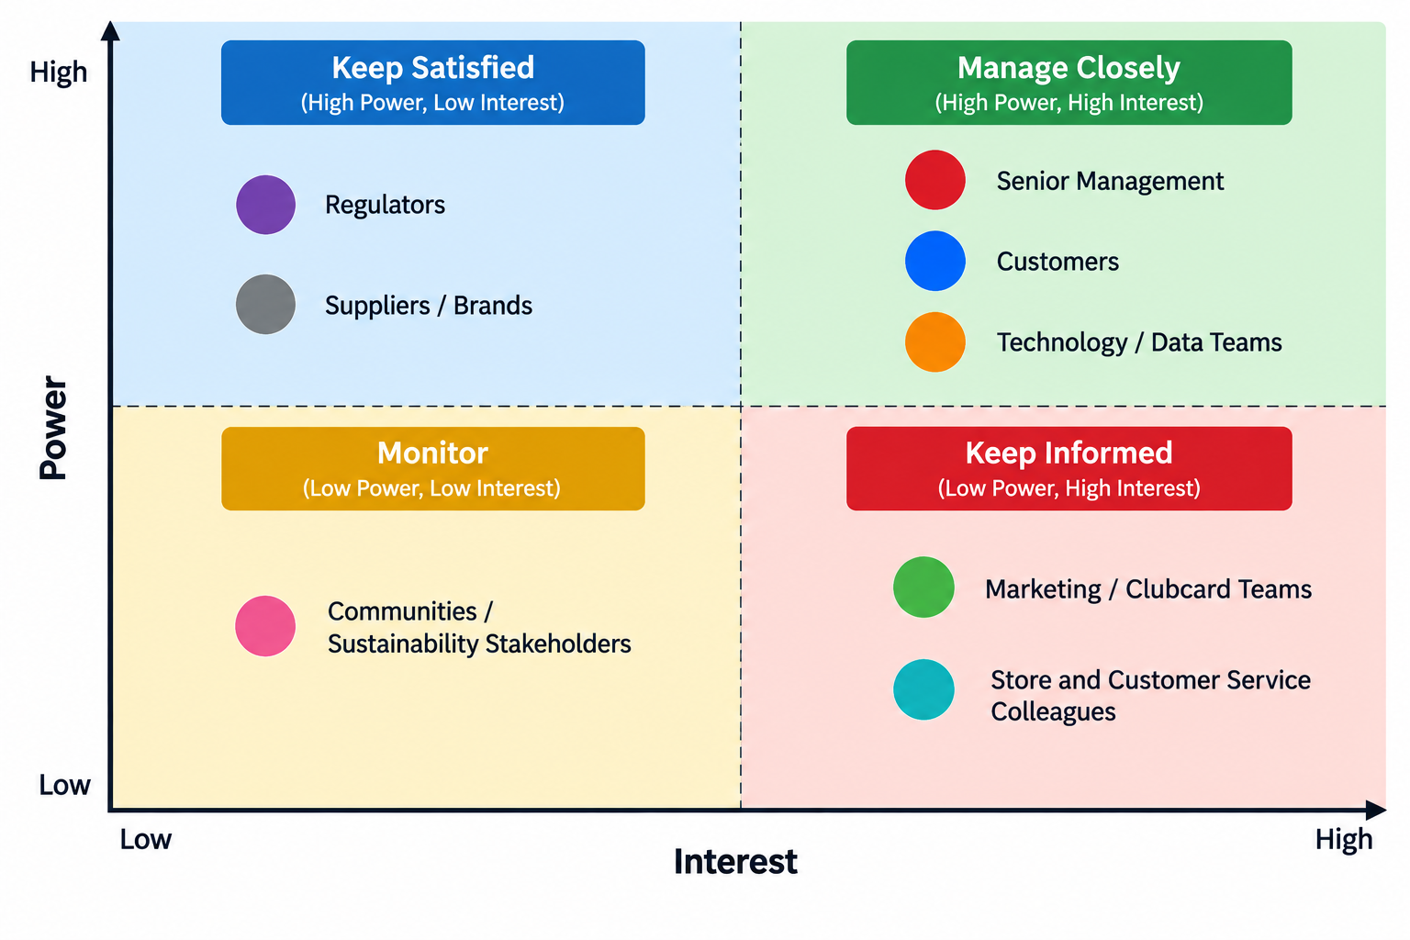

6. Data Analysis and Framework Application

6.1 Analytical approach and framework selection
A consultancy project consists of three strategic frameworks - PESTLE, Porter's Five Forces and SWOT. The frameworks were chosen as they look at various aspects of the same business question. PESTLE is used to highlight the macro factors impacting on digital loyalty, whereas Porter's Five Forces can be used to explore competitive forces. SWOT links Tesco's internal environment with opportunities and threats in the external environment.
Strategic-management literature from recent years still considers these frameworks as useful when applied to a particular business problem and not just as a checklist of the ingredients to be copied. While PESTLE, Porter's Five Forces and SWOT can give different insights into the environmental and competitive landscape, they require reliable information and context to be truly useful (Kurnia et al., 2026).
The application of PESTLE, Porter's Five Forces, and SWOT can provide different perspectives of the environmental and competitive landscape, but it is important that the information is accurate and interpreted correctly.

6.2 Secondary data evidence

Table 2: Selected Tesco and UK grocery indicators
Indicator | Recent evidence | Strategic meaning
Tesco UK grocery market share | 28.5% FY2025/26 | Strong market position
Tesco UK online sales | >£7bn | Digital channel is commercially important
UK online market share | 35.7% | Strong digital position
Online sales growth | +11% | Digital demand is increasing
Clubcard households | >24m | Large loyalty ecosystem
Personalised digital rewards | >9m customers | Personalisation already operates at scale
Clubcard Challenge audience | Up to 7m | Behavioural engagement is already being tested
Personalised online grocery journeys | 100% of active Clubcard customers | High personalisation maturity
Tesco Media brands | >800 | Supplier ecosystem adds commercial value
Source: Tesco plc (2026); Adobe (2026).
This is evidence that Tesco is not having a problem of adoption. It already has scale, customer data, and digital infrastructure. The next question is then whether this infrastructure is value-adding enough to customers for them to stick around.

6.3 PESTLE Analysis
Political factors
The grocery sector is highly visible within the political environment due to issues with food affordability, consumer protection, and competition being public policy concerns. There has already been regulatory interest in loyalty pricing in the UK. The CMA review was conducted based on evidence gathered in 2024, which is outside of the preferred evidence time window for the project, but useful as a piece of regulatory context. However, fairness and understanding of consumers remain a key concern. It is therefore not considered to be primary evidence and is discussed as background.
Economic factors
Still, the economy is having a strong influence on grocery decision-making. The price of food and non-alcoholic beverages increased by 4.5% in the UK in the 12 months leading up to December 2025, according to Deloitte's retail analysis, while consumers remained conscious of the value they were getting for their money. It also found that there was an uptick in the use of discount retailers.
This makes a clear connection between personalisation and retention. While a generic discount can drive down the price for all, a personalised discount can incentivize towards products that a customer is purchasing.
Social factors
Expectations from customers are shifting towards a more relevant and convenient shopping experience. According to the research by KPMG 2025/26, the most highly weighted customer-experience pillar is personalisation, which received a score of 20.1%. Personalisation is the most weighted of the customer-experience pillars with a score of 20.1%, followed by integrity and time and effort.
This discovery bolsters Tesco's efforts towards personalisation but also alters the meaning of the concept of loyalty. It's not enough for a retailer to know what a customer has bought if they don't also build a sense of loyalty in their customer. The information has to be something that will lead to a useful experience.
Technological factors
The biggest opportunity and large risk is technology. Tesco has been increasing the size of its technology department and is experimenting with AI in the customer journey. Its 2026 AI-assisted trial will be based on previous shopping history and preferences to assist customers in meal planning and basket creation (Tesco plc, 2026).
The Adobe partnership also signals a transition towards more sophisticated personalisation, as the companies are building an innovation lab dedicated to personalisation with the support of AI (Adobe, 2026).
Legal factors
The primary legal concern is with the use of personal data in profiling and in AI systems. Organisations must take into account the individual rights' impacts, transparency, and fairness in AI processes involving personal data, according to the ICO guidelines (ICO, 2026).
The legal problem for Tesco is therefore whether it is possible to collect data lawfully or not. Consumers must be given some value to what data is going to be used for to make automated or personalized decisions. As Tesco transitions to AI-powered recommendations from just basic coupons, this is a crucial factor to consider.
Environmental factors
Personalisation can help towards sustainability if it induces behaviour change rather than simply fuels increased consumption. Tesco's 2026 sustainability report is an example that is relevant. The company reached out to 2.4 million customers to offer them personalized Clubcard stamps that are associated with fresh fruits and vegetables, and it has observed a 10% growth in fruit and vegetable purchases since 2022.
As well, Tesco announced the possibility of helping customers utilize food products that are already available at home thanks to the company's AI assistant, which would help minimize food waste (Tesco plc, 2026).

6.4 Porter’s Five Forces
Competitive rivalry — High
Competition is significant, as Tesco competes with large supermarket groups, discounters, convenience stores, and online specialists. Kantar’s December 2025 data placed Tesco at 28.7%, Sainsbury’s at 16.3%, Asda at 11.4%, Aldi at 10.1% and Lidl at 7.8%.
Tesco's size is an asset, but Aldi and Lidl provide a shield for Tesco from being too sure of its position. Loyalty programmes are an important competitive tool. Therefore, personalisation must offer some positive value to the customer if they are to stay with the brand and not just sign up for a plethora of offers.
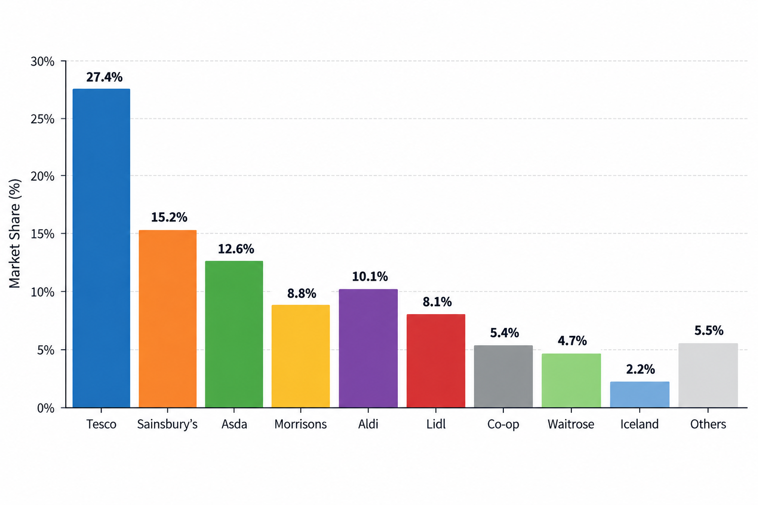
Threat of new entrants — Moderate
The scale needed to create a national physical grocery network is very high and it presents big entry barriers. Some barriers are reduced, though, with digital retail with specialist online businesses being allowed to be a part of certain categories without having to duplicate a full supermarket estate.
The huge base of Tesco's clubcard users is therefore a tool for strategy and marketing. It would be challenging to match the amount of data bought and customer relationships that Tesco has to offer a new competitor.
Buyer power — High
It's pretty easy for consumers to compare prices and move from one retailer to another. When paying for groceries, consumers switch because of competing loyalty offers.
There are also several loyalty schemes which add to the power of the buyer. That Tesco has to create and prove value to the consumer at all times. If a customer is being offered an irrelevant personalised product, there doesn't really seem to be any reason why they should stick around (Euromonitor, 2026).
Supplier power — Moderate
Tesco's scale and heft provide power in its buying ability, and its retail-media capabilities provides access to customer insight and advertising. In FY2025/26, over 800 brands took advantage of the Tesco Media (Tesco plc, 2026).
Yet if more of these suppliers' personalised marketing is funded, there is a risk of the objectives of the supplier and the relevance to the customer coming into conflict. Tesco should thus avoid using personalisation as a commercial target.
Threat of substitutes — High
Customers can replace Tesco with supermarkets, discounters, convenience stores, online retailers and rapid delivery services. The rise of e-groceries also brings convenience without the trip to a Tesco store.
In 2026, it was reported that a third of grocery shoppers in the UK would choose availability over price and that one in five grocery trips was at least one item was unavailable by DHL and Retail Economics. It's important because it shows that you can't build loyalty just by personalising content digitally. Personalised communications are not a substitute for an unsatisfying shopping experience if it isn't.

6.5 SWOT analysis
Table 3: Tesco SWOT related to personalised digital loyalty
Strengths | Weaknesses
Large Clubcard ecosystem | High dependence on customer data
Strong UK market position | Complexity of personalised offers
Strong online presence | Risk of excessive promotional communication
Large technology and data capability | Customer experiences may differ by segment
Existing AI partnerships | Increasing governance requirements

Opportunities | Threats
AI-supported shopping assistance | Privacy and trust concerns
More relevant rewards | Competitor loyalty schemes
Personalised healthy-choice campaigns | Price competition from discounters
Food-waste reduction through recommendations | Customer fatigue from excessive targeting
Stronger supplier/customer data ecosystem | Regulatory scrutiny
Tesco's greatest strength is the synergy of scale, customer data, and digital infrastructure, as indicated by the SWOT analysis. The very attributes that make for strengths are also weaknesses. The more data, the more governance responsibility, the more personalised communication, the more the customer can get fatigued.

6.6 Interpretation of the combined findings
All three frameworks conclude that Tesco needs a more compelling and trusted loyalty experience.
The proof is in the success of the market and Tesco has scale. Tesco has the capacity to personalise as evidenced by the technology. There is a competitive edge, though, that can be obtained as well: Loyalty pricing and digital engagement. Research in the academic sphere shows that personalisation can be employed to support loyalty, and that it will have a positive effect thanks to privacy and trust.
Tesco should therefore consider personalisation as a system that creates value to customers instead of a system for market targeting.
This system must link four outcomes:
Relevance → Customer value → Trust → Retention
The perceived value rises if a customer is presented with a relevant offer. When the information that the offer is based on is something that the customer would normally expect Tesco to have, then there is trust that can be maintained. Then, repeated useful interactions can facilitate retention.
Too many ads shown for too little relevance → privacy concern → low engagement
That's why it's important to integrate responsible data use into the strategic problem, not as its own problem that must be solved.

6.7 Ethics and sustainability implications
The ethical question is primarily about balancing the customer benefit against the customer control. Tesco can learn from data about the way customers shop, without them losing control of that data.
ICO's latest guidance focuses on the risk-based approach to AI systems that use personal data, such as their fairness, transparency, and risks to individual rights. Tesco should introduce indicators of customer trust into its personalisation initiative, it's implied.
Sustainability is also an opportunity to take personalisation into a deeper meaning. Tesco has already implemented Clubcard personalisation to help shoppers make healthier food decisions, such as one with 2.4 million shoppers. Personalisation might also help to reduce food waste by suggesting dishes made with items that have already been bought.

7. Recommendations and Conclusion

7.1 Summary of findings
The analysis showed that Tesco has a solid basis for personalised digital loyalty. Tesco plc is a prominent player in the grocery retail market in the UK, has over 24 million households with Clubcard, has a major online operation, and currently offers personalised rewards to over nine million customers.
But that's not to say that it's okay to neglect retention if you're in the market leader position. UK customers are members of several loyalty schemes and are able to switch retailers based on price, availability and convenience.
Hence, three recommendations are suggested.

Recommendation 1: Suggest a more transparent model for a personalised experience for customers on Clubcard
Priority: 1 — Immediate
Tesco has a need to put in place a clearly defined personalisation control area in the digital journey of the Clubcard. There needs to be visibility for customers into the principal categories of information which are used to tailor their experience, to choose their communication preferences and to manage how much they are recommended.
This recommendation is a direct result of the identified privacy and trust risks from the analysis. The findings suggest that using AI personalisation can drive better loyalty results, while privacy concerns may diminish the effectiveness of these benefits (Thangaraj, Rani and Pavithra, 2026).
Key measures:
- personalisation opt-in/opt-out rates;
- customer understanding scores;
- complaints relating to data use;
- recommendation relevance ratings;
- repeat engagement among customers using personalisation controls.
The primary concern will be that more controls might eliminate the data that is available for use. The promise of the longer term is greater trust and greater informed participation, though.

Recommendation 2: Shift personalised loyalty from discount targeting towards customer-value journeys
Priority: 2 — Short to medium term
Tesco should focus on customer-value journeys, not just individual discounts, using the Clubcard personalisation. These trips may consist of:
- weekly meal planning;
- healthier shopping challenges;
- food-waste reduction;
- family-budget support;
- personalised replenishment reminders;
- relevant product substitutions;
- convenience-based shopping recommendations.
Tesco has already showcased the possibilities of this method with its AI shopping assistant and healthier-choice campaigns. Previous shopping behaviour and preferences can be used by the AI assistant to help with meal planning and basket building (Tesco plc, 2026).
This could prove more useful for Tesco's digital relationship between transactions. It also establishes a better connection between customer engagement with sustainability. The 2026 sustainability report reveals that, using Tesco's Clubcard, members are already encouraged to buy more fruit and vegetables through their personal activity.
Success should be measured through:
- active Clubcard engagement;
- repeat online orders;
- customer retention;
- use of digital planning tools;
- food-waste-related engagement;
- customer satisfaction.

Recommendation 3: Establish a Personalisation Performance and Ethics Dashboard
Priority: 3 — Medium term
Tesco needs to develop a cross-functional dashboard to quantify the commercial and customer implications of personalisation.
It's easy to be caught up with sales, clicks and redemption on current digital marketing measurement. There are measures, but these are incomplete. A personalisation dashboard should be a mix of commercial, customer and ethical.

Suggested dashboard
Dimension | KPI
Engagement | Active Clubcard users
Retention | Repeat purchase rate
Relevance | Offer acceptance rate
Customer value | Average digital basket value
Trust | Customer trust score
Control | Personalisation preference changes
Fairness | Complaint and exclusion indicators
Sustainability | Healthy-choice and waste-reduction engagement
Marketing, technology, data governance, customer service and sustainability teams should review the dashboard. This contributes to SDG17 by enabling a cross-functional partnership and allows for a greater alignment of commercial decisions with responsible data management.

7.2 Expected benefits
The recommendations should have 4 main benefits.
First, customers might be better retained, since they will be given benefits that are more meaningful to them than generic promotions.
Secondly, increased transparency and customer control could help build customer confidence. Especially as Tesco scales up their use of AI.
Thirdly, there could be greater opportunities to leverage Tesco's existing customer data and digital channels for commercial performance.
Fourth, better outcomes for sustainability may be realised when personalised engagement is an enabler to healthier food choices and a decrease in food waste.

7.3 Conclusion
The consultancy project revealed that Tesco's biggest issues are not about the lack of digital skills. Tesco already has significant Clubcard reach, scale online, customer data, and AI investment. The trick is how to turn these assets into worthwhile, trusted, and long-lasting customer relationships that will be valuable as competition grows.
The Porter's analysis revealed that there is a high level of rivalry, buyers have a high choice and there are multiple substitutes, which makes it difficult to retain customers. A SWOT analysis then revealed that Tesco's customer-data ecosystem is a great asset, but also poses privacy, trust, and customer fatigue risks.

8. Employability Reflection
The consultancy project has created multiple work skills necessary for job positions in management and digital marketing. This required the consultant to make a step beyond the description of the company and to evaluate the particular company's problem based on secondary data. This involved research, critical analysis, structured problem solving, and strategic communication.
Research capability has been built by identifying and comparing sources of recent academic, corporate, and industry information. The project needed evidence to be evaluated based on its relevance to Tesco and not just because it was about loyalty or AI. Organisation-specific evidence was provided by Tesco's corporate reports, and relationships between personalisation, trust, and loyalty were explained based on academic studies. Sourced industry giving broader market context. This mix assisted the consultant to differentiate between company evidence and industry evidence in general.
Analytical skills were acquired by using PESTLE, Porter's 5 forces, and SWOT. Each of the frameworks dealt with a different aspect of the business problem. PESTLE was used to identify external forces, Porter's model took the competition into account and SWOT was used to link external forces to Tesco's internal forces. The project illustrated that frameworks are more useful if evidence is provided to clarify the meaning of the various factors in relation to the chosen business enquiry.
Problem-solving skills were gained from taking a general topic and focusing it on one particular problem. There are numerous examples of consultancy problems for Tesco, such as pricing, sustainability, e-shopping, AI and suppliers. The project was a narrow focus on personalised digital loyalty to engage and retain customers. This more specific definition allowed the evidence, analysis and recommendations to be related more directly.
Professional judgement was also developed during the project. The consultant understood that Tesco has a massive Clubcard base but this does not necessarily mean that they will have high levels of loyalty. Data demonstrating several memberships to several loyalty programs and restrictions on the use of loyalty were used to illustrate the distinction between programme membership and meaningful use. An analysis was therefore not conducted, which presupposed that more personalisation would always be more effective.
At the same time, there was also a great enhancement of the students' ethical consciousness. The project demonstrated the potential of business value and raised privacy, transparency and control issues with customers. The consultant thus took the trust factor as a part of strategic performance as opposed to solely focusing on data protection as a legal issue. Sustainability was also implemented by Tesco's personalised engagement, which encouraged healthier food choices and could help to cut down on food waste.
Communication skills have been acquired in the process of having to convert complex research into accessible recommendations. Recommendations were tied to a specific finding and included performance measures and risks of implementation. This is a reflection of professional consultancy practice, as conclusions to be linked to action are required by the senior decision makers.

References
Adobe (2026) Adobe & Tesco enter strategic AI partnership to personalise experiences and reward loyalty for Tesco’s customers. [Online].
https://news.adobe.com/en/gb/news/2026/04/adobe-tesco-enter-strategic-ai-partnership

Das, A., Mishra, S. and Mayaluri, Z.L. (2026) ‘Business intelligence, AI-driven personalization, and ethical customer segmentation in e-commerce: a systematic review of consumer trust and digital marketing’, SN Business & Economics, 6, Article 84.
https://doi.org/10.1007/s43546-026-01079-8

DHL Supply Chain and Retail Economics (2026) The Availability Effect: Why trust, margin and loyalty start at the shelf edge. [Online].
https://www.dhl.com/gb-en/home/press/press-archive/2026/new-dhl-report-reveals-availability-is-the-biggest-driver-of-customer-loyalty.html

Information Commissioner's Office (ICO) (2026) Guidance on AI and data protection: About this guidance. [Online].
https://ico.org.uk/for-organisations/uk-gdpr-guidance-and-resources/artificial-intelligence/guidance-on-ai-and-data-protection/about-this-guidance/

Kantar (2026) Promotions, premium own label and no alcohol options: inside Britain’s £13.8bn Christmas grocery shop. [Online].
https://www.kantar.com/uki/inspiration/fmcg/2026-wp-promo-premium-own-label-and-no-alcohol-options-inside-britains-13-8-bn-xmas-grocery-shop

KPMG (2025) UK Customer Experience Excellence Report 2025/26: The shift to agentic customer experience. [Online]. https://assets.kpmg.com/content/dam/kpmgsites/uk/pdf/2025/11/cee-uk-2025.pdf

Mintel (2026) UK Customer Loyalty in Retailing: 2026. [Online]. https://store.mintel.com/report/uk-customer-loyalty-in-retailing-market-report

Tesco plc (2026a) Preliminary results 2025/26. [Online]. https://www.tescoplc.com/media/ch1fbgss/tesco-plc-preliminary-results-statement-fy26.pdf

Tesco plc (2026b) Tesco launches large-scale colleague trial of new AI assistant, designed to lighten the load for customers. [Online].
https://www.tescoplc.com/tesco-launches-large-scale-colleague-trial-of-new-ai-assistant-designed-to-lighten-the-load-for-customers/

Tesco plc (2026c) Tesco PLC Sustainability Report 2026. [Online].
https://www.tescoplc.com/sustainability-report-2026

United Nations (2026) Sustainable Development Goals. [Online]
https://sdgs.un.org/goals

Srivastava, R.K. and Gurme, V. (2026) ‘Artificial intelligence and consumer behaviour on social media: A study of personalization, trust, and privacy’, Media and Communication, 5, Article 100021.
https://doi.org/10.1016/j.meadig.2025.100021

