Brain MRI classification baseline replication and proposed model comparison
M2 and M3 evaluation report 6 October 2026
Vishesh Rao, Pranay Vishwakarma and Manu Vahan
Sajjan Agarwal School of Technology, Rishihood University

Executive assessment
We established a selected Xception baseline from Disci, Gurcan and Soylu (2025) and completed a matched experiment with MobileNetV2. Xception achieved 93.67% clean test accuracy against the paper’s 95.27%. Our proposed smaller replacement failed the macro-F1 preservation criterion, despite using 80.52% fewer total parameters. These measured findings support the baseline and experiment deliverables. They do not establish exact numerical replication or clinical validity.

Introduction
The project classifies MRI slices into glioma, meningioma, no tumor and pituitary tumor. Transfer learning adapts pretrained image features to a limited MRI collection. Our Phase 1 literature survey motivates measuring predictive performance together with resource use and evaluation reliability. The present work establishes a reproducible baseline before broader preprocessing, radiomics and explainability extensions.
The selected paper compares six pretrained CNNs. We replicate its best reported model, Xception, rather than the entire six-model benchmark. We then test MobileNetV2 as a smaller replacement under matched conditions. An additional paper-based MobileNetV2 run is supplementary evidence.

Proposed change and hypothesis
Proposed change: replace Xception with MobileNetV2 to reduce model size and computational cost. Under the same leakage-audited protocol, MobileNetV2 should achieve test macro-F1 no more than 0.02 below Xception while using fewer total model parameters. The 0.02 margin is our criterion, not a claim from the source paper. The initial experiment uses one seed.

Dataset and methods
We pin version 1 of Masoud Nickparvar’s Brain Tumor MRI Dataset. Its 7,023 images match the paper. Version 2 contains 7,200 images and is excluded. The download archive checksum and all eight partition and class counts are recorded.
Partition | Glioma | Meningioma | No tumor | Pituitary | Total
Training | 1,321 | 1,339 | 1,595 | 1,457 | 5,712
Testing | 300 | 306 | 405 | 300 | 1,311

Preprocessing and model
Images are converted to grayscale, blurred, thresholded for the largest foreground contour, cropped, resized to 128 × 128, replicated into three channels and scaled to [0,1]. Training brightness and contrast factors range from 0.8 to 1.2. A crop identifies foreground and is not validated tumor segmentation.
Each ImageNet backbone uses Flatten, Dropout(0.3), Dense(128, ReLU), Dropout(0.2) and Dense(4, Softmax). All backbone layers are trainable. Adam uses learning rate 0.0001 with sparse categorical cross-entropy, batch size 20 and five epochs. We evaluate final-epoch weights without selecting a checkpoint on test performance.
Disclosed assumptions: Gaussian kernel 5 × 5, threshold 45, bounding-rectangle crop retaining blurred grayscale intensities, seed 42 and full backbone fine-tuning. The source leaves these choices incompletely specified. All 7,023 images produced a foreground contour, with zero crop fallbacks.

Separate evaluation protocols
Paper-based: retain the official partitions and report clean test images plus one fixed, seeded brightness/contrast transformation per test image, reflecting the paper’s stated test augmentation. Combined training/testing accuracy remains a secondary statistic, not a held-out score.
Leakage-audited: exclude exact training/test overlap and redundant training copies. Reserve 15% of the remaining training pool for diagnostic validation: 4,518 training and 798 validation images. Retain the same 1,311 test images. Only training images receive augmentation. Both proposed-comparison models use identical data and shared settings.

Selected Xception baseline replication
Xception evaluation | Accuracy | Macro-F1
Paper Table 8 | 95.27% | 0.9491
Our clean test | 93.67% | 0.9354
Our fixed transformed test | 93.29% | 0.9315

Our clean accuracy is 1.60 percentage points below the published result. The fixed transformed view is 1.98 percentage points below it. This is an approximate selected-model replication under disclosed assumptions. The paper’s headline 98.73% is consistent with a sample-weighted combination of training/testing scores, inferred from its tables, rather than ordinary test accuracy.
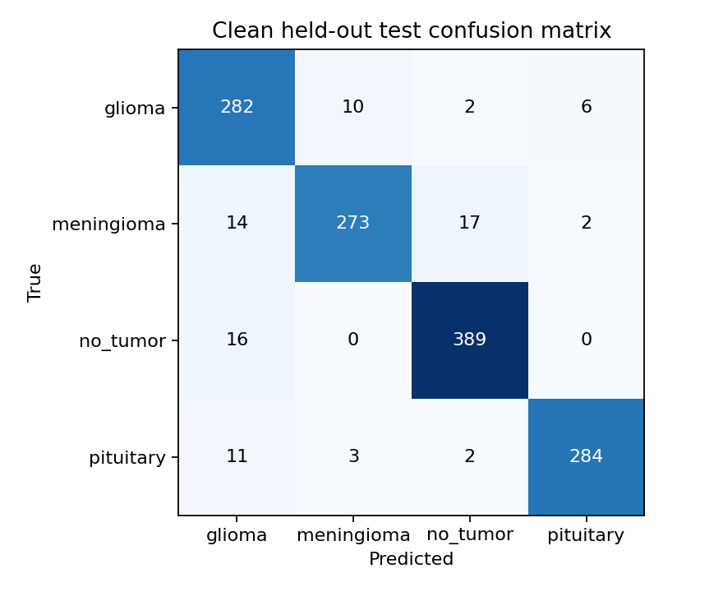
Figure 1. Xception clean test confusion matrix, generated from 1,311 saved predictions. Each row gives a true class and each column a predicted class.
The main Colab environment uses Python 3.12.13, TensorFlow 2.18.1 and Keras 3.8.0. Dataset identities and ordered predictions match the pinned collection. Finite histories contain all five requested epochs. No published scores are substituted for measured scores.

Proposed comparison and hypothesis outcome
Audited model | Test accuracy | Macro-F1 | Parameters
Xception | 91.76% | 0.9176 | 25,056,428
MobileNetV2 | 74.29% | 0.7372 | 4,880,068

The Xception minus MobileNetV2 macro-F1 gap is 0.1804, exceeding the allowed 0.02. MobileNetV2 satisfies the parameter criterion with 80.52% fewer parameters, but it does not satisfy the performance criterion. The joint hypothesis is not supported in this single-seed experiment. An unfavorable outcome remains a valid experimental finding.
Audited model | Training time | Median inference
Xception | 239.2 seconds | 10.02 milliseconds
MobileNetV2 | 179.4 seconds | 5.32 milliseconds

Timings use the same Colab runtime. Training excludes downloads and final evaluation. Median inference uses 20 warmed-up, synchronized batch-1 measurements. Timings describe this runtime and are not universal speed claims. The audited pair shares configuration, ordered data fingerprints and environment metadata.

Supplementary paper-based MobileNetV2
Clean accuracy is 72.08%, with macro-F1 0.6798. The fixed transformed view gives 71.17% and macro-F1 0.6691. This run is retained as supplementary evidence and does not replace Xception as the selected baseline.

Dataset audit and interpretation
Decoded-pixel hashing found 263 training images identical to test images, 207 redundant training images and 30 redundant test images. Identical images have no conflicting labels. We also found 1,254 perceptual near-match candidate pairs beyond exact matches. They remain unreviewed candidates, not proof of duplicate patients. Reliable patient identifiers are absent.
The test set still includes internal duplicates. Exact exclusion reduces known overlap without establishing patient independence. Changes between the two protocols include sample count and augmentation policy, so their performance difference cannot isolate leakage removal as the sole cause.

Reproducibility and evaluation readiness
The executed notebook includes introduction, dataset audit, methods, measured tables, learning curves, confusion matrices, prediction-based metric checks and the hypothesis outcome. Four full Colab runs yield six accepted test views. Each view contains 1,311 ordered predictions. The 31 focused tests pass and repository lint checks pass. Presentation mode reads compact evidence with training disabled.
The repository includes pinned requirements, dataset version and checksum, reproducible configuration, manifests, histories, probabilities, metrics and environment provenance. Raw MRI images and large checkpoints stay outside Git. The user-exported cloud ZIP contains no model checkpoints; it supports recomputing metrics from saved predictions, but cannot independently rerun inference from cloud weights.

Limitations
The source does not fully specify preprocessing, trainability or random sampling, so exact numerical matching is not established. One seed does not support a statistical non-inferiority conclusion. Missing patient IDs, unresolved near-matches and duplicate test images limit generalization claims. This is an image-classification experiment rather than a clinically validated diagnostic system.
The earlier Mac M2/Metal MobileNetV2 run gave 68.27% clean accuracy and macro-F1 0.5789. Its evidence is preserved separately and excluded from the matched Colab comparison. The hardware-dependent difference has no established causal explanation.

Work after the evaluation
Retain the current baseline and negative hypothesis result. Next, investigate normalization and BatchNorm behavior with controlled configurations, repeat the comparison across seeds, review near-matches and seek patient metadata or external test data. Distillation or staged fine-tuning could be evaluated as new proposed changes. Do not claim these untested ideas have improved performance.

References and evidence
R. Disci, F. Gurcan and A. Soylu. Advanced Brain Tumor Classification in MR Images Using Transfer Learning and Pre-Trained Deep CNN Models. Cancers 17(1), 121, 2025. DOI: 10.3390/cancers17010121. https://doi.org/10.3390/cancers17010121
Masoud Nickparvar. Brain Tumor MRI Dataset, version 1. https://www.kaggle.com/datasets/masoudnickparvar/brain-tumor-mri-dataset/versions/1
Project sources: original Phase 1 literature-survey PDF; notebooks/disci2025_reproduction.ipynb; results/disci2025/summary.csv, provenance.json, hypothesis.json and runs/. Local report source: docs/report/Disci2025_Reproduction_Addendum.md.

