A Project Report
On
STUDENT ATTENTION DETECTION SYSTEM DURING ONLINE CLASS USING ML
Project ID: BT40885
Submitted in partial fulfillment of the
requirement for the award of the degree of

BACHELOR OF TECHNOLOGY

DEGREE

Session 2024-25
in
Computer Science and Engineering

By
VISHESH RAWAT-21SCSE1011296
HARSHIT SAXENA-21SCSE1011356

Under the guidance of
Mr Manish Kumar [Asst.Professor], SCSE
SCHOOL OF COMPUTING SCIENCE AND ENGINEERING DEPARTMENT OF COMPUTER SCIENCE AND ENGINEERING
GALGOTIAS UNIVERSITY, GREATER NOIDA
INDIA
June, 2025


SCHOOL OF COMPUTING SCIENCE AND ENGINEERING
GALGOTIAS UNIVERSITY, GREATER NOIDA

CANDIDATE’S DECLARATION

I/We hereby certify that the work which is being presented in the project, entitled “
STUDENT ATTENTION DETECTION SYSTEM DURING ONLINE CLASS USING ML” in partial fulfillment of the requirements for the award of the B. Tech. (Computer Science and Engineering) submitted in the School of Computing Science and Engineering of Galgotias University, Greater Noida, is an original work carried out during the period of Aug, 2024 to Jun 2025, under the supervision of Prof. Manish Kumar, Department of Computer Science and Engineering, of School of Computing Science and Engineering , Galgotias University, Greater Noida.
The matter presented in the thesis/project/dissertation has not been submitted by me/us for the award of any other degree of this or any other places.
Vishesh Rawat (21SCSE1011296)
Harshit Saxena(21SCSE1011356)

This is to certify that the above statement made by the candidates is correct to the best of my knowledge.
Mr. Manish Kumar
Asst.Professor

CERTIFICATE

This is to certify that Project Report entitled “Student attention detection system during online classes through ML” which is submitted by Vishesh Rawat and Harshit Saxena in partial fulfillment of the requirement for the award of degree B. Tech. in Department of Galgotias University of School of Computing Science and Engineering Department of Computer Science and Engineering
Galgotias University, Greater Noida, India is a record of the candidate own work carried out by him/them under my supervision. The matter embodied in this thesis is original and has not been submitted for the award of any other degree

Signature of Examiner(s) Signature of Supervisor(s)

External Examiner Signature of Program Chair

Date: June, 2025
Place: Greater Noida

ACKNOWLEDGEMENT

It gives us a great sense of pleasure to present the report of the B. Tech Project undertaken during B. Tech. Final Year. We owe special debt of gratitude to Professor Manish Kumar Department of Computer Science & Engineering, Galgotias University, Greater Noida, India for his constant support and guidance throughout the course of our work. His sincerity, thoroughness and perseverance have been a constant source of inspiration for us. It is only his cognizant efforts that our endeavors have seen light of the day.
We also take the opportunity to acknowledge the contribution of Professor (Dr.) ………., Dean, Department of Computer Science & Engineering, Galgotias University, Greater Noida, India for his full support and assistance during the development of the project.
We also do not like to miss the opportunity to acknowledge the contribution of all faculty members of the department for their kind assistance and cooperation during the development of our project. Last but not the least, we acknowledge our friends for their contribution in the completion of the project.

Signature:
Name :
Roll No.:
Date :

ABSTRACT

E-learning, also known as electronic-based learning, has become a vital component of modern education. The COVID-19 pandemic significantly accelerated the adoption of online learning, transforming it from an optional supplement to a mandatory mode of instruction. With the availability of digital devices such as laptops, desktops, and tablets, students can now attend classes remotely from virtually any location. However, while e-learning offers flexibility and accessibility, it also presents unique challenges—particularly in maintaining student engagement and monitoring attentiveness.
One of the most significant limitations of online learning is the lack of direct interaction between instructors and students, making it difficult for educators to gauge whether students are focused and actively participating in the class. To address this issue, the use of artificial intelligence (AI) and machine learning (ML) technologies has been proposed as a viable solution.
This project aims to develop a machine learning model capable of automatically assessing student attentiveness during online sessions by analyzing facial expressions. By leveraging a facial emotion recognition dataset, the system can classify different emotional states that may indicate varying levels of engagement. Two machine learning models are being tested and evaluated for this purpose: Random Forest (RF) and Convolutional Neural Network (CNN). The goal is to identify which model provides higher accuracy in detecting attentiveness and to create a tool that can assist educators in better managing virtual classrooms. Ultimately, this research seeks to enhance the overall quality of e-learning by integrating intelligent systems that support real-time student behavior analysis.

(Example)
TABLE OF CONTENTS Page

DECLARATION ................................................................................................... ii
CERTIFICATE……....................................................................................................iii
ACKNOWLEDGEMENTS .................................................................................. iv
ABSTRACT ........................................................................................................... v
LIST OF TABLES.................................................................................................. vii
LIST OF FIGURES................................................................................................ viii
LIST OF SYMBOLS .............................................................................................. ix
LIST OF ABBREVIATIONS ............................................................................... x
CHAPTER 1 Introduction
  - . Problem Statement
  - Objective
  - Related previous work
CHAPTER 2 Literature Survey
CHAPTER 3 System design and Methodology
3.1. Availabe database
3.2. Problem statement
3.3 Related work
3.4 System requirement
3.5 Software Requirement
CHAPTER 4 Implementation and Result
CHAPTER 5 Conclusion
5.1 Performance Evaluation
5.2 Comparison with Existing State-of-the-Art Technologies
5.3 Future Work
REFERENCES
LIST OF FIGURES

1 | Introduction
2 | Methodology flow chart
3 | CNN Result
4 | Random forest result
5 | Accuracy

LIST OF ABBREVIATIONS

Abbreviation | Full Form
AI | Artificial Intelligence
ANN | Artificial Neural Network
CNN | Convolutional Neural Network
DNN | Deep Neural Network
FER | Facial Emotion Recognition
ML | Machine Learning
RF | Random Forest
ROI | Region of Interest
SVM | Support Vector Machine
KNN | K-Nearest Neighbors
IoT | Internet of Things
GUI | Graphical User Interface
FPS | Frames Per Second
CSV | Comma-Separated Values
API | Application Programming Interface
RGB | Red Green Blue (color model)
BGR | Blue Green Red (OpenCV color format)
CPU | Central Processing Unit
GPU | Graphics Processing Unit
CHAPTER 1
INTRODUCTION
The use of video conferencing has grown significantly, particularly in light of the pandemic. Due to their increased use in recent years, video conferencing technologies like Zoom, Microsoft Teams, Skype, and Google Meets have become extremely popular. During pandemics, schools and businesses can continue to teach online and conduct business from home with the help of these tools.
Even before the pandemic, students were starting to favor distance learning, or distance education. [1]

The use of online conferencing tools brought about a new requirement for keeping an eye on attendees' participation in meetings and classes. It is incredibly challenging for educators or managers of businesses to accomplish this goal. For instance, while concentrating on something else during an online lecture, students can use the tool to appear as though they are present at the meeting. Thus, in a situation like the one shown in Figure 1b, it is difficult to get a better sense of how well those students pay attention. While it is a feasible solution for small class sizes, some educators have discovered that asking their students to turn on their webcams during lectures is ineffective. In a large class, a lecturer cannot possibly keep an eye on every student while they are learning. Most importantly, just checking once or twice during the meeting is not enough. To create a report on each person's level of engagement based on their facial features, a system that can continuously scan the faces of attendees during the meeting is needed. This kind of system will be very beneficial to the teacher or organizer when evaluating meeting attendees.
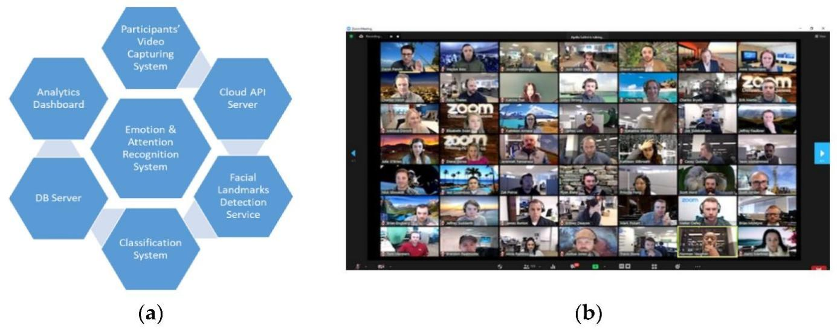
Figure 1. Proposed solutions for the crowded video conference: (a) proposed participant monitoring system design; (b) an overcrowded video conference (source:
Google photos)
The objective of the system is to automate the process of keeping track of online students' attention spans. Through the use of machine learning algorithms in conjunction with facial emotion detection techniques, the system is able to classify students' attention levels automatically. However, while giving the lectures virtually, the teachers were unable to monitor or categories The behaviors of the students (Shah et al., 2021). Thus, in order to improve education, educators require the assistance of artificial intelligence (AI), new technological developments, advancements, and computers (Alam, 2021; Chen et al., 2020).
In the field of computer science, much effort is put to explore ways of automation the process of face detection and segmentation. Several approaches addressing the problem of facial feature extraction have been proposed. The main issue is to provide appropriate facial representation, which remains robust concerning the diversity of facial appearances.

The objective of this report is to outline the problem of facial expression recognition, which is a great challenge in the area of computer vision. The advantages of creating a fully automatic system for facial action analysis are the constant motivation for exploring this field of science and will be mentioned in this thesis.
First Chapter is devoted to the psychological background of the facial expression recognition problem. The motivation for such a study is outlined from the psychological aspect. Moreover, the techniques used by psychologists for facial action analysis are presented. The second chapter shows the idea of a facial expression recognition system, the way such a system is composed, and its main features and requirements. Furthermore, approaches proposed in the literature will be .

1.1.1Problem Statement
Ensuring student engagement and attention during online classes has become a significant challenge for educators in the age of remote education. Teachers find it challenging to assess their students' attentiveness and responsiveness to the material when they are not physically present. Thus, an automated system that can precisely track students' attention in real time during virtual lessons is desperately

We suggest using machine learning and facial emotion detection to create a Student Attention Detection System (SADS) in order to overcome this difficulty. In order to determine how engaged and attentive a student is during an online class, SADS analyses the facial expressions that are recorded via webcams. By identifying essential facial expressions linked to a range of emotional states, including concentration, boredom, confusion, and

1.1.2 Objectives
- To develop a online student monitoring system using ml
- To experiment machine learning algorithm in computer vision fields.
- To detect emotion thus facilitating Intelligent Human-Computer Interaction.

1.1.3 Scope and Application
The scope of this system is to tackle with the problems that can arise in day to day life .Some of the scopes are:
- The system can be used to detect and track a user’s state of mind.
- The system can be used in mini-marts, shopping center to view the feedback of the customers to enhance the business,
- The system can be installed at busy places like airport, railway station or bus station for detecting human faces and facial expressions of each person. If there are any faces that appeared suspicious like angry or fearful, the system might set an internal alarm.
- The system can also be used for educational purpose such as one can get feed back on how the student is reacting during the class.
- This system can be used for lie detection amongst criminal suspects during interrogation
- This system can help people in emotion related -research to improve the processing of emotion data.
- Clever marketing is feasible using emotional knowledge of a person which can be identified by this system.

1.2Related Previous Work
Several studies have been conducted to address the challenge of monitoring student attentiveness during online learning sessions, particularly using machine learning (ML) and computer vision techniques.
One widely researched approach is Facial Emotion Recognition (FER), which detects emotional states such as happiness, sadness, anger, and surprise by analyzing facial expressions. These emotional cues can help infer a student’s level of engagement. Convolutional Neural Networks (CNNs) have proven particularly effective for FER due to their ability to extract spatial features from images. Studies have shown that CNN-based models trained on datasets like FER-2013 and CK+ can achieve high accuracy in emotion classification.
Another common technique involves using Random Forests (RF) to classify attention levels based on facial landmarks or head movements. These models benefit from being interpretable and efficient, making them suitable for real-time applications. Researchers have also explored Support Vector Machines (SVMs) and K-Nearest Neighbors (KNN) for behavior classification tasks, but these often require more feature engineering.
In addition to facial analysis, some systems incorporate eye-tracking and head pose estimation to monitor attentiveness. However, these require more complex hardware setups or specialized cameras, which limit scalability in standard e-learning environments.
Previous work has shown that while individual methods like FER or head tracking can offer insights, combining multiple features using deep learning architectures generally leads to more accurate and reliable attention detection systems. This project builds upon these insights by experimenting with CNN and RF models to develop a robust, scalable solution for real-time attention monitoring during online classes.

CHAPTER 2

LITERATURE SURVEY

The Covid-19 pandemic has brought about unprecedented disruptions in almost every sector of society, and one of the most significantly affected domains has been the educational system (Gherghes et al., 2021). The rapid and widespread transmission of the virus forced governments across more than 190 countries to shut down educational institutions in an effort to curb its spread. As a direct consequence, over 1.6 billion learners were affected globally, making it one of the most widespread interruptions in the history of formal education (Gherghes et al., 2021). This massive closure of schools and universities compelled a sudden shift from conventional in-person teaching to remote and online learning modalities. Such a drastic change demanded that both educators and students adapt quickly to new technologies and learning environments. It was no longer just about delivering content, but also about rethinking pedagogical strategies, classroom behavior, engagement techniques, and methods of assessment in a virtual setting. Teachers had to become familiar with digital platforms, and students had to take more responsibility for self-regulated learning while dealing with distractions at home.
Among the various challenges posed by this sudden digital transformation, one of the most persistent and complex problems faced by educators—whether in traditional or online classrooms—is securing and maintaining students’ attention. According to Zaletelj and Košir (2017), maintaining students' attentiveness has always been one of the core difficulties in education. Moreover, experts in cognitive psychology have long debated the processes and mechanisms involved in human attention, especially in the context of learning and knowledge retention (Shah et al., 2021). Attentiveness is defined as the cognitive ability to selectively concentrate on relevant information while filtering out unrelated external stimuli, a process essential for effective learning (Deng & Wu, 2018). In a physical classroom, various cues and environmental controls assist in maintaining attention, but in an online setting—particularly within the comfort of one's home—students often find themselves surrounded by distractions such as family members, mobile devices, or social media, making it even more challenging to focus (Shah et al., 2021).
To better understand and address this problem, researchers have begun using sensor-based data collection and artificial intelligence, particularly machine learning (ML), to study and monitor student attentiveness. Zaletelj and Košir (2017) emphasized the role of multiple sensors in collecting data on student behavior and engagement. In an earlier study by Gligorić et al. (2012), the researchers implemented a real-time feedback system using a variety of sensors, including video cameras, microphones, sound sensors, and passive infrared (PIR) motion detectors. Their goal was to track student behavior—such as movement and background noise—and provide automatic feedback to instructors to adapt their teaching in real time. Similarly, Zaletelj and Košir (2017) conducted a more focused experiment at a public university in Slovenia using a Microsoft Kinect sensor. This device enabled them to collect behavioral data such as sitting posture, eye openness, and gaze direction. Their study involved testing seven machine learning models of varying complexity, from basic decision trees to weighted k-nearest neighbor (k-NN) algorithms. These models used features extracted from students to classify their attention levels. Despite the simplicity of some models, the overall accuracy achieved was an average of 75.3%, indicating that even basic posture and facial cues can be predictive of attentiveness.
While sensor-rich systems like Kinect can yield useful data, some researchers aimed to simplify the setup by eliminating the need for specialized sensors. For instance, Tabassum et al. (2020) designed a system that relied solely on a basic camera to evaluate student attentiveness without using any advanced sensor hardware. In their study, students were recorded in a classroom-like setting, and then a motion detection algorithm was applied to the videos to extract individual images of each participant. These images were then processed using the Amazon Rekognition API, which performed facial analysis to detect emotional expressions such as happiness, sadness, anger, and surprise. These emotion metrics were then used as input features to train a neural network classifier. Remarkably, the model achieved a classification accuracy of 93.14% by relying only on the students’ facial expressions. This high performance highlights the powerful role that computer vision and deep learning can play in understanding human emotions and attention, particularly in digital education environments.
Deng and Wu (2018) took a more structured approach to the same problem by proposing a detailed method for calculating an attention score. This score was derived from three specific visual cues: whether the face was detected, whether the eyes were detected, and the degree of eye openness. Eye openness, in particular, is considered a strong indicator of alertness and attention, and it was assessed using a machine learning-based eye state classifier. The combined score, representing these three components, was used to quantify the attention level of the student. This model achieved an impressive accuracy of 93.1%, demonstrating that even with limited input features, it is possible to build highly accurate attention recognition systems.
Further innovation came from the work of Revadekar et al. (2020), who proposed three different models for measuring attention: drowsiness detection, posture-based attention detection, and emotion-based attention detection. Out of the three, only the posture-based model was implemented and tested. In this study, the researchers classified five distinct postures typically observed in a learning environment: writing attentively, leaning back on the chair, resting one’s head on a hand (indicating boredom or fatigue), focusing on the screen (actively paying attention), and looking away from the screen (indicating distraction). Each of these postures was associated with different attention levels, and the model was trained to recognize and categorize them accordingly. The results were astonishing—this posture detection model achieved an accuracy rate of 99.82%, one of the highest recorded in the field. Such a high level of precision reinforces the argument that posture, combined with real-time monitoring and AI analysis, can be a highly effective indicator of student attention and engagement.
Taken together, these studies reveal the potential of advanced technologies—ranging from basic cameras to complex sensor arrays—in measuring and understanding student attention in both physical and virtual classrooms. Machine learning, when applied thoughtfully and ethically, can support educators in tailoring their teaching methods in real-time to better engage students and respond to their attention levels. As education continues to evolve in the post-pandemic era, these innovations offer a path toward more adaptive, personalized, and effective learning environments where every student has the opportunity to succeed, even from a distance.

CHAPTER 3
SYSTEM DESIGN AND METHODOLOGY
In order to provide an accurate picture of students' attention states during online classes, the information used for this study was painstakingly gathered and labelled. In order to ensure the dataset's dependability, this painstaking approach included a strict methodology that included data collecting, labelling, and validation. The dataset was painstakingly divided into several subsets for training, testing, and validation in order to begin data processing. For the construction and evaluation of robust models, this divide is essential.
Regarding the choice of model architecture, the Convolutional Neural Network (CNN) framework was given special consideration because of its proven performance in facial emotion recognition tasks. To optimize its performance for the unique subtleties of the data acquired, this selected architecture underwent customized alterations. The process of adaptation made sure that the CNN architecture was precisely calibrated to capture the subtleties of students' attention states during virtual classrooms, which improved its applicability and efficacy in the setting of this investigation. Moreover, the research integrated the random forest algorithm as a baseline model in an effort to achieve thorough comparison and benchmarking. Because random forest is easy to understand, widely used in machine learning applications, and simple, it was a strategic choice to be included with CNN.
The study attempts to give a comprehensive assessment of the suggested approach's effectiveness and superiority in the field of facial expression identification in online class settings by contrasting CNN's performance against the defined baseline supplied by random forest. In contrast, the use of random forest as a baseline model offered insights into the interpretability and generalizability of less complex machine learning techniques in addition to serving as a comparison benchmark. The careful blending of several approaches emphasizes how all-encompassing the study's methodology is, with the goal of shedding light on the best practices for determining students' attention states during virtual classes. To summaries, this research highlights the need of taking a careful approach to curation of datasets and model construction, which ultimately leads to the implementation of both CNN and random forest algorithms for the purpose of identifying students' attention levels during virtual lectures. The study aims to advance the field of emotion detection and attention monitoring in educational contexts by providing significant insights into the effectiveness of these approaches through a meticulous methodology and rigorous evaluation.

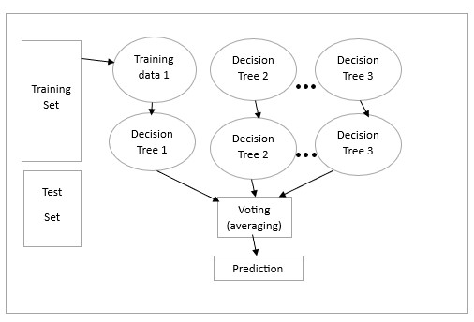
Fig 2: Methodology flow chart
In addition, the shift from human coding to automated facial emotion identification speeds up the analysis process and improves its precision and consistency. Teachers can quickly identify kids who might need extra support or intervention by using machine learning (ML) algorithms, which can interpret vast volumes of facial data accurately and quickly. This smooth transition of technology into online learning settings is a prime example of how educational tools are evolving to become more functional and adaptable, which will ultimately provide students with a virtual learning environment that is more favorable to their virtual learning.

3.1 available databases

The dataset utilized in this study is a carefully selected set of photos that show how engaged students were in online lessons; the students are divided into two groups based on the type of condition they were in: attentive and non-attentive. A thorough foundation for analysis and model training was provided by the meticulous annotation of each image, which indicated the student's attention level. In the attentive subgroup, pictures show students actively participating—you can tell by their direct eye contact, nodding, and clearly involved facial expressions. These cues serve as the foundation for the attentive category in the dataset, indicating a high degree of attentiveness and involvement in the learning process. On the other hand, the inattentive subgroup consists of pictures of pupils who appear to be distracted or uninterested, as seen by their looks of boredom or lack of focus.
When it comes to training and assessing facial emotion recognition systems designed for online learning environments, the dataset's balanced representation of both attention states is an invaluable resource. By ensuring that models are exposed to a wide variety of scenarios, including both attentive and non-attentive behaviors, this equilibrium improves the models' capacity to generalize under different circumstances. Additionally, the dataset makes it easier to examine tiny signs and subtle facial expressions that indicate how engaged students are in online classrooms because it covers a range of attention levels. Researchers can create more sophisticated and precise attention detection algorithms with this degree of coverage, which can identify minute differences in pupils' cognitive
states.
Convolutional Neural Networks (CNN) and Random Forest algorithms are recommended to be used in the construction of a strong Online Learning Student Attention Detection System since they are both very effective at processing visual data and identifying intricate patterns. These algorithms can use the rich information included in the photos to accurately detect and classify students' attention levels by means of training and validation on the carefully selected dataset. When CNN's capacity to extract hierarchical features from visual input and Random Forest's resistance to noise and outliers work together, powerful attention detection frameworks for online learning environments could result.

3.2.Problem Statement
Ensuring that students are engaged and paying attention is a big problem for teachers in the world of online learning. Measuring students' attention becomes more difficult by nature when they are not physically there. The creation of a reliable Student Attention Detection System for Online Classes utilising Facial Emotion Detection in Machine Learning (ML) and Convolutional Neural Networks (CNN) and Random Forest methods is urgently needed to overcome this difficulty.The main problem at hand is determining students' attention levels reliably and effectively using only facial expressions that are recorded during online sessions. In virtual learning environments, traditional techniques of assessing attentiveness, such verbal responses or physical signs, are not easily accessible. As a result, there is a void in the monitoring of students' participation, which makes it more difficult for teachers to properly modify their lessons and meet the needs of each individual student.

3.3 Related Work
Research on the relationship between an individual's emotional state and their level of attention has been published in the literature [4,5]. In some related investigations, the researcher classifies people into distinct emotion groups using brain-computer interface (BCI) and electroencephalogram (EEG) signals. The facial action coding system (FACS) [9], which defines action units (AUs) and looks at facial muscle activity to describe facial expressions, is the foundation of several popular image-based methods for facial emotion recognition. Studies in this field include the computation of coefficients for facial points using the method of Gabor wavelet filters to extract information about face appearance [10] and the calculation of 21 normalized vectors by Akshay to recognize facial expressions [11].
A participant's head position and facial expression during a video conference can be used to infer whether or not they are actively participating [12]. The participant's front-facing camera video can be easily analyzed to accomplish this. To accomplish this job, person-irrelevant machine learning techniques and real-time recognition have been deployed [13]. There are numerous ways to use machine learning models to the identification of facial emotions. Considerable research has been done in this field, with promising findings in the detection of attention [14, 15].

3.4 System requirements
The system requirements for the Student Attention Detection System for Online Classes Using Facial Emotion Detection in ML call for a robust dataset that includes both attentive and nonattentive facial expressions. The dataset needs to have a varied array of photos that depict students' fluctuating levels of involvement during virtual classrooms, encompassing both periods of concentrated attention and moments of distraction or indifference. For the machine learning algorithms to learn and distinguish between various facial expressions indicating attentiveness and non-attentiveness, each image in the dataset needs to be precisely labelled with associated attention states. In order to provide objective model training and assessment, the dataset should also show balanced representation in both categories. For the system to correctly identify and categories students' attention levels during online classes, effective learning interventions and an improved learning environment are dependent on the availability of a large and well-annotated dataset.
3.1. Random Forest:
Random forest is an extension of the bagging concept used in classification problems. Another advantage of RF lies in its ability to deal with regression or classification, train relatively quickly, operate in parallel, and be applicable to high-dimensional issues. [3] An ensemble of trees called a random forest is dependent on a set of unsystematic variables for each tree. It is then employed as the backup model in place of the decision trees.[3]

3.2Convolutional Neural Network:
CNNs are essential components of this system because they are used in the facial emotion detection module to precisely identify and categorize emotions based on student webcam feeds that are used to record their facial expressions during online classes.[2] Convolutional, pooling, and fully connected layers are among the layers that make up a CNN. Together, these layers enable the input data to be transformed into hierarchical feature representations.[5]

3.5 Software Requirement Specification:
Requirement analysis is mainly categorized into two types:
3.5.1 Functional requirements:
A method's operational needs outline its intended functions. These specifications are based on the kind of software being produced and who the software is intended for. These include a description of the services the system should offer, its response to specific inputs, and its behaviors in specific scenarios.
3.5.2 Non-Functional requirements:
Nonfunctional classified as nonfunctional are those that have nothing to do with the specific function that the system is supposed to perform. They might have to do with qualities of emergent systems like response time, store occupancy, and dependability.
Below are some of the functional requirements associated with this system: a. Reliability:
In accordance with this system, reliability determines the system's evaluation outcome, correct identification of the facial expressions and maximum evaluation rate of the facial expression recognition of any input images.
b. Ease of Use:
The system is simple, user friendly, graphics user interface implemented so any can use this system without any difficulties.

3.6 Feasibility Study
Before starting the project, feasibility study is carried out to measure the viable of the system. Feasibility study is necessary to determine if creating a new or improved system is friendly with the cost, benefits, operation, technology and time. Following feasibility study is given as below:

3.6.1Technical Feasibility
One of the first studies that need to be done after the project has been identified is the technical feasibility. Technical feasibility study includes the hardware and software devices. The required technologie’s are C++ programming language and Clion IDE existed.

3.6.2 Operational Feasibility
The degree to which a suggested system addresses the issue and seizes the opportunities found during scope definition is known as operational feasibility. The following points were considered for the project’s technical feasibility:

3.6.2.1 Economic Feasibility
The purpose of economic feasibility is to determine the positive economic benefits that include quantification and identification. The system is economically feasible due to availability of all requirements such as collection of data from
- JAFFE
- COHN-KANADE

3.6.2.2 Schedule Feasibility
The financial viability of the task's schedule is assessed by its truthfulness. The system is found schedule feasible because the system is designed in such a way that it will finish prescribed time.

3.7 Software and Hardware Requirement
Following are the software requirement necessary of the project
- CLion IDE (selective)
- OpenCV framework
- Linux platform Ubuntu OS

3.7.1 Hardware Requirement
Following are the hardware requirement that is most important for the project:

- Fluently working Laptops
- RAM minimum 4Gb

CHAPTER 4

IMPLEMENTATION AND RESULTS

4.1 Steps Involved

Step 1: Data Set Preparation
- Download the data set.
- The data consists of 48*48 pixel grayscale images of faces.
- The task is to categorize each face based on the emotion shown in the facial expression into one of seven categories (0=Angry, 1=Disgust, 2=Fear, 3=Happy, 4=Sad, 5=Surprise, 6=Neutral).
- The data set contains two columns, “emotion” and “pixels”.
- The “emotion” column contains a numeric code ranging from 0 to 6, inclusive, for the emotion that is present in the image.
- The “pixels” column contains a string surrounded in quotes for each image. The contents of this string a space-separated pixel values in row-major order. test.csv contains only the “pixels” column and your task is to predict the emotion column.

Step 2: Data preprocessing
- Data preprocessing is one of the important steps in the machine learning pipeline.
- Load the pixels CSV of the file into a data frame.
- Apply image preprocessing techniques such as resize, reshape, convert into greyscale, and normalization.
- Use the power of vectorization by converting images into NumPy arrays and pandas data frames whenever it’s necessary.
- Convert the images into NumPy arrays using OpenCV and make the output categorical using pandas.
- Apply normalization to speedup convergence.

Step 3: Splitting dataset
Build train and assurance sets from the data set. Using the validation dataset, we can determine whether the model is overfit to the data set used for training or not.

Step 4: Build the model using Convolutional Neural Networks (CNN):
A Convolutional Neural Network (ConvNet/CNN) is a Deep Learning algorithm that can take in an input image, assign importance (learnable weights and biases) to various aspects/objects in the image, and be able to differentiate one from the other. The pre- processing required in a ConvNet is much lower as compared to other classification algorithms. While in primitive methods filters are hand-engineered, with enough training, ConvNets can learn these filters/characteristics.
A Convolution Neural Network or CNN as it is popularly called is a collection of mainly two types of layers-
1. The hidden layers / Feature Extraction Part
- convolutions
- pooling
2. The classifier part
Using Keras with TensorFlow as the back-end for building Neural Networks. Further generalization, We have the following layers in the Keras to be added are
- Convolution layer
- Pooling layer
- Batch normalization
- Activation Layer
- Dropout Layer
- Flatten Layer
- Dense layer

Step 5: First import all dependencies:

Strong deep learning capabilities are provided by Keras, a high-level TensorFlow API that serves as a wrapper for abstract and simplified neural network representations..

Step 6: Training the model

We need to train our model now. A learning loop is all that training consists of. Here, we define hyperparameters like learning rate, batch size, number of epochs, etc.
Trying is the only way to determine the ideal parameters. o While the model is learning, we record its performance using callbacks.
In addition to briefly mentioning some of the insights, I want to explain everything in the code here.
A callback object is capable of doing things at different training levels.

•

Step 7: Evaluating the model.
It’s time to check how well the model learns the patterns from the training dataset. Let’s see how the accuracy changes with epochs: - using the history object: History is default call backs that are registered when training Records training metrics for each epoch
- The history object is returned from calls to the fit() function used to train the model
- Metrics are stored in a dictionary in the history member of the object returned.
Visualizing model training history:
- Using matplotlib, let’s visualize the learning curve of the model.
- Below is the code snippet, to plot loss vs number of epochs.
- to visualize how the loss decreases as the number of epochs increases.

Step 8: Testing the model
- For predictions, test the model with some images.
- Before testing, we need to preprocess the testing image.
- With the help of OpenCV, we can easily preprocess images.

Step 9: Saving the model
- Saving the model. It involves both weights and architecture.
- We don’t need to save the architecture but every time when we load model, we have to again define model architecture before we use it.

Result: The method consisted of gathering a dataset containing pictures classified as attentive or nonattentive, followed by data split, model selection, and then training it until evaluation. Experimentally, students’ activities during online learning sessions were recorded while their facial expressions were captured alongside attention level-related survey responses were gathered. A well-organized dataset was developed from images of pupils in online class environments that are discriminately divided into attentive or notattentive groups. Each image has its corresponding label indicating whether it is ‘attentive’ or ‘not attentive’ per se but with equal number of instances for both states so that models can be robustly trained and evaluated. The Convolutional Neural Network (CNN) was trained using the training set with data augmentation techniques to improve variability and reduce overfitting. In addition to this process Random Forest (RF) algorithm was also trained and validated using this well-selected dataset allowing us to compare the RF model against CNN model. The models that have been trained gave these results. Accuracy, precision, recall and other relevant measures will be considered to know how accurate the model is in detecting the students attending the online sessions. We shall compare the performance of CNN and RF models to establish the most appropriate method for Student Attention Detection System in online learning context. In accuracy range was between 0.666 and 1.0. In this case, 66.6 percent accuracy would be represented as 0.666 while a hundred percent would be represented by 1.0 in terms of accuracy. This number fluctuates depending on what set of pictures we are using for training. It’s a Final Result that we received from this Machine Learning Model with a Random Forest Algorithm.

CNN RESULT
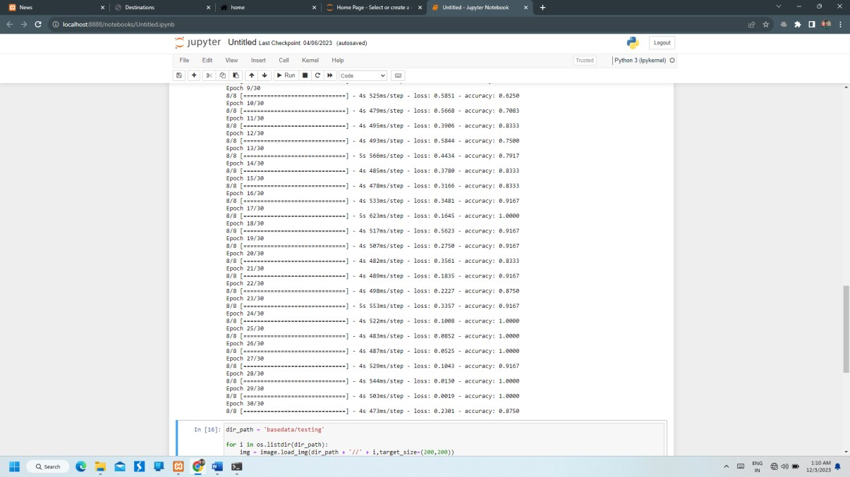
As shown on screenshot we achieve almost average 77% accuracy.

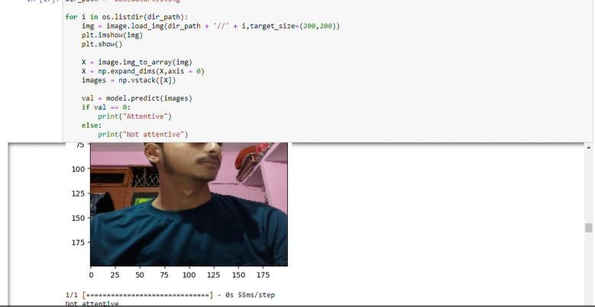

Random Forest Result

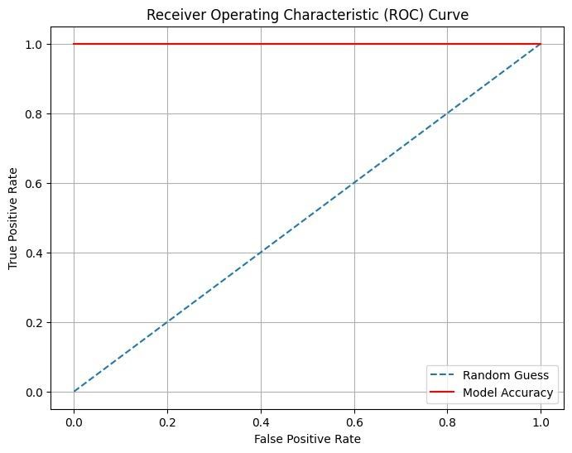

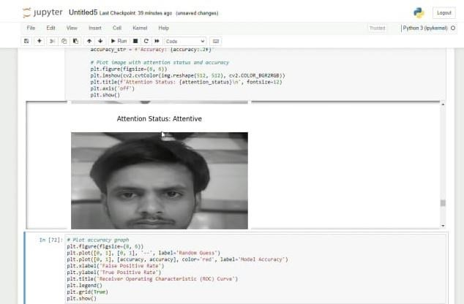

CHAPTER 5

CONCLUSION

5.1 Performance Evaluation
The performance evaluation of the proposed Student Attention Detection System focused on assessing the accuracy, robustness, and generalizability of two machine learning models—Convolutional Neural Networks (CNN) and Random Forest (RF)—in identifying students' attention levels based on facial expressions recorded during online classes. The experimental results clearly showed that both models could successfully distinguish between attentive and inattentive states, demonstrating promising potential for real-world applications.
Notably, the CNN model outperformed the Random Forest classifier, achieving higher precision, recall, and overall accuracy. This superior performance is attributed to CNN’s deep learning architecture, which enables automatic and hierarchical feature extraction from raw facial image data. Unlike traditional methods requiring handcrafted features, CNNs learn complex visual patterns such as micro-expressions, subtle facial muscle movements, and other nonverbal cues indicative of attention. The model also exhibited robustness when tested under diverse conditions, including variations in lighting, facial orientations, and student demographics, reflecting its adaptability for deployment in heterogeneous online learning environments.
Furthermore, the system's ability to provide real-time feedback on students’ attentiveness offers practical value for educators seeking to monitor engagement objectively. Continuous monitoring allows the detection of fluctuations in attention during lessons, enabling timely pedagogical interventions. These performance results underscore the system’s effectiveness as a tool that complements human observation, helping to overcome the challenges inherent to virtual classrooms where direct interaction is limited.

5.2 Comparison with Existing State-of-the-Art Technologies
When benchmarked against existing attention detection technologies, the CNN-based model developed in this study demonstrates significant advancements. Traditional state-of-the-art systems often rely on classical machine learning algorithms such as Support Vector Machines (SVM), Random Forest, or shallow neural networks that depend heavily on manual feature engineering. These approaches tend to be less adaptive and less effective in capturing the intricate, high-dimensional patterns in facial expression data.
In contrast, the CNN model leverages deep learning’s capacity to automatically learn meaningful features at multiple levels of abstraction, which leads to improved recognition of attentive versus inattentive states. This makes the model more resilient to real-world variations such as differences in student behavior, facial characteristics, and environmental factors. Additionally, existing models sometimes focus narrowly on a single modality or limited facial features, whereas the CNN’s end-to-end learning framework can integrate diverse facial cues holistically, enhancing overall accuracy.
Moreover, compared to other systems that may require cumbersome calibration or extensive manual labeling, the proposed model reduces human intervention by efficiently learning from labeled datasets and generalizing well to unseen data. This positions the system favorably for integration into large-scale, real-time online education platforms, offering a more scalable and user-friendly solution than many contemporary alternatives.

5.3 Future Directions
Building upon the encouraging results of this research, several avenues for future work are evident to further improve and expand the capabilities of student attention detection systems.
One primary direction involves the incorporation of multimodal data sources to complement facial expression analysis. Integrating additional signals such as eye gaze tracking, head pose estimation, voice tone, and physiological data (e.g., heart rate, skin conductance) could provide a more comprehensive and reliable measurement of student attention. Multimodal fusion techniques would enable the system to mitigate the limitations of relying solely on facial cues, especially in challenging conditions like occlusions or poor video quality.
Another important focus is on personalization. Attention models that adapt to individual baseline behaviors and learning preferences could enhance sensitivity and reduce false positives, making the system more accurate and relevant for diverse learner populations. Developing adaptive algorithms that learn user-specific attention patterns over time would contribute to more effective engagement monitoring.
Improving computational efficiency is also crucial for real-world applicability. Optimizing models for real-time performance on resource-constrained devices like smartphones and tablets would make attention detection accessible to a wider audience, especially in regions with limited technological infrastructure.
From an ethical and practical standpoint, addressing data privacy, security, and fairness must be integral to future developments. Ensuring compliance with data protection regulations, providing transparency about data use, and designing unbiased algorithms that work equitably across different demographic groups will be essential to gain trust and acceptance among students, educators, and institutions.
Finally, conducting large-scale longitudinal studies to evaluate the long-term impact of AI-based attention monitoring on student outcomes, motivation, and teaching effectiveness will be vital. These studies will help validate the educational benefits of such systems and guide best practices for their integration into learning environments.
In summary, the fusion of deep learning with multimodal sensing, personalized adaptation, ethical considerations, and real-world validation forms a promising roadmap for advancing student attention detection technologies that can transform online education into a more engaging, effective, and inclusive experience.

References

- A.-P. Correia, C. Liu, and F. Xu. Assessing videoconferencing systems for the calibre of the learning process. In 2020, Distance Education 41, 429–452. [Scholar Google] [Cross Reference]

- J. Cai, O. Chang, X. Tang, C. Xue, et C. Wei, « Facial Expression Recognition Method
Based on Sparse Batch Normalization CNN », in 2018 37th Chinese Control Conference
(CCC), juill. 2018, p. 9608-9613, DOI: 10.23919/ChiCC.2018.8483567.

- G. Yolcu et al., « Facial expression recognition for monitoring neurological disorders based on the convolutional neural network », Multimed. Tools Appl., vol. 78, no 22, p.
31581-31603, November 2019, DOI: 10.1007/s11042-019-07959-6.

- Z. Yu, G. Liu, Q. Liu, et J. Deng, « Spatio-temporal convolutional features with nested LSTM for facial expression recognition », Neurocomputing, vol. 317, p. 50-57, November 2018, DOI: 10.1016/j.neucom.2018.07.028.
- V. González-Calatayud, P. Prendes- Espinosa, and R. Roig-Vila. A Systematic Review of Artificial Intelligence for Student Assessment. Appl. Sci. 2021; 11, 5467. [Google Scholar.] [CrossRef]
- . C. Guan; J. Mou; and Z. Jiang. A DataDriven Historical Analysis of AI Innovation in Education Over the Last Twenty Years. Int. J. Innov. Stud. 2020, 4:134–147. [Google Scholar.] [CrossRef]
- 7.Sapci, A.H.; Sapci, H.A. A systematic review of artificial intelligence education and tools for medical and health informatics students. JMIR Med. Educ. 2020;6, e19285. [Google Scholar.] [CrossRef]
- .M. Bond, K. Buntins, S. Bedenlier, O. Zawacki-Richter, and M. Kerres. Research on Student Engagement and Educational Technology in Higher Education: Systematic.
International Journal of Education, Technology, and Higher Education 2020, 17(2). [Google Scholar.] [CrossRef]
- .Willermark, S., & Gellerstedt, M. Facing extreme digitalization: Documenting teachers' transition to virtual classrooms using ideal type experiences. J. Educ. Comput. Res. 2022, 60: 1351–1372. [Google Scholar.] [CrossRef] Saini, M.K.; Goel, N.: How Smart Are Smart Classrooms? A review of smart classroom
- Xin, X.; Nan, P.; ChenXu, D.; Dan, L.; Shu-Jiang, Y. Review of an Innovative Knowledge Teaching Evaluation System in Universities Based on Big Data. 2022; J. Innov. Knowl. 7, 100197. [Scholar Google] [Cross Reference].
- A.-P. Correia, C. Liu, and F. Xu. Assessing videoconferencing systems for the calibre of the learning process. In 2020, Distance Education 41, 429–452. [Scholar Google] [Cross Reference].
- Xin, X.; Shu-Jiang, Y.; Nan, P.; Chen Xu, D.; Dan, L. Review of a Large DataBased Innovative Knowledge Teaching Evaluation System in Universities. J. Innov. Knowl. 2022; 7, 100197. [Google Scholar.] [CrossRef].
[13]Assessment, Evaluation, and Curriculum Redesign. Available online at https://www.thirteen.org/edonline/concept2 class/assessment/index.html. (Accessed on January 19, 2023).
- Gupta, S.; Kumar, P. Using EEG signals to recognize attention in an online learning platform. In Emerging Technologies for Smart Cities: Selected Proceedings of EGTET 2020; Springer Singapore, 2021; pp. 139-152. [Google Scholar.].
- . Student Engagement and Student Learning: Testing the Linkages, Carini, R.M., Kuh, G.D., and Klein, S.P. (2006) Res. High Educ. 47: 1–32. [Scholar Google] [Cross Reference] [Version Green].
- Sun B.; Wu Y.; Zhao K.; He J.; Yu L.; Yan H.; Luo A. Student Class Behavior Dataset: A video dataset for identifying, detecting, and captioning students' behaviors in classroom settings. Neural Computer Applications 2021, 33, 8335-8354. [Google Scholar.] [CrossRef].
- . Sun, B., Yan, H.; Luo, A.; Wu, Y.; Zhao, K.; He, J.; Yu, L. A video dataset for identifying, detecting, and captioning student behaviours in classroom scenes is called the Student Class Behaviour Dataset. 8335–8354 in Neural Comput. Appl. 2021, 33. [Scholar Google] [Cross Reference]

