**Linux Commands**

**Section A:**

1. **Command: man ls**

1. **Command: man internsctl**

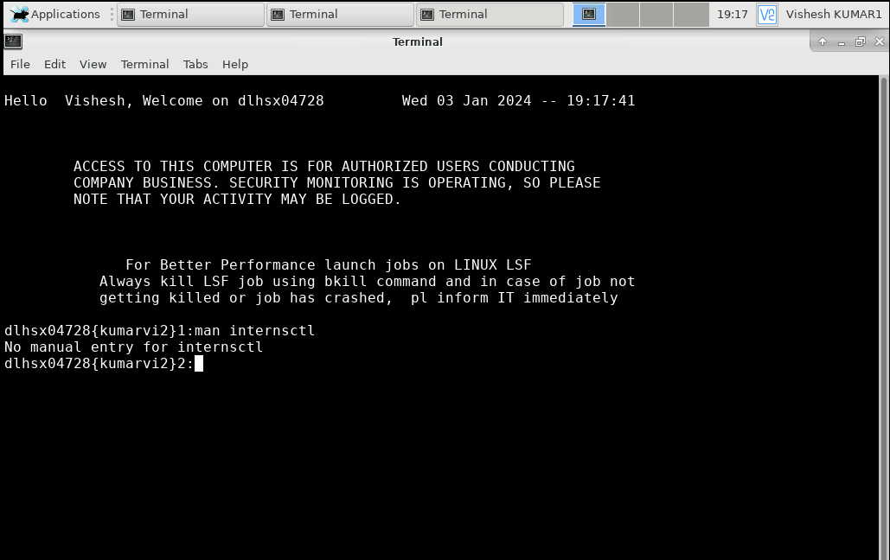

1. **Command: internsctl –help**

1. **Command: internsctl –version**

**Section B**

1. **Command: internsctl cpu getinfo**

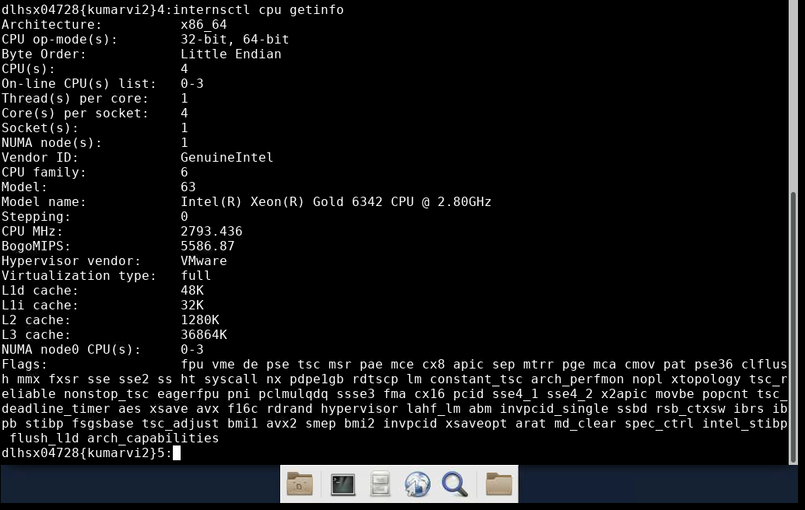

1. **Command: internsctl memory getinfo**

1. **Command: internsctl user create<username>**
2. **Command: internsctl user list**

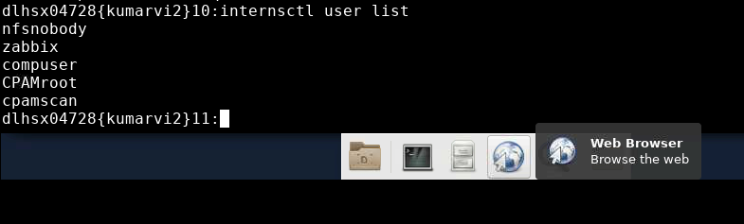

1. **Command: internsctl file getinfo hello.txt**

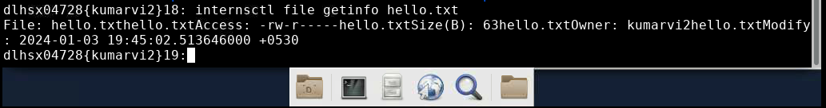

1. **Command: internsctl file getinfo hello.txt -s**

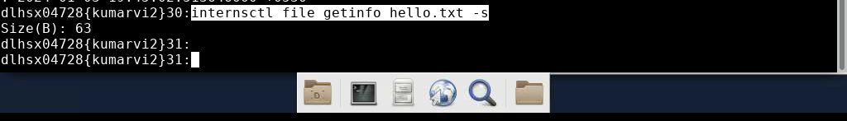

1. **Command:**

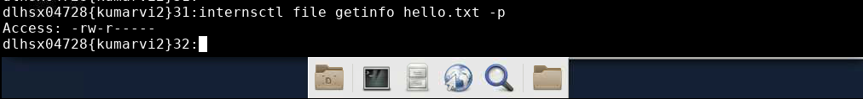

1. **Command:**

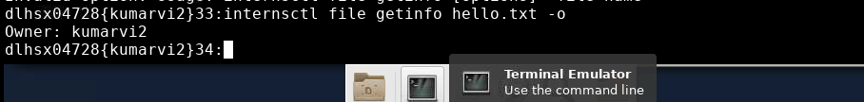

1. **Command:**

