CGS BP-MOD Devices User Guide
Release 5.2, August 2023 - DRAFT

Revision History

Revision | Date | Description
5.2 | August 28, 2023 | Initial release

Disclaimer
PLEASE READ THESE LEGAL NOTICES CAREFULLY.
By using any of CGS Tower Networks Ltd. (the “Company”) BP-MOD-1-4, BP-MOD-2-8, BP-MOD-4-16 products you agree to the terms and conditions of usage set forth by CGS Tower Networks Ltd.
No licenses, express or implied, are granted with respect to any of the technology described in this manual. The Company retains all intellectual property rights associated with the technology described in this manual. This manual is intended to assist with installation of BP-MOD-1-4, BP-MOD-2-8, BP-MOD-4-16 into your network.
Trademarks
CGS Tower Networks Ltd and BP-MOD-1-4, BP-MOD-2-8, BP-MOD-4-16 are trademarks of CGS Tower Networks Ltd. Additional company and product names may be trademarks or registered trademarks of the individual companies. Use of all trademarks requires the permission of the trademark owner.
Additional Information
CGS Tower Networks Ltd reserves the right to make changes in specifications and other information contained in this document without prior notice. Effort have been made to ensure that the information in this document is accurate.
Limitations on Warranty and Liability
CGS Tower Networks Ltd offers a limited warranty for all its products. IN NO EVENT, SHALL CGS Tower Networks Ltd. BE LIABLE FOR ANY DAMAGES INCURRED BY THE USE OF THE PRODUCTS (INCLUDING BOTH HARDWARE AND SOFTWARE) DESCRIBED IN THIS MANUAL, OR BY ANY DEFECT OR INACCURACY IN THIS MANUAL ITSELF. THIS INCLUDES BUT IS NOT LIMITED TO LOST PROFITS, LOST SAVINGS, AND ANY INCIDENTAL OR CONSEQUENTIAL DAMAGES ARISING FROM THE USE OR INABILITY TO USE THIS PRODUCT, even if CGS Tower Networks Ltd has been advised of the possibility of such damages. Some states do not allow the exclusion or limitation of implied warranties or liability for incidental or consequential damages, so the above limitation or exclusion may not apply to you.
CGS Tower Networks Ltd. warrants this device to be in good working order for a period of ONE YEAR from the date of purchase from CGS Tower Networks Ltd or an authorized CGS Tower Networks Ltd reseller.
Should the unit fail anytime during the said ONE YEAR period, CGS Tower Networks Ltd will, at its discretion, repair or replace the product or refund amounts that you paid for the product. This warranty is limited to defects in workmanship and materials and does not cover damage from accident, disaster, misuse, abuse or unauthorized modifications.
In order to make a claim under the warranty, or if you have a problem and require service, please call the number listed at the end of this section and speak with our technical service personnel. They may provide you with an RMA number, which must accompany any returned product. Return the product in its original shipping container (or equivalent) insured and with proof of purchase. The Company shall not be obligated to honor warranty claims that do not follow the procedure set forth herein.
The limited warranty set forth in Section 1 shall not apply in the event that a breach of such warranty results from the product or device, being (a) used other than in accordance with this manual or other published guidelines, (b) modified, repaired, serviced, maintained or altered by anyone other than the Company without the prior written approval of the Company in each instance; for the avoidance of doubt, the modification of any software embedded in the products shall result in the immediate voiding of the limited warranty; (c) damaged by causes beyond the reasonable control of the Company, such as a fire, flood or earthquake. The warranties do not apply (a) to consumable parts, such as batteries, that are designed to diminish over time, (b) to cosmetic damage, such as scratches and dents or (c) to defects caused by normal wear and tear and the normal aging of the product. The warranties extend only to you and do not extend to any other individual or entity. The warranties shall be voided if any serial number shall be removed or defaced.
Additional Information
THE WARRANTY AND REMEDIES SET FORTH ABOVE ARE EXCLUSIVE AND IN LIEU OF ALL OTHERS, EXPRESS OR IMPLIED. No CGS Tower Networks Ltd reseller, agent, or employee is authorized to make any modification, extension, or addition to this warranty.
CGS Tower Networks Ltd is always open to any comments or suggestions you may have about its products and/or this manual.
Send correspondence to
CGS Tower Networks Ltd
15 Hamelacha St. Rosh Haayin,
Israel, 4809136
Telephone: +972 (3) 6166026
Fax: +972 (3) 6166026
E-mail: info@cgstowernetworks.com / URL: www.cgstowernetworks.com

This manual is copyrighted by the Company. All Rights Reserved. No part of this publication may be reproduced, transmitted, transcribed, stored in a retrieval system, or translated into any language or computer language, in any form, by any means, without prior written consent CGS Tower Networks Ltd., with the following exceptions: Any person is authorized to store documentation on a single computer for personal use only and that the documentation contains CGS Tower Networks Ltd copyright notice.

Contents
Introduction 7
Product Overview 7
Key Features 7
Segments and Modules 7
Device Setup 9
Network Management 9
General settings 9
Other settings 11
Connecting the network and tool interfaces 11
Device Operation 11
Heartbeats 12
Signal Monitoring 13
Bypass Operational Modes 13
Management 15
GUI 15
Keypad 16
Device Information menu items: 17
Link information menu items (per link): 17
SNMP MIB 17
TCP based API 18
HW Specifications 23
LEDs 23
Physical and Environmental 23
BP-MOD-1-4 23
BP-MOD-2-8 24
BP-MOD-4-16 25
BP-MOD Module 25
BP-MOD-BIDI Module 26
Form factor 27
BP-MOD-1-4 27
BP-MOD-2-8 27
BP-MOD-4-16 28

Introduction

Product Overview
CGS BP-MOD is an Optical Bypass Protection (OBP) switch which adopts a modular architecture over the standard 19 inches chassis design, using 1U, 2U and 4U form factors. An OBP switch can bypass fault nodes in optical transmission networks to avoid breakdown of the whole network communication when there appears to be power interruptions, connectivity issues, hardware failures or software deadlocks. The bypass logic is based on detected optical signals and heartbeat mechanisms.

CGS provides three PB-MOD devices:
- BP-MOD-1-4: 1U chassis, up to 4 modules
- BP-MOD-2-8: 2U chassis, up to 8 modules
- BP-MOD-4-16: 4U chassis, up to 16 modules

Key Features

- Low insertion loss and fast switching speed
- Active and passive heartbeats
- Multi-segments monitoring
- Modular architecture
- 1U, 2U and 4U form factors
- AC/DC power supply
- APIs for scripting and automation
- GUI, front panel keypad, APIs, and SNMP management
- LED display of optical line status.

Segments and Modules
The PB-MOD device supports a modular architecture and a set of bypass modules. Each module contains one or two monitored segments.

A monitored segment contains two pairs of networks interfaces, marked R3/T3 and R4/T4 and two pairs of tool interfaces marked R1/T1 and R2/T2. Optionally, a single pair of monitor interfaces is provided, marked M1/M2.

The diagram below displays a two segments module, with and without monitoring interfaces:

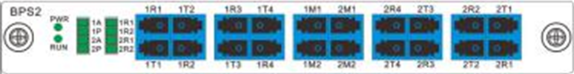

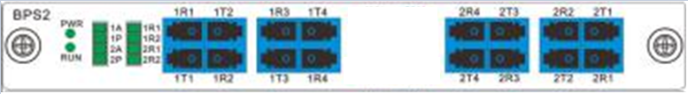

Figure X.a-X.b, two segments module a. with monitoing interfaces b. without

Different modules support different bypass behavior, which are described below, note that the difference between the four modes is the existence of a splitter before the optical switch in bypass (1+1) modes, forwarding traffic to the tool regardless of the bypass condition and the existence of the monitoring interfaces M1 and M2:

- Serial (1:1): traffic from interfaces R1, R2, R3 and R4 is forwarded to two optical switches, under normal condition the switch forwards the traffic from network interfaces R3 and R4 to the tool interfaces T1 and T2 respectively, and traffic from the tool interfaces R1 and R2 to network interfaces T3 and T4 respectively. Under bypass conditions, the tool interfaces are skipped, and the switches forward the traffic from R3 to T4 and from R4 to T3. See figure XXX.
- Parallel (1+1): traffic from the network interfaces R3 and R4 is split between tools interfaces T1 and T2 and two optical switches, meaning the tool receives this traffic regardless of the bypass condition, traffic from tool interfaces R1 and R2 are also forwarded to the optical switches. Under normal condition, the switches forward the traffic from the tool interfaces R1 and R2 to the network interfaces T3 and T4 respectively. Under bypass conditions, the switch forwards the traffic from R3 to T4 and from R4 to T3. See figure XXX.
- Serial (1:1) Tap: same as Serial (1:1), in addition, the monitor interfaces M1 and M2 receive a copy of the T3 and T4 network interfaces respectively. See figure XXX.
- Parallel (1+1) Tap: same as Parallel (1+1), in addition, the monitor interfaces M1 and M2 receive a copy of the T3 and T4 network interfaces respectively. See figure XXX.

The four bypass modes are described in the following diagrams.

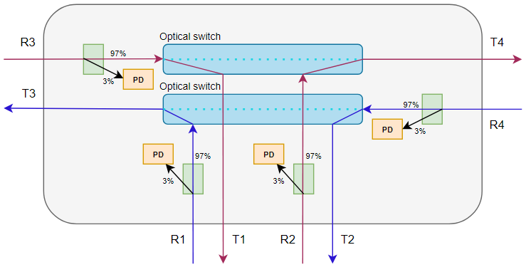

Serial (1:1)

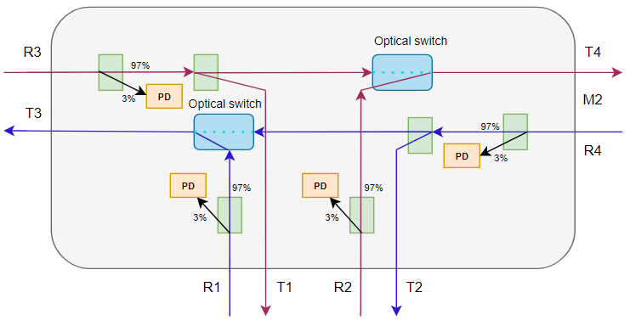

Parallel (1+1)

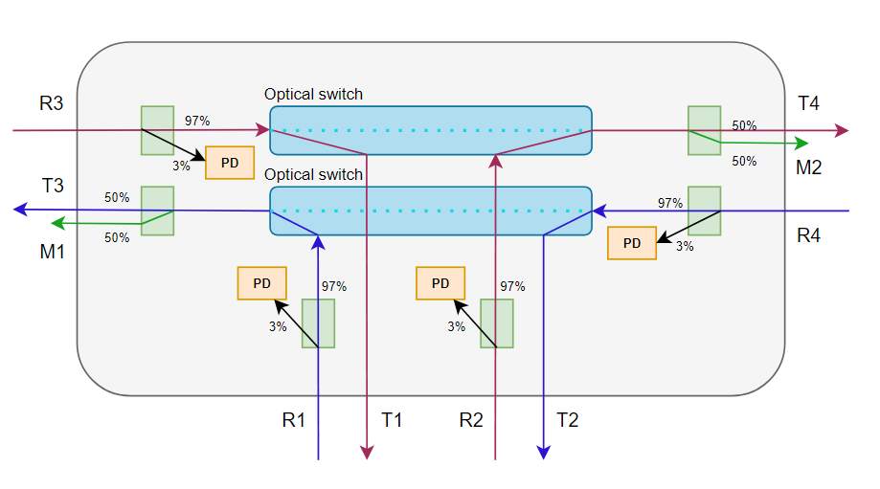
Serial (1:1) Tap

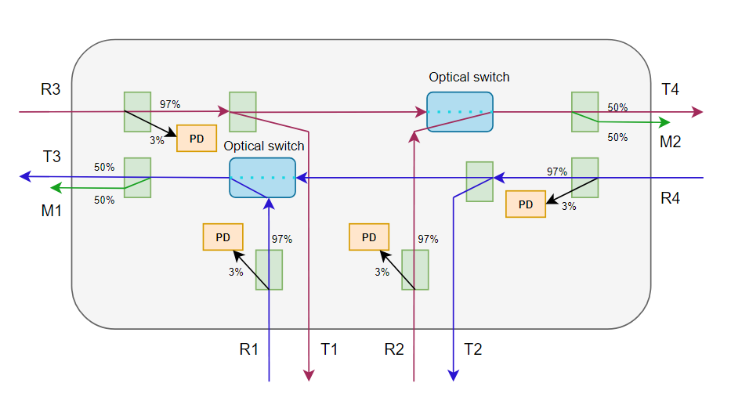

Parallel (1+1) Tap

Figure X.a – X.d: the four bypass modes, PD indicates power detectors, used for detecting the link power and status

Device Setup
This section describes the device’s initial setup which consists of connecting the device to the management network, configuring additional parameters such as time and date, SNMP, and users accounts, and connecting the data network and monitored tools.

Network Management

By default, the device is configured to use the following network settings:
IP address: 10.42.42.78
Subnet Mask: 255.255.255.0
Default Gateway: 10.42.42.1

To connect to the device for the first time, configure your host to use an IP in the device’s subnet (e.g., 10.42.42.44) and connect it directly to the device using the management port. Once connected, direct your web browser to access the device using in this address http://10.42.42.78. Login to the device GUI using the default username and password admin/admin.

Once logged in, select the NMU tab on the top bar and select the Net Config section on the left. Use this page to configure the network settings for the device.

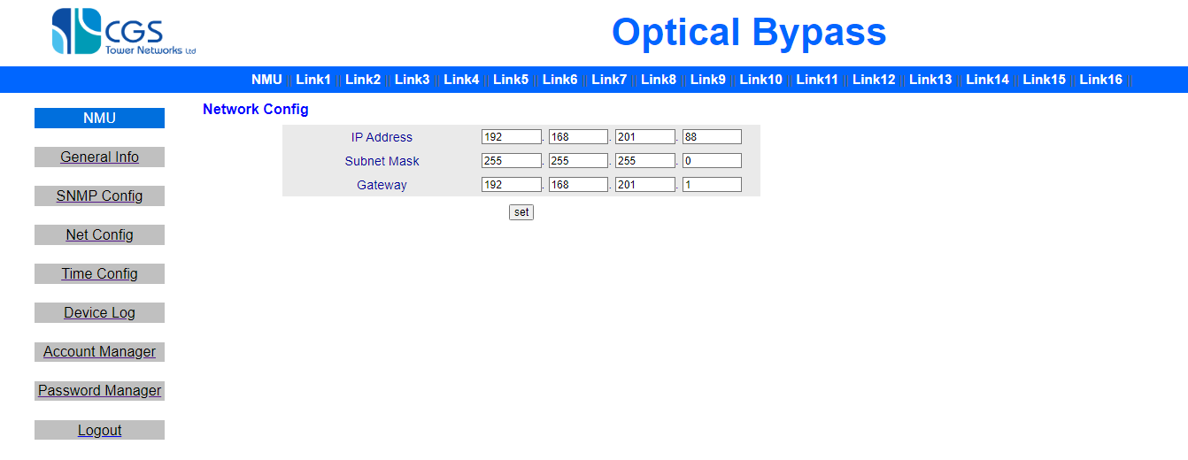
Alternatively, use the front panel keypad to configure the network parameters. See more details in the next section.

General settings

The table below describes the device’s general settings, they can be configured using the GUI as explained above, or by other configuration methods such as the keypad and SNMP, see section XXX for full details on the device’s configuration methods.

Name | Description | Possible Values
IP Address | The device management IP address | Valid IPv4 address
Subnet Mask | The device management IP subnet mask | Valid IPv4 subnet mask
Gateway | The gateway IP address | Valid IPv4 address
MAC Address | The device address (read only)
TCP Port | The TCP port to be used for passive heartbeats and API management | 0 - 65534  Default is 4001
Startup DLY | The delay in seconds since power on, after which, bypass logic is activate and the device may exit bypass mode. Use this parameter to sync bypass activation with the uptime of the tools connected to the device. | 0 - 9999  Default is 0
Key Locked | Protect keypad with a password | Unlock – do not use a password  Lock – use a password  Default is Unlocked
LCD Password | Keypad password | Six-digit password
Buzzer STA | Enable or disable the sound alarm | On  Off  Default is on
Device Address | Internal device address, used for API management when managing several devices | 0 – 99  Default is 1
Power 1 STA | Power supply 1 status (read only)
Power 2 STA | Power supply 2 status (read only)
Software version | The device software version (read only)
Hardware version | The device hardware version (read only)
Serial Num | The device serial number (read only)
Factory Date | Manufacturing date (read only)

Other settings
The device supports the following additional settings:
- SNMP
- Time and date
- Users and accounts management
- GUI Password

These settings are supported only from the GUI, select the NMU tab on the top bar and use the required section on the left.

Connecting the network and tool interfaces
This section describes the basic wiring and configuration needed to use the device in an inline setup. For each segment follow these steps:

- Connect your network to the pair of network interfaces R3/T3 and R4/T4
- Connect your monitored tool to the pair of tool interfaces R1/R2 and R3/R4
- Optionally, connect the monitoring tool to the monitor interfaces M1 and M2
- Configure the heartbeat type (active, passive, both) and parameters. When using active heartbeat, make sure you configure it with the tool’s IP.
- When using active bypass configure your tool to respond to incoming ICMP requests from the device’s IP with ICMP replies destined to the device.
- When using passive IP, configure your tool to periodically send heartbeat messages to the device over TCP.
- Configure other the per segment configuration according to your needs

See section device operation on page XXX for more details about heartbeat operation and parameters.

Device Operation

This section describes the device’s operation in detail. Being an OBP switch, the device constantly monitors the tools status to detect failures such as SW irresponsiveness, HW failures, and connectivity issues. When such a failure is detected, or in case of power loss to the device the device may enter a failed segment into bypass mode, in this mode traffic skipp the tool and is transferred bidrectionaly on the network interfaces.

When in bypass mode, the device continues to monitor the tools and interfaces, when conditions are valid again, it may take recovered segment out of bypass mode. The logic behind entering and exiting byass mode is defined by several parameters as explained later in this section, these parameters are configurable per segment.

Heartbeats
The PB-MOD device supports both active and passive heartbeat messages to determine the status of the monitored tool.

- When using active heartbeat, the device periodically sends ICMP request messages through its management port to the IP address configured to the segment and expects to receive ICMP responses, failing to do so indicates a failure and may cause entering bypass mode.
- When using passive heartbeat, the device expects receiving periodic TCP messages through its management port, failing to do so indicates a failure and may cause entering bypass mode. For more details on passive message format see section XXX (APIs)

The table below describes the heartbeat parameters, these parameters are set per monitored segment. For details on how to configure these values see section XXX.

Name | Description | Possible Values
Active HBT | Activate/deactivate the active heartbeat mechanism | On/Off
Send Interval | Active heartbeat messages frequency in msec | 1-9999 * 10 msec, representing the range 10-99990 msec.  Default is 10 msec.
APKT Timeout | Acceptable timeout between sending ICMP request and receiving ICMP response | 1-9999 * 10 msec, representing the range 10-99990 msec.  Default is 10 msec.
APKT Loss BPS | Acceptable number of lost ICMP responses | 1-9999  Default is 3
Heart IP | The IP address to send the ICMP requests to | Valid IPv4 address
Passive HBT | Activate/deactivate the passive Heartbeat mechanism | On/Off
PPKT Timeout | Acceptable timeout for between passive heartbeat messages | 1-9999 * 10 msec, representing the range 10-99990 msec.  Default is 10 msec.
PPKT Loss BPS | Acceptable number of lost messages | 1-9999  Default is 3

Signal Monitoring
The PB-MOD device monitors the signal values on the tool RX interfaces (R1 – R4), when the signal fails under a predefine thresholds this indicates a failure and may cause entering bypass mode. The set of monitored tool interfaces is configurable.

The following table describes the signal monitoring parameters, these parameters are set per monitored segment. For details on how to configure these values see section XXX.

Name | Description | Possible Values
R1-R4 Power | Current power level in interface R1-R4 (read only)
R1-R4 Wave | Wavelength of interface R1-R4 | 1310 nm  1550 nm
R1-R4 Alarm | Power threshold for interface R1-R4. When power is below this threshold and depending on the value of ALM BPS the segment may switches to bypass | (-50.00) – (+23.00) dBm
ALM BPS | Sets when to switch to bypass mode due to power alarms in R1–R4 | R1 ALM – when R1 is below alarm threshold  R2 ALM – when R2 is below alarm threshold  R3 ALM – when R3 is below alarm threshold  R4 ALM – when R4 is below alarm threshold  R1–R4 any ALM – when any of the links is below alarm threshold  R1–R4 all ALM – when all link are below alarm threshold

Bypass Operational Modes
The PB-MOD device supports two operational modes:
- Automatic: bypass mode is set automatically according to the links and heartbeat status
- Manual: bypass mode is set manually by the user.

Notes regarding bypass operation:
- When set to manual mode, the device will automatically switch back to automatic mode if ‘return auto’ is set (default is 30 minutes).
- The device exits bypass mode (when conditions allow) based on the value of ‘back mode’ and ‘back delay’.
- The device may protect itself against frequent switches using a hysteresis mechanism as defined in the SW Protect parameter.

The following table describes the bypass operational configuration options, these parameters are configured per monitored segment. For details on how to configure these values see section XXX.

Name | Description | Possible Values
Work Mode | Set the device operational mode | Auto mode  Manual mode  Default is auto mode
CH Select | Manually set the bypass mode  Valid when work mode is manual | Bypass – enter bypass mode  Primary – exit bypass mode
Return Auto | The delay in minutes after which the operational mode is switched from normal to auto (configuring any value in the device resets the measured interval) | 0000 – 9999 minutes  Default is 30  Set to 0 to never switch from manual to auto mode
Back Mode | Set the back mode behavior.  In auto back mode the return from bypass mode to normal mode (when condition allow) happens automatically after the interval defined in ‘Back Delay’.  In manual back mode, the return to normal mode requires manual intervention.  Auto back mode is valid only in Auto operation mode. | Auto mode  Manual mode  Default is auto
Back Delay | Set the interval in seconds after which a switch from bypass to normal takes place.  Valid only if back mode is auto | 0000 – 9999 seconds
SW Protect | Enable/disable the hysteresis mechanism that stops frequent switches. When set to On, if there were more than 10 status changes within 20 seconds the operational mode is switched to manual.  Valid only when operational mode is auto | On  Off

Management

The device supports the following configuration methods:
- Graphical User Interface (GUI)
- Front panel keypad and LCD screen
- SNMP MIB
- API using Telnet over TCP through the management port

Note that not all parameters are available in all management methods. These methods are described below.

GUI
The BP-MODE device supports configuration using the Graphical User Interface, see section XXX for details on how to login to the GUI for the first time.

The GUI homepage contains a general settings section (Network Management Unit or NMU) and per link sections. Use the tabs on the top bar to select a section.

The diagram below shows the NMU page:

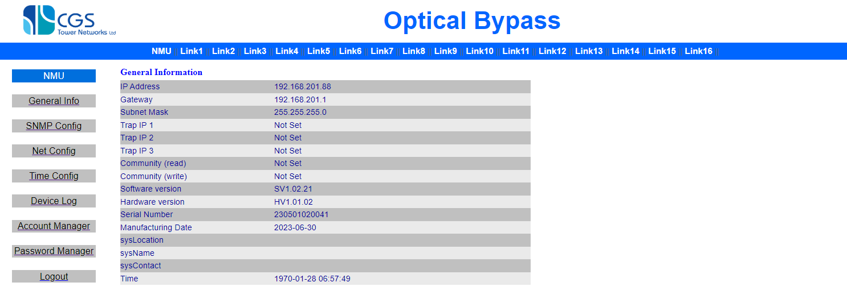
Use the navigation panel on the left to select the relevant section to edit. After filling in a new value, press the ‘set’ button to apply your changes.

To configure per-link parameters select one of the link tabs then select Link Config on the left to modify the link parameters. Press the ‘set’ button to apply your changes.

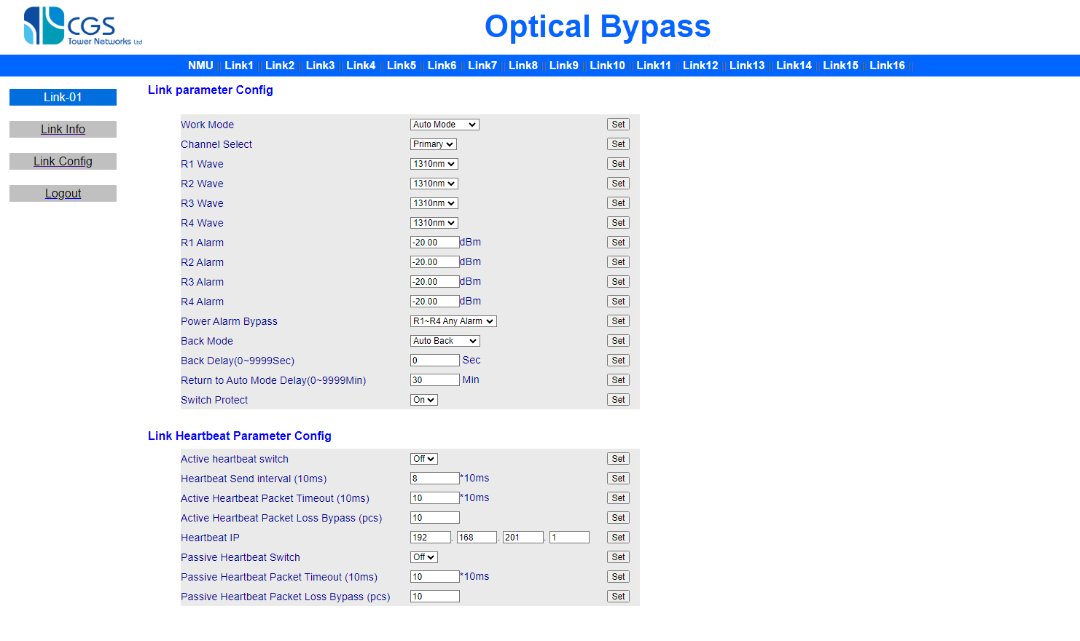

Keypad
The PM-MOD device supports configuration through a front panel keypad and an LCD screen.

The LCD main menus are:
- Welcome screen with the device name (e.g, ‘BP-MOD-1-4’)
- Device settings menu (marked ‘0. Device Info’)
- Per-link settings menus, numbered according to link ID (e.g., ‘01. Lin01 Info’)

To switch between the main menus use the up (▲) and down (▼) buttons, to enter a menu use the OK button, to go back use the ESC button.

Editable parameters are marked with an asterisk (*), to change a value, select it using the up (▲) and down (▼) buttons and press OK, use the arrows button to edit the new value (up (▲) and down (▼) to set a digit value, left (◄) and right (►) to move between digits), press OK to keep the new value or ESC to discard the change. If the value was changed successfully a set success message is displayed.

For example, to change the device’s TCP port follow these steps:

- Starting with the main menu, press the down button once to reach the device settings menu
- Press OK
- Press the down button 4 times to reach ‘*5. TCP Port’ menu
- Press OK
- Use the arrows buttons to set a new value
- Press OK
- A “set success” message appears

The following sections list the available configuration options per menu, note that not all the device’s parameters are configurable from the front panel. Use the GUI for non-supported parameters such as SNMP and time and date.

Device Information menu items:

- IP Address
- Subnet Mask
- Gateway
- MAC Address (read only)
- TCP Port
- Startup DLY
- Key Locked
- LCD Password
- Buzzer STA
- Device Address
- Power 1 STA (read only)
- Power 2 STA (read only)
- Software version (read only)
- Hardware version (read only)
- Serial Num (read only)
- Factory Date (read only)

Link information menu items (per link):

- Work Mode
- CH Select
- R1 Power (read only)
- R2 Power (read only)
- R1 Wave
- R2 Wave
- R1 Alarm
- R2 Alarm
- ALM BPS
- Return Auto
- Back Mode
- Back Delay
- Active HBT
- Send Interval
- APKT Timeout
- APKT Loss BPS
- Heart IP
- Passive HBT
- PPKT Timeout
- PPKT Loss BPS
- SW Protect

SNMP MIB
The device supports configuration through SNMP protocol. The SNMP root is given by the following ID: so(1).org(3).dod(6).internet(1).private(4).enterprises(1).cgs(47477).bypass(200).XXX(1)

To use SNMP first configure the SNMP setting using the GUI.

TCP based API

The device can receive API commands on its management port using Telnet over TCP, this can be used for automated management and configuration.

Note the following when working with APIs:

- Standard Telnet, TCP, and IP communication are used, TCP port 4001 is used by default.
- The device process commands serially, wait for a response before issuing a new command.
- The syntax is case sensitive, ‘<’ and ‘>’ are part of the syntax and shall appear in the message.
- In the syntax description below, capital letters are part of the message while noncapital letters indicate a parameter, such as the device address, link ID, or a value to set.
- The prefix BPxx_ indicates the device internal address (default is 01), xx is in the range 00-99
- The prefix BPxx_y_ indicates the device internal address (xx) and the link number (y)

Command | Description | In/Out Values
<BP_ADR_?> | Query the device internal address. | In: none  Out: <BPXX_OK> where XX is in the range 00-99 and indicates the device’s internal address
<RESTORE> | Restore factory defaults | In: none  Out: none
<BPxx_ADR_yy> | Change the internal address from xx to yy | In: yy is the new address (00-99)  Out: <BPxx_ADR_OK> on successful setting or <CMD_ERR> on failure.
<BPxx_RESET> | Reset the device | In: None  Out: None
<BPxx_KEY_y> | Set or query the keypad lock status | In: use y=0 for locking, y=1 for unlocking, y=? for querying  Out: <BPxx_KEY_OK> on successful setting, <BPxx_KEY_OK/OFF> on querying, or <CMD_ERR> on failure.
<BPxx_BEEONE_OFF> | Turn off the buzzer if it is on (one time) | In: None  Out: None
<BPxx_BEE_y> | Set or query the buzzer alarm status | In: use y=0 for enabling, y=1 for disabling, or y=? for querying  Out: <BPxx_BEE_OK> on successful setting, <BPxx_BEE_0/1> on querying, or <CMD_ERR> on failure.
<BPxx_y_M_z> | Set or query working mode | In: use z=0 for manual, z=1 for auto, or z=? for querying  Out: <BPxx_y_M_OK> on successful setting, <BPxx_y_M_0/1> on querying, or <BPxx_CMD_ERR> on failure.
<BP01_x_S_Y> | TODO | TODO
<BPxx_y_QS_z> | Set or query the segment bypass mode, setting the mode automatically changes the working mode to manual | In: use z=0 for bypass, z=1 for normal, or z=? for querying  Out: <BPxx_y_QS_OK> on successful setting, <BPxx_y_QS_0/1> on querying, or <BPxx_y_QS_ER> on failure.
<BPxx_y_ACC_z> | Set or query return mode | In: use z=0 for manual, z=1 for auto or z=? for querying  Out: <BPxx_y_ACC_OK> on successful setting, <BPxx_y_ACC_0/1> on querying, or <CMD_ERR> on failure.
<BPxx_y_Q_zzzz> | Set or query the return mode delay in seconds | In: zzzz=delay or ? for querying  Out: <BPxx_y_Q_OK> on successful setting, <BPxx_y_Q_zzzz> on querying, or <CMD_ERR> on failure.
<BPxx_y_R_zzzz> | Set or query return mode delay in minutes | In: zzzz=delay, zzzz=0000 for no return, or ? for querying  Out: <BPxx_y_R_OK> on successful setting, <BPxx_y_R_zzzz> on querying, or <CMD_ERR> on failure.
<BPxx_SY_yyyy> | Set or query booting delay in seconds | In: yyyy=delay or ? for querying  Out: <BPxx_SY_OK> on successful setting, <BPxx_SY_yyyy> on querying, or <CMD_ERR> on failure.
<BPxx_y_LINKSTS_?> | Query the link status | In: None  Out: <BPxx_y_LINKSTS_z_w> z is the working mode (0 for manual, 1 for auto) and w is the current mode (0 for bypass, 1 for normal) or <CMD_ERR> on failure.
<BPxx_IP_yyy_yyy_yyy_yyy> | Query or set the device IP address | In: yyy_yyy_yyy_yyy is a valid IPv4 address or ? for querying  Out: <BPxx_IP_OK> on successful setting, <BPxx_IP_ yyy_yyy_yyy_yyy > on querying, or <CMD_ERR> on failure.
<BPxx_GW_ yyy_yyy_yyy_yyy> | Query or set the gateway IP address | In: yyy_yyy_yyy_yyy is a valid IPv4 address or ? for querying  Out: <BPxx_GW_OK> on successful setting, <BPxx_GW_yyy_yyy_yyy_yyy> on querying, or <CMD_ERR> on failure.
<BPxx_SM_ yyy_yyy_yyy_yyy> | Query or set the device IP subnet mask | In: yyy_yyy_yyy_yyy is a valid IPv4 address or ? for querying  Out: <BPxx_SM_OK> on successful setting, <BPxx_SM_yyy_yyy_yyy_yyy> for querying, or <CMD_ERR> on failure.
<BPxx_y_PIP_zzz_zzz_zzz_zzz> | Set or query the active heartbeat IP | In: y is the segment ID, zzz_zzz_zzz_zzz is a valid IPv4 address or ? for querying  Out: <BPxx_y_PIP_OK> on successful setting, <BPxx_y_PIP_zzz_zzz_zzz_zzz> on querying, or <CMD_ERR> on failure.
<BPxx_TCPP_yyyyy> | Set or query TCP API port | In: yyyyy is a valid TCP port or ? for querying  Out: <BPxx_TCPP_OK> on successful setting, <BPxx_TCPP_yyyyy> on querying, or <CMD_ERR> on failure.
<BPxx_y_HI_zzzz> | Set or query the active bypass interval time | In: zzzz is the interval time or ? for querying  Out: <BPxx_y_HI_OK> on successful setting, <BPxx_y_HI_zzzz> on querying, or <CMD_ERR> on failure.
<BPxx_y_PO_zzzz> | Set or query the active bypass timeout | In: zzzz is the timeout or ? for querying  Out: <BPxx_y_PO_OK> on successful setting, <BPxx_y_PO_zzzz> on querying, or <CMD_ERR> on failure.
<BPxx_y_LP_zzzz> | Set or query the active bypass packet loss limit | In: zzzz is the packet loss limit or ? for querying  Out: <BPxx_y_LP_OK> on successful setting, <BPxx_y_LP_zzzz> on querying, or <CMD_ERR> on failure.
<BPxx_y_SC_z> | Enable/disable active heartbeat | In: use z=0 for disabling, z=1 for enabling, or z=? for querying  Out: <BPxx_y_SC_OK> on successful setting, <BPxx_y_SC_0/1> on querying, or <CMD_ERR> on failure.
<BPxx_y_PPO_zzzz> | Set or query the passive bypass timeout | In: zzzz is the timeout or ? for querying  Out: <BPxx_y_PPO_OK> on successful setting, <BPxx_y_PPO_zzzz> on querying, or <CMD_ERR> on failure.
<BPxx_y_PLP_zzzz> | Set or query the passive bypass packet loss limit | In: zzzz is the packet loss limit or ? for querying  Out: <BPxx_y_PLP_OK> on successful setting, <BPXX_y_PLP_zzzz> on querying, or <CMD_ERR> on failure.
<BPxx_y_PSC_z> | Enable/disable passive heartbeat | In: use z=0 for disabling, z=1 for enabling, or z=? for querying  Out: <BPxx_y_PSC_OK> on successful setting, <BPxx_y_PSC_0/1> on querying, or <CMD_ERR> on failure.
<BPxx_y_BP> | Sent a passive heartbeat message | In: Nobe  Out: <BPxx_y_BP_OK> on success or <CMD_ERR> on failure.
<BPxx_y_PROTECT_z> | Set or query the SW protect mode | In: use Z=0 for disable, z=1 of enable or z=? for querying  Out: <BPxx_y_PROTECT_OK> on successful setting, <BPXX_y_PROTECT_0/1> on querying, or <CMD_ERR> on failure.
<BPxx_LINK_?> | Query the number of segments | In: None  Out: <BPxx_LINK_yy> where yy indicates the number of segments
<BPxx_y_PA_z> | Set which R interfaces can trigger bypass mode due to low signal | In: use z=0 for no interface, z=1,2,3,4 for interfaces R1-R4 respectively, z=5 to trigger bypass when one of R1-R4 is below threshold and z=6 to trigger bypass when all R1-R4 are below threshold  Out: <PBxx_y_PA_OK> on successful setting or <CMD_ERR> on failure.
<BPxx_y_Rz_P_?> | Query the current optical signal power on one of the R’s interfaces | In: z is the interface number (1-4)  Out: <BPxx_y_Rz_P_www.ww> where z is the interface number and www.ww is the power including a sign (+/-), for example: <BP01_1_R1_P_-20.00>, or <CMD_ERR> on failure.
<BPxx_y_Rz_SP_www.ww > | Set or query the optical power threshold on one of the R’s interfaces | In: z is the interface number (1-4), www.ww is the threshold value including a sign (+/-) in the range (-50.00) – (+23.00), for example: <BP01_1_R1_SP_+16.00>  Out: <BPxx_y_Rz_SP_OK> on successful setting, <BPxx_y_Rz_SP_www.ww> where z is the interface number and www.ww is the power including a sign (+/-) for querying, for example: <BP01_1_R1_SP_+08.00>, or <CMD_ERR> on failure.
<BPxx_y_Rz_W_u> | Set or query the wavelength for one of the R’s interfaces | In: z is the interface number (1-4), use u=0 for 1310nm, u=1 for 1550 nm. o,r u=? for querying  Out: <BPxx_y_Rz_W_OK> on successful setting, <BPxx_y_Rz_W_0/1>, on querying, or <CMD_ERR> on failure.

HW Specifications

LEDs
NMU LEDs specification are explained in the following table.

RUN | Status, flickers when status is OK
PWR1 | Indicates PSU1 status, ON when status is OK, OFF when PSU is not present or not functioning
PWR2 | Indicates PSU2 status, ON when status is OK, OFF when PSU is not present or not functioning

Module LEDS specification are explained in the following table. These LEDs are present per segment.

R1-R4 | R1-R4 status, ON when power is above threshold, OFF when no power, or power is below thresholds
Auto (A) | Indicates the segment working mode, ON when mode is auto, OFF when mode is manual
Priority (P) | Indicates the segment’s bypass mode, ON when in normal mode, OFF when in bypass mode

Physical and Environmental

BP-MOD-1-4

Slots | 1 NMU, 4 bypass, 1 fan, 2 PSU
Dimensions (WxDxH): | 48.26 x 30.0 x 4.4 cm
Weight: | 6 kg
Power Supply | Dual hot-swap and redundant power:  DC -36V~-72V (DC -48V) or AC 100V~240V
Maximal Power | 50W or 100W
Fans: | 1 plugin
Operating temperature: | -5°C to 55°C
Storage temperature: | -20°C to 70°C
Operating humidity: | 5% to 95% non-condensing
Operating altitude: | 0 to 10,000 feet

BP-MOD-2-8

Slots | 1 NMU, 8 bypass, 1 fan, 2 PSU
Dimensions (WxDxH): | 48.26 x 30.0 x 8.9 cm
Weight: | 8 kg
Power Supply | Dual hot-swap and redundant power:  DC -36V~-72V (DC -48V) or AC 100V~240V
Maximal Power | 100W or 160W
Fans: | 1 plugin
Operating temperature: | -5°C to 55°C
Storage temperature: | -20°C to 70°C
Operating humidity: | 5% to 95% non-condensing
Operating altitude: | 0 to 10,000 feet

BP-MOD-4-16

Slots | 1 NMU, 16 bypass, 1 fan, 2 PSU
Dimensions (WxDxH): | 48.26 x 30.0 x 17.8 cm
Weight: | 12 kg
Power Supply | Dual hot-swap and redundant power:  DC -36V~-72V (DC -48V) or AC 100V~240V
Maximal Power | 160W or 300W
Fans: | 1 plugin
Operating temperature: | -5°C to 55°C
Storage temperature: | -20°C to 70°C
Operating humidity: | 5% to 95% non-condensing
Operating altitude: | 0 to 10,000 feet

BP-MOD Module

Parameters |  |  |  | Unit |  |  | Value
Dimension |  |  |  | mm |  |  | 160×200×21（WxDxH）
Maximal Power |  |  |  | W |  |  | 1 W (single link), 2W (dual link)
Consumption |  |  |  | W
Protection Ways |  |  |  |  | Serial 1:1 (SM) |  | Parallel 1+1  (SM) |  | Serial 1:1 (MM) |  | Parallel 1+1  (MM)
 |  | R3–T1 |  |  | ≤ 1.5 |  | ≤ 3.8 |  | ≤ 1.5 |  | ≤ 3.8
 |  | R4–T2 |  |  | ≤ 1.5 |  | ≤ 3.8 |  | ≤ 1.5 |  | ≤ 3.8
Insertion |  | R1–T3 |  | dB | ≤ 1.5 |  | ≤ 1.5 |  | ≤ 1.5 |  | ≤ 1.5
Loss |  | R2–T4 |  | dB | ≤ 1.5 |  | ≤ 1.5 |  | ≤ 1.5 |  | ≤ 1.5
 |  | R3–T4 |  |  | ≤ 1.5 |  | ≤ 5.0 |  | ≤ 1.5 |  | ≤ 5.0
 |  | R4–T3 |  |  | ≤ 1.5 |  | ≤ 5.0 |  | ≤ 1.5 |  | ≤ 5.0
Protection Ways |  |  |  |  | Serial 1:1 Tap (SM) |  | Parallel 1+1 Tap (SM) |  | Serial 1:1 Tap (MM) |  | Parallel 1+1 Tap (MM)
 |  | R3–T1 |  |  | ≤ 1.5 |  | ≤ 3.8 |  | ≤ 1.5 |  | ≤ 3.8
 |  | R4–T2 |  |  | ≤ 1.5 |  | ≤ 3.8 |  | ≤ 1.5 |  | ≤ 3.8
 |  | R1 | – T3/M50 |  | ≤ 5.0/5.0 |  | ≤ 5.0/5.0 |  | ≤ 5.0/5.0 |  | ≤ 5.0/5.0
 |  | R2 | – T4/M50 |  | ≤ 5.0/5.0 |  | ≤ 5.0/5.0 |  | ≤ 5.0/5.0 |  | ≤ 5.0/5.0
 |  | R3 | – T4/M50 |  | ≤ 5.0/5.0 |  | ≤ 8.5/8.5 |  | ≤ 5.0/5.0 |  | ≤ 8.5/8.5
 |  | R4 | – T3/M50 |  | ≤ 5.0/5.0 |  | ≤ 8.5/8.5 |  | ≤ 5.0/5.0 |  | ≤ 8.5/8.5
Insertion |  | R1 – T3/M40 |  | dB | ≤ 4.0/6.0 |  | ≤ 4.0/6.0 |  | ≤ 4.0/6.0 |  | ≤ 4.0/6.0
Loss |  | R2 – T4/M40 |  | dB | ≤ 4.0/6.0 |  | ≤ 4.0/6.0 |  | ≤ 4.0/6.0 |  | ≤ 4.0/6.0
 |  | R3 | – T4/M40 |  | ≤ 4.0/6.0 |  | ≤ 7.5/9.5 |  | ≤ 4.0/6.0 |  | ≤ 7.5/9.5
 |  | R4 | – T3/M40 |  | ≤ 4.0/6.0 |  | ≤ 7.5/9.5 |  | ≤ 4.0/6.0 |  | ≤ 7.5/9.5
 |  | R1 | – T3/M30 |  | ≤ 3.3/7.2 |  | ≤ 3.3/7.2 |  | ≤ 3.3/7.2 |  | ≤ 3.3/7.2
 |  | R2 | – T4/M30 |  | ≤ 3.3/7.2 |  | ≤ 3.3/7.2 |  | ≤ 3.3/7.2 |  | ≤ 3.3/7.2
 |  | R3 | – T4/M30 |  | ≤ 3.3/7.2 |  | ≤6.8/10.7 |  | ≤ 3.3/7.2 |  | ≤6.8/10.7
 |  | R4 | – T3/M30 |  | ≤ 3.3/7.2 |  | ≤6.8/10.7 |  | ≤ 3.3/7.2 |  | ≤6.8/10.7
Return Loss |  |  |  | dB |  | ≥ 45 |  |  |  | ≥ 30
Crosstalk |  |  |  | dB |  | ≥ 55 |  |  |  | ≥ 35
 | PDL |  |  | dB |  | ≤ 0.2 |  |  |  | ≤ 0.2
 | WDL |  |  | dB |  | ≤ 0.3 |  |  |  | ≤ 0.3
Switching Time |  |  |  | ms |  | ＜ 8 |  |  |  | ＜ 8
Operating Temperature |  |  |  | ℃ |  |  |  | -5 ~ +55
Storage Temperature |  |  |  | ℃ |  | -20 ~ +70
Relative Humidity |  |  |  |  |  |  | 5% ~ 95% (non-condensing)

BP-MOD-BIDI Module

Parameters |  |  |  | Unit | Value
 | Dimension |  |  | mm | 160×200×21（WxDxH）
Maximal Power |  |  |  | W | 1 W (single link), 2W (dual link)
Consumption |  |  |  | W
Protection Ways |  |  |  |  | Serial 1:1 (SM) |  | Parallel 1+1 (SM)
Insertion |  |  | R1–R3 |  | ≤ 1.5 |  | ≤ 3.8
 |  |  | R2–R4 | dB | ≤ 1.5 |  | ≤ 3.8
Loss |  |  | R2–R4 | dB | ≤ 1.5 |  | ≤ 3.8
 |  |  | R3–R4 |  | ≤ 1.5 |  | ≤ 5.0
Protection Ways |  |  |  |  | Serial 1:1 Tap (MM) |  | Parallel 1+1 Tap (MM)
 |  |  | R1 – R3/M50 |  | ≤ 5.0/5.0 |  | ≤ 7.3/7.3
 |  |  | R2 – R4/M50 |  | ≤ 5.0/5.0 |  | ≤ 5.0/5.0
 |  |  | R3 – R4/M50 |  | ≤ 8.5/8.5 |  | ≤ 12.0/12.0
Insertion |  |  | R1 – R3/M40 |  | ≤ 4.0/6.0 |  | ≤ 6.3/8.3
 |  |  | R2 – R4/M40 | dB | ≤ 4.0/6.0 |  | ≤ 4.0/6.0
Loss |  |  | R2 – R4/M40 | dB | ≤ 4.0/6.0 |  | ≤ 4.0/6.0
 |  |  | R3 – R4/M40 |  | ≤ 6.5/10.5 |  | ≤ 10.0/12.0
 |  |  | R1 – R3/M30 |  | ≤3.3/7.2 |  | ≤ 5.6/9.5
 |  |  | R2 – R4/M30 |  | ≤ 3.3/7.2 |  | ≤ 3.3/7.2
 |  |  | R3 – R4/M30 |  | ≤ 5.1/9.0 |  | ≤ 8.6/12.5
Return Loss |  |  |  | dB |  | ≥ 45
 | Crosstalk |  |  | dB |  | ≥ 55
 |  | PDL |  | dB |  | ≤ 0.2
 |  | WDL |  | dB |  | ≤ 0.3
Switching Time |  |  |  | ms |  | ＜ 8
Operating Temperature |  |  |  | ℃ |  | -5 ~ +55
Storage Temperature |  |  |  | ℃ |  | -20 ~ +70
Relative Humidity |  |  |  |  | 5% ~ 95% (non-condensing)

Form factor

BP-MOD-1-4

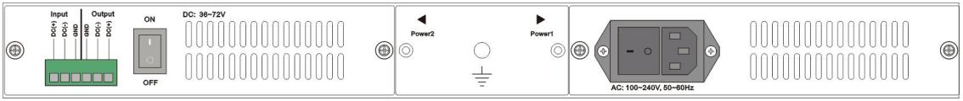

BP-MOD-2-8

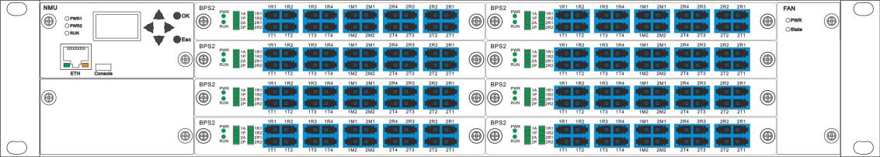

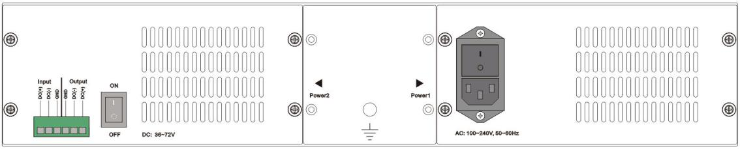

BP-MOD-4-16

