SIMATS ENGINEERING
VISHAL KRUTHIK
192521179

ASSESSMENT TOOL 1

COURSE NAME: Database Management Systems COURSE CODE: CSA05

COURSE OUTCOME COVERED

CO2: Apply the relational model, relational algebra, SQL query structures, and views to solve database querying and data manipulation problems. (BL3, BL6)

Activity Tool : Analytical Problem Solving (High) Assessment Tool Weightage: 35%

Dr

QUESTIONS Total Marks: 50
Q.No | Question | Bloom's Level | Marks
1 | Apply relational algebra operations (σ, π, ∪, -, ×, ⋈) on the given Employee and Department relations to retrieve required records. | BL3 – Apply | 5
2 | Write SQL DDL statements to create STUDENT(SID, Name, DOB, DeptID) and DEPARTMENT(DeptID, DeptName) tables with all appropriate constraints. | BL3 – Apply | 5
3 | Formulate SQL queries using GROUP BY, HAVING, and aggregate functions (COUNT, SUM, AVG, MAX, MIN) on a given Sales dataset. | BL3 – Apply | 5
4 | Write a correlated sub-query to find employees earning more than the average salary of their own department. | BL3 – Apply | 5
5 | Apply all types of JOIN operations (INNER, LEFT OUTER, RIGHT OUTER, FULL OUTER, CROSS) on Employee and Project tables. | BL3 – Apply | 5
6 | Create a view 'DeptSalaryView' that displays department name, total employees, and average salary. Write a query on this view. | BL6 – Create | 5
7 | Construct a relational algebra expression for the following: Find names of students who are enrolled in all courses offered. | BL6 – Create | 5
8 | Write SQL DML statements (INSERT, UPDATE, DELETE) with | BL3 – Apply | 5

 | integrity constraint enforcement for a given scenario.
9 | Apply tuple relational calculus to express a query: Find all employees who work in the 'IT' department and earn more than 50000. | BL3 – Apply | 5
10 | Design a relational schema for an Airline Reservation System and write 5 SQL queries demonstrating joins, sub-queries, and views. | BL6 – Create | 5

Code of Conduct:

I Vishal kruthik.V (192521179) certify that this submission is my original work and that I have adhered to the guidelines specified for this assessment. I understand that any violation of academic integrity rules will result in disciplinary action.

Signature of the student:
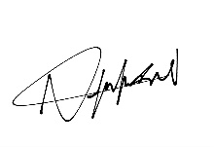

RUBRICS FOR CALCULATION:

Numerical Problems
Criteria | Weightag e | Level 4 (Exemplary) | Level 3 (Proficient) | Level 2 (Developing) | Level 1 (Beginning)
Problem Understandin g | 20% | Clearly interprets problem, identifies all parameters and requirements accurately | Understands problem with minor gaps | Partial understanding  ; misses key elements | Misinterprets or unable to understand problem
Method Selection | 20% | Selects most appropriate  method/formul a with strong justification | Selects correct method with minor errors | Inappropriate or partially correct method | Unable to select method
Solution Process | 25% | Logical, systematic steps with | Mostly correct steps with minor | Disorganized steps; multiple errors | No clear process

 |  | correct approach  throughout | mistakes
Accuracy of Calculation | 20% | All calculations accurate; correct final answer | Minor calculation errors | Frequent errors; incorrect final answer | No valid calculations
Interpretation of Results | 15% | Clearly interprets results with units and engineering relevance | Basic interpretatio n with minor omissions | Limited or unclear interpretation | No interpretatio n

SIMATS

Part B — Complete Answers

Question 1. Relational Algebra Operations on Employee and Department

Assumed Schema
Employee (EmpID, Name, Salary, DeptID, DOJ)
Department (DeptID, DeptName, Location)
Below are the six required operators applied to this schema, one query for each.

(a) Selection (σ) — employees earning above 50000
σ Salary > 50000 (Employee)

(b) Projection (π) — names and salaries only
π Name, Salary (Employee)

(c) Union (∪) — employees who are in IT or HR department
π EmpID (σ DeptID = 'D01' (Employee)) ∪ π EmpID (σ DeptID = 'D02' (Employee))

(d) Set Difference (–) — employees not assigned to any department
π EmpID (Employee) – π EmpID (σ DeptID IS NOT NULL (Employee))

(e) Cartesian Product (×)
Employee × Department
(pairs every employee row with every department row)

(f) Natural Join (⋈) — employee details with department name
Employee ⋈ Department ≡ Employee ⋈ (Employee.DeptID = Department.DeptID) Department

Combined query: names & salaries of employees earning > 50000, with department name
π Name, Salary, DeptName ( σ Salary > 50000 ( Employee ⋈ Department ) )
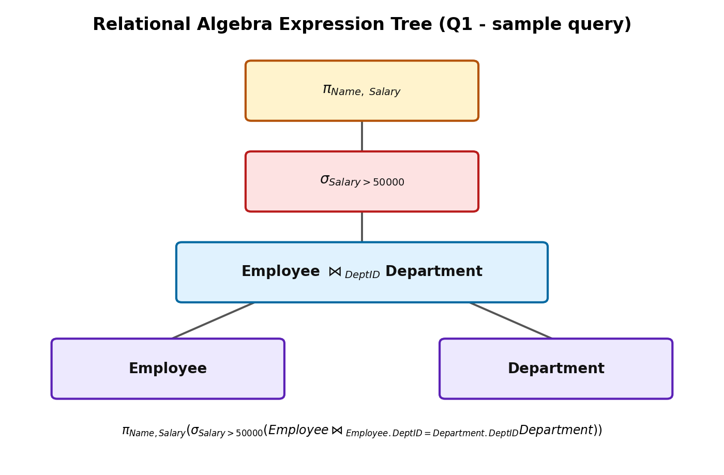
Fig 1.1: Expression tree for the combined relational algebra query.

Question 2. SQL DDL — STUDENT and DEPARTMENT Tables
DEPARTMENT is created first because STUDENT references it through a foreign key.
CREATE TABLE DEPARTMENT (
DeptID VARCHAR(10) PRIMARY KEY,
DeptName VARCHAR(50) NOT NULL UNIQUE
);

CREATE TABLE STUDENT (
SID VARCHAR(10) PRIMARY KEY,
Name VARCHAR(50) NOT NULL,
DOB DATE NOT NULL CHECK (DOB <= CURRENT_DATE),
DeptID VARCHAR(10),
CONSTRAINT fk_student_dept FOREIGN KEY (DeptID)
REFERENCES DEPARTMENT(DeptID)
ON DELETE SET NULL
ON UPDATE CASCADE
);

Constraints used
- PRIMARY KEY on DeptID and SID — uniquely identifies each row.
- NOT NULL on Name, DeptName, DOB — mandatory data.
- UNIQUE on DeptName — no two departments share a name.
- CHECK on DOB — date of birth cannot be in the future.
- FOREIGN KEY on DeptID (STUDENT → DEPARTMENT) — referential integrity, with ON DELETE SET NULL / ON UPDATE CASCADE.

Question 3. GROUP BY, HAVING, and Aggregate Functions on Sales Data
Assumed schema: SALES(SaleID, ProductName, Region, Quantity, Amount, SaleDate)

a) Total and average sales amount per region
SELECT Region,
COUNT(*) AS Total_Orders,
SUM(Amount) AS Total_Sales,
AVG(Amount) AS Avg_Sales,
MAX(Amount) AS Max_Sale,
MIN(Amount) AS Min_Sale
FROM SALES
GROUP BY Region;

b) Regions whose total sales exceed 100000
SELECT Region, SUM(Amount) AS Total_Sales
FROM SALES
GROUP BY Region
HAVING SUM(Amount) > 100000;

c) Products sold more than 50 units in total, ordered by quantity
SELECT ProductName, SUM(Quantity) AS Total_Qty
FROM SALES
GROUP BY ProductName
HAVING SUM(Quantity) > 50
ORDER BY Total_Qty DESC;

Question 4. Correlated Sub-query — Employees Earning Above Department Average
SELECT E.EmpID, E.Name, E.DeptID, E.Salary
FROM Employee E
WHERE E.Salary > (
SELECT AVG(E2.Salary)
FROM Employee E2
WHERE E2.DeptID = E.DeptID -- correlation with outer row
);
This is a correlated sub-query because the inner SELECT references E.DeptID from the outer query — it re-executes once for every row of the outer Employee table, recomputing the department's average salary each time.

Question 5. JOIN Operations — Employee and Project
Assumed schema: Employee(EmpID, Name, DeptID) and Project(ProjID, ProjName, EmpID). Every employee may or may not be assigned to a project, and every project may or may not have an assigned employee, which is why the join type changes the result set.

INNER JOIN — only employees who are assigned to a project
SELECT E.EmpID, E.Name, P.ProjName
FROM Employee E
INNER JOIN Project P ON E.EmpID = P.EmpID;

LEFT OUTER JOIN — all employees, with project if any
SELECT E.EmpID, E.Name, P.ProjName
FROM Employee E
LEFT JOIN Project P ON E.EmpID = P.EmpID;

RIGHT OUTER JOIN — all projects, with employee if assigned
SELECT E.EmpID, E.Name, P.ProjName
FROM Employee E
RIGHT JOIN Project P ON E.EmpID = P.EmpID;

FULL OUTER JOIN — every employee and every project, matched where possible
SELECT E.EmpID, E.Name, P.ProjName
FROM Employee E
FULL OUTER JOIN Project P ON E.EmpID = P.EmpID;

CROSS JOIN — Cartesian product of both tables
SELECT E.EmpID, E.Name, P.ProjName
FROM Employee E
CROSS JOIN Project P;
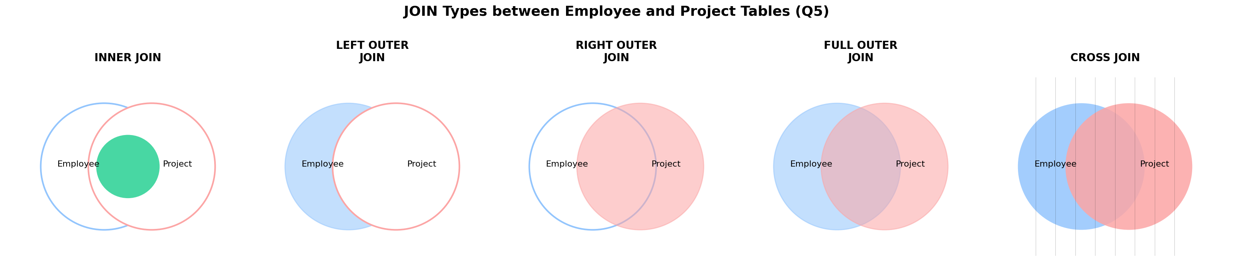
Fig 5.1: Shaded region shows which rows each JOIN type returns.

Question 6. View — DeptSalaryView
CREATE VIEW DeptSalaryView AS
SELECT D.DeptName,
COUNT(E.EmpID) AS Total_Employees,
AVG(E.Salary) AS Avg_Salary
FROM Department D
JOIN Employee E ON D.DeptID = E.DeptID
GROUP BY D.DeptName;

Query on the view — departments with average salary above 40000
SELECT *
FROM DeptSalaryView
WHERE Avg_Salary > 40000
ORDER BY Avg_Salary DESC;
A view does not store data itself; it stores this SELECT definition, and each time it is queried, the underlying Department and Employee tables are re-evaluated to produce the result.

Question 7. Relational Algebra — Students Enrolled in ALL Courses
Assumed schema: Student(SID, SName), Course(CID, CName), Enrolled(SID, CID).
This is a classic “division” query — finding students related to every tuple of the Course relation.
π SName ( π SID,CID (Enrolled) ÷ π CID (Course) ⋈ Student )
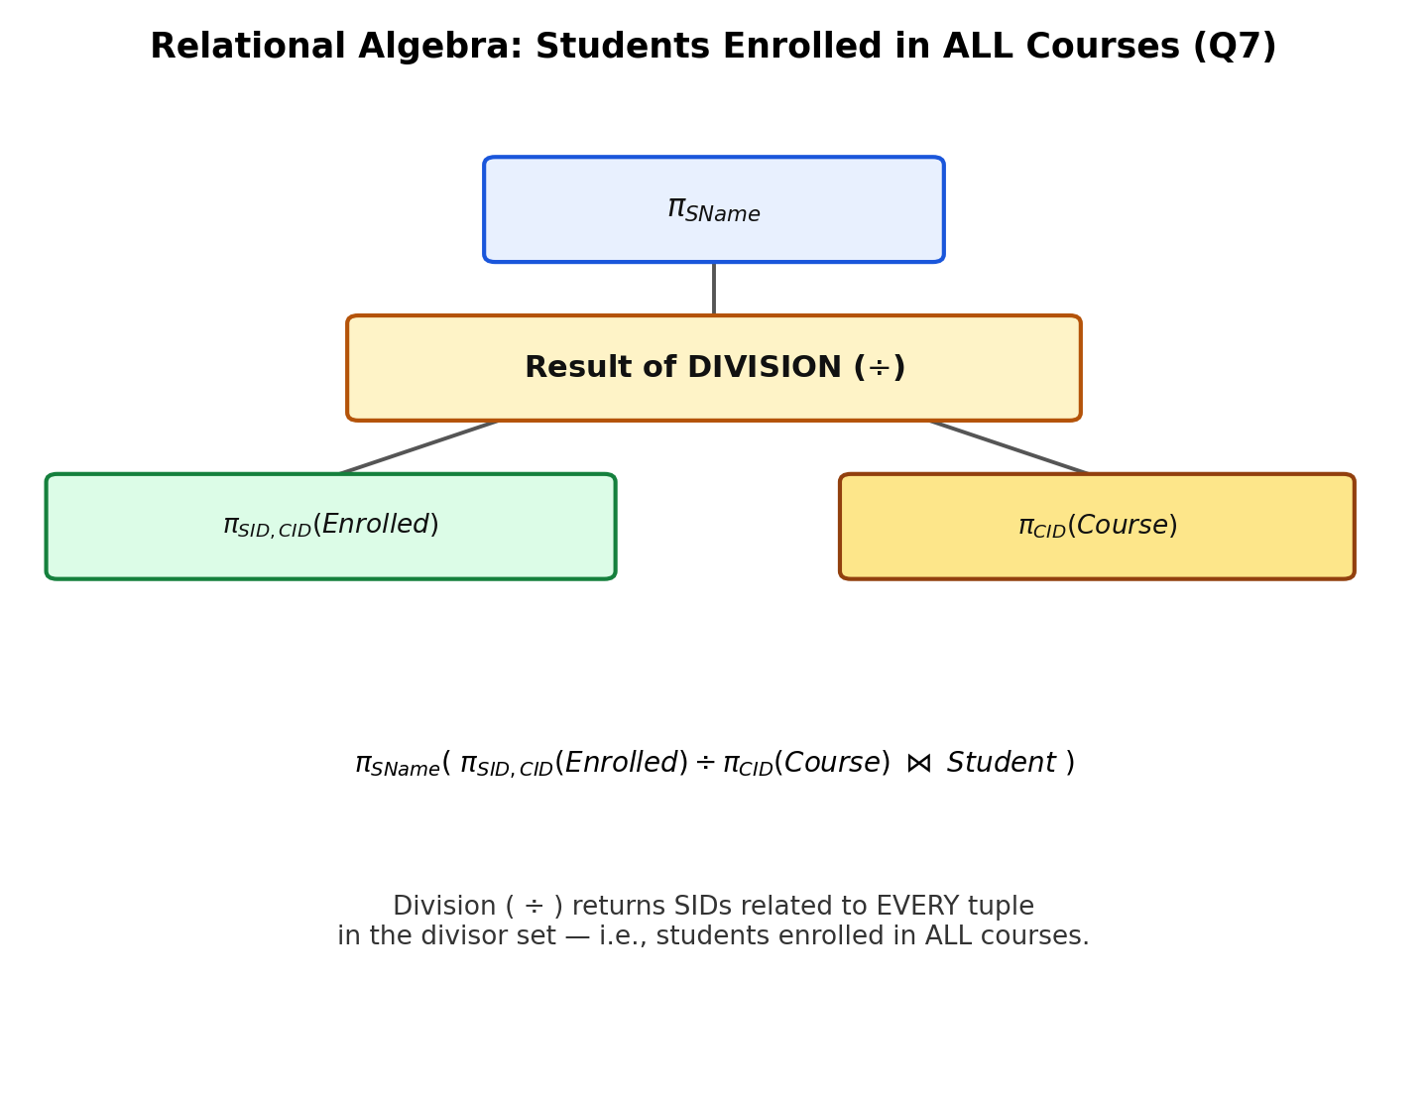
Fig 7.1: Division (÷) isolates students whose set of enrolled CIDs is a superset of all offered CIDs.

Equivalent SQL for reference
SELECT S.SName
FROM Student S
WHERE NOT EXISTS (
SELECT C.CID FROM Course C
WHERE NOT EXISTS (
SELECT 1 FROM Enrolled EN
WHERE EN.SID = S.SID AND EN.CID = C.CID
)
);

Question 8. SQL DML with Integrity Constraint Enforcement
Scenario: STUDENT(SID PK, Name, DOB, DeptID FK → DEPARTMENT).

INSERT — succeeds only if DeptID exists (FK enforced by the DB engine)
INSERT INTO STUDENT (SID, Name, DOB, DeptID)
VALUES ('S101', 'Aditi Rao', '2004-05-12', 'D01');
-- Fails with a foreign-key violation if 'D01' is not present in DEPARTMENT.

UPDATE — moving a student to another department
UPDATE STUDENT
SET DeptID = 'D02'
WHERE SID = 'S101';
-- Fails if 'D02' does not exist in DEPARTMENT (referential integrity).

DELETE — removing a department safely
DELETE FROM DEPARTMENT
WHERE DeptID = 'D01';
-- Blocked (or cascades, per ON DELETE rule) while STUDENT rows still reference 'D01',
-- preventing orphaned foreign keys.

Question 9. Tuple Relational Calculus — IT Employees Earning > 50000
{ t | t ∈ Employee ∧ t.Dept = 'IT' ∧ t.Salary > 50000 }
Read literally: “the set of all tuples t such that t belongs to the Employee relation, and t’s Dept attribute equals 'IT', and t’s Salary attribute is greater than 50000.”

Equivalent SQL
SELECT * FROM Employee
WHERE Dept = 'IT' AND Salary > 50000;

Question 10. Airline Reservation System — Schema Design and Queries

Relational Schema
AIRLINE (AirlineID PK, AirlineName, Country)
AIRCRAFT (AircraftID PK, Model, Capacity, AirlineID FK → AIRLINE)
FLIGHT (FlightID PK, FlightNo, AircraftID FK → AIRCRAFT,
Origin, Destination, DepartTime, ArriveTime)
SEAT (SeatID PK, FlightID FK → FLIGHT, SeatNo, Class, Fare)
PASSENGER (PassengerID PK, Name, Passport_No, Phone, Email)
BOOKING (BookingID PK, PassengerID FK → PASSENGER,
FlightID FK → FLIGHT, BookingDate, Status)
TICKET (TicketID PK, BookingID FK → BOOKING, SeatID FK → SEAT, IssueDate)
PAYMENT (PaymentID PK, BookingID FK → BOOKING, Amount, PaymentDate, Method)
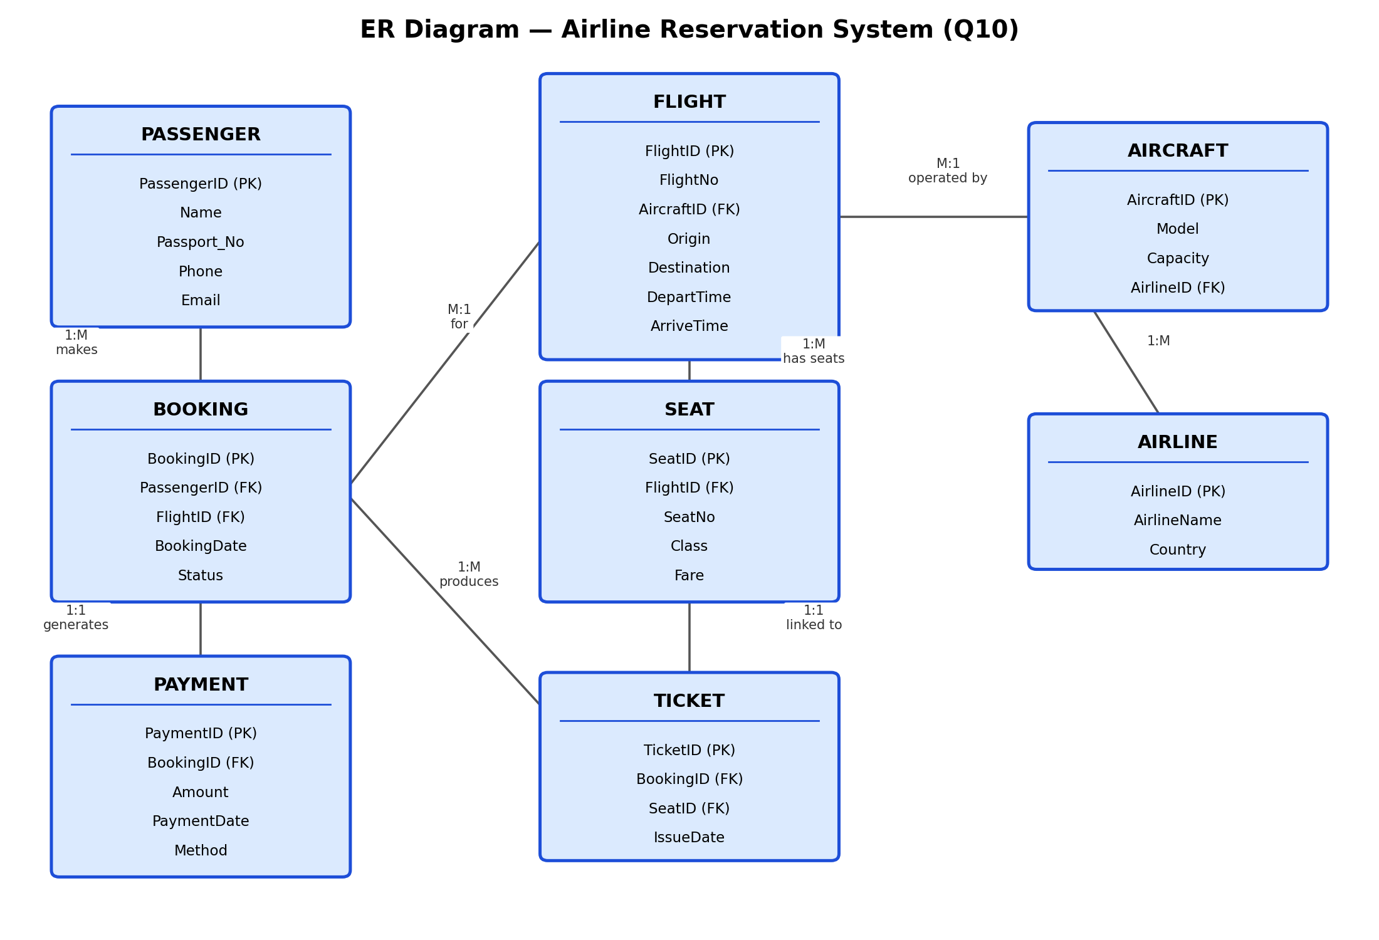
Fig 10.1: Entity-Relationship diagram for the Airline Reservation System.

Query 1 — JOIN: passenger name with their flight details
SELECT P.Name, F.FlightNo, F.Origin, F.Destination, B.BookingDate
FROM Booking B
JOIN Passenger P ON B.PassengerID = P.PassengerID
JOIN Flight F ON B.FlightID = F.FlightID;

Query 2 — JOIN: seat and fare details for a given flight
SELECT F.FlightNo, S.SeatNo, S.Class, S.Fare
FROM Flight F
JOIN Seat S ON F.FlightID = S.FlightID
WHERE F.FlightNo = 'AI-202';

Query 3 — Sub-query: passengers who booked the most expensive seat class
SELECT DISTINCT P.Name
FROM Passenger P
JOIN Booking B ON P.PassengerID = B.PassengerID
JOIN Ticket T ON B.BookingID = T.BookingID
JOIN Seat S ON T.SeatID = S.SeatID
WHERE S.Fare = ( SELECT MAX(Fare) FROM Seat );

Query 4 — Sub-query: flights with more bookings than the average
SELECT F.FlightNo, COUNT(B.BookingID) AS Total_Bookings
FROM Flight F
JOIN Booking B ON F.FlightID = B.FlightID
GROUP BY F.FlightNo
HAVING COUNT(B.BookingID) > (
SELECT AVG(cnt) FROM (
SELECT COUNT(*) AS cnt FROM Booking GROUP BY FlightID
) AS FlightCounts
);

Query 5 — View: revenue collected per flight
CREATE VIEW FlightRevenueView AS
SELECT F.FlightNo, SUM(PM.Amount) AS Total_Revenue
FROM Flight F
JOIN Booking B ON F.FlightID = B.FlightID
JOIN Payment PM ON B.BookingID = PM.BookingID
GROUP BY F.FlightNo;

-- usage:
SELECT * FROM FlightRevenueView ORDER BY Total_Revenue DESC;

