
CSA05-DATABASE MANAGEMENT SYSTEMS

DBMS LAB - Experiment 5 (CoffeeShop Dataset)

AIM
To view the records from the table using SELECT commands with WHERE Clause and Pattern matching.

DESCRIPTION
The WHERE clause is used to filter records based on a specified condition. Pattern matching using LIKE is used to search for records matching a specified pattern. The % wildcard represents zero or more characters and the _ wildcard represents one character.

1. Select Database
USE collegedb;
OUTPUT:
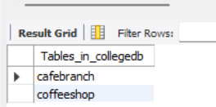

2. Display Coffee Name, Price and Customer Rating
SELECT CoffeeName, Price, CustomerRating
FROM CoffeeShop;
OUTPUT:
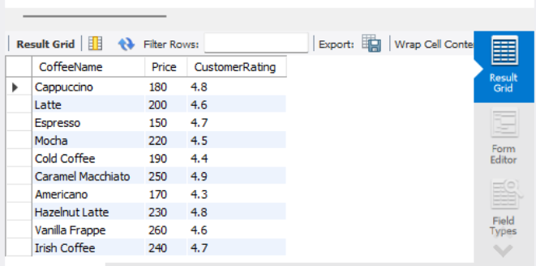

3. Display Coffees with Price Greater Than ₹200
SELECT *
FROM CoffeeShop
WHERE Price > 200;
OUTPUT:
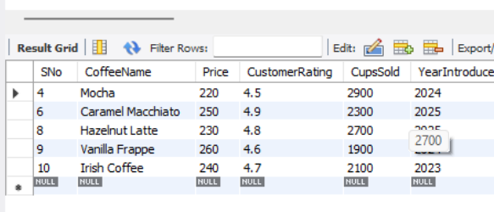

4. Display Coffees Introduced in 2023 or 2025
SELECT *
FROM CoffeeShop
WHERE YearIntroduced IN (2023, 2025);
OUTPUT:
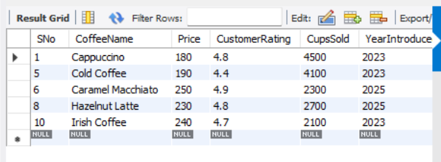

5. Display Coffees Introduced Before 2024
SELECT *
FROM CoffeeShop
WHERE YearIntroduced < 2024;
OUTPUT:
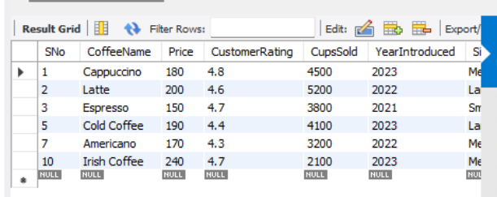

6. Display Coffees That Are Not Large
SELECT *
FROM CoffeeShop
WHERE Size <> 'Large';
OUTPUT:
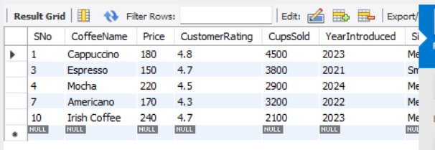
____________________________________________________________

7. Display Coffees Whose Name Ends With 'Coffee'
SELECT *
FROM CoffeeShop
WHERE CoffeeName LIKE '%Coffee';
OUTPUT:
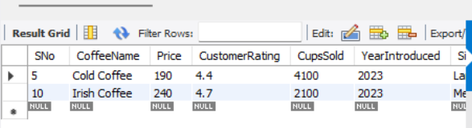

8. Display Coffees Whose Name Contains 'Latte'
SELECT *
FROM CoffeeShop
WHERE CoffeeName LIKE '%Latte%';
OUTPUT:
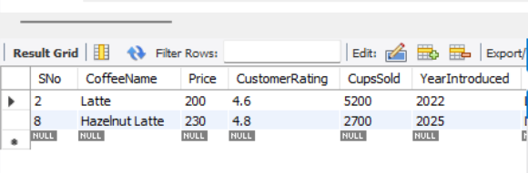

9. Display Coffees Whose Name Contains the Letter 'o'
SELECT *
FROM CoffeeShop
WHERE CoffeeName LIKE '%o%';
OUTPUT:
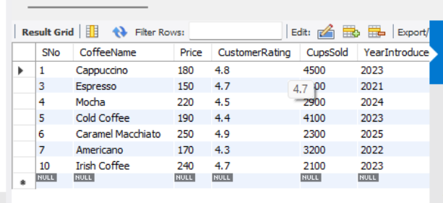
____________________________________________________________

10. Display Coffees Whose Names Are Not Exactly Six Characters
SELECT *
FROM CoffeeShop
WHERE CoffeeName NOT LIKE '______';
OUTPUT:
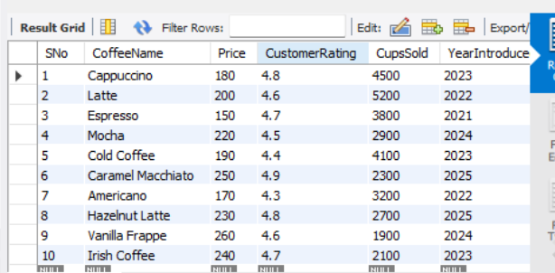
____________________________________________________________

11. Display Coffees Whose Name Contains 'am'
SELECT *
FROM CoffeeShop
WHERE CoffeeName LIKE '%am%';
OUTPUT:
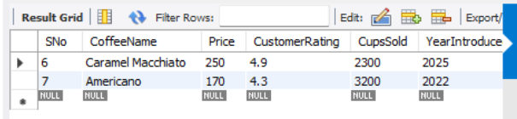
____________________________________________________________

RESULT
Thus, the SELECT commands using the WHERE clause and pattern matching with LIKE were successfully executed on the CoffeeShop table.

