
CSA05-DATABASE MANAGEMENT SYSTEMS

DBMS LAB - Experiment 4

AIM
To perform Data Manipulation Language (DML) operations using UPDATE and DELETE statements on the CoffeeShop table.

DESCRIPTION
UPDATE modifies existing records. DELETE removes records based on a condition.

1. Select Database
USE collegedb;
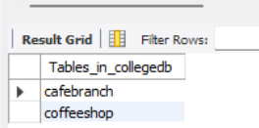

2. Display Records
SELECT * FROM CoffeeShop;
OUTPUT:
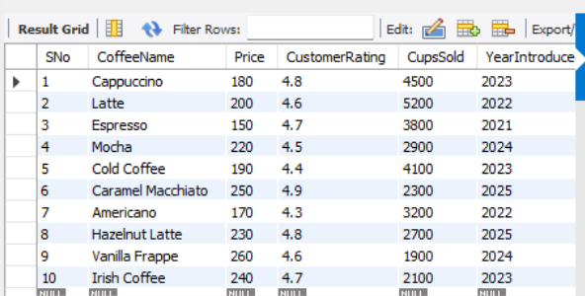

3. Update Coffee Name
UPDATE CoffeeShop SET CoffeeName='Cafe Latte' WHERE CoffeeName='Latte';
SELECT * FROM CoffeeShop WHERE CoffeeName='Cafe Latte';
OUTPUT:
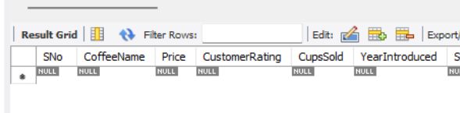
____________________________

4. Update Price
UPDATE CoffeeShop SET Price=260 WHERE CoffeeName='Irish Coffee';
SELECT * FROM CoffeeShop WHERE CoffeeName='Irish Coffee';
OUTPUT:
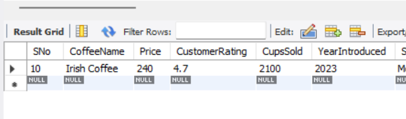

5. Delete One Record
DELETE FROM CoffeeShop WHERE CoffeeName='Vanilla Frappe';
SELECT * FROM CoffeeShop;
OUTPUT:
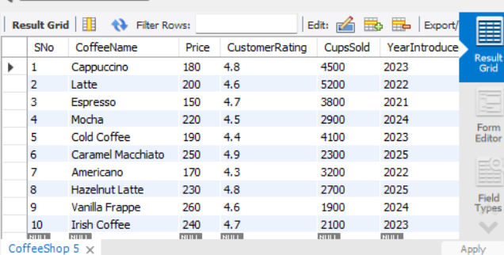

6. Delete by Condition
DELETE FROM CoffeeShop WHERE YearIntroduced<2022;
SELECT * FROM CoffeeShop;
OUTPUT:
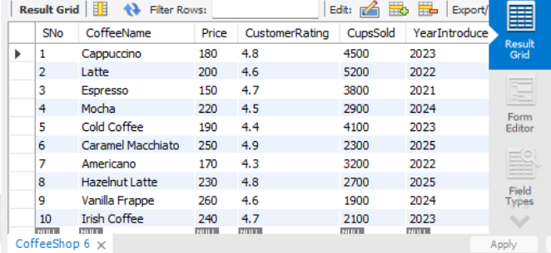

RESULT
Thus, UPDATE and DELETE DML statements were successfully executed on the CoffeeShop table.

