
CSA05-DATABASE MANAGEMENT SYSTEMS

DBMS LAB - Experiment 2 (CoffeeShop Dataset)

AIM

To implement Integrity Constraints using Data Definition Language (DDL) statements such as
PRIMARY KEY,
UNIQUE,
FOREIGN KEY.

Select Database

USE CoffeeDB;
OUTPUT:
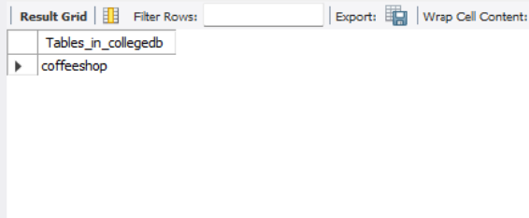

Create Parent Table

CREATE TABLE CafeBranch(
BranchID INT PRIMARY KEY,
BranchName VARCHAR(30)
);
OUTPUT:
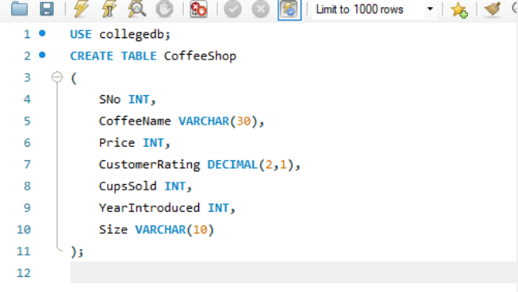
____________________________

3. Create CoffeeShop Table

CREATE TABLE CoffeeShop(
SNo INT,
CoffeeName VARCHAR(30),
Price INT,
CustomerRating DECIMAL(2,1),
CupsSold INT,
YearIntroduced INT,
Size VARCHAR(10),
BranchID INT
);
OUTPUT:
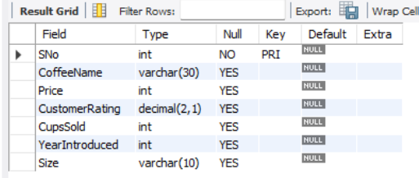

4. Add PRIMARY KEY

ALTER TABLE CoffeeShop ADD CONSTRAINT PK_Coffee PRIMARY KEY(SNo);
OUTPUT:
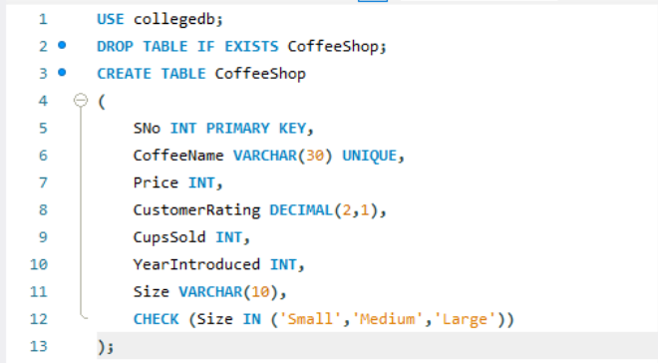

5. Add UNIQUE

ALTER TABLE CoffeeShop ADD CONSTRAINT UK_CoffeeName UNIQUE(CoffeeName);
OUTPUT:
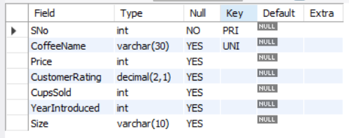

6. Add CHECK

ALTER TABLE CoffeeShop ADD CONSTRAINT CHK_Size CHECK(Size IN ('Small','Medium','Large'));
OUTPUT:


7. Add FOREIGN KEY

ALTER TABLE CoffeeShop ADD CONSTRAINT FK_Branch FOREIGN KEY(BranchID) REFERENCES CafeBranch(BranchID);
OUTPUT:
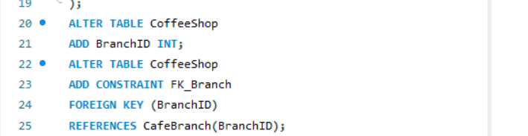
____________________________

8. Verify Structure

DESC CoffeeShop;

9. Display Table Definition

SHOW CREATE TABLE CoffeeShop;
OUTPUT:
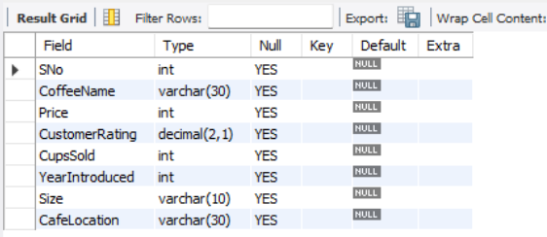

RESULT
Thus, the integrity constraints (PRIMARY KEY, UNIQUE, CHECK and FOREIGN KEY) were successfully implemented on the CoffeeShop table.

