
CSA05-DATABASE MANAGEMENT SYSTEMS
LAB MANUAL
DDL Commands – CREATE, ALTER, DROP

DBMS LAB - Experiment 1
AIM:
To Create, Alter, Drop, Rename, Truncate using Data Definition Language (DDL) statements. Description:
Data Definition Language (DDL) statements are used to define the database structure or schema. DDL Commands: Create, Alter, Drop, Rename, Truncate
➢ CREATE - to create objects in the database
➢ ALTER - alters the structure of the database
➢ DROP - delete objects from the database
➢ TRUNCATE - remove all records from a table, including all spaces allocated for the records are removed
➢ RENAME - rename an object
COMMANDS

Create Database

CREATE DATABASE CoffeeDB;
OUTPUT:
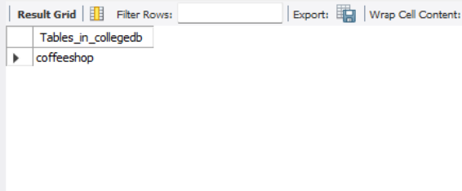

2. Select Database

USE CoffeeDB;
OUTPUT:
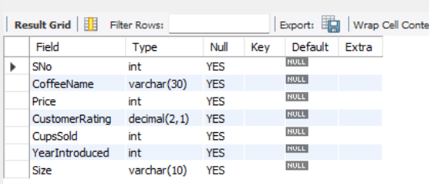

3. Create Table

CREATE TABLE CoffeeShop(
CoffeeName VARCHAR(30),
Price INT,
CustomerRating DECIMAL(2,1),
CupsSold INT,
YearIntroduced INT,
Size VARCHAR(10)
);
OUTPUT:
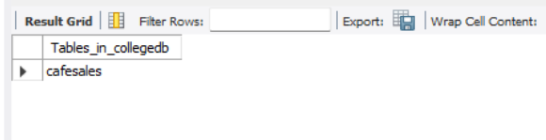

4. Display Table Structure

DESC CoffeeShop;
OUTPUT:


5. Insert Records

INSERT INTO CoffeeShop VALUES
('Cappuccino',180,4.8,4500,2023,'Medium'),
('Latte',200,4.6,5200,2022,'Large'),
('Espresso',150,4.7,3800,2021,'Small'),
('Mocha',220,4.5,2900,2024,'Medium'),
('Cold Coffee',190,4.4,4100,2023,'Large'),
('Caramel Macchiato',250,4.9,2300,2025,'Large'),
('Americano',170,4.3,3200,2022,'Medium'),
('Hazelnut Latte',230,4.8,2700,2025,'Large'),
('Vanilla Frappe',260,4.6,1900,2024,'Large'),
('Irish Coffee',240,4.7,2100,2023,'Medium');
OUTPUT:
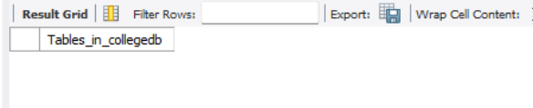

6. Display Records

SELECT * FROM CoffeeShop;
OUTPUT:


7. Add New Column
ALTER TABLE CoffeeShop ADD CafeLocation VARCHAR(20);
OUTPUT:



8. Verify Table
DESC CoffeeShop;
OUTPUT:


9. Drop Added Column
ALTER TABLE CoffeeShop DROP COLUMN CafeLocation;
OUTPUT:


10. Verify Table
DESC CoffeeShop;

OUTPUT:

11. Rename Table

ALTER TABLE CoffeeShop RENAME TO CoffeeShopDetails;
OUTPUT:

12. Display Tables

SHOW TABLES;
OUTPUT:
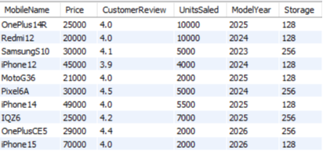
______________________________

13. Rename Back

ALTER TABLE CoffeeShopDetails RENAME TO CoffeeShop;
OUTPUT:

______________________________

14. Display Tables
SHOW TABLES;
OUTPUT:
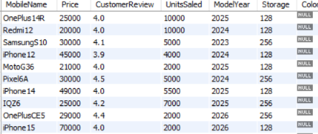

RESULT
Thus, the DDL commands (CREATE, ALTER, RENAME, DROP COLUMN, TRUNCATE and DROP) were executed successfully on the CoffeeShop table.

