
CSA05-DATABASE MANAGEMENT SYSTEMS

DBMS LAB - Experiment 3

AIM
To perform Data Manipulation Language (DML) commands such as
INSERT and SELECT on the CoffeeShop table.

DESCRIPTION
INSERT - Inserts data into a table.
SELECT - Retrieves data from a table.

1. Select Database

USE CoffeeDB;
OUTPUT:
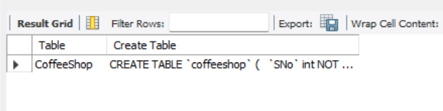

2. Create CoffeeShop Table

CREATE TABLE CoffeeShop(
CoffeeName VARCHAR(30),
Price INT,
CustomerRating DECIMAL(2,1),
CupsSold INT,
YearIntroduced INT,
Size VARCHAR(10));
OUTPUT:
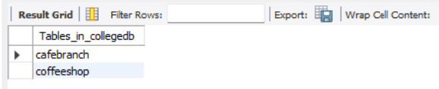

3. Insert Records

INSERT INTO CoffeeShop VALUES
('Cappuccino',180,4.8,4500,2023,'Medium'),
('Latte',200,4.6,5200,2022,'Large'),
('Espresso',150,4.7,3800,2021,'Small'),
('Mocha',220,4.5,2900,2024,'Medium'),
('Cold Coffee',190,4.4,4100,2023,'Large'),
('Caramel Macchiato',250,4.9,2300,2025,'Large'),
('Americano',170,4.3,3200,2022,'Medium'),
('Hazelnut Latte',230,4.8,2700,2025,'Large'),
('Vanilla Frappe',260,4.6,1900,2024,'Large'),
('Irish Coffee',240,4.7,2100,2023,'Medium');
OUTPUT:
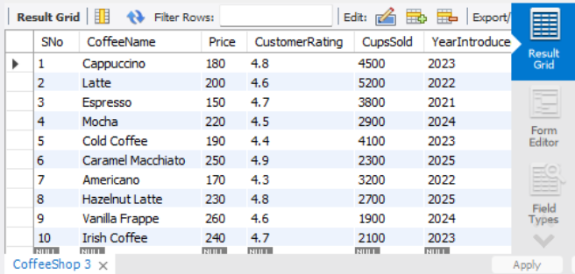

4. Display Records

SELECT * FROM CoffeeShop;
OUTPUT:


RESULT
Thus, INSERT and SELECT DML commands were successfully executed on the CoffeeShop table.

