SIMATS ENGINEERING Vishal kruthik .V

(192521179)

ASSESSMENT TOOL 2

COURSE NAME: Database Management Systems COURSE CODE: CSA05

COURSE OUTCOME COVERED

CO4: Design database solutions incorporating file organization, indexing, and hashing techniques to optimize data storage and retrieval efficiency. (BL3, BL4)

Activity Tool : Industry Problem Solving Task (Medium) Assessment Tool Weightage: 35%

Dr

QUESTIONS Total Marks: 50
Q.No | Question | Bloom's Level | Marks
1 | An e-commerce company needs to store 10 million product records. Recommend a file organization strategy and justify your choice with cost analysis. | BL4 – Analyze | 5
2 | A banking system requires fast retrieval of transactions by account number and date range. Design an indexing strategy with appropriate index types. | BL4 – Analyze | 5
3 | A healthcare system stores patient records accessed both by PatientID and by doctor name. Design a multi-level indexing solution. | BL4 – Analyze | 5
4 | A logistics company needs to efficiently handle dynamic insertions and deletions of shipment records. Analyze whether B-Tree or B+ Tree is more suitable. | BL4 – Analyze | 5
5 | Design a hashing scheme for an HR system with 5000 employees. Evaluate static hashing vs. extendible hashing for your scenario. | BL3 – Apply | 5
6 | An airline reservation system must support point queries by flight number and range queries by date. Propose a combined index structure. | BL4 – Analyze | 5
7 | For a university student database, design the file organization and | BL4 – Analyze | 5

 | secondary indexing to support fast queries by department and CGPA range.
8 | Analyze the disk block utilization for Heap, Sorted, and Hashed file organizations given 100,000 records with 50 bytes each and 4KB blocks. | BL4 – Analyze | 5
9 | A social media platform needs to index 500 million posts by user_id, timestamp, and hashtag. Design a composite indexing strategy. | BL4 – Analyze | 5
10 | Compare the performance (insert, delete, search time) of Heap File, Sorted File, and Hashed File for a supermarket billing system with 1 million daily transactions. | BL4 – Analyze | 5

Code of Conduct:

I Vishal Kruthik (192521179) certify that this submission is my original work and that I have adhered to the guidelines specified for this assessment. I understand that any violation of academic integrity rules will result in disciplinary action.

Signature of the student:


RUBRICS FOR CALCULATION:

Criteria | Weighta ge | Level 4 – Exemplary | Level 3 – Proficient | Level 2 – Developing | Level 1 – Beginning
Criteria | Weightag e | Level 4 – Exemplary | Level 3 – Proficient | Level 2 – Developing | Level 1 – Beginning
Understandin g of Industry Problem | 20% | Comprehensi ve  understandin g of real-world problem and constraints | Good  understandin g with minor gaps in requirements | Basic understandi ng; some  requirement s unclear | Poor understandi ng;  misinterpret s problem context
Application of  Engineering Concepts | 25% | Applies advanced and relevant concepts effectively to solve the problem | Applies  appropriate concepts with minor errors | Limited  application of concepts | Incorrect or no  application of concepts
Solution | 25% | Innovative, | Logical and | Basic | Unclear or

Design |  | practical, and feasible  solution aligned with industry standards | feasible  solution with minor gaps | solution with limited feasibility | impractical solution
Use of Tools | 15% | Effective use of modern  tools,  technologies, and real data | Appropriate use of tools with correct implementati on | Limited or inconsistent use of tools | Minimal or incorrect use  of tools
Analysis | 10% | Thorough analysis with validated results and  performance evaluation | Good analysis with  reasonable validation | Basic analysis with limited  validation | Poor or no analysis
Professionali sm | 5% | Highly  professional, well-  documented, and clearly presented work | Good documentati on and  presentation | Basic documentati on with  some gaps | Poor documentati on and  presentation

\

Q1. File Organization for 10 Million Product Records

Recommended Strategy
Use a Hashed file organization for the primary product table, keyed on ProductID, combined with a B+Tree secondary index for range/category queries. Product-catalog access is dominated by exact-match lookups (add to cart, view product, update stock) rather than range scans, so O(1) average-case retrieval from hashing gives the best cost/performance trade-off at this scale.

Cost Analysis (≈10,000,000 records, ~100 B/record, 4 KB blocks, blocking factor ≈ 40)
Organization | Avg. block accesses (search) | Insert cost | Suitability
Heap (unordered) | ≈125,000 (linear scan of 250,000 blocks) | O(1) — append | Poor for search-heavy catalog
Sorted | ≈18 (binary search, log₂ 250,000) | O(n) — shift records | Bad insert cost at this volume
Hashed | 1–2 (direct bucket access) | O(1) avg. | Best fit for point lookups by ProductID
B+Tree index | 3–4 (tree height) | O(logF n) | Add as secondary index for category/price range queries

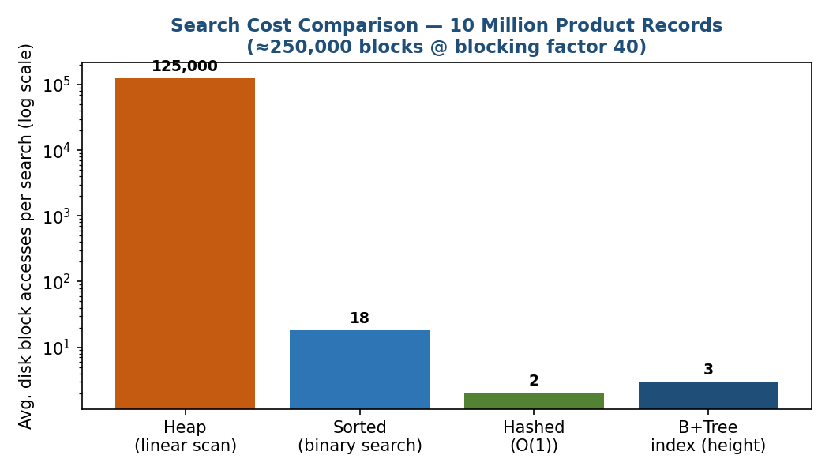
Justification: pure hashing minimises the dominant cost — disk block accesses — for the platform's most frequent operation (point lookup). A secondary B+Tree index is layered on top for category/price-range browsing, giving a hybrid design that is both cost-efficient and query-flexible.
Q2. Indexing Strategy for Banking Transactions (Account No. + Date Range)
Design

- Primary (clustering) index: B+Tree on AccountNo — transactions are naturally stored/retrieved clustered by account, giving fast exact-match and range access per account.
- Secondary (non-clustering) index: B+Tree on TransactionDate — supports bank-wide date-range reporting (e.g. all transactions on a given day) independent of account.
- Leaf nodes of both indexes are linked sequentially, so once the starting key is located, a range scan (date range within an account, or account range within a date) is a simple leaf-chain traversal — no repeated root-to-leaf descents.
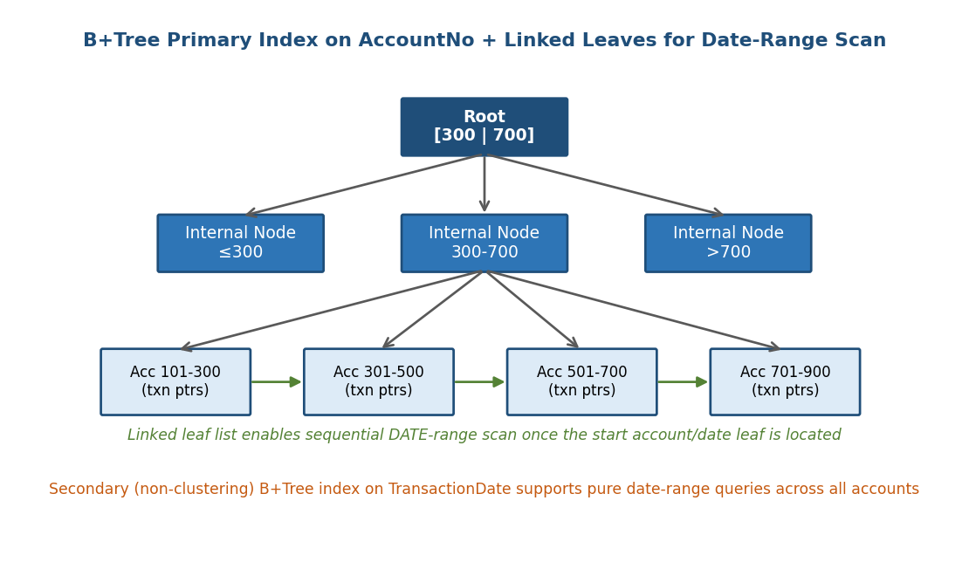

Why B+Tree over B-Tree or Hashing here
Hashing would give O(1) point lookup by AccountNo but cannot support the date-range requirement at all (hash order carries no ordering information). B+Tree supports both point queries (O(logF n)) and efficient range scans via the linked-leaf structure, which is essential for statements and audit queries over a date range.

Q3. Multi-Level Indexing for Patient Records (PatientID + Doctor Name)

Design
- Primary index: multilevel, dense B+Tree-style index on PatientID (the ordering/clustering key). A 2-level index keeps the top level small enough to stay memory-resident, cutting disk accesses to O(2) + 1 data block instead of a single huge first-level index scan.
- Secondary index: a separate dense index on DoctorName, since doctor name is not the storage key. Each entry points to a bucket of matching PatientID pointers (a doctor treats many patients), giving fast 'all patients of Dr. X' queries.
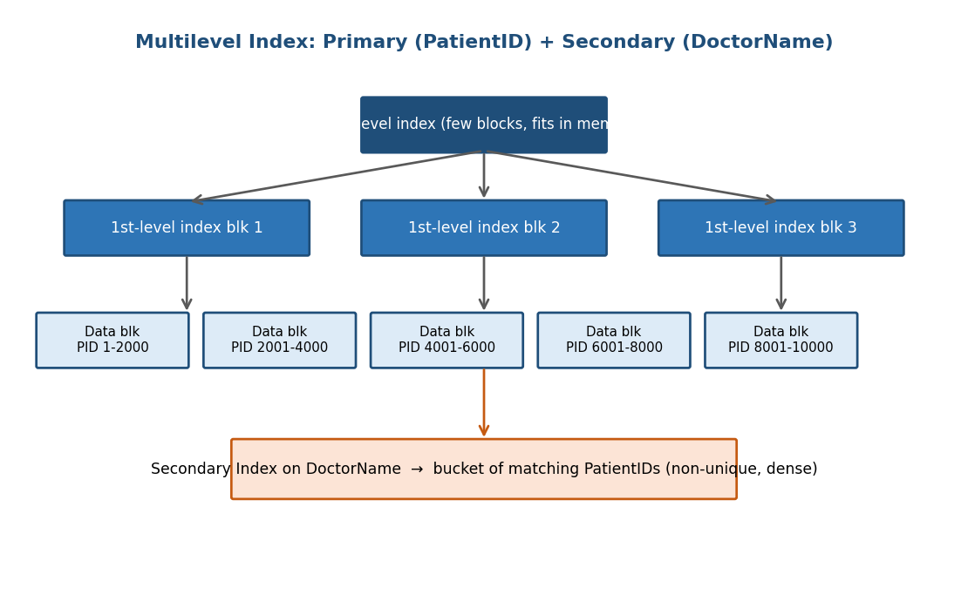

Cost Benefit
For N patient records with a first-level index of b1 blocks, a second level index of b2 = ⌈b1/fanout⌉ blocks reduces search cost from O(log₂ b1) with a single-level index to O(2) index-block accesses + 1 data-block access, which matters once the first-level index itself no longer fits in a handful of blocks (typical once patient counts reach the hundreds of thousands).

Q4. B-Tree vs B+Tree for Dynamic Shipment Records

Recommendation: B+Tree
A logistics system with frequent, unpredictable insertions and deletions of shipment records (created on booking, removed/archived on delivery) is better served by a B+Tree.

Reasoning
- All actual records live only in leaf nodes; internal nodes hold copies of keys purely for routing. Insert/delete operations therefore only restructure leaves (with occasional split/merge propagation), which is cheaper and more predictable than B-Tree, where records can live at any level.
- Leaf nodes are linked in sorted order, so range queries (e.g., 'all shipments dispatched this week') are answered by a single leaf-chain scan — critical for logistics reporting and route planning.
- Because non-leaf nodes hold only keys (no record data), B+Tree nodes are smaller and have a higher fan-out for the same block size, keeping the tree shallower and reducing the number of disk accesses per insert/delete/search as the shipment table grows.
- B-Tree can, in principle, answer a point query slightly faster if the key is found in an internal node, but this benefit is minor and is outweighed by the loss of efficient sequential/range access needed for shipment tracking dashboards.

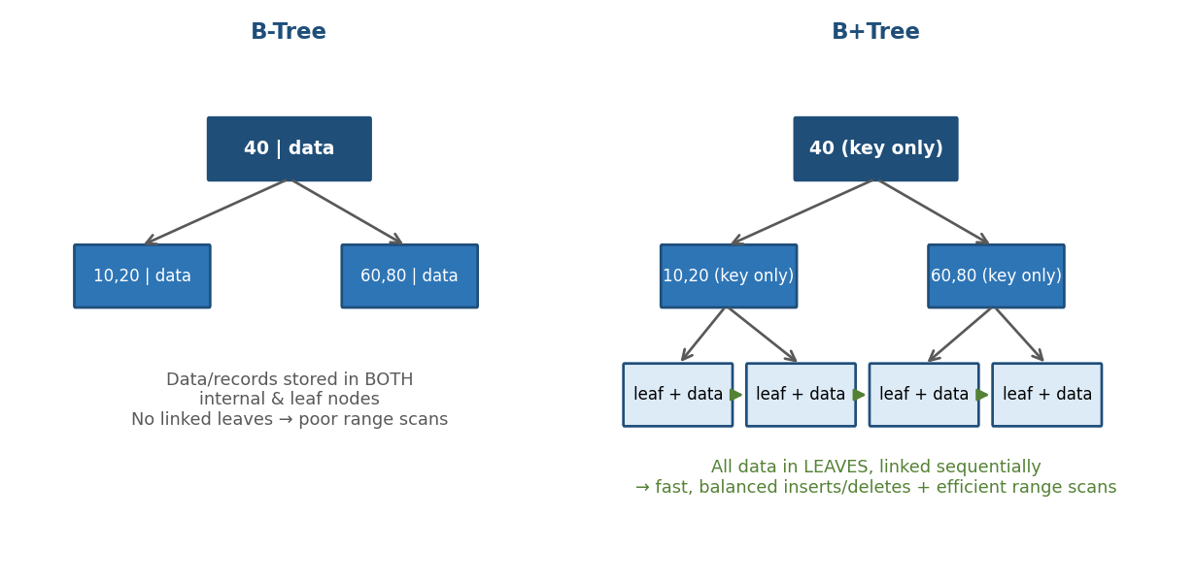

Q5. Hashing Scheme for an HR System (5,000 Employees)

Recommended: Static Hashing
With a known, slowly-changing population of ~5,000 employees, static hashing is the more appropriate and simpler choice.

Design
- Hash function: h(EmpID) = EmpID mod 10, giving 10 buckets.
- Target ≈50% load factor headroom: size buckets for ~1000 records capacity (200 employees/bucket at 5000 records) to absorb growth for a few years without overflow.
- Chained overflow buckets handle any bucket that exceeds capacity, at a small extra-access cost.

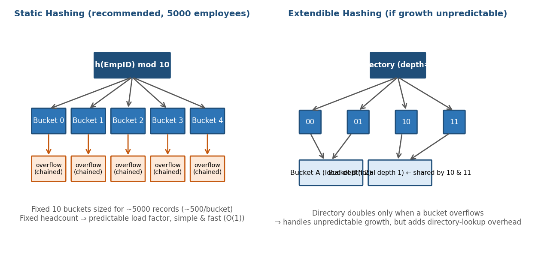

Static vs Extendible Hashing — Evaluation
Criterion | Static Hashing | Extendible Hashing
Best when | Record count known & stable (HR, ~5000) | Highly unpredictable/rapid growth
Lookup cost | O(1), no directory indirection | O(1) + 1 directory lookup
Implementation complexity | Simple, fixed bucket array | Directory + local/global depth bookkeeping
Growth handling | Needs full reorganization/rehashing if it overflows badly | Grows gracefully via directory doubling & bucket splits
Since HR headcount grows gradually and predictably (new hires, attrition), static hashing sized with reasonable headroom is simpler and equally fast, without extendible hashing's directory-indirection overhead.

Q6. Combined Index for Airline Reservations (Flight No. + Date)

Proposed Structure: Composite B+Tree Index on (FlightNo, Date)
- The index key is the concatenation (FlightNo, Date), ordered primarily by FlightNo and secondarily by Date within each flight.
- Point query on FlightNo alone: root-to-leaf traversal locates the first entry for that flight directly — O(logF n).
- Range query by Date for a specific flight: once the flight's leaf is located, its entries are already sorted by date, so the date range is read sequentially from the linked leaf chain.
- For date-only queries across all flights (e.g., 'all departures today'), a secondary index on Date alone is added, since the composite index does not order well by date across different flights.

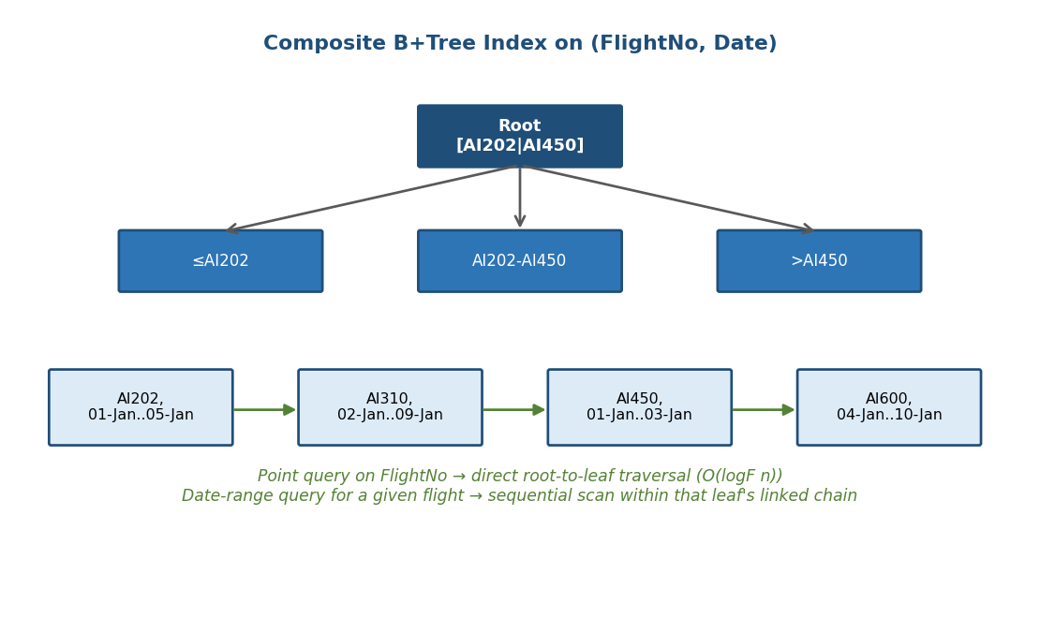

Q7. File Organization & Secondary Indexing for a University Student Database

Design

Primary file organization: Clustering file organization on Department — student records for the same department are stored physically together, since 'list all students in Department X' is a very common query and benefits from sequential block reads with no extra index lookup.
- Secondary index: a dense B+Tree index on CGPA — CGPA-range queries (e.g., 'CGPA ≥ 8.5 across all departments') cut across the clustering key, so a separate ordered index is required to avoid a full scan.

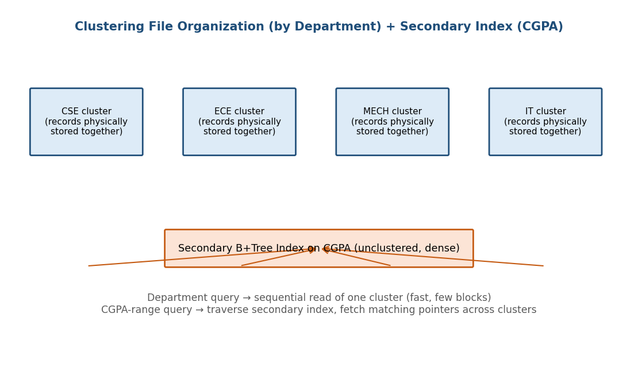
Query Cost Summary

- By-department query → sequential scan of that department's cluster only (≈ N_dept / bfr block accesses).
- CGPA-range query → B+Tree descent (O(logF n)) + sequential leaf scan for the range, then one random fetch per qualifying record (since the table is clustered by department, not CGPA).

Q8. Disk Block Utilization — Heap, Sorted & Hashed (100,000 × 50 B, 4 KB blocks)

Calculation

- Block size = 4096 bytes; record size = 50 bytes.
- Blocking factor bfr = ⌊4096 / 50⌋ = 81 records/block.
- Heap / Sorted (unspanned, no reserved slack): blocks = ⌈100,000 / 81⌉ = 1,235 blocks.
- Hashed (target ~80% load factor to limit overflow chains): effective capacity/block ≈ 81 × 0.8 ≈ 64.8 → blocks = ⌈100,000 / 64.8⌉ ≈ 1,543 blocks.

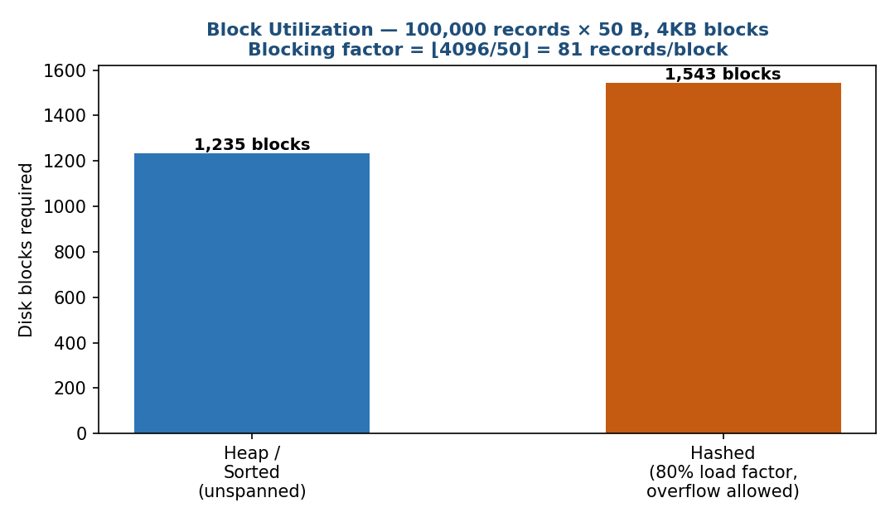

Interpretation
Heap and Sorted organizations achieve the same (near-100%) block utilization since both pack records tightly with no reserved space — they differ only in search/insert cost, not storage. Hashed files intentionally under-fill blocks (~80%) to leave room for new keys hashing into the same bucket, trading roughly 25% more storage for O(1) average search and insert time — a worthwhile trade-off for a 100,000-record table.

Q9. Composite Indexing for a Social Media Platform (500 M Posts)
Design

- Horizontal sharding: partition posts by hash(user_id) across many shards, so no single index structure has to scale to 500M entries alone.
- Per-shard composite index: B+Tree on (user_id, timestamp) inside each shard — supports a user's timeline (newest-first) with a single index descent plus a sequential leaf scan.
- Global inverted index on hashtag: a separate, term-partitioned inverted index mapping each hashtag → posting list of post_ids, since hashtag search cuts across all users/shards and needs its own structure (an LSM-tree-based index suits the very high write rate of new posts).

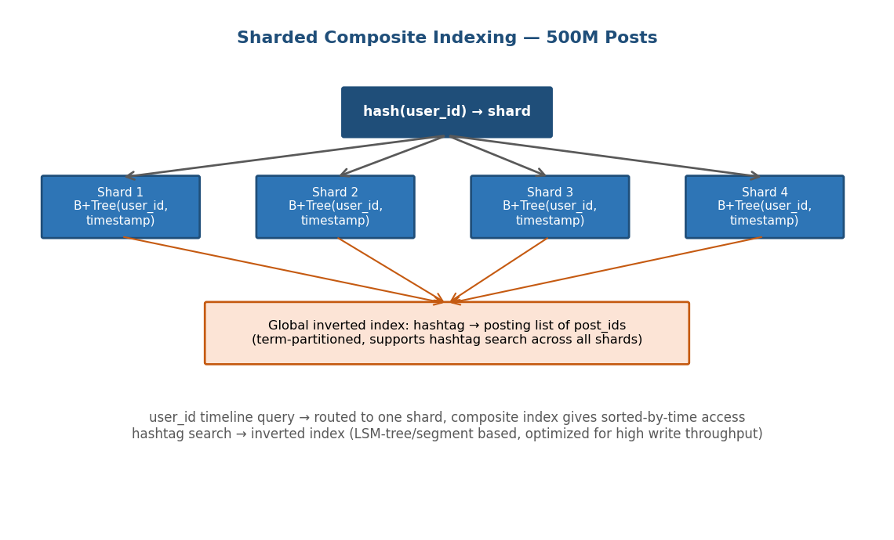
Why not one giant B+Tree
A single composite index over 500M rows would still work logically, but sharding keeps each physical index small enough that its upper levels stay cache-resident, keeps write hotspots distributed across machines, and lets the write-heavy hashtag index (posts are created far more often than searched by exact user+time) use a structure (LSM-tree) optimized for high insert throughput rather than a read-optimized B+Tree.

Q10. Heap vs Sorted vs Hashed — Supermarket Billing (1 M Transactions/Day)
Comparison

Operation | Heap File | Sorted File | Hashed File
Search (by key) | O(n) — avg. n/2 block reads | O(log₂ n) — binary search | O(1) avg. — direct bucket access
Insert | O(1) — append at end | O(n) — find position + shift records | O(1) avg. — hash to bucket (overflow if full)
Delete | O(n) — must search first, then mark/remove | O(n) — search + shift to close gap | O(1) avg. — search + unlink within bucket
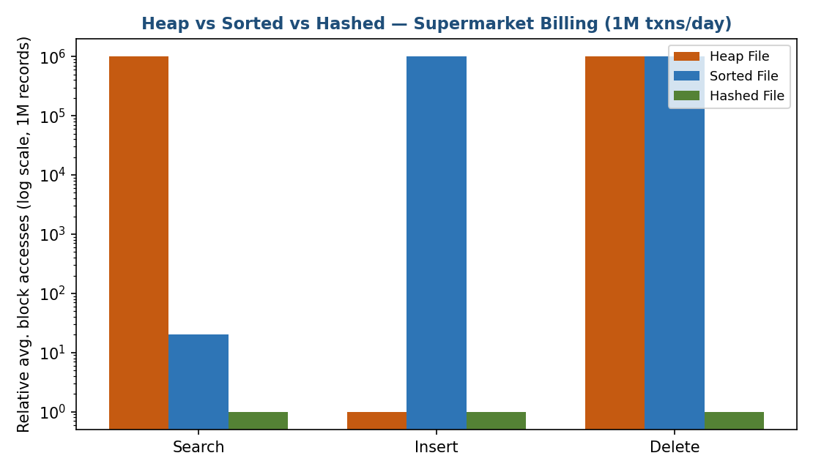

Recommendation for Billing
For a supermarket billing system with 1M transactions/day, Hashed file organization (keyed on transaction/bill ID) is best overall: billing is dominated by fast point inserts at checkout and fast point lookups for receipts/returns, both O(1) average case. Sorted files are ruled out by their O(n) insert cost at this volume; Heap files are fast to insert but too slow to search for receipt lookups and end-of-day reconciliation. A supplementary B+Tree index on Date/TerminalID can be added for range-based daily sales reports.

