**Step 1:**

**Open the solution; Update the appsettings.json inside Sales.ServiceApi. In our case it is SQL Azure.**

**Step 2:**

**Set Sales.ServiceApi as Start-up project. Select Sales.ServiceApi in Package Manager Console and execute the below mentioned commands**

* **EntityFrameworkCore\Add-Migration BusinessMigration1**
* **EntityFrameworkCore\Update-Database**

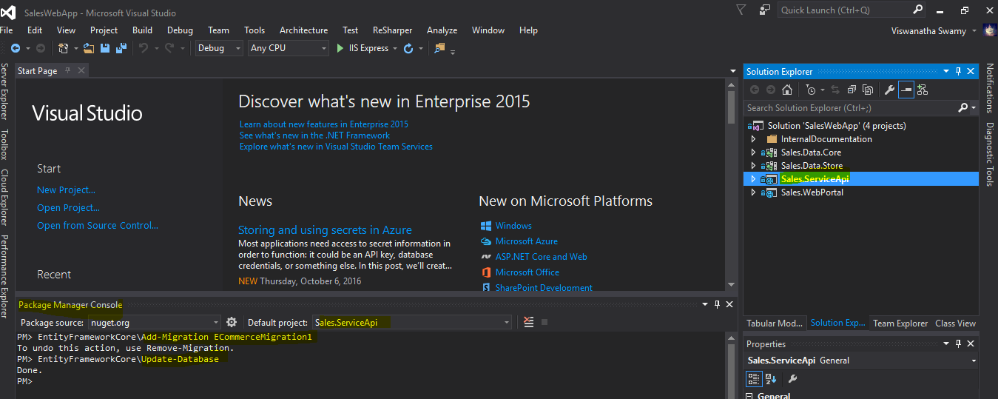

**Step 3:**

**Publish the Web API to Azure Cloud (**<http://salesserviceapi.azurewebsites.net/api/Products>**)**

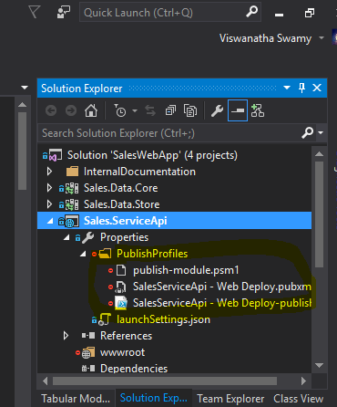

**Step 4:**

**Login into SQL Azure using SQL Management Studio. Execute TestDataInsertion.sql to create test data.**

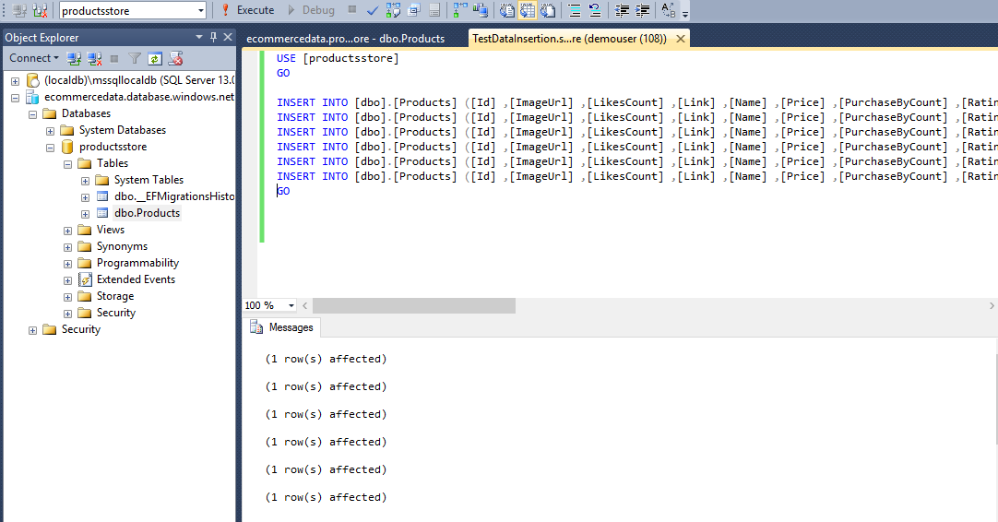

**Step 5:**

**Browse (**<http://salesserviceapi.azurewebsites.net/api/Products>**) to view the data.**

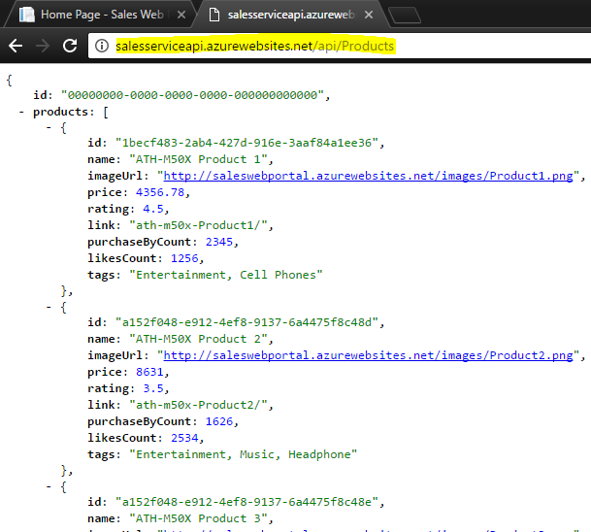

**Step 6:**

**Set Sales.WebPortal as Start-up project. Update the URL on line 18 inside product.controller.js [YourPath\SalesWebApp\Sales.WebPortal\wwwroot\app\product\product.controller.js]**

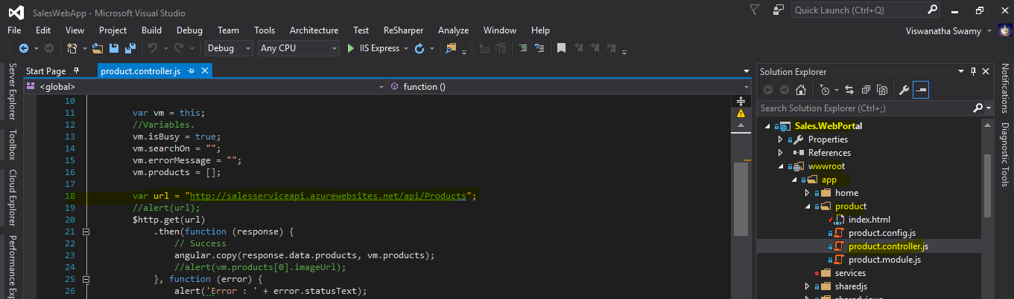

**Step 7:**

**Execute the application in Visual Studio 2015.**

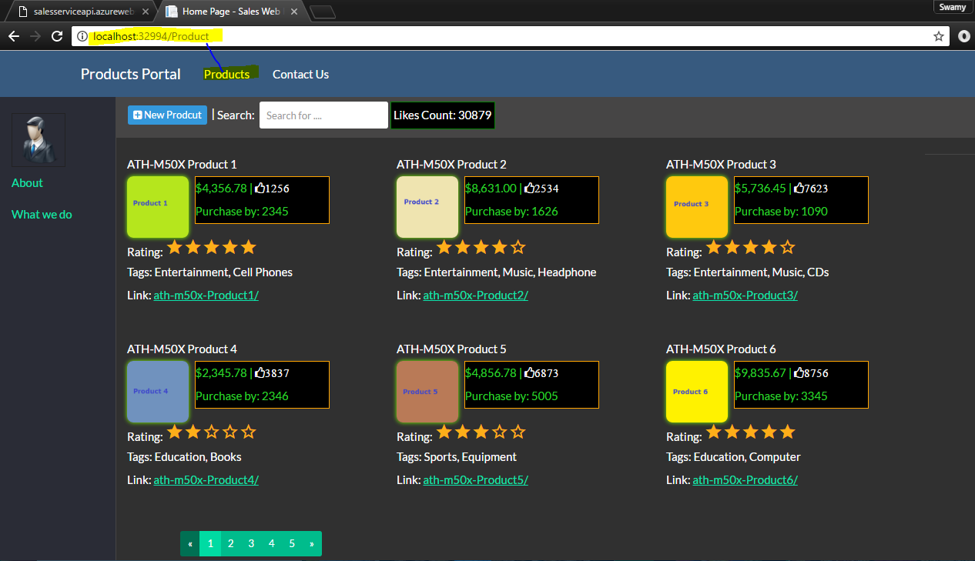

**Appendix**

Web API URL:

* <http://salesserviceapi.azurewebsites.net/api/Products>

Web Application URL:

* <http://saleswebportal.azurewebsites.net/>

Source Code:

* <https://github.com/vishipayyallore/ASP-Dotnet-Core-Samples/tree/master/SalesWebApp>

Read Me Path:

* <https://github.com/vishipayyallore/ASP-Dotnet-Core-Samples/tree/master/SalesWebApp/InternalDocumentation>