**Introduction**

Reverse auction application. Each product/service will have quantity assigned to it. The lowest price bid will be selected. Buyer will not be able to create an auction without start and stop time. Currently application will be support to single country and English language.

Currently single user who will be a Buyer. Buyer will create new auction and it will get added to the master list of auctions. Buyer will be able to see all the bids from suppliers for a given auction. Buyer will be able to invite the suppliers to auction. Even suppliers can join the currently running auctions.

Multiple Users (up to 50) who will be Suppliers. Suppliers will be from different countries and regions. To make a bid, supplier must lower the price below current best bid. Suppliers will be able to see their bids and the best bid in auction.

**Architecture Diagram** 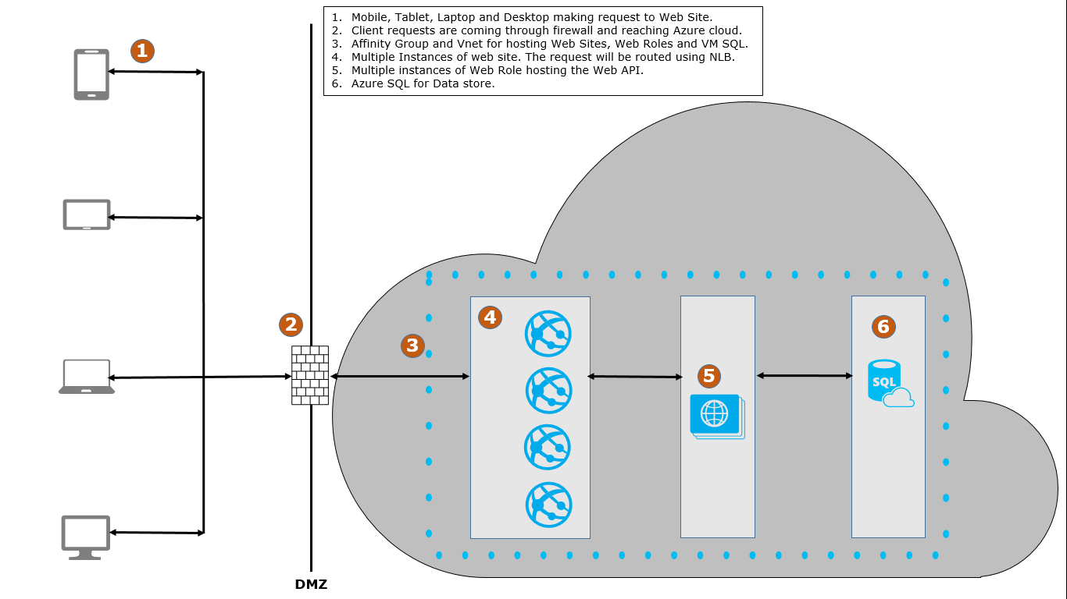

**Technologies:**

ASP.Net MVC is used to give the user a responsive UI. As we would be hosting this application as SaaS modal application will be hosted in Azure. Data Store will be SQL Server running in Azure. Web API with Entity Framework will be the interface to store and retrieve the data into data store. The same Web API infrastructure can be used with other client/mobile applications.

Front End UI will be developed using ASP.Net MVC, Bootstrap, jQuery and Angular JS.

**Registrations:**

* Each organization which would like to participate in Auctions should be registered.
* An Organization can either be Buyer OR Supplier.
* Each organization can have 1 OR more users.
* Each user has to register to participate in the auctions and will only belong to single company.

**Security:**

* Any unauthorized users will be able to access only Home, About, Contact, Register and login pages.
* Once a user logs in with registered credentials he will be able to participate (either buy/supply) in auctions.
* Data of one organization will not be visible to others.

**Validations:**

* Only one bid of same bid amount is allowed within the auction. Validation will be up to 2 decimal points.

**Limitations:**

* Initially there is no need to data mine or to provide statistics.
* Initially it is acceptable to the customer to manually setup all the suppliers that would participate in the auctions (worst case even with company x help and into the database directly).

**Testing:**

* Web API functionality will be unit tested using MS test (Automation).
* Controllers UI will be unit tested (Automation).
* Completed UI automation will be written in next version.
* Base lining, Perf Test and Load Testing along with Application Insights will be part of next version.
* Fault Tolerance testing will be part of next version.

**Future Enhancements:**

* It may even be considered that the auction will extend by 5 minutes after every bid automatically during the last 10 minutes of auction.
* Inviting suppliers to the group and approving/Rejecting.

**Auctions page of a buyer Wireframe:**

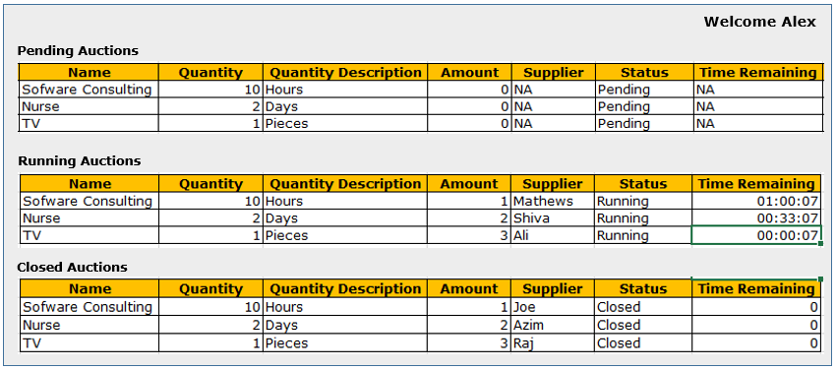

AuctionItem: Name, Description, StartTime, EndTime,

An Organization can either be Buyer OR Supplier. Each organization can have 1 OR more login credentials. User will only belong to single company.

Organization A [MSFT]

User 1 [Supplier]

Organization B [Citi Bank]

User 3 [Buyer] => Software Product

Organization B [HDFC Bank]

User 4 [Buyer] => Consultancy Service

Organization Details { }

Login Details

[www.Auctions.com](http://www.Auctions.com) [Web Application]

Model -> Organization ->

Model -> User/Login Credentials

Organization

Org_Users | OrgId | UserId [Many to Many]

AspNetUsers

Buyer -> entering the auctions

View -> Auctions.

There should be a details **button** in the grid. On click it should shows all the bids made by all the suppliers.

Read the requirement for the order of bids to be displayed.

Buyer auctions can be hardcoded **into the database**.

Suppliers will see all the auctions which are either pending OR running.

He will only see the best bid amount. He will not see who made that bid.

Display the Time for Supplier too.

Supplier has to see all of the bids made by him on a particular auction.

Supplier should be able to see the **best bid and also his best bid** too.

Bid Amount/Best Bid | Supplier Name | Auction Item |

| | 10 Hours of Software Consultancy |

| | 5 Pens of Parker Brand |

**Extending** ->

If External libraries should be extended such that future versions can be upgraded without code modifications in our framework.

Need to ensure (if we are extending a FW) that future versions of the framework is not breaking our existing code.