**Step 1:**

Execute both azure functions. Hospital Service on port 7071, and Pharmacy Service on port 7072.

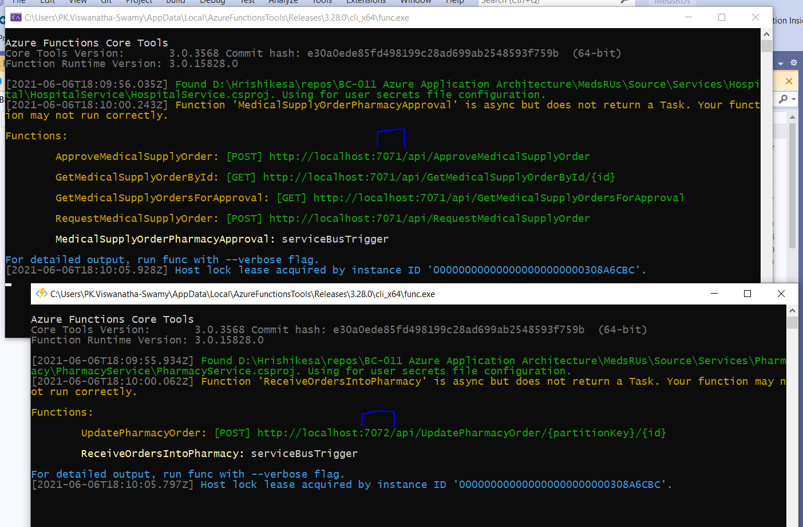

**Step 2:**

Open **medsrus-web** folder inside the Visual Studio Code.

Inside the **Terminal** execute “***npm i***”. This will install all the dependencies needed.

Inside the **Terminal** execute “**npm start**”. This will compile the solution and open the browser.

