**Installation of Docker for Windows on Windows 10**

**Virtual Machine VS Docker**

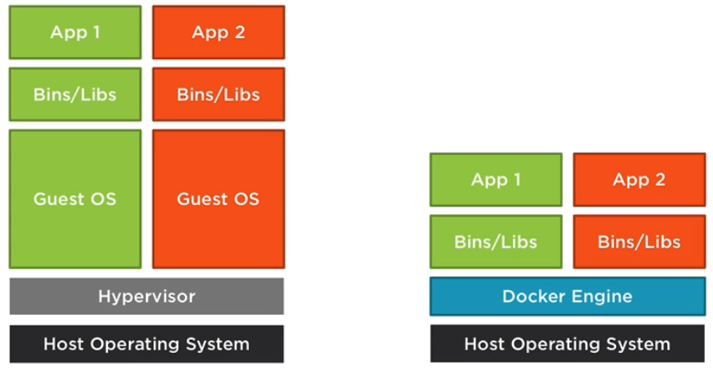

**Docker Community Edition & Hyper-V**

Windows 10 OS

Hyper-V

**Docker Client:**

* Interacts with Docker Engine
* Build and Manage Images
* Run and Manage Containers

<https://docs.docker.com/engine/docker-overview/>

**Image:** Read only template composed of layered file systems. Used to share common files and create Docker Container instances.

**Container:** As isolated and secure process created from the Image. This can be run, started, stopped, moved and deleted.

**Working with Existing Images**

Docker pull

Docker run

Docker images

Docker ps

Docker rm [Full Container Id OR first few unique characters]

Docker rmi [Remove images]

**Running containers from downloaded images**

docker run -p 8090:80 kitematic/hello-world-nginx

docker run -p 8090:80 -d kitematic/hello-world-nginx

docker exec -it sqlserver2017withoutmount bash

**Creating a Docker file**

**Creating our custom Image**

**Running containers from our custom Image**