Tools Set

.Net Command Line Interface (cli) Tools

https://www.microsoft.com/net/core#windowscmd

Text Editor [Windows: Notepad, Ubuntu: gedit]

Visual Studio Code

Git

**Demo 1:**

Using Terminal, CLI and Text Editor [Ubuntu 14.04 and Windows 10]

Github: <https://github.com/vishipayyallore/SpeakerSessions/tree/master/CSharpCorner_20May2017>

**Ubuntu 14.04**

Create a folder called “SortDemo”. Navigate to the Folder. Execute ***dotnet new console*** command to create a new project. Execute ***dotnet restore*** to restore the dependencies of the project. Please refer the image below.

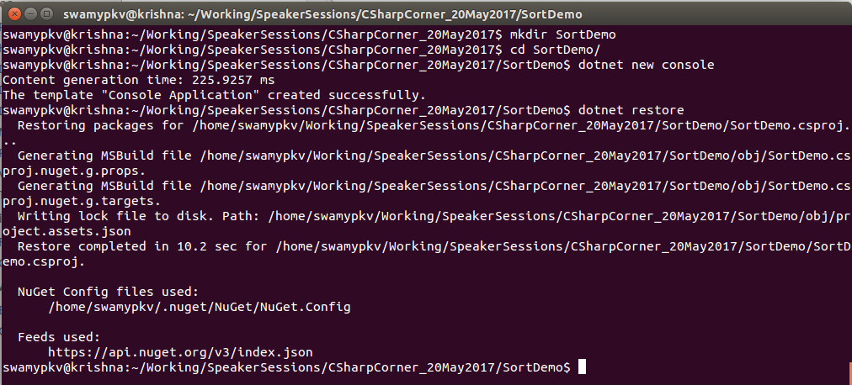

Execute ***dotnet build*** and ***dotnet run*** to execute the application. Please refer the image below.

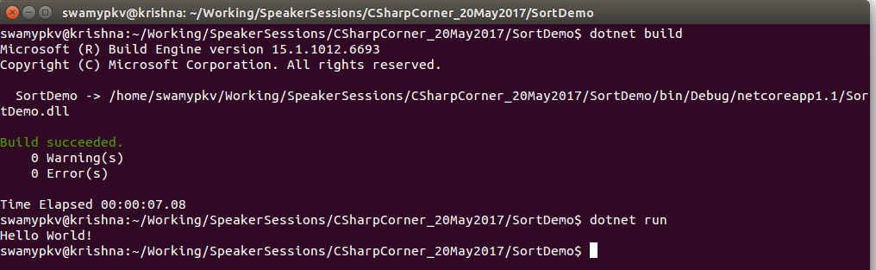

Open Program.cs in any text editor. In my case I am using gedit.

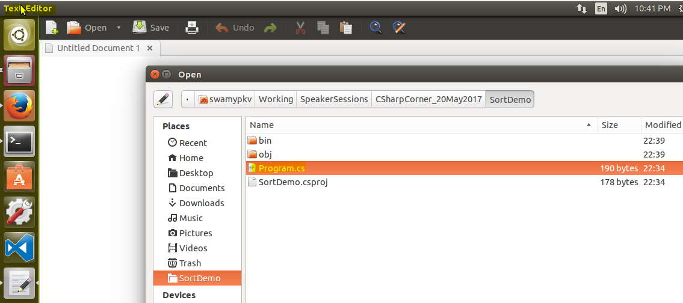

Replace the existing code with the code shown below.

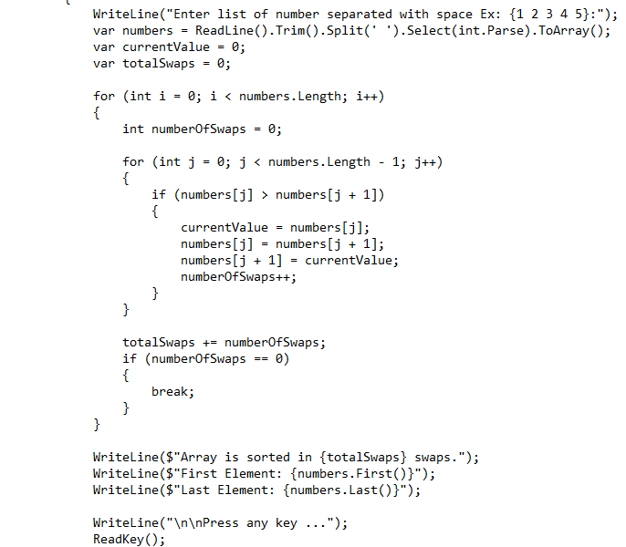

Execute the ***dotnet run*** to view the program execution. Please refer the image below.

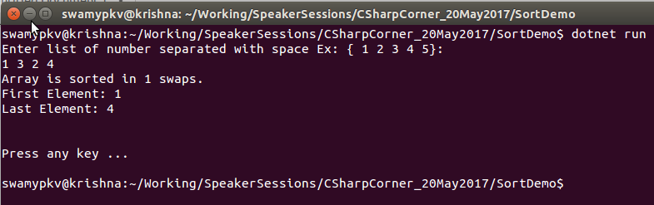

Push the code into Github.

**Windows 10:**

Get the latest from Github.

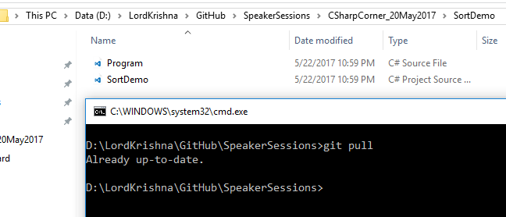

Open the Program.cs in notepad.exe. Add a comment to the Main method. Please refer the image below.

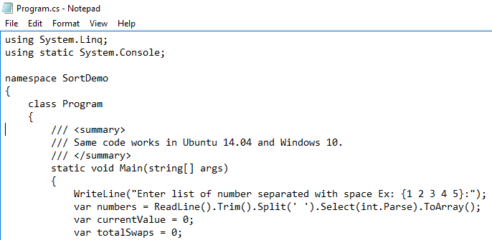

Execute ***dotnet restore*** and **dotnet run**, to view the program exection.

