oGr ak



**ak**

**Gr**

ak

Gr

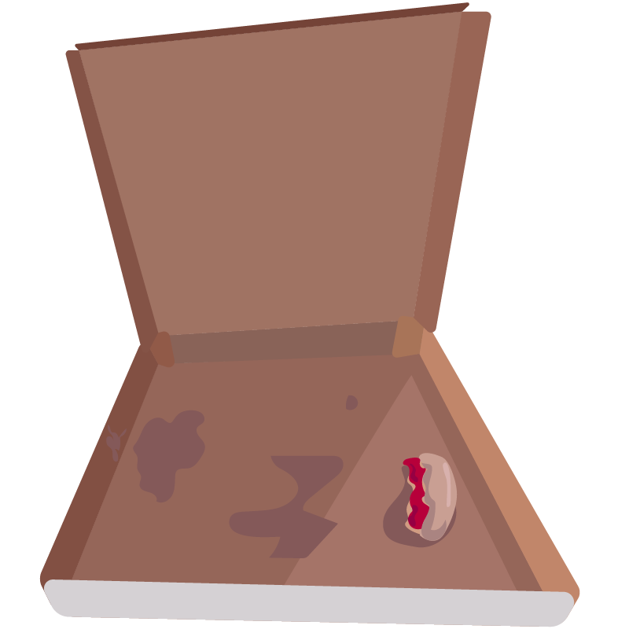

**There are no restaurant around you**