# Materials and methods

In this study, we performed current source density analysis of chronic laminar local field potential (LFP) recorded from the anterior frontal field A (FrA) of awake behaving Mongolian gerbils (Meriones *unguiculatus*). The goal was to capture the layer specific, spatiotemporal population activity in FrA at a mesoscopic scale. Animals (n=5) were made to perform a probabilistic foraging task where they learn to either exploit a food resource or explore an alternative option. A series of continuous foraging sessions with electrophysiological recordings from FrA allowed us to investigate the frontal activity patterns involved in decision making during an exploitation/exploration dilemma.

## Neural recordings from frontal region A (FrA)

Chronic in vivo electrophysiology data were recorded using a 32 multichannel laminar electrode (Neuronexus, A1x32-6 mm-50-177_H32_21mm), while the gerbils perform the probabilistic foraging task. The electrode was surgically implanted into FrA (5mm anterior to Bregma, 1.5 mm lateral to lambda). Animals were allowed to recover for at least one week post-surgery before starting the first foraging session. As gerbils have a genetic tendency to develop epileptic seizures, a 3-day behavioural screening protocol (established by Gonzalo Arias Gil and Dr. Kentaroh Takagaki at the SPL Department – LIN, based on Seto-Ohshima et al., 1992) took place before the surgery. Only the animals that did not show epileptic seizure during the screening test were included for the study.

### Experimental setup

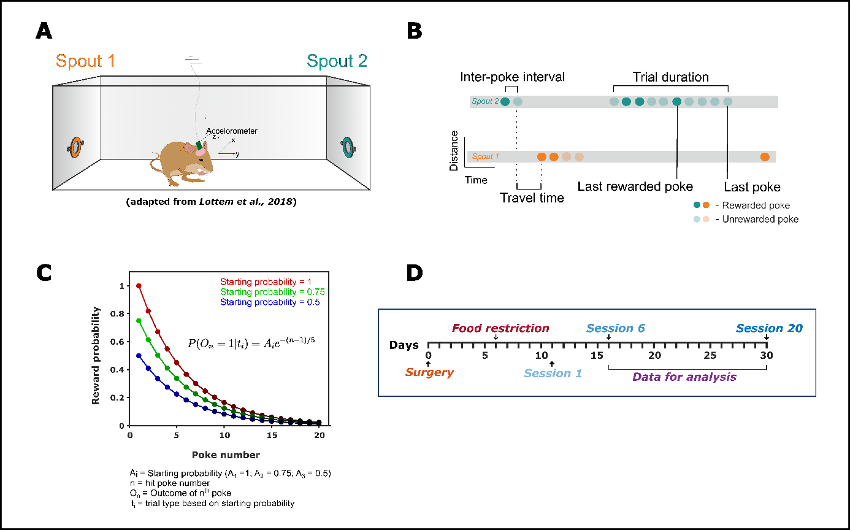

**Figure 1: Schematic representation of the behavioural setup and behavioural paradigm. A** –The foraging box (37cm x 26cm x 48cm) containing two spouts on the right (orange) and left (green) separated by a distance of 36 cm. The animal is placed in the middle and the head connecter is attached with the pre-amplifier of the data acquisition system. The animal freely moves within the box while the LFP signals are recorded simultaneously. **B** –The probabilistic foraging paradigm performed by the animal showing the inter-poke interval, trial duration and travel time. **C** – The exponential decay of reward probabilities for three different starting probabilities (Lottem et al., 2018). **D** – Timeline of the whole experiment from surgery to analysis.

The foraging box (37cm x 26cm x 48cm) was placed in a chamber that is electrically and acoustically shielded. It contained two spouts on the right and left side separated by a distance of 36 cm and each spout had an infrared (IR) emitter/sensor pair on the sides to detect the nose poke (Fig.1). Each spout was attached to a food dispenser (Campden Instruments Ltd., USA) placed outside the foraging cage.

Once a poke has been detected by the IR sensor, the signal is communicated to an external Arduino device which converts it into a digital signal. This digital signal indicating a poke registration is communicated to the computer through a MATLAB (MathWorks, R2020b) interface. Consequently, the starting reward probability and the following probabilities of reward was generated in MATLAB according to Eq.1. The starting probability was randomly selected from the three different possibilities (1, 0.75, 0.5, Fig.1C). The generated digital reward outcome (1 – reward; 0 – no reward) based on the reward probability was converted into an analog signal by a DAC (Arduino) and communicated to the commutator which provides the food pellet into the spout. The whole Arduino-MATLAB interface was performed using a custom Arduino and MATLAB script. There were two video cameras (Microsoft LifeCam HD-3000, top and side) to track the real-time behaviour of the animal inside the cage. The video recordings were captured using OBS 25.0.8 software.

Multichannel electrophysiology recordings were performed after connecting the head connector of the implanted electrode to the preamplifier (20-fold gain, HST/32V-G20, Plexon Inc.) which in turn is connected to a data acquisition system (INTAN Technologies). The electric cable was covered by a metal mesh for bite protection. Tension of the cable was relieved by a spring and a commutator that allows rotation and free movement of the animal inside the cage. Broadband LFPs were acquired using a broad band filter (range) and sampled at 30 kHz. Proper grounding of the animal through its common ground was ensured to avoid ground loops between recording system, foraging cage and the animal.

## Probabilistic foraging paradigm

The probabilistic foraging task was adapted from Lottem et al., 2018 in which the gerbils learn to do a nose poking behaviour to obtain rewards (Fig.1). Every foraging session consists of N trials, with each trial comprising a sequence of nose pokes (Fig.1B). Each individual nose poke has a probability of being rewarded with a 20 mg food pellet. The reward probability for consequent pokes within a trial decreased exponentially forcing the gerbil to alternate between the spouts, thereby introducing the exploitation-exploration dilemma (Fig.1C). Only the pokes that lasted for at least 100 ms were assigned as hit pokes and followed the reward probability rule. The error pokes (poke duration < 100 ms) were unrewarded.

Three different reward starting probabilities were used that followed the exponentially decreasing trend according to equation (1).

P (On = 1|ti) = Ai e-(n-1)/5 (1)

Where ti is the ith trial type (i = 1, 2, 3) corresponding to different exponential scaling factors (starting probabilities) with A1 = 1.0, A2 = 0.75, A3 = 0.5. ‘n’ denotes the hit poke number within a trial while On denotes the outcome of the nth poke (1 – reward and 0 – no reward). Trial types (A1, A2, and A3) were randomly ordered and the trial type was not cued to the animal. In order to obtain more trials within a session and to maintain the motivation to forage for longer period of time, the reward probability was forced to zero after the 20th poke in trial. A dead time of 100 ms was set to pause the session after every rewarded poke.

The strategy to adopt three different starting probability is to incentivize the goal directed behaviour of the animal. This way, they could benefit from the actual reward in each trial instead of adopting a reward independent strategy in the case of a fixed starting probability. The decay rate remained the same regardless of the starting probability.

There were no prior training sessions for the animals. They directly started the foraging session and learnt the behaviour over the course of time. Each session lasted a maximum of 30 minutes. There was a total of 20 sessions per animal that was performed continuously without any break. The behaviour of the gerbil was consistent throughout the session.

## Data analyses

All the pre-processing and analyses were performed in MATLAB (MathWorks, R2022b) using our custom written script.

### Data storage and analysis pipeline

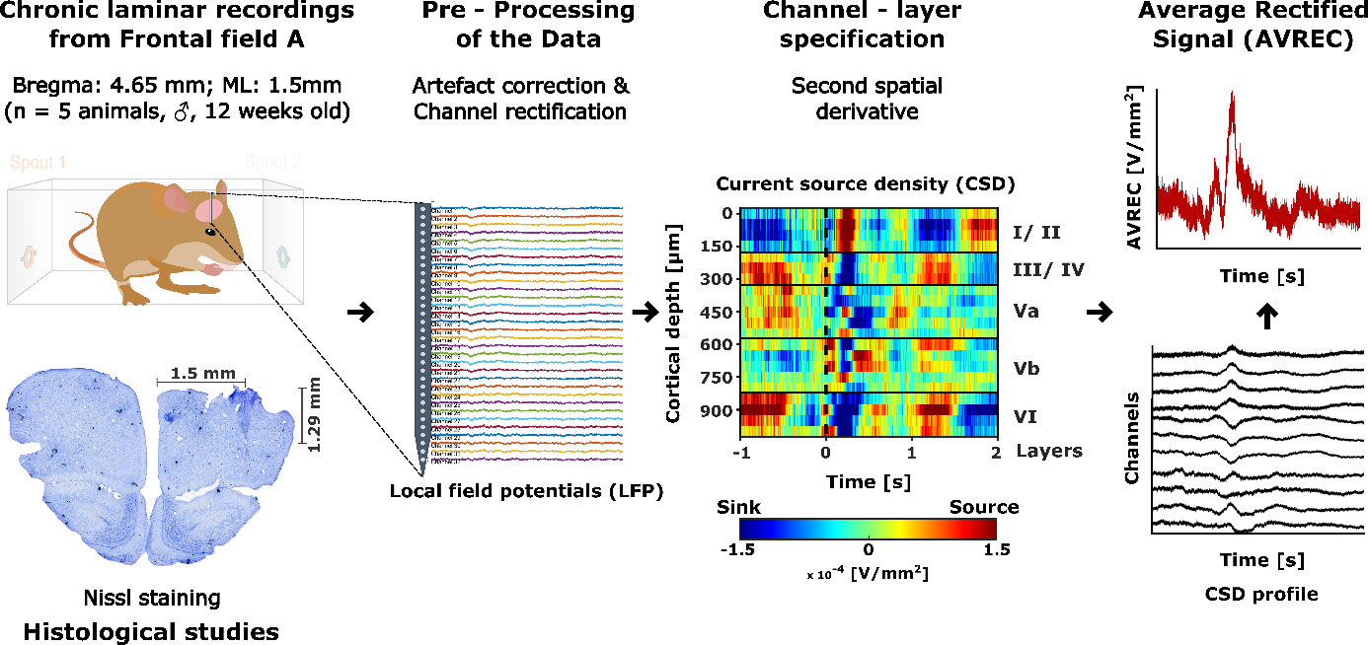

**Figure 2: Schematic representation of the data analysis pipeline.** The raw laminar local field potentials are pre-processed for artefact correction and channel rectification. The pre-processed LFP is then transformed into its respective current source profile by applying a second spatial derivative. Based on the activity profile and electrode depth information from histology, channel layer specifications are performed. Finally, the signals from current source profiles are rectified and averaged across the channels to obtain the overall cortical activity.

For each foraging session, the raw behaviour data was acquired as both “.csv” and “.mat” format while the raw electrophysiological data was acquired in “.dat” format. The size of raw electrophysiological data reached about (~ 423 GB). In order to reduce the complexity and combine the behaviour and electrophysiology data, a conversion routine was set up in MATLAB. The converted .mat file contained information about epochs of interest at the LFP level along with the important behavioural variables. The converted LFP data was stored as a three dimensional matrix (channels x samples x trials) containing the spatial (channel) and temporal (samples) information for each trial.

A data analysis pipeline was created in MATLAB that converts the raw LFP data into epochs of interest followed by preprocessing and current source density analysis as shown in Fig.1. The analysis pipeline runs for all animals, all sessions and creates a data container for each session. Finally, all session data containers were used to create animal wise and grand averaged CSDs and AVRECs.

### Pre-processing

Trial wise session data were analyzed to remove motion and chewing artefacts from the LFP using an amplitude cut-off factor (Threshold = mean ± 2 *standard deviation of raw signal). Furthermore, LFPs and CSDs were visualized to identify broken or damaged channels. The identified channels were corrected by a linear interpolation method based on the neighbouring unaffected channels at the LFP level. Trials with artefacts that couldn’t be removed were discarded from further analysis (< 1% of total trials). Once the LFPs are channel rectified and artefact corrected, the current source density profile for each trial were re-obtained and averaged per session. The artefact corrected and channel interpolated data was exported as a data container consisting of session averaged LFPs and CSDs for separate epochs of interest.

### Behaviour analysis

The behavioural data output (.mat/.csv) files for each session included all the required information to investigate and reconstruct the behavioural of each animal during the probabilistic foraging paradigm. For example, time stamps of starting of a nose poke, ending of a nose poke, duration of a poke, trial number and type, each poke’s reward probability and reward outcome (rewarded or not) are recorded. For this study, we mainly focused on three different behavioural features.

***Travel time.*** Travel time is defined as the time taken for the animal to travel from one spout to another (Fig.1B, Eq.2). This crucial parameter was used to distinguish whether the animal was randomly exploring the cage or showing a more goal-directed exploratory behaviour. The idea here is when the animal learnt the task properly, the travel time should be less (< 5s) and consistent across different sessions.

Travel time (in s) = (Starting time of the first poke in the current trial) – (End time of the last poke in the preceding trial) (2)

***Total rewarded pokes.*** The total number of rewarded pokes for different trial types was obtained to measure the animal’s performance in each session. Also, this measure was used to verify if the system correctly provides rewards based on the probability rule.

***Total consecutive unrewarded pokes made before leaving a spout.*** This is a critical measure to investigate the crucial decision-making behaviour of the animal i.e., the decision to explore the other spout. In a given trial, this measure is completely decided by the animal and hence acts as a good proxy to measure how much time the animal required to make up the decision to explore.

### Current source density (CSD) analysis

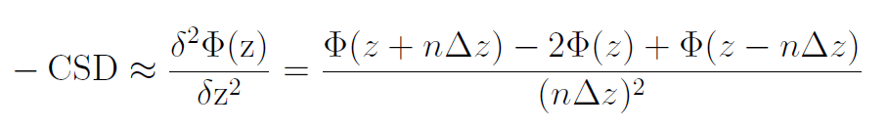The CSD profile was computed from the laminar LFPs by taking a second spatial derivative as shown in equation (3).

(3)

Φ is the field potential, z is the spatial coordinate perpendicular to the cortical laminae, Δz is the spatial sampling interval, and n is the differential grid (Mitzdorf, 1985). LFP signals were smoothed using a Hamming window of 9 channels that corresponds to a spatial kernel filter of 400 µm (Happel et al., 2010a).

CSD reflects the net amplitude of extracellular current flowing in (sinks) or out (source) of the neuronal tissue at a given point in time and space. Functionally, the current sinks represents the activation of excitatory synaptic populations while the source mainly represent the balancing return currents. This local functional spatiotemporal map of synaptic populations allows us to identify cortical layers by visualizing the spatiotemporal sequence of neuronal activation across the layers (Mitzdorf, 1985, Happel et al., 2010a).

Unlike the single- or multi-unit activity profile, the CSD profile provides a functional readout of cortical micro circuits in a wider mesoscopic scale. CSD transformation of LFPs is reference free and thereby less affected from referencing artefacts and far-field potentials. Furthermore, it improves the spatial resolution of the local synaptic current flow which is otherwise very poor in LFPs.

In order to get an overall columnar activity, the CSD profiles were transformed by averaging the rectified waveforms of each channel according to equation 4.

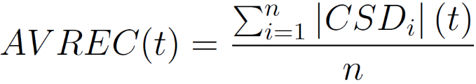

(4)

N is the number of recording channels and t is the time. The AVREC represents the temporal profile of the whole columnar activity (Givre et al., 1994; Schroeder, 1998).

### Feature extraction

Cortical layers were identified from the averaged CSD profile per session based on the functional spatiotemporal sequence of activation. Unlike sensory cortices such as auditory or visual cortex, the stimulus driven activation of layer IV is difficult to identify in FrA. Therefore, we time-locked (-1 to +2 seconds) the CSD profile to the end of a poke and compared it between two different conditions (with and without reward) in order to identify the reward/ prediction error response respectively in certain cortical layers. Typically, the first response is assumed to mark the infragranular layer V (reference). Upon identifying the infragranular layers, the granular and supragranular layers are identified and confirmed based on the electrode depth in the cortex retrieved from histology slides (Fig.2).

Early (0-100 ms) and late phases (100-500 ms) from the end of the poke were identified within the time-locked CSD and AVREC (-1 to +2 seconds) that could best separate the encoding of expectation and evaluation of reward respectively. Analyses were also carried out at individual poke level and the activity patterns were compared within and across these phases. CSDs were computed for individual pokes in each trial followed by grand AVREC per animal. Root mean square (RMS) for the grand AVREC signal was computed as a measure to compare and study the change in frontal activity patterns involved across pokes.

Further, to study the activity profiles at layer specific level, the sources were removed and only the sinks were considered to ensure that the signal is contributed only by layer specific local excitatory synaptic populations and eliminate the contribution of return currents from other cortical layers. Three channels that best represents a layer activity was taken and the RMS was computed for the average rectified sinks for each layer at individual poke level.

### Statistics

Statistical difference between pokes was tested by one-way ANOVA with each poke being a separate group. We used an overall significance level of 0.05 (α = 0.05).and Bonferroni correction for post-hoc testing. Before the statistical tests, the poke data was z-normalized within each animal.