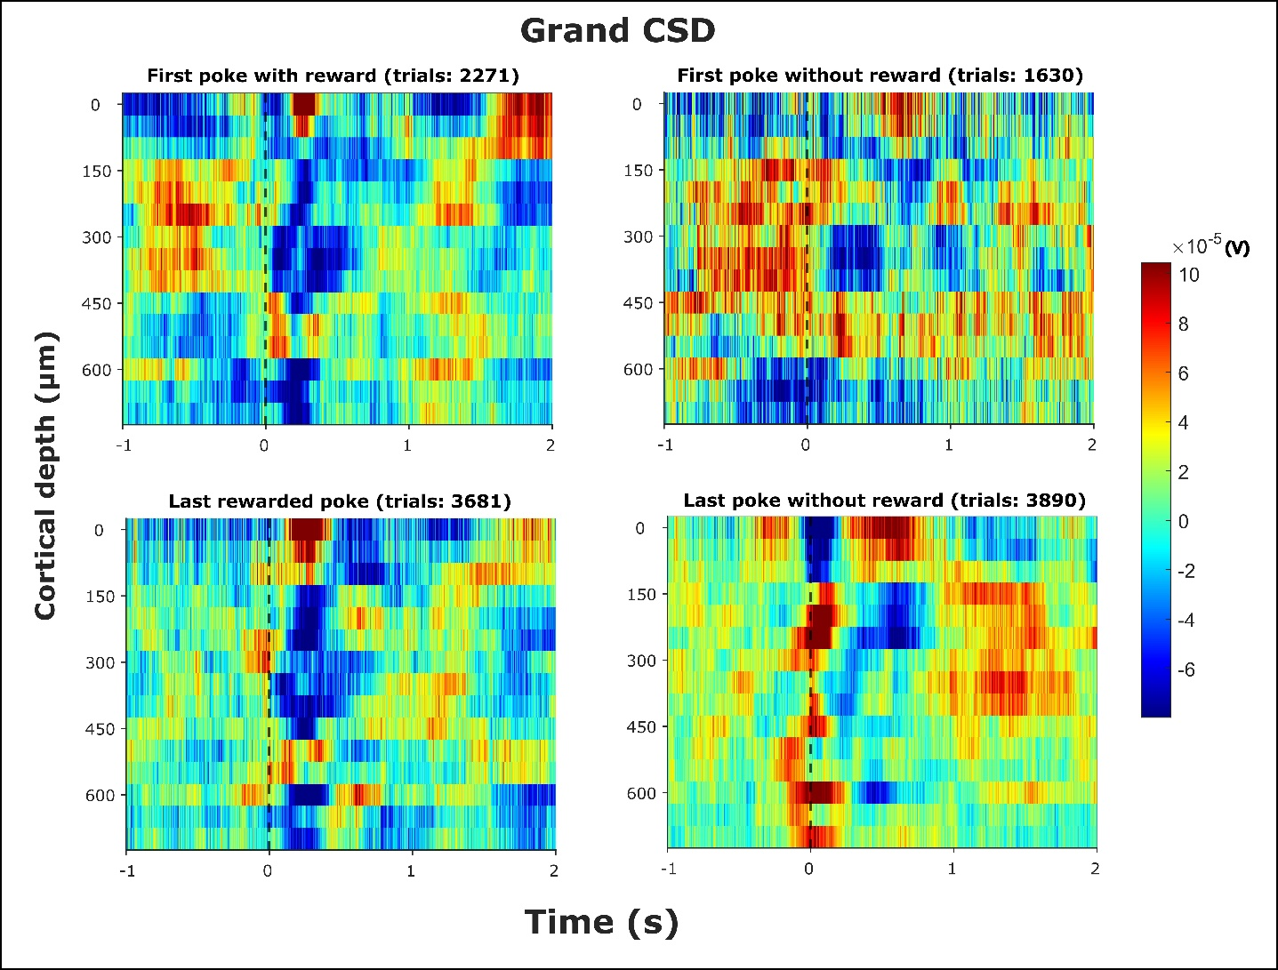

**Figure 1: Grand CSD**

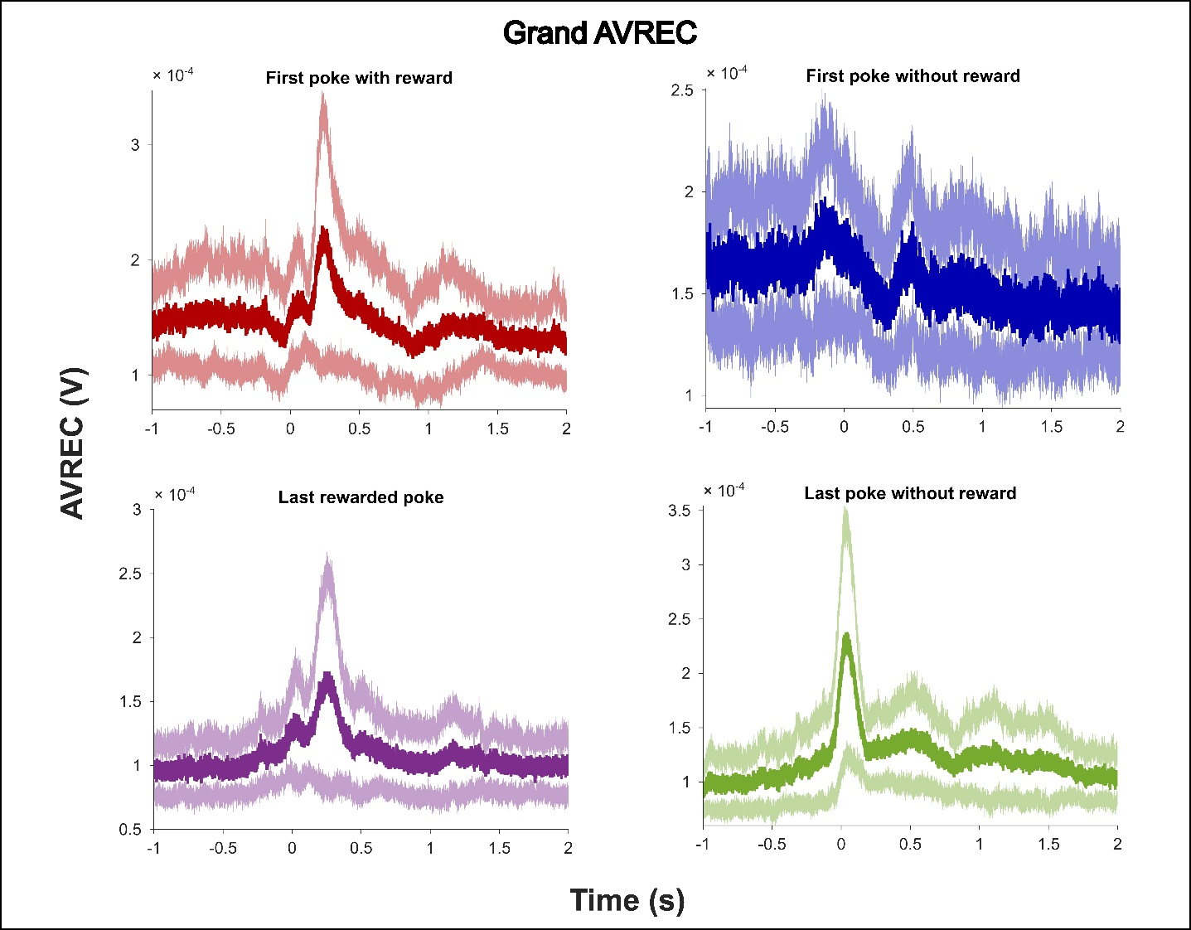

**Figure 1: Grand CSD**

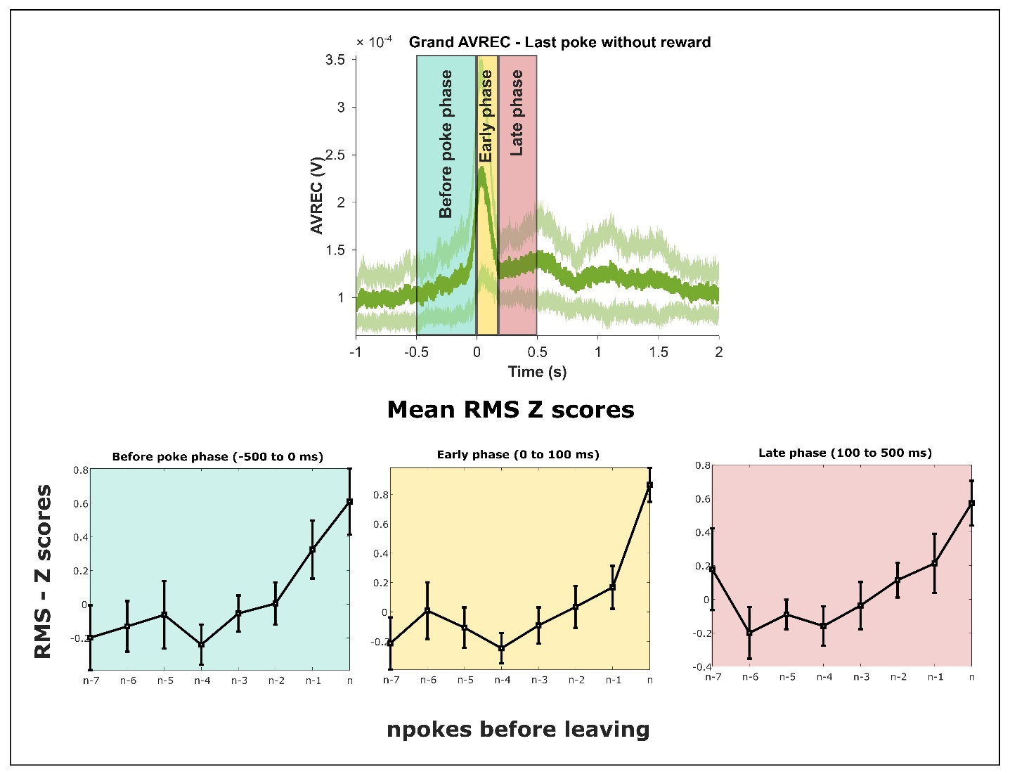

**Figure 1: Grand CSD**