**Front-end (React)**

* Components like : given in screen-shot are made to update ,view, register the employee

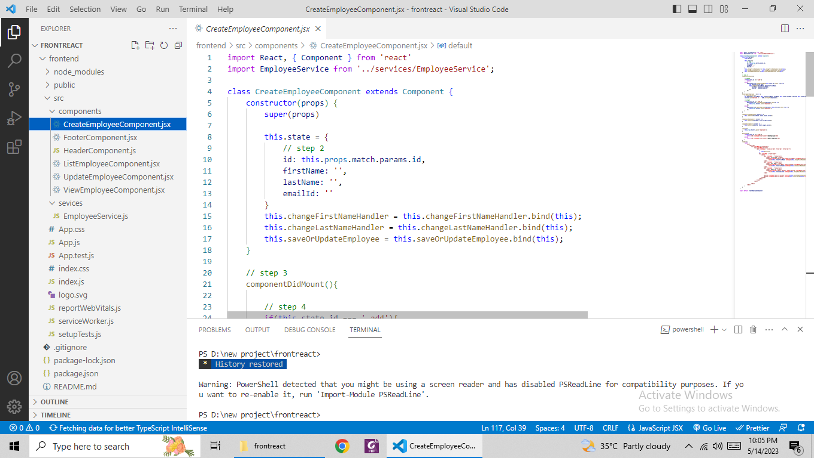

* Employee services

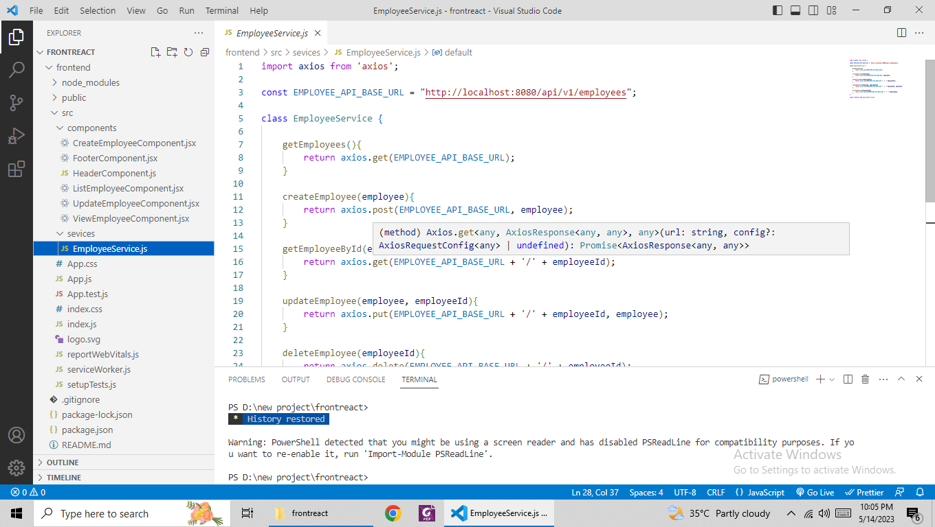

**Back-end(Spring-Boot)**

* All layers like controller service and repository is made

