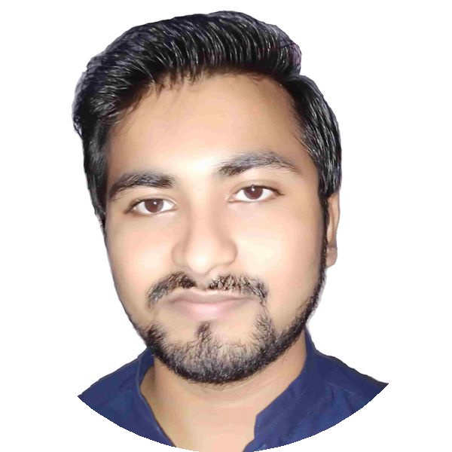Vishwas Maheshwari

Senior Software Engineer

 **+91-7839925747 ** [**vishmahe21@gmail.com**](mailto:vishmahe21@gmail.com)

 [**www.linkedin.com/in/vishwas- maheshwari-21061997**](https://www.linkedin.com/in/vishwas-%20maheshwari-21061997)

 **Uttar Pradesh, India**

# EXPERIENCE

## Senior Software Engineer

### LTIMindtree

08/2021 - Present Noida

#### Data Catalog Product

* Worked for the development of a data catalog tailored for data scientists, facilitating seamless data discovery and collaboration.
* Utilizing Microservices architecture with Docker and Kubernetes to ensure scalability, modularity, and ease of deployment.
* Implemented a secure authentication and authorization system using Spring Security and integrated Keycloak as an IAM tool.
* Developed RBAC mechanism for authorization.
* **Technology Used** - Core Java, Spring Boot, Spring Security, Microservices, Docker, Kubernetes, Apache Kafka, AWS (Basics), PostgreSQL.

# SUMMARY

Dedicated software developer with 6 years of experience specializing in Core Java, Spring Boot, Spring Security, and Microservices

(Docker, Kubernetes). Currently contributing to the development of a cutting-edge data catalog for data scientists. Proven track record of delivering high-quality software solutions. Seeking opportunities to leverage my skills and experience in a dynamic and challenging

environment.

# SKILLS

**Primary Skills**

**Core Java (5.8yrs)**

## Senior Systems Engineer

### Infosys Limited

**Spring Boot (5yrs)**

10/2018 - 08/2021 Pune

#### Material Cost Tracking and Amortization Tool

**Spring Security (2yrs)**

* Designed and implemented RESTful APIs using Spring Boot.

**Microservices (3yrs)**

* Implemented various algorithm to track the cost of material (e.g., parts) and reporting.

**Docker (3yrs)**

**Kubernetes (3yrs)**

* Troubleshot and resolved complex technical issues, ensuring optimal performance of applications.

**Rest APIs (4yrs)**

* **Technology Used -** Core Java, Servlet, Hibernate, Spring Boot, MySQL.

**Multithreading (3yrs)**

**Spring JPA (4yrs)**

**Hibernate (4yrs)**

# EDUCATION

## B.Tech (Information Technology)

### Dr. A.P.J. Abdul Kalam Technical University

08/2014 - 07/2018 Lucknow

**Apache Kafka (1yr)**

**MySQL (2yrs)**

**PostgreSQL (3yrs)**

**Other Skills**

**AWS (Basics)**

**IAM**

**Keycloak**

**Data Structures**

**Oauth2.0**

**Linux**

**PL/SQL**