**Name: Vishal Kumar**

**Division: CS-D**

**Roll No.: 68 Subject: OS**

**PRN: 12210207**

**Assignment No. 1**

**1. Change your password to a password you would like to use for the remainder of the semester.**

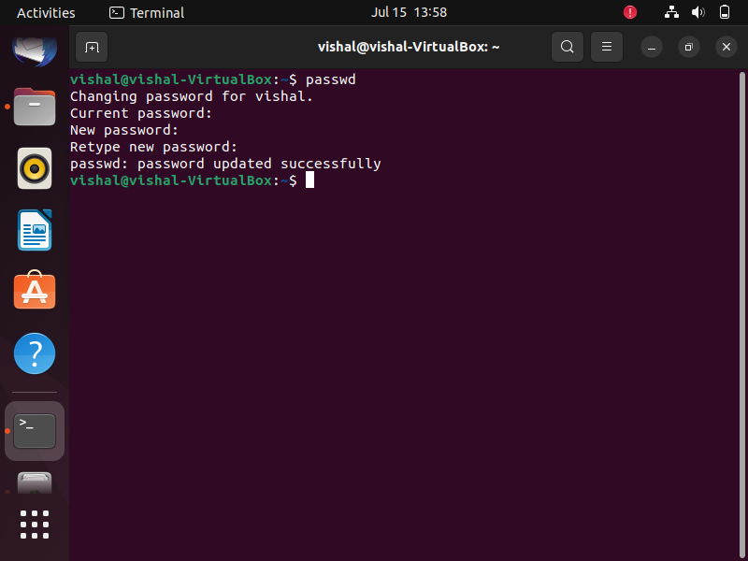

**2. Display the system’s date.**

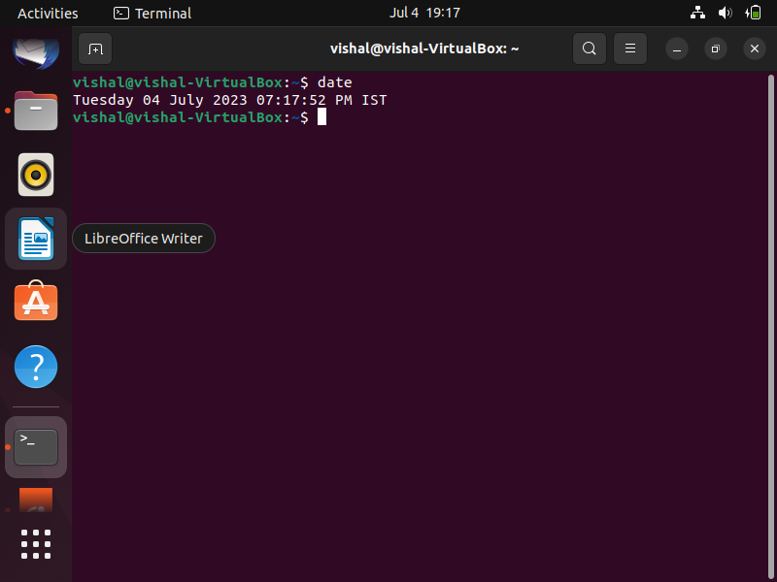

**3. Count the number of lines in the /etc/passwd file.**

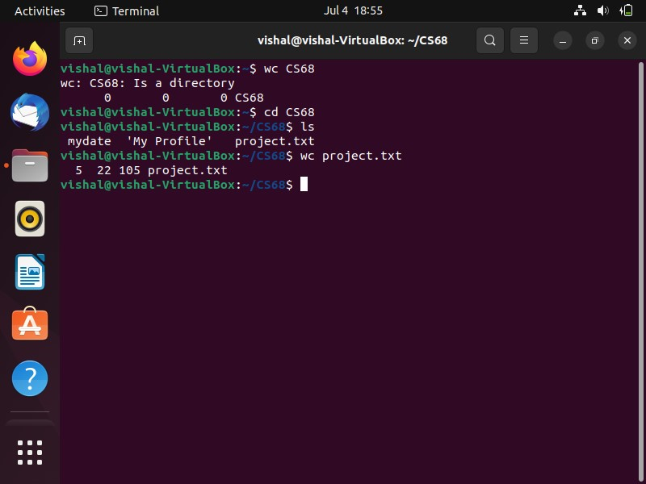

**4. Find out who else is on the system.**

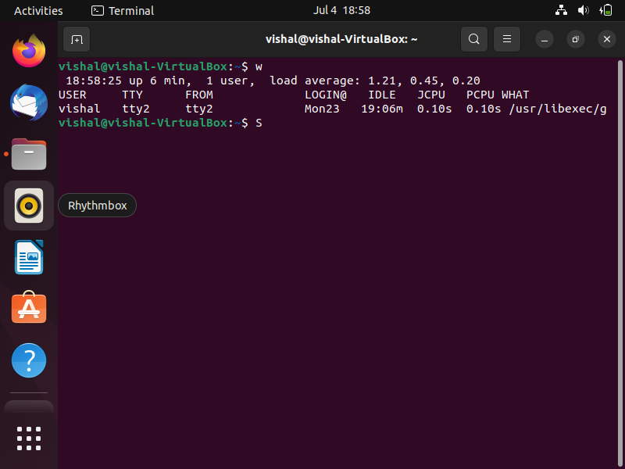

**5. Direct the output of the man pages for the date command to a file named mydate.**

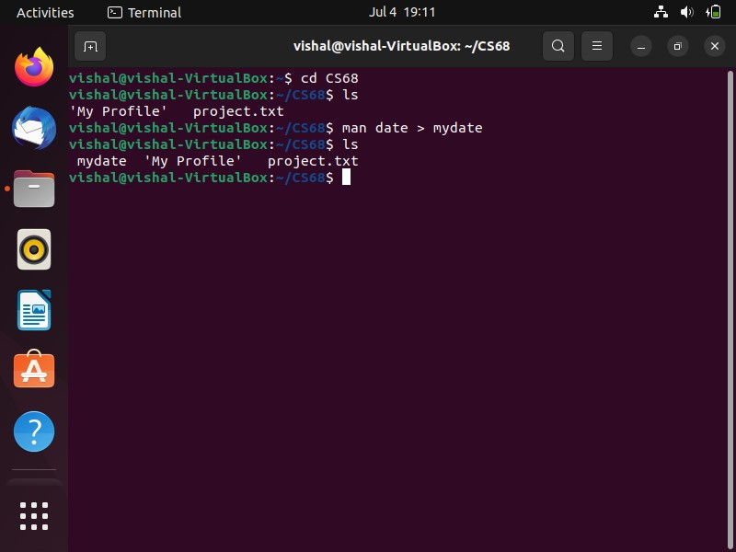

**6. Create a subdirectory called mydir.**

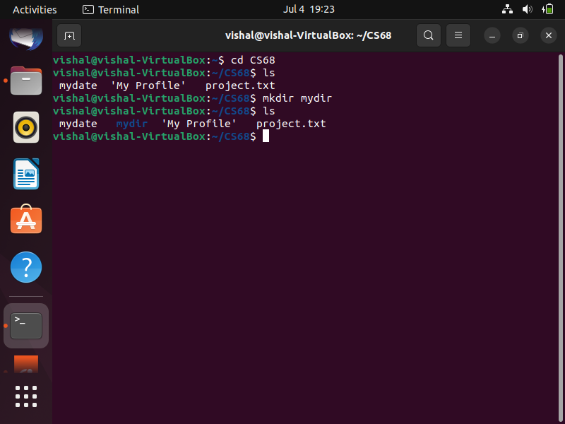

**7. Move the file mydate into the new subdirectory.**

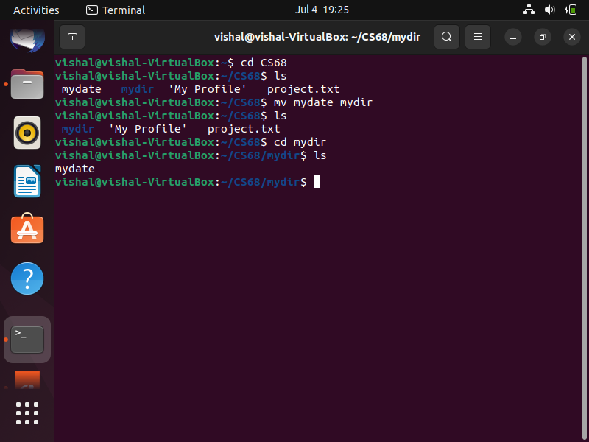

**8. Go to the subdirectory mydir and copy the file mydate to a new file called ourdate.**

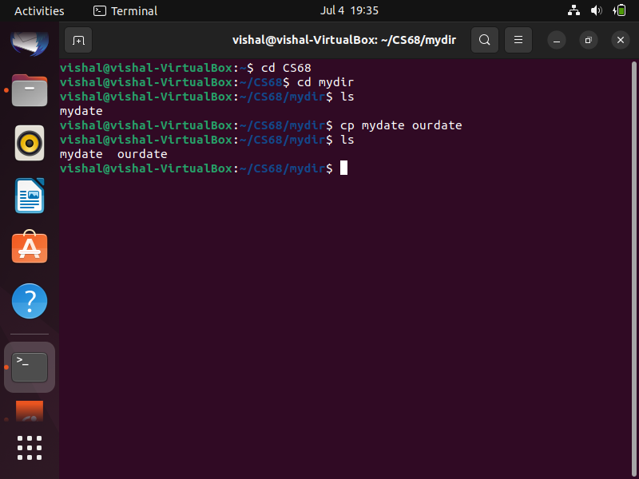

**9. List the contents of mydir.**

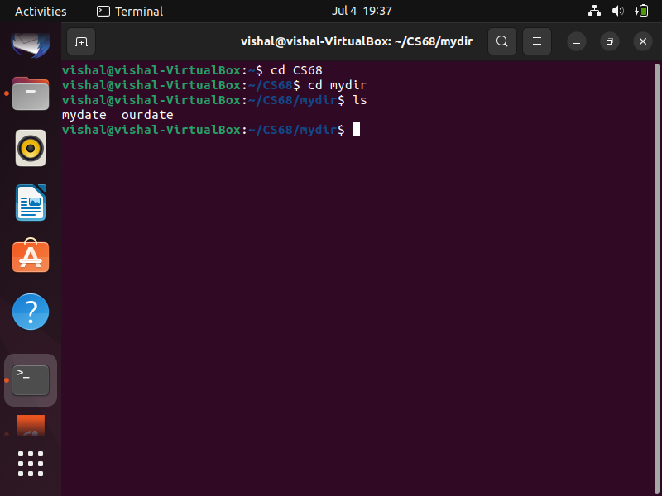

**10. Do a long listing on the file ourdate and note the permissions.**

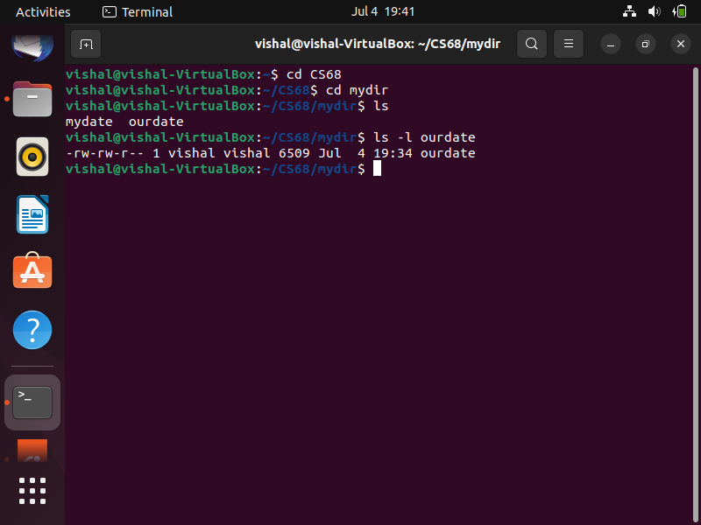

**11. Display the name of the current directory starting from the root.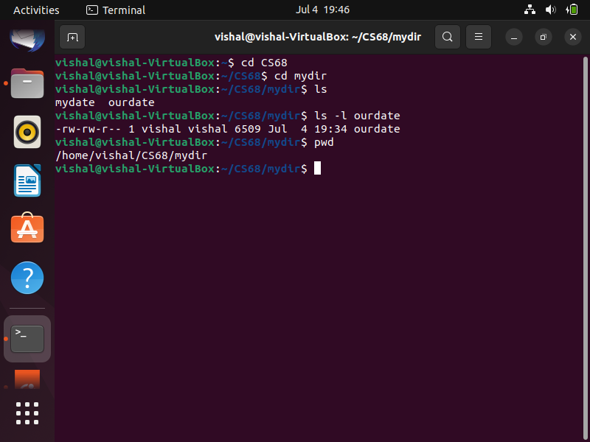12. Move the files in the directory mydir back to your home directory.**

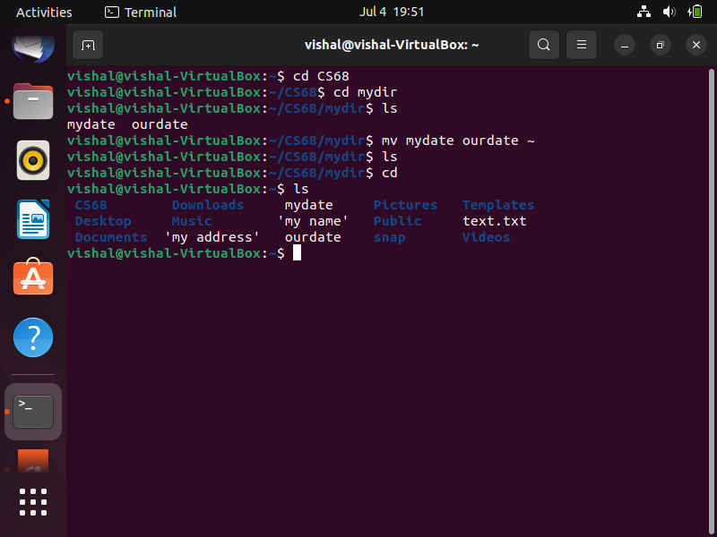

**13. Display the first 5 lines of mydate.**

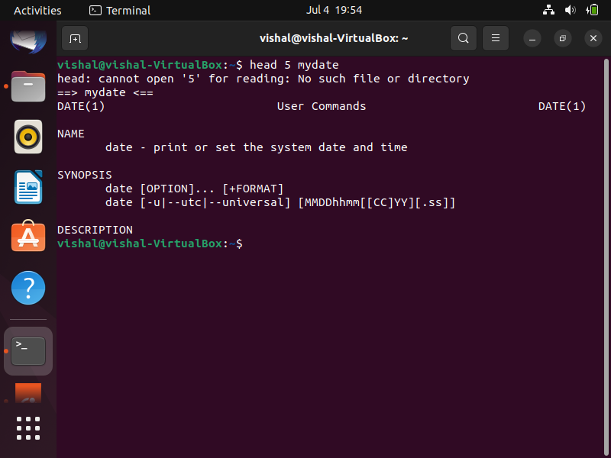

**14. Display the last 8 lines of mydate.**

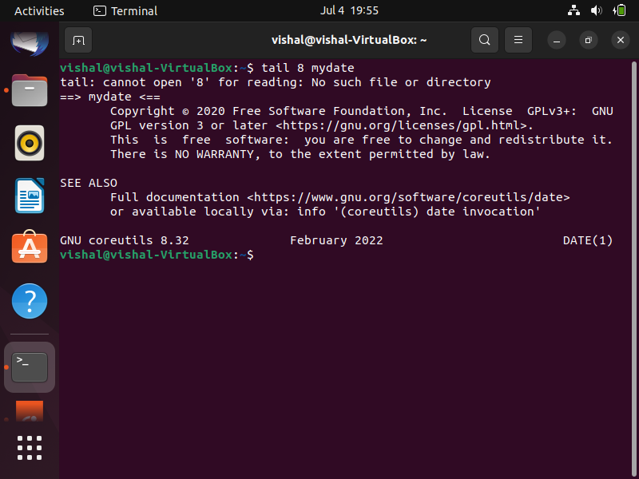

**15. Remove the directory mydir.**

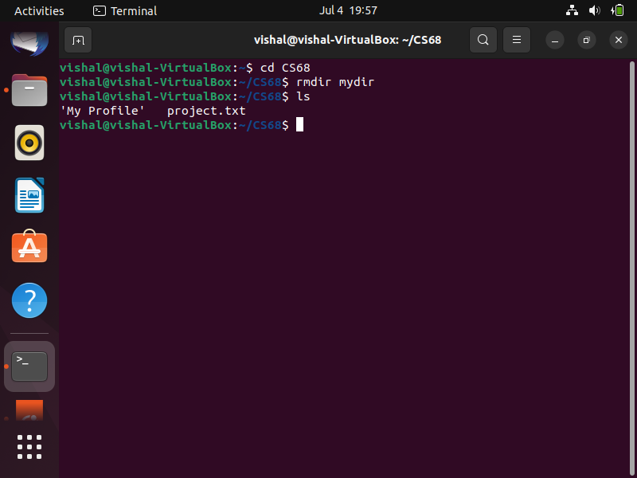

**16. Redirect the output of the long listing of files to a file named list.**

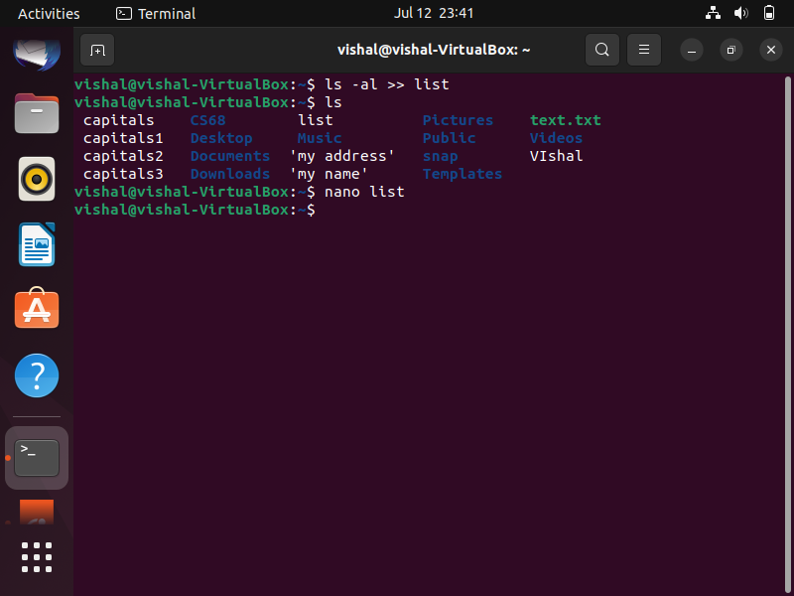

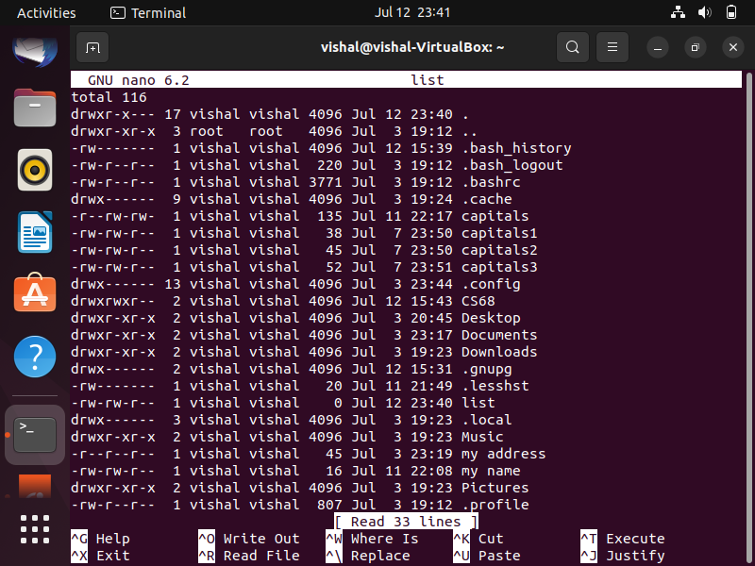

**17. Select any 5 capitals of states in India and enter them in a file named capitals1. Choose 5 more capitals and enter them in a file named capitals2. Choose 5 more capitals and enter them in a file named capitals3. Concatenate all 3 files and redirect the output to a file named capitals.**

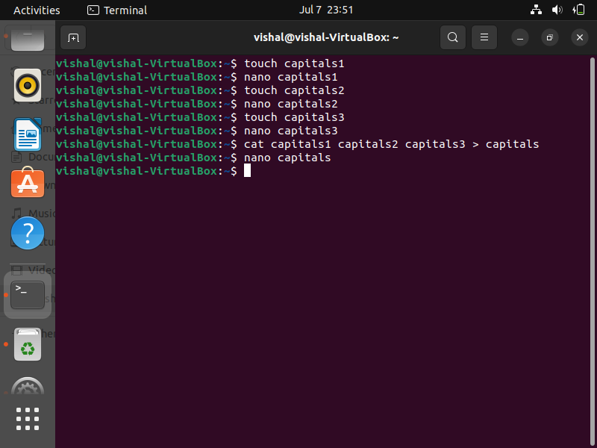

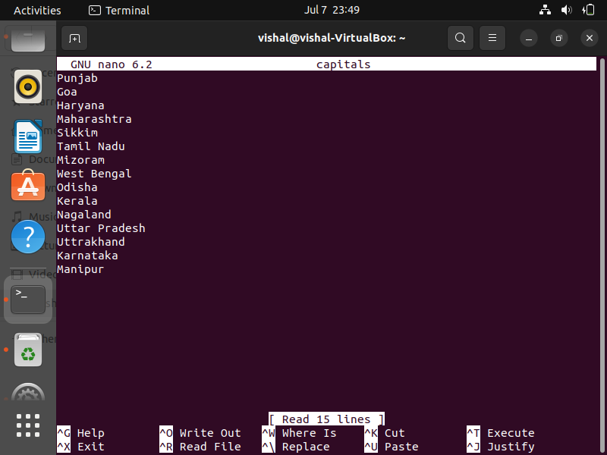

**18. Concatenate the file capitals2 at the end of file capitals.**

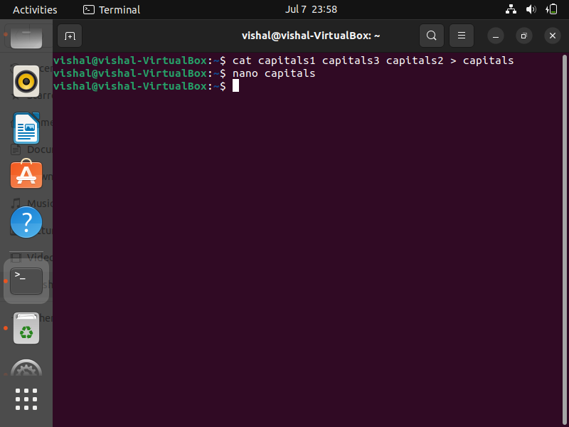

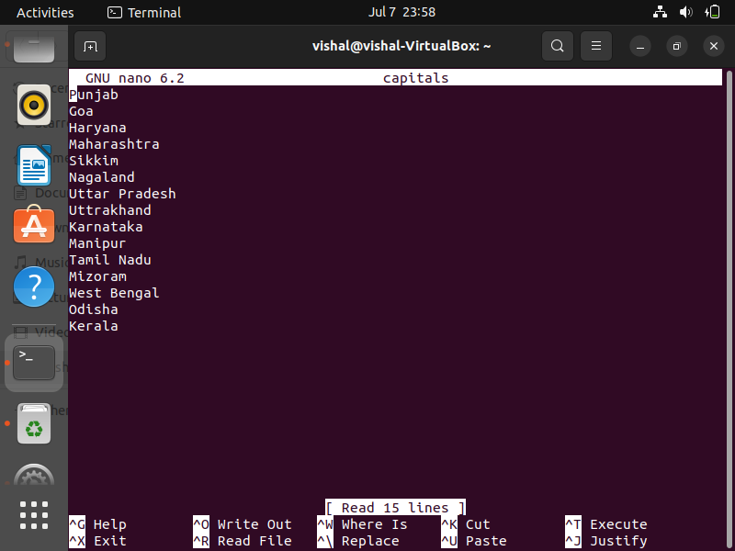

**19. Give read and write permissions to all users for the file capitals.**

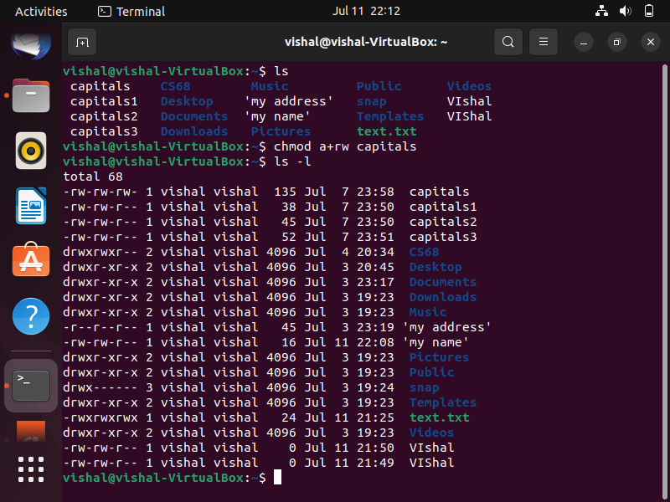

**20. Give read permissions only to the owner of the file capitals. Open the file, make some changes and try to save it. What happens ?**

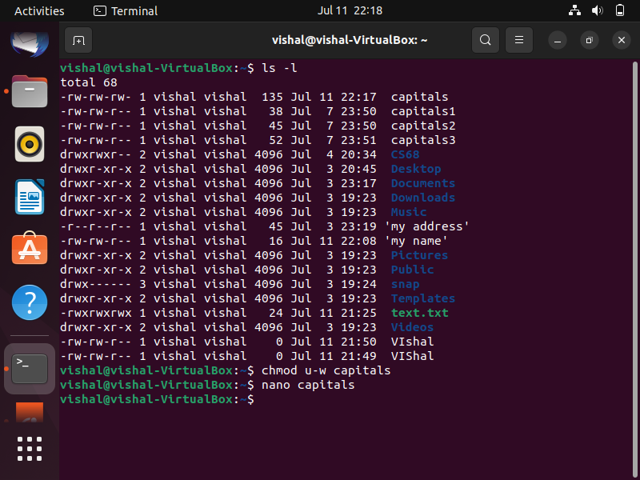

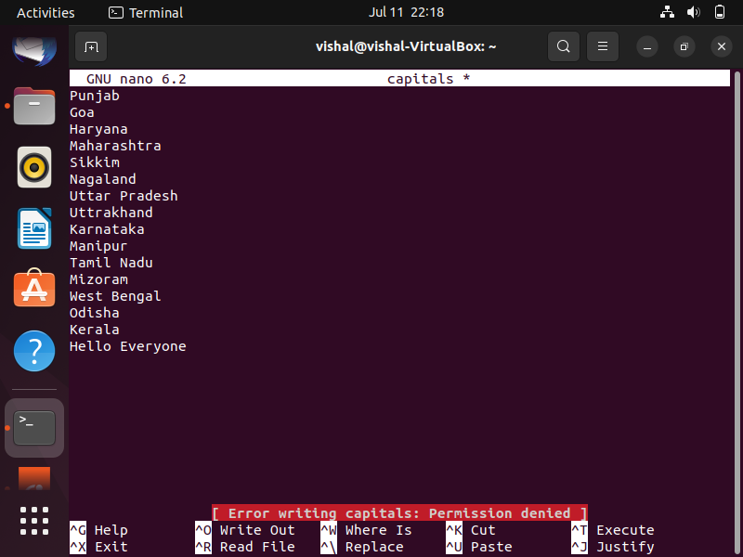

**21. Create an alias to concatenate the 3 files capitals1, capitals2, capitals3 and redirect the output to a file named capitals. Activate the alias and make it run.**

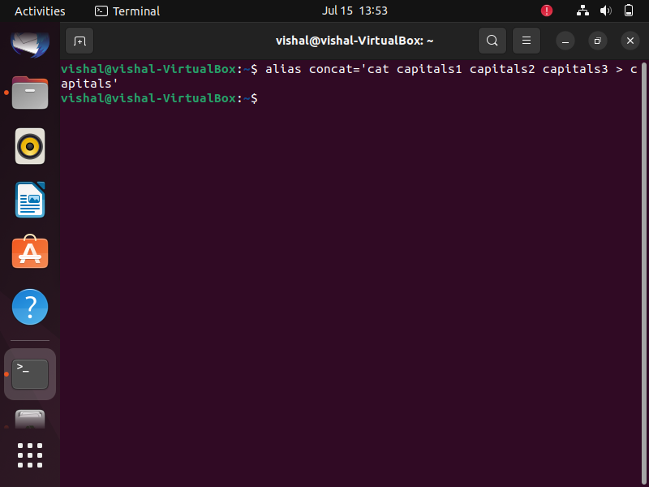

**22. Find out the number of times the string “the” appears in the file mydate.**

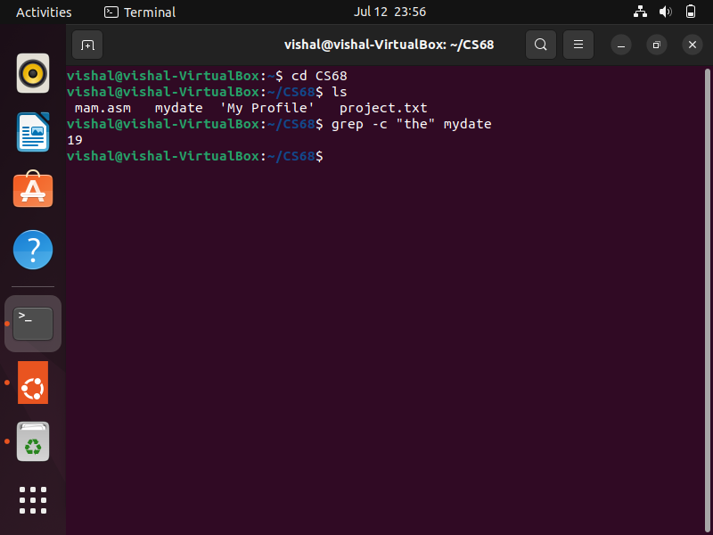

**23. Find out the line numbers on which the string “date” exists in mydate.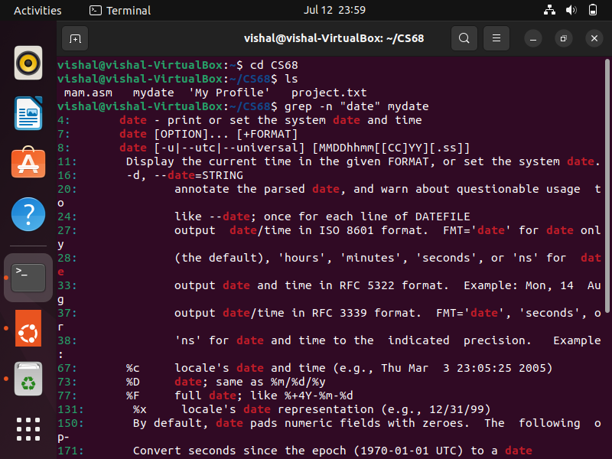24. Print all lines of mydate except those that have the letter “i” in them.**

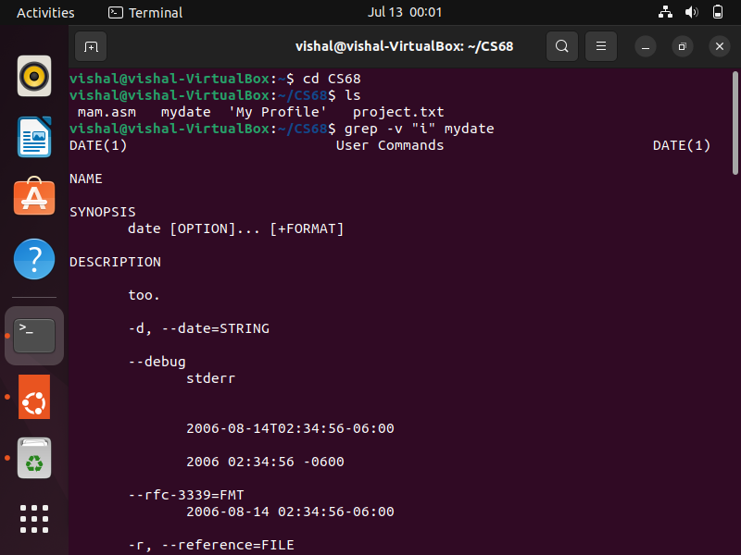

**25. List the words of 4 letters from the file mydate.**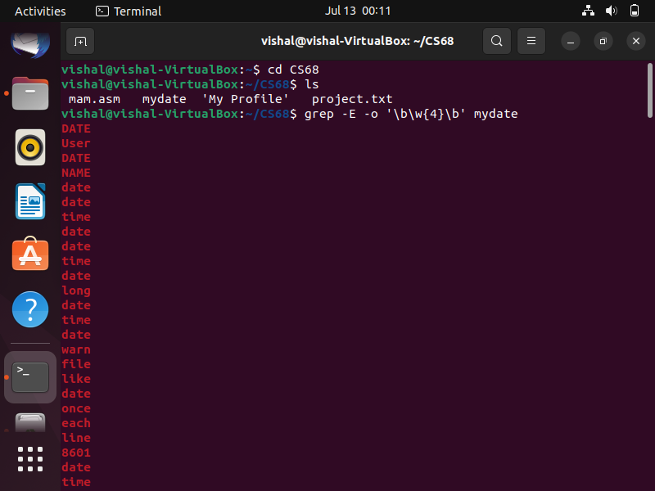

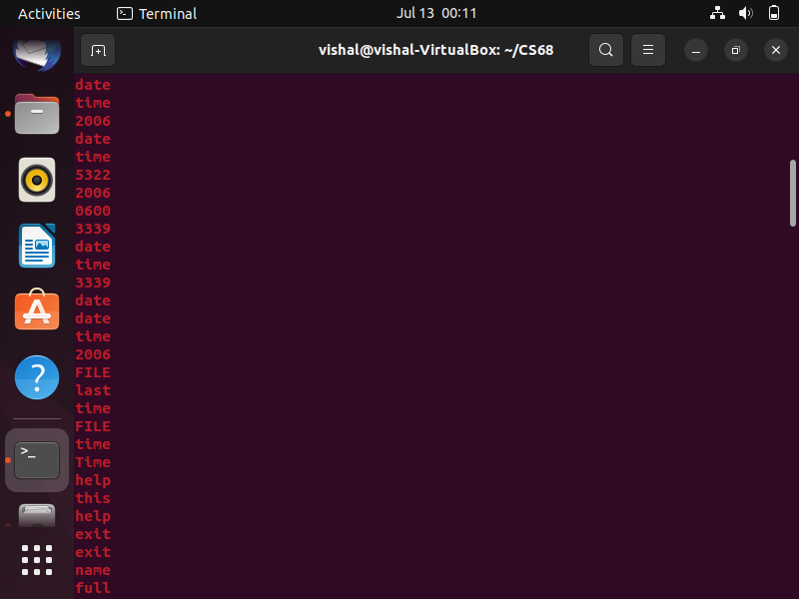

**26. List 5 states in north east India in a file mystates. List their corresponding capitals in a file mycapitals. Use the paste command to join the 2 files.**

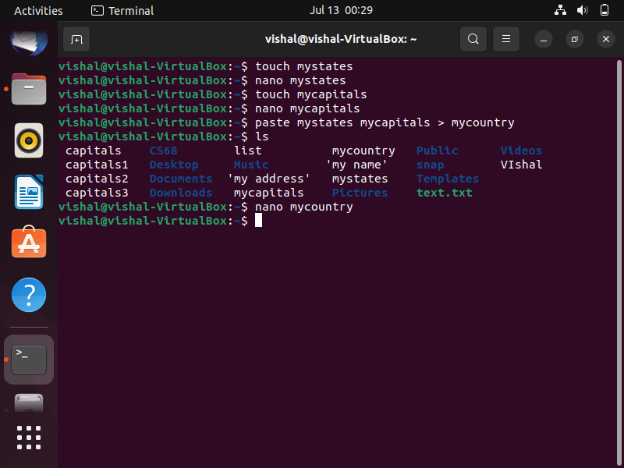

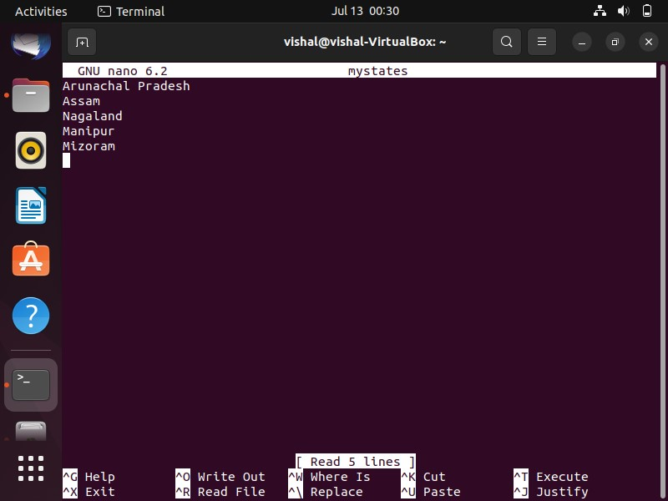

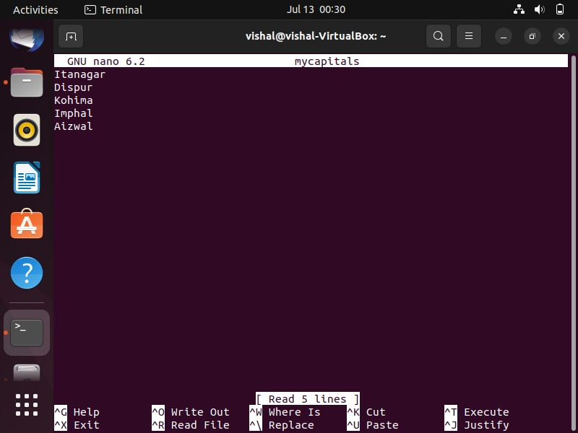

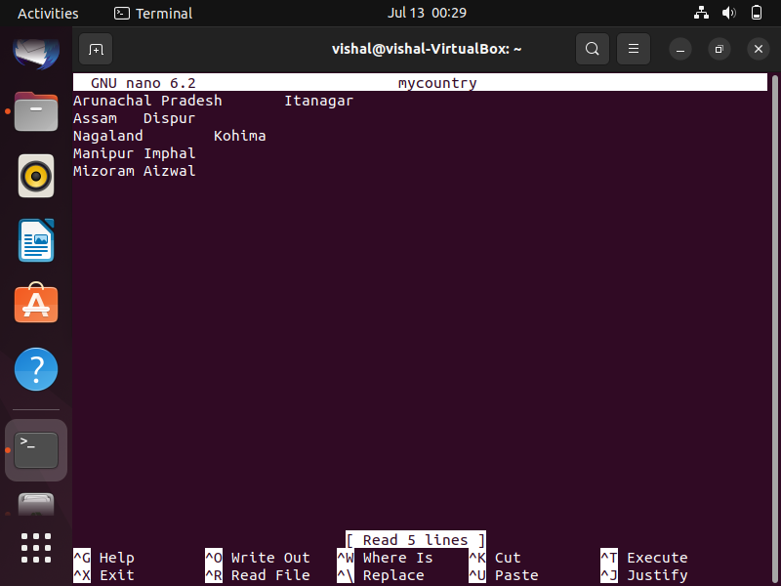

**27. Use the cut command to print the 1 st and 3 rd columns of the /etc/passwd file for all students in this class.**

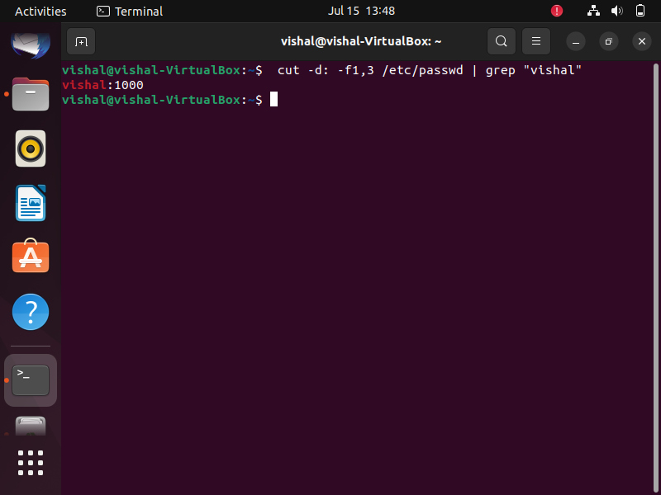

**28. Count the number of people logged in and also trap the users in a file using the tee command.**

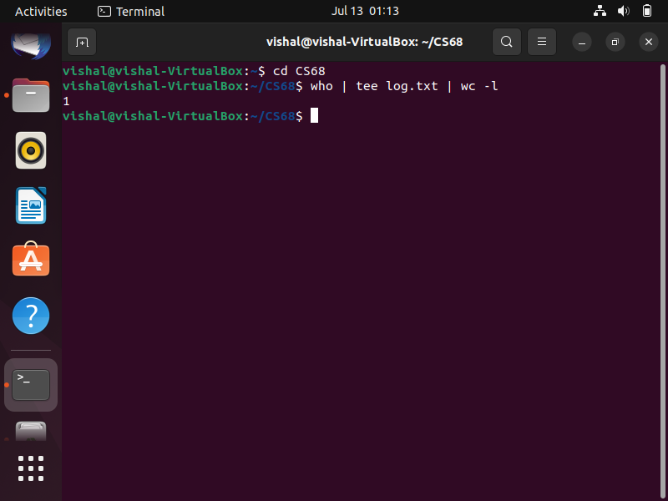

**29. Convert the contents of mystates into uppercase.**

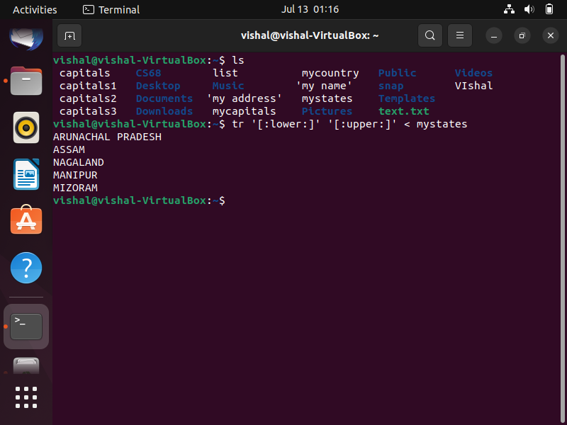

**30. Create any two files & display the common values between them.**

