**Name: Vishal Kumar Division: CS-D**

**Roll No: 68 Year: SY**

**PRN: 12210207**

**SHELL SCRIPTING:**

**1. Write a shell program to find whether argument is positive or negative.**

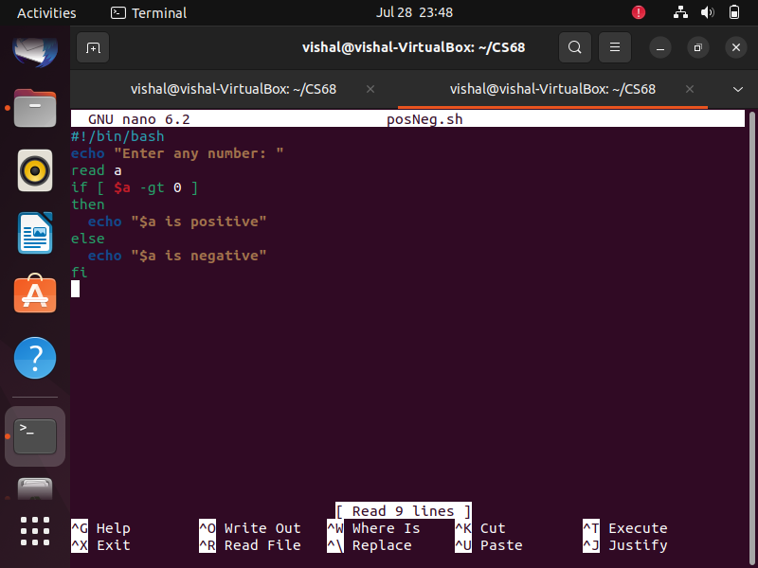

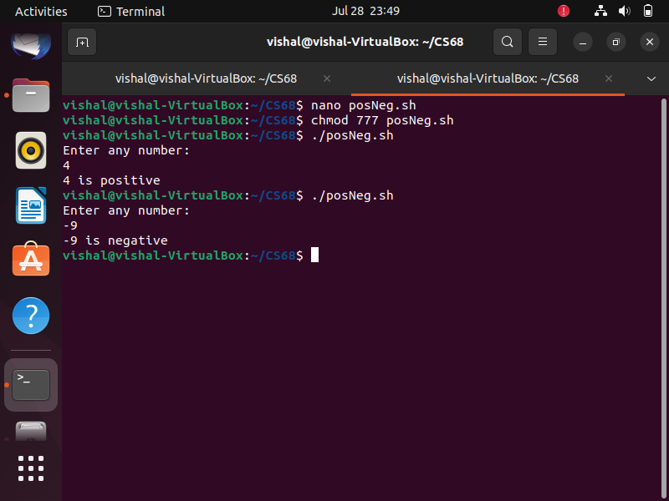

**2. Write arithmetic calculation program by using case statement.**

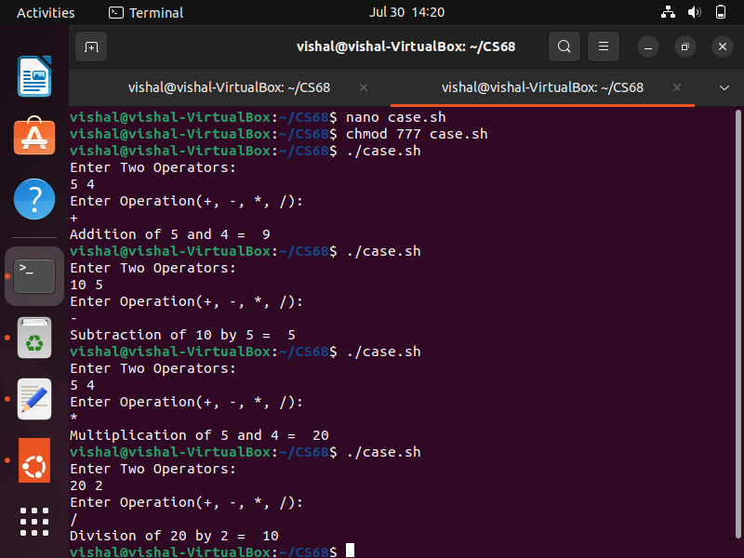

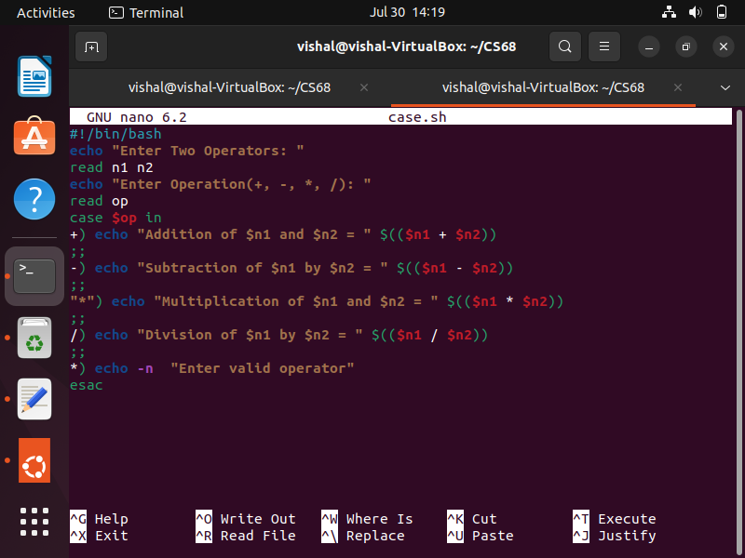

**3. Write a program to calculate factorial of given number.**

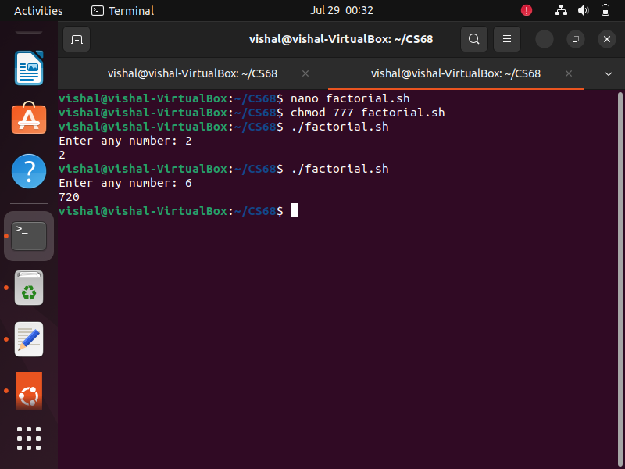

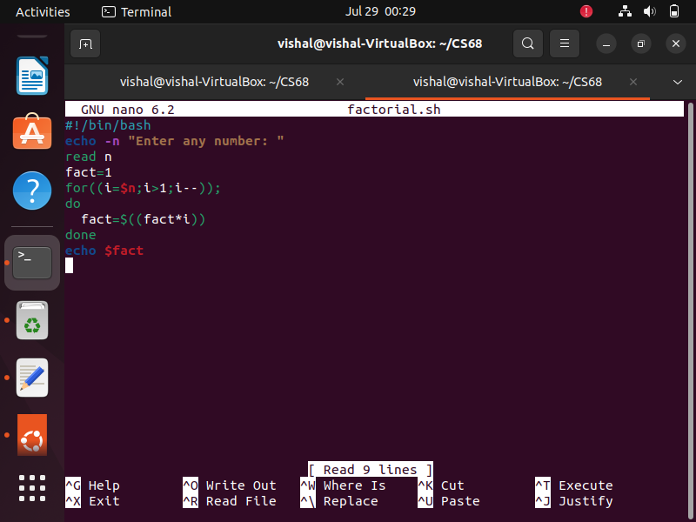

**4. Write a program for checking whether string is Palindrome or not.**

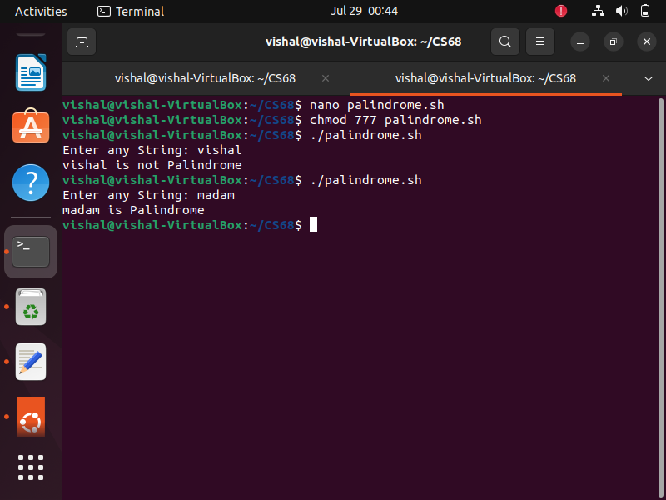

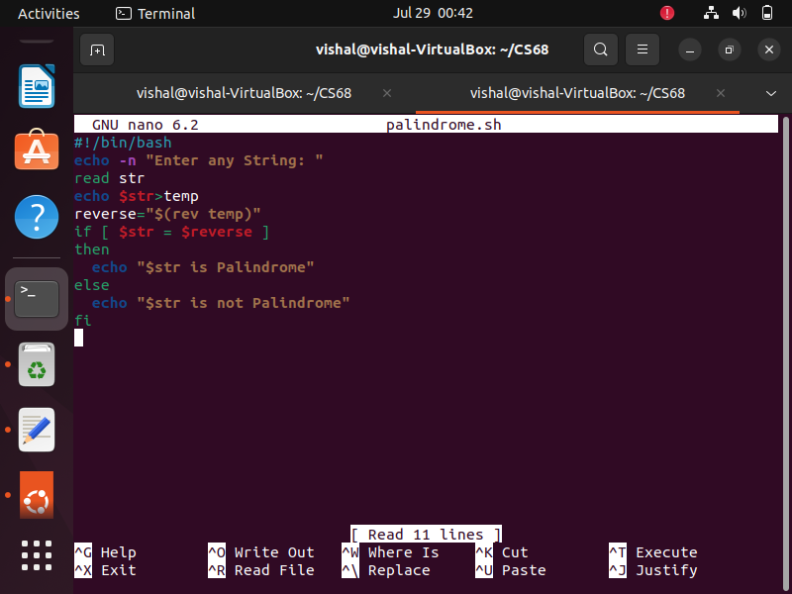

**5. Write a program to check whether given number is prime or not.**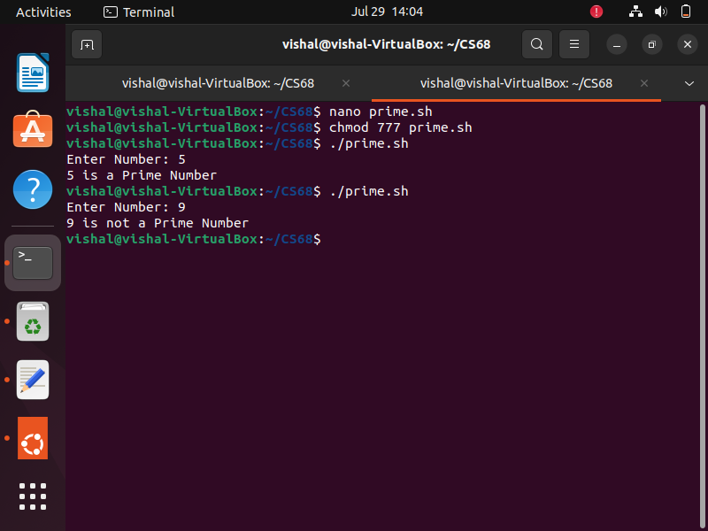

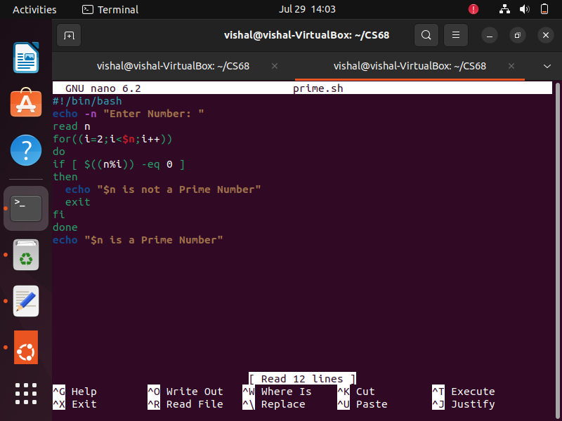

**6. Write a program to print reverse of given number.**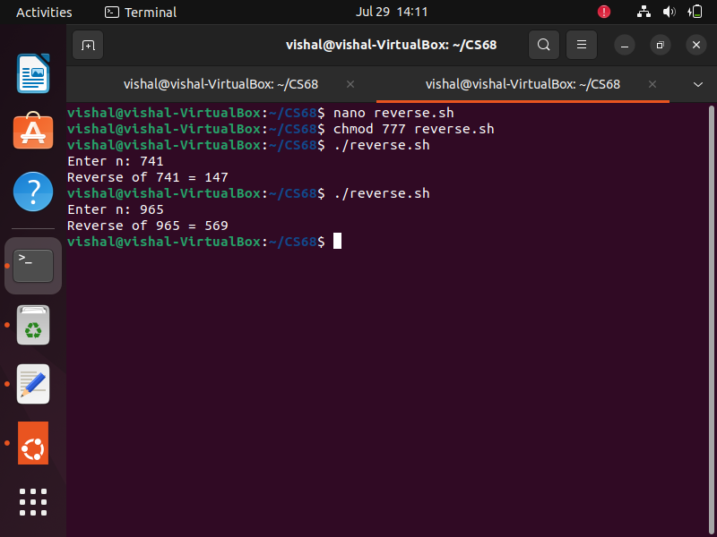

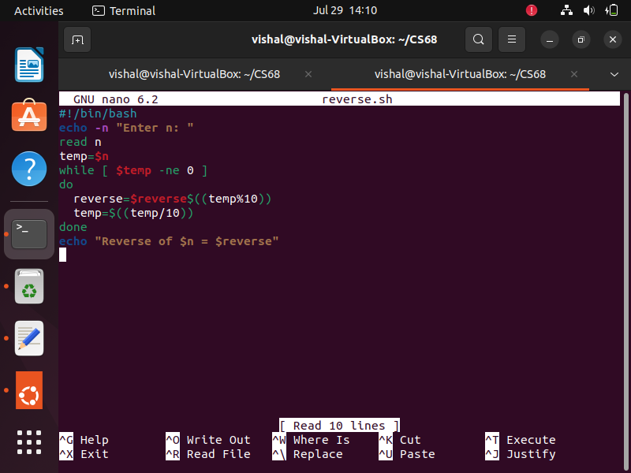

**7. Write a shell script to check and count occurrences of substring in given string by using CLA.**

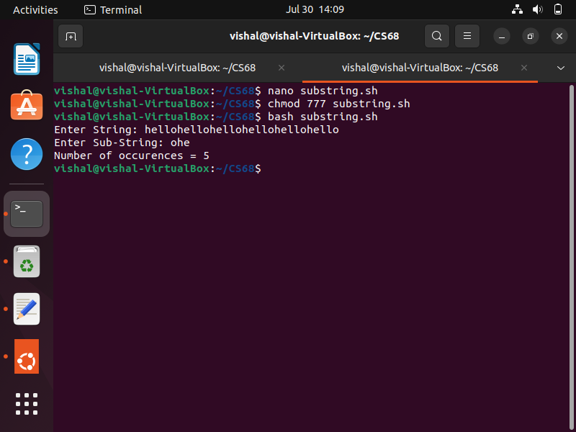

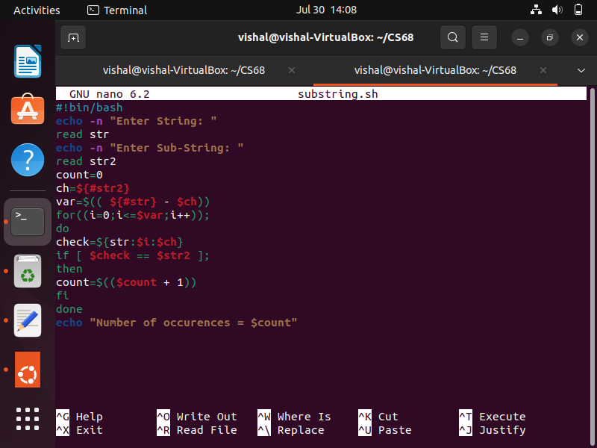

**LINUX COMMANDS:**

**1. Redirect the output of ls command to file named as ‘outfile’.**

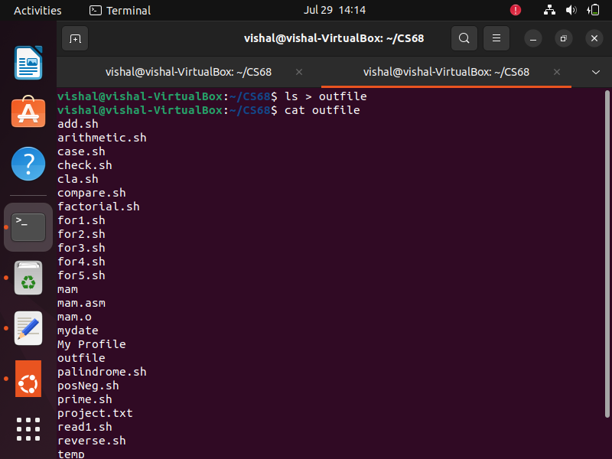

**2. To select the lines in file which has ‘digit’ as one of the character in that line and redirect the output to file named as list.**

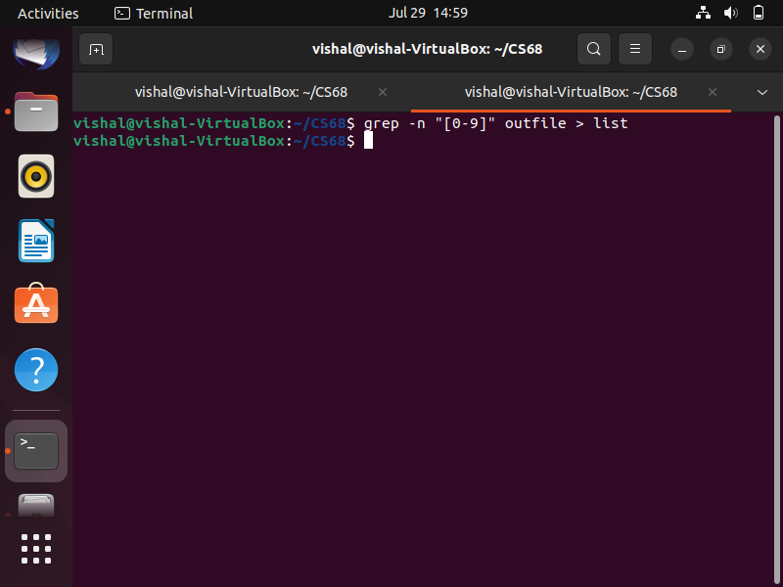

**3. Assign execute permission to owner and remove read permission.**

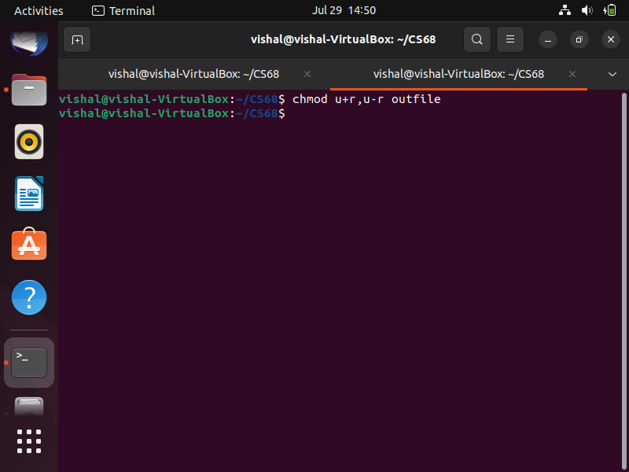

**4. Create an alias named as ‘RM’ that always deletes files interactively.0**

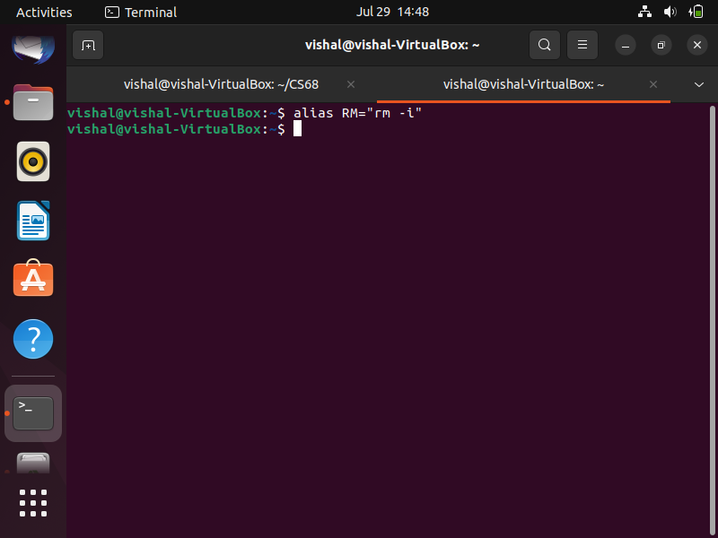

**5. Count currently login user to system.**

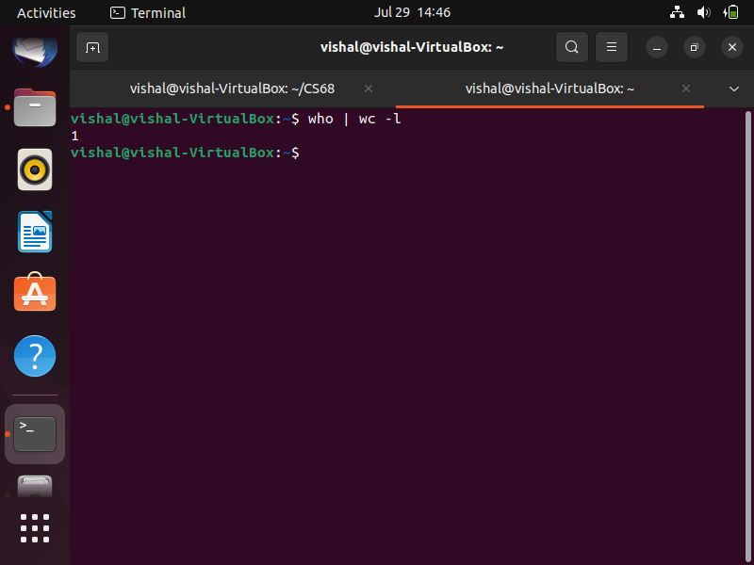

**6. List all hidden files under current directory.**

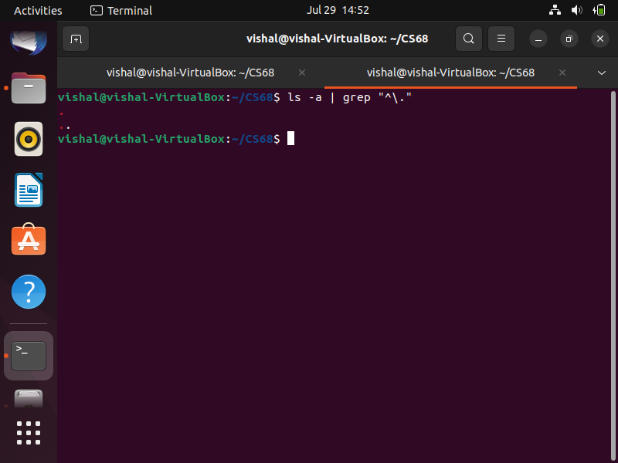

**7.Convert lower case to upper case of given file.**

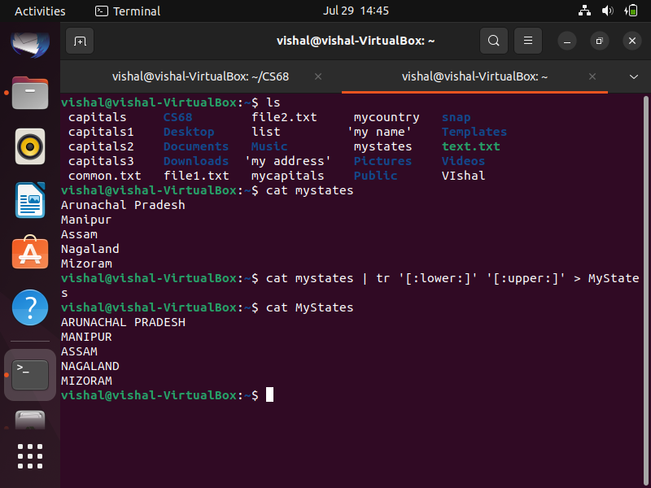

**8. Display how many times lines are repeated in given file.**

