Faculty of Computing
BSc (Hons) in Computer Systems Engineering
IE3034 – Control Systems Engineering
Year 3, Semester 1 – 2026 July
PID-Based Temperature Control of a
Peltier-Cooled Surface
Assignment: PID-Based Real-World Control System Design and Implementation
Final Report
Group members
Student name | Student ID | Main responsibility
[FILL] | [FILL] | Modelling and identification
[FILL] | [FILL] | Simulation and PID tuning
[FILL] | [FILL] | Hardware and power electronics
[FILL] | [FILL] | Firmware and experiments

Lecturer in charge: [FILL]
Group number: [FILL]
Date of submission: [FILL]

Contents
Abstract 4
1. Introduction 5
2. Description of the real-world application 5
3. Problem definition 5
4. Control-system design 5
5. Mathematical modelling 6
5.1 Variables and parameters 6
5.2 Governing equations 7
6. Transfer function and state-space model 8
6.1 Parameter status 9
6.2 Identifying K, τ and L 9
6.3 Is first order enough? 9
7. MATLAB/Simulink simulation 9
7.1 Open-loop response (no controller) 10
7.2 Which setpoints can be held 10
7.3 Before and after applying the controller 11
7.4 How the disturbance is modelled matters 12
8. PID controller design 13
8.1 Controller structure 13
8.2 Tuning method 13
8.3 Comparison of tuning methods 14
8.4 Effect of changing Kp, Ki and Kd 15
8.5 Robustness to parameter uncertainty 16
9. Hardware design and implementation 17
9.1 Components 17
9.2 Connections (basis for the schematic PDF) 18
9.3 Design choices 18
9.4 Firmware 19
10. Experimental methodology 19
11. Results 20
11.1 Setpoint tracking (E6, E7) 20
11.2 Load disturbance (E8) 21
11.3 Stability 21
12. Results comparison — simulation vs experiment 22
13. Discussion 22
14. Limitations 23
15. Proposed improvements 24
16. Conclusion 24
17. References 25
Appendix A — Review of the supplied material 26
A.1 Signal trace of the supplied diagram 26
A.2 Problems found 27
A.3 How the conflict was resolved 28
Appendix B — Simulink construction guide 29
Appendix C — MATLAB package and firmware 30

Abstract
This report presents the design, simulation and physical implementation of a closed-loop PID controller that regulates the temperature of a Peltier-cooled surface. A lumped energy balance gives a first-order-plus-dead-time model, G(s) = −K e^(−Ls)/(τs + 1), in which a heat load enters at the plant input. Simulation in MATLAB/Simulink with provisional parameters (K = 15 °C, τ = 180 s, L = 5 s) showed the following for a reverse-acting PID tuned by the SIMC method (Kp = 0.48, Ki = 0.0048, Kd = 1.2):
- It reaches a 15 °C setpoint without overshoot and settles in 294 s.
- It limits a 3 °C-equivalent heat load to a 0.30 °C rise.
- It has a 78° phase margin and a 15.8 dB gain margin.
The analysis also shows that a cooling-only Peltier can hold only setpoints between T_{amb} − K and T_{amb}, so 5 °C and 10 °C setpoints were excluded. Three errors in the preliminary block diagram were found and corrected (Appendix A). The controller runs on an Arduino Uno that drives a TEC1-12706 module through a 25 kHz MOSFET stage, with a DS18B20 sensor on the cold surface.
[FILL: measured K, τ and L from test E2; measured settling time, overshoot, steady-state error and disturbance peak from tests E6–E8; one sentence on how closely they matched the simulation.]

1. Introduction
This project designs, simulates, builds and tests a closed-loop PID controller that holds the temperature of a Peltier-cooled surface at a chosen setpoint. It follows the full control-engineering chain the assignment asks for: problem, model, simulation, PID design, implementation, experiment, analysis and improvement.

2. Description of the real-world application
Thermoelectric (Peltier) cold plates hold samples, sensors and components at a fixed temperature below ambient without moving parts or refrigerant. Typical uses are PCR and sample-storage blocks, laser-diode and camera-sensor cooling, portable vaccine and insulin coolers, and climate chambers for electronics testing. In each, the useful quantity is the temperature of a surface, not of the air around it. The surface must stay at its setpoint while the room temperature, the load placed on the plate and the heat-sink condition all change.
The prototype is a TEC1-12706 module with an aluminium cold plate on its cold face, a fan-cooled heat sink on its hot face, a DS18B20 sensor bonded to the plate, and an Arduino that drives the module through a MOSFET with PWM.

3. Problem definition
Element | This system | Unit / range
Controlled variable | Cold-surface temperature T_{surface} | °C
Manipulated variable | Normalised PWM duty u to the Peltier module | 0–1 (cooling only)
Reference / setpoint | Desired surface temperature T_{ref} | 13–22 °C feasible (section 7)
Disturbances | Heat load on the plate, ambient change, heat-sink warming, supply-voltage change, condensation | —
Sensor | DS18B20 on the plate, 12-bit | 0.0625 °C resolution, ±0.5 °C accuracy
Actuator | TEC1-12706 driven by a logic-level MOSFET at 25 kHz | 12 V, up to about 6 A
Why feedback is needed. A fixed duty computed from the model reaches 15 °C only if K and ambient are exactly right. In simulation, a 3 °C-equivalent heat load then leaves it at 18 °C indefinitely. The real gain also drifts as the heat sink warms and the room changes. Feedback measures the actual surface temperature and corrects for all of these without knowing their size. Integral action removes the steady-state error that remains with proportional-only control (16.2 °C instead of 15 °C, section 7).

4. Control-system design
The loop keeps every block name from the supplied diagram, with four connections corrected (Figure 1; Appendix A).
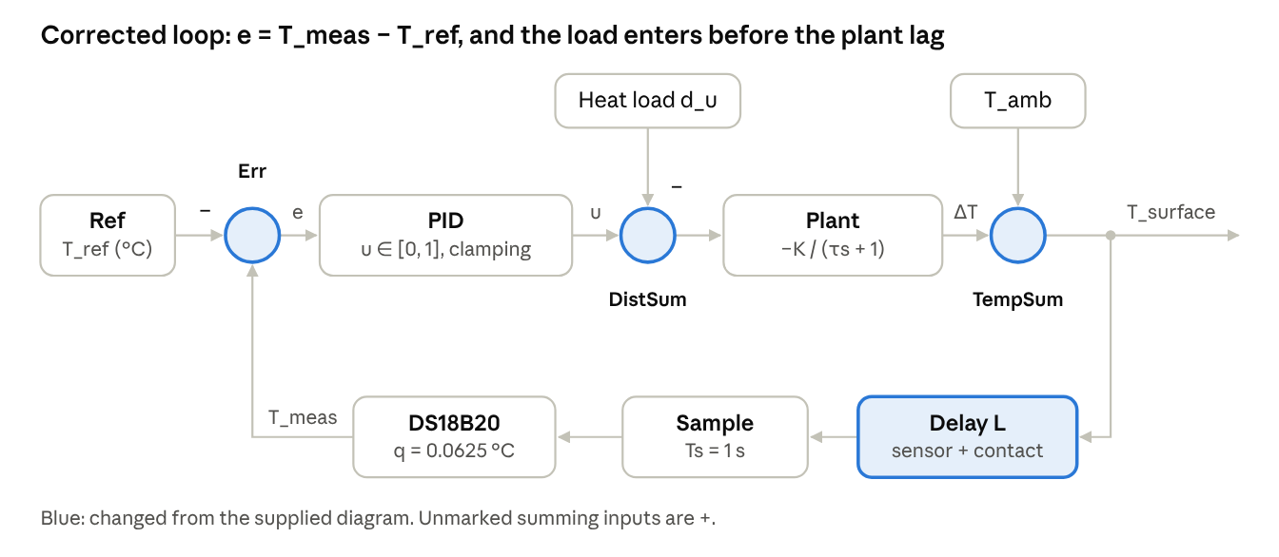
corrected closed-loop architecture · supplied block names kept
Figure 1. Corrected closed-loop block diagram. Blue marks the parts changed from the supplied diagram.
The PID compares the measured absolute temperature with the setpoint and outputs a duty between 0 and 1. A heat load subtracts from that duty before the plant's thermal lag. The plant's (negative) temperature change is added to ambient to give the surface temperature. Dead time, 1 s sampling and the sensor's resolution sit only in the feedback path, so the actual and measured temperatures can both be logged.
Design decision | Choice | Reason
Control structure | Single-loop feedback PID, reverse acting | Negative plant gain; one sensor, one actuator
Sampling period | 1 s | About 1/25 of the closed-loop time constant; matches DS18B20 12-bit conversion (750 ms)
Actuator range | Duty 0–1, cooling only | Single low-side MOSFET; defines the reachable range (§7.2)
Windup protection | Clamping (conditional integration) | Long saturation during large pull-downs
Disturbance test | Switched resistor heater on the plate | Repeatable, timed, loggable load
Safety | Heat-sink trip at 60 °C, sensor-fault trip, fan always on, 8 A fuse | Module and operator protection

5. Mathematical modelling
A lumped energy balance on the cold plate gives exactly the supplied first-order model, −K/(τs + 1). It also says what K and τ physically are, and that a heat load enters at the plant input, not at its output.

5.1 Variables and parameters
Symbol | Meaning | Unit
T_{s} | Cold-surface temperature (controlled variable) | °C
T_{amb} | Ambient (room) temperature | °C
T_{h} | Hot-side (heat-sink) temperature | °C
x = T_{s} − T_{amb} | Surface temperature change from ambient (the model's output) | °C
u | Normalised PWM duty, the command (0 = off, 1 = fully on) | —
I₀ | Module current while the MOSFET is on | A
α, R_{e}, K_{t} | Module Seebeck coefficient, electrical resistance, thermal conductance | V/K, Ω, W/K
C | Heat capacity of plate + ceramic + attached load | J/K
R_{a} | Thermal resistance from plate to room (convection, leakage through insulation) | K/W
Q_{load} | Heat load placed on the plate (disturbance) | W

5.2 Governing equations
Heat pumped from the cold face of a Peltier module at current I (standard thermoelectric model):
$$Q_{c}=αIT_{c}−\frac{1}{2}I^{2}R_{e}−K_{t}(T_{h}−T_{c})$$
With PWM at 25 kHz the current is either I₀ or 0. That is far faster than the thermal response, so only the average matters. During the on-time the current is fixed, so the average pumped heat is linear in duty:
$${\overline{Q}}_{c}=u\left(αI_{0}T_{c} − \frac{1}{2}I_{0}^{2}R_{e}\right)−K_{t}(T_{h}−T_{c})=uP_{p}−K_{t}(T_{h}−T_{c})$$
This is the physical reason a linear model in u is reasonable. With smoothed DC current I = u·I₀, the Joule term would instead grow as u², and the gain would fall at high duty.
Energy balance on the plate:
$$C\frac{dT_{s}}{dt}=−{\overline{Q}}_{c}+\frac{T_{amb}−T_{s}}{R_{a}}+Q_{load}$$
Assumptions.
- Plate, ceramic and load are one lumped mass at T_{s}. This holds for a thin aluminium plate; the Biot number is small.
- Contact is good, so T_{c} ≈ T_{s}.
- The heat sink holds T_{h} ≈ T_{amb} + a constant. Its rise at the operating point is absorbed into K.
- α, R_{e} and K_{t} are constant near the operating point, so P_{p} is constant.
- R_{a} is constant: no drafts, and no condensation (which would add a latent-heat load).
- Operation stays within u ∈ [0, 1]. The driver cannot reverse current, so the plate cannot be actively heated above ambient.
Substituting, with G_{th} = K_{t} + 1/R_{a} and x = T_{s} − T_{amb}:
$$C\frac{dx}{dt}=−G_{th}x−P_{p}u+Q_{load} ⟹ τ\frac{dx}{dt}+x=−Ku+Kd_{u}$$

$$τ=\frac{C}{G_{th}}, K=\frac{P_{p}}{G_{th}}, d_{u}=\frac{Q_{load}}{P_{p}}$$
So τ is heat capacity over total thermal conductance, and K is the steady cooling that full duty produces. The heat load d_{u} is expressed in duty units: d_{u} = 0.2 is a load that needs 20 % more duty to cancel. An ambient change ΔT_{amb} acts identically, as d_{u} = ΔT_{amb} / K.
Absolute temperature vs change. The model's output is the change x. The absolute surface temperature is T_{s} = T_{amb} + x, which is why the Simulink model has a separate T_{amb} summing junction.
Command vs power. u is a duty, not a power. Electrical input is P_{e} = u·V·I₀, about 66 W at u = 1 (12 V, about 5.5 A). The hot side must reject Q_{c} + P_{e}. That is why the heat sink matters, and why the fan must always run.

6. Transfer function and state-space model
Taking Laplace transforms with zero initial deviation (the plate starts at ambient):
$$X(s)=\frac{−K}{τs+1}U(s)+\frac{K}{τs+1}D_{u}(s), G(s)=\frac{ΔT_{s}(s)}{ΔU(s)}=\frac{−Ke^{−Ls}}{τs+1}$$
The dead time L lumps the sensor's thermal lag, the 1 s DS18B20 conversion and the contact resistance. With the provisional values:
$$G(s)=\frac{−15e^{−5s}}{180s+1}$$
This has a pole at s = −0.00556 rad/s, a DC gain of −15 °C per unit duty and a 2 % open-loop settling time of 4τ = 720 s.
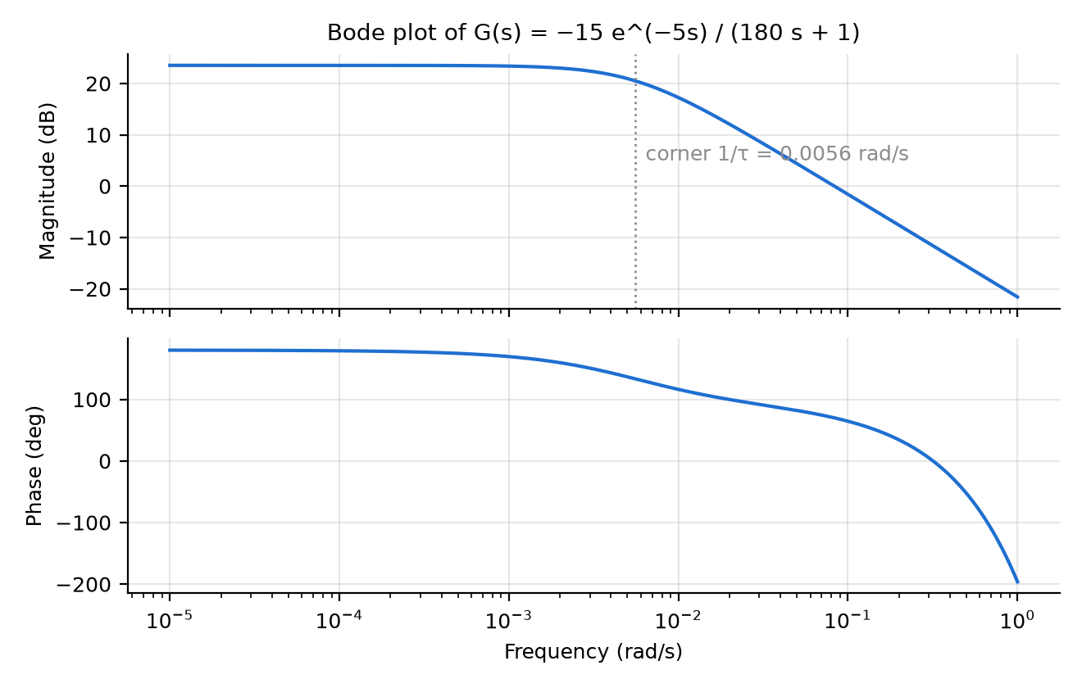
Figure 2. Bode plot of G(s) = −15e^(−5s)/(180s + 1): a first-order lag with its corner at 1/τ = 0.0056 rad/s. The dead time adds phase lag at higher frequencies.
State space, with state x = T_{s} − T_{amb} and inputs [u; d_{u}]:
$$\frac{dx}{dt}=−\frac{1}{τ}x+[\begin{matrix}−\frac{K}{τ} & \frac{K}{τ}\end{matrix}][\begin{aligned}u \\ d_{u}\end{aligned}], y=x$$

$$A=−0.005556, B=[\begin{matrix}−0.08333 & 0.08333\end{matrix}], C=1, D=[\begin{matrix}0 & 0\end{matrix}]$$
The system is controllable and observable, since B and C are non-zero scalars. In absolute form, T_{amb} becomes a third input with gain 1/τ.

6.1 Parameter status
Parameter | Design value used in simulation | Source of design value | Measured value | How it is measured
K | 15 °C per unit duty | Supplied preliminary script | [FILL] | Open-loop duty step, test E2, s08
τ | 180 s | Supplied preliminary script | [FILL] | Test E2, s08
L | 5 s | Assumed | [FILL] | Test E2, s08
T_{amb} | 25 °C | Assumed | [FILL] | 10 min log with the module off, test E1
Heater load d_{u} | 0.2 (3 °C equivalent) | Assumed | [FILL] | Heater calibration, test E4
Sensor resolution | 0.0625 °C | DS18B20 datasheet | — | —
Sample time Ts | 1 s | Design choice | — | —
Plausibility check (not a measurement). K = 15 °C puts full-power temperature at 10 °C in a 25 °C room. That is believable for a loaded plate on a fan heat sink; the module's no-load ΔT_{max} of about 66 °C is never reached in practice. For a plate plus load of about 60 J/K, τ = 180 s implies G_{th} ≈ 0.33 W/K and net pumped heat P_{p} = K·G_{th} ≈ 5 W, a realistic net figure at this temperature difference.

6.2 Identifying K, τ and L
Hold u = 0 until T_{s} is steady, step to u = 0.6 and log for at least 5τ. Then:
$$K=\frac{T_{0}−T_{∞}}{Δu}, τ=1.5(t_{63}−t_{28}), L=t_{63}−τ$$
Here t₂₈ and t₆₃ are the times to 28.3 % and 63.2 % of the change (Smith's two-point method). s08_identify_plant.m computes these and then refines all three by least squares on the whole curve. Repeat at u = 0.3 and 0.9: if K differs by more than about 10 %, the plant is nonlinear and the gains must hold across that range.

6.3 Is first order enough?
A first-order model is adequate when the residual of the fit in s08 shows no slow trend. Four effects can break it:
- Heat-sink warming. T_{h} rises over minutes, adding a slow second mode. The plate drops fast, then creeps back up. Fix with a better heat sink, or model it as G = −K(τ_z s + 1)/((τ_1 s + 1)(τ_2 s + 1)).
- Sensor and contact lag. A few seconds of extra delay, absorbed into L. Bond the bare TO-92 sensor with thermal paste and tape; a waterproof sleeve adds lag.
- Operating-point dependence. P_{p} depends on T_{c} and T_{h}, so K changes with setpoint and room temperature. Section 8 checks robustness to ±30 %.
- Condensation. Below the dew point, water condenses and adds a latent-heat load. In an un-air-conditioned Sri Lankan lab the dew point can be 22–26 °C, so this is likely at every useful setpoint. Measure room humidity on the test day.

7. MATLAB/Simulink simulation
Without feedback the surface misses the setpoint as soon as anything changes. With the PID it returns to 15.02 °C after a heat load, while open-loop drive ends at 18 °C.
The simulation is built three ways so each can check the others:
- simulate_loop.m, a toolbox-free MATLAB loop that includes the effects a real loop has.
- peltier_pid_model.slx, created by build_simulink_model.m from the corrected diagram (Appendix B).
- verify_sim.py, a line-for-line Python copy that produced every number quoted in this report.
All three use the same settings:
- A 0.1 s plant step with exact discretisation of the first-order lag.
- A 1 s controller period, matching the firmware.
- 5 s of dead time and 0.0625 °C sensor quantisation.
- Duty limited to [0, 1], with clamping anti-windup.

7.1 Open-loop response (no controller)
At full duty the surface falls from 25 °C to 10.02 °C. It passes 15.52 °C (63.2 %) at exactly t = 180 s = τ, which confirms the model. The fastest any controller can pull the plate from 25 °C to 15 °C is 198 s, because that is what u = 1 throughout achieves. Large setpoint steps are therefore actuator-limited, and tuning mainly decides how the last few degrees and disturbances are handled. Script: s01_model_analysis.m.
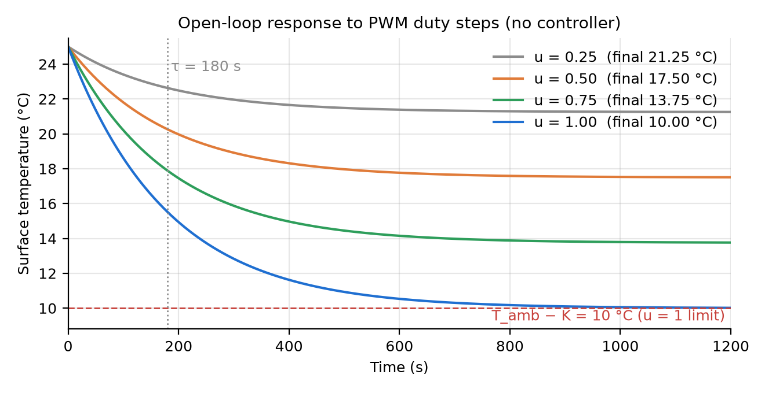
Figure 3. Open-loop response to duty steps of 0.25–1.0 with no controller. Full duty passes 15.52 °C (63.2 %) at t = τ = 180 s and settles at T_{amb} − K = 10 °C.

7.2 Which setpoints can be held
A unidirectional driver gives u ∈ [0, 1], so the reachable steady range is T_{amb} − K to T_{amb}, which is 10–25 °C here. A setpoint also needs duty headroom to reject a load. The 0.2 duty load used in the tests needs u_{ss} + 0.2 ≤ 1, which means r ≥ 13 °C.
Setpoint (°C) | Duty needed, no load | Duty needed, with load | Simulated T before load (°C) | Simulated T after load (°C) | Verdict
5 | 1.33 | 1.53 | 10.03 | 12.99 | Infeasible
10 | 1.00 | 1.20 | 10.13 | 13.00 | Infeasible (no margin)
13 | 0.80 | 1.00 | 13.02 | 13.04 | Marginal
15 | 0.67 | 0.87 | 15.02 | 15.02 | Feasible
18 | 0.47 | 0.67 | 18.02 | 18.02 | Feasible
20 | 0.33 | 0.53 | 20.01 | 20.02 | Feasible
22 | 0.20 | 0.40 | 21.99 | 22.02 | Feasible
This explains the supplied plots. Their 5 °C and 10 °C curves are identical because duty is pinned at 1 in both, and the 5 °C trace is hidden under the 10 °C one. The demonstration should use 15–22 °C setpoints, and show one infeasible setpoint deliberately as an actuator-limit case. The limit moves with the room: at 30 °C ambient the floor is 15 °C.
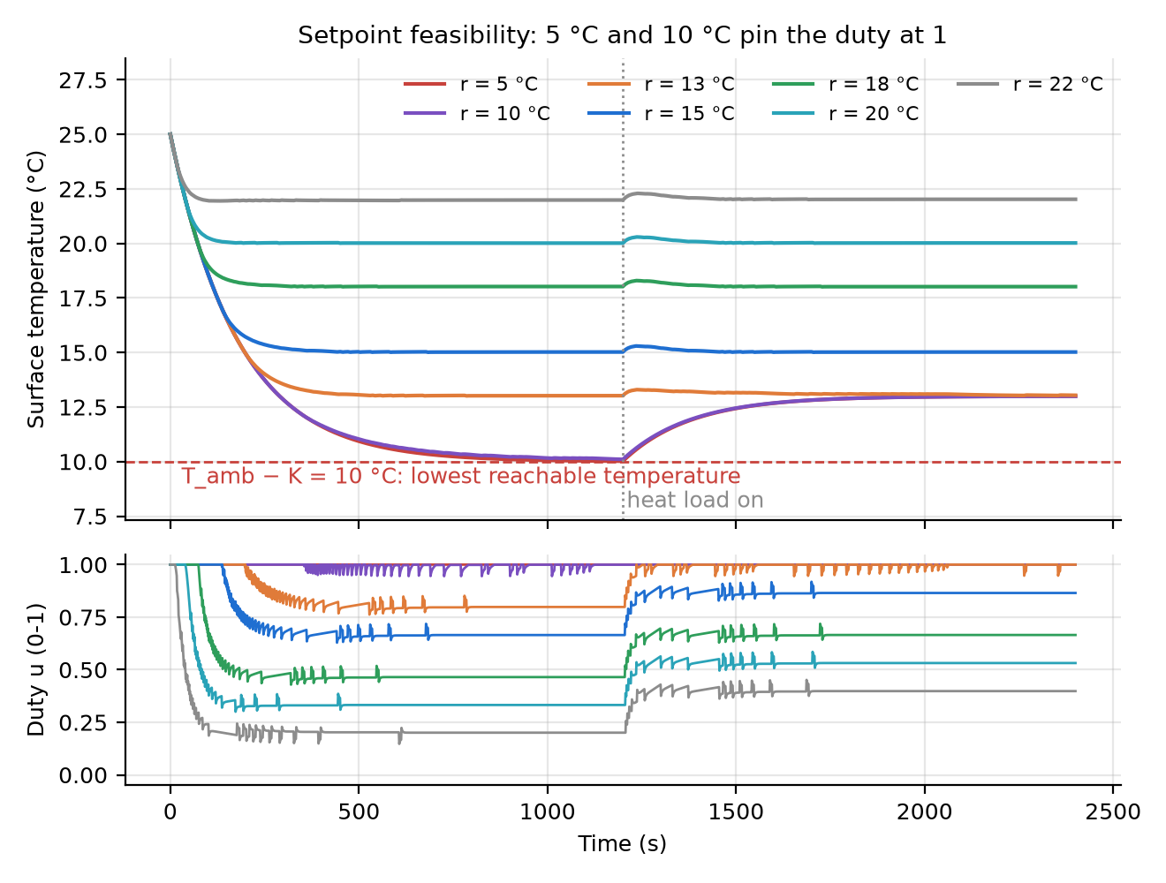
Figure 4. Setpoint feasibility with the recommended PID and a heat load at 1200 s. At 5 °C and 10 °C the duty is pinned at 1 and the load cannot be rejected; 13 °C is marginal. The small duty spikes are the derivative term reacting to the sensor's 0.0625 °C steps.

7.3 Before and after applying the controller
The standard test is a 25 → 15 °C setpoint with a 0.2 duty heat load (3 °C open-loop equivalent) switched on at 1200 s. Script: s02_before_after.m.
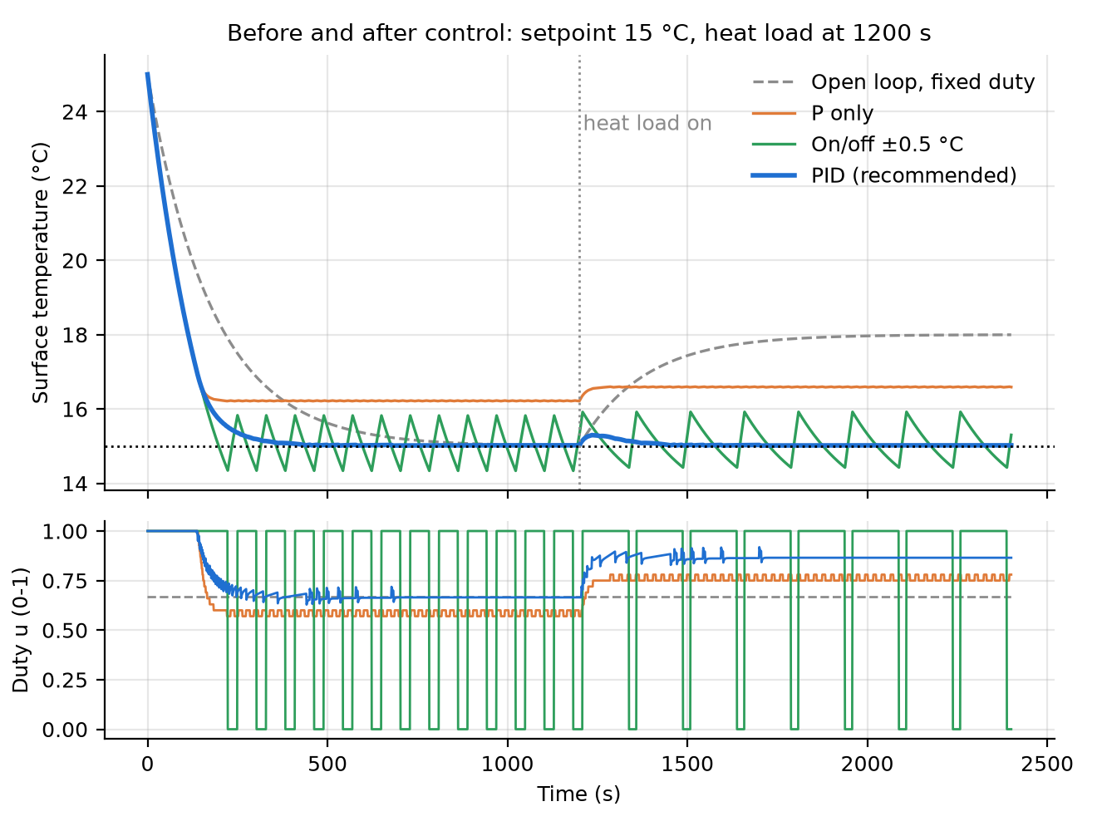
Figure 5. Before and after control on the standard test (setpoint 15 °C, 0.2-duty heat load from 1200 s): surface temperature (top) and duty (bottom).
Strategy | T before load (°C) | T at end (°C) | Peak-to-peak at end (°C) | Duty std. dev.
Open loop, fixed duty 0.667 | 15.02 | 17.99 | 0.02 | 0.000
Proportional only (Kp = 0.48) | 16.22 | 16.59 | 0.01 | 0.014
On/off, ±0.5 °C hysteresis | 15.00 | 15.10 (cycle mean) | 1.49 | 0.347
PID (recommended) | 15.02 | 15.02 | 0.00 | 0.007
- Open loop works only while the model is exact. The load leaves a 3 °C error that nothing corrects.
- P-only has a steady-state error, e_{ss} = (T_{amb} − r)/(1 + K·Kp) = 1.2 °C, which grows with load.
- On/off holds the average but cycles about 1.5 °C peak-to-peak with a 150 s period and switches the module fully on and off. That thermal cycling shortens Peltier life.
- PID removes both the offset and the cycling.
The final 0.02 °C offset is sensor quantisation. The integrator stops when the rounded reading equals the setpoint, so the true temperature can sit up to ±0.031 °C away.

7.4 How the disturbance is modelled matters
The supplied model added the disturbance as an instantaneous +3 °C step on the output. A real heat load must first warm the plate's thermal mass, so it enters at the plant input and passes through 1/(τs + 1). With the same controller and the same 3 °C equivalent size, the two give very different answers (s06_disturbance_rejection.m):
Disturbance model | Peak rise (°C) | Recovery to ±0.2 °C (s)
Output step (supplied model) | 3.02 | 182
Heat load at the input (physical) | 0.30 | 103
The output-step version overstates the peak tenfold, and no real load can produce it. The corrected model is used throughout.
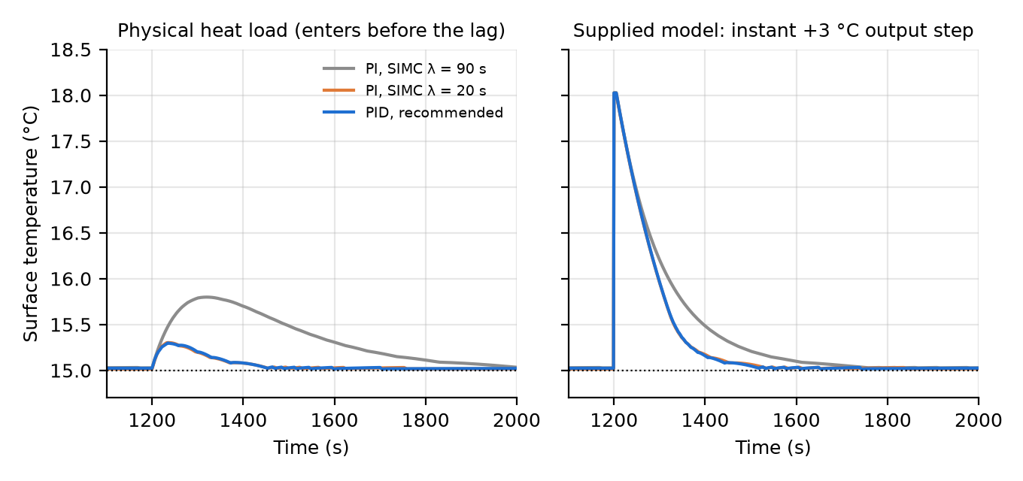
Figure 6. The same 3 °C-equivalent disturbance modelled physically (left: enters before the thermal lag) and as in the supplied model (right: an instant output step). The PI with λ = 20 s lies almost exactly under the recommended PID.

8. PID controller design
The chosen gains are Kp = 0.48 per °C, Ki = 0.0048 per °C·s, Kd = 1.2 s/°C, Tf = 2 s. They come from SIMC tuning with a 20 s closed-loop time constant, plus a derivative time of L/2.

8.1 Controller structure
$$u={sat}_{\left[0 , 1\right]}\left(K_{p}e + K_{i}\int_{0}^{t}{e}dτ + \frac{K_{d}s}{T_{f}s+1}T_{meas}\right), e=T_{meas}−T_{ref}$$
- Reverse-acting error. The plant gain is negative, since more duty means colder. The error is therefore taken as e = T_{meas} − T_{ref}: too warm gives positive e, which gives more cooling. The loop is then L(s) = C(s)·K e^{−Ls}/(τs + 1), with positive gains and negative feedback. Using the usual e = T_{ref} − T_{meas} would require all three gains to be negative. Getting this wrong produces positive feedback, and the plate runs away from the setpoint.
- Derivative on the measurement, through a filter. The derivative acts on the measurement with filter Tf = 2 s (≥ Ts). This avoids a derivative kick when the setpoint changes, and limits amplification of sensor noise.
- Clamping anti-windup. The integrator stops while the output is saturated in the direction the error is pushing. Without this, the 200 s at full duty during a large pull-down would wind up the integral and cause a large undershoot.
- Discrete form at Ts = 1 s, exactly as in the firmware:
$$I_{k}=I_{k−1}+K_{i}T_{s}e_{k}, D_{k}=\frac{T_{f}}{T_{f}+T_{s}}D_{k−1}+\frac{K_{d}}{T_{f}+T_{s}}(T_{m,k}−T_{m,k−1}), u_{k}=sat(K_{p}e_{k}+I_{k}+D_{k})$$

8.2 Tuning method
The plant is first-order-plus-dead-time, so a model-based rule is more defensible than trial and error. SIMC (Skogestad 2003) gives, for a desired closed-loop time constant λ:
$$K_{p}=\frac{τ}{K(λ+L)}=\frac{180}{15×25}=0.48, τ_{I}=min\{τ, 4(λ+L)\}=100 s, K_{i}=\frac{K_{p}}{τ_{I}}=0.0048$$
- λ = 20 s (about 4L). Smaller λ rejects loads faster but loses robustness to dead time. Larger λ is sluggish.
- τ_{I} = 100 s rather than τ = 180 s. The IMC choice τ_{I} = τ cancels the plant pole. The plant pole then reappears in the load response, so loads recover at the plant's own 180 s pace (the IMC row below takes 221 s).
- Derivative time τ_{D} = L/2 = 2.5 s, so Kd = Kp·τ_{D} = 1.2. This adds phase lead to offset the dead time.
s03_pid_design.m also runs MATLAB's pidtune at the same crossover as an independent cross-check.
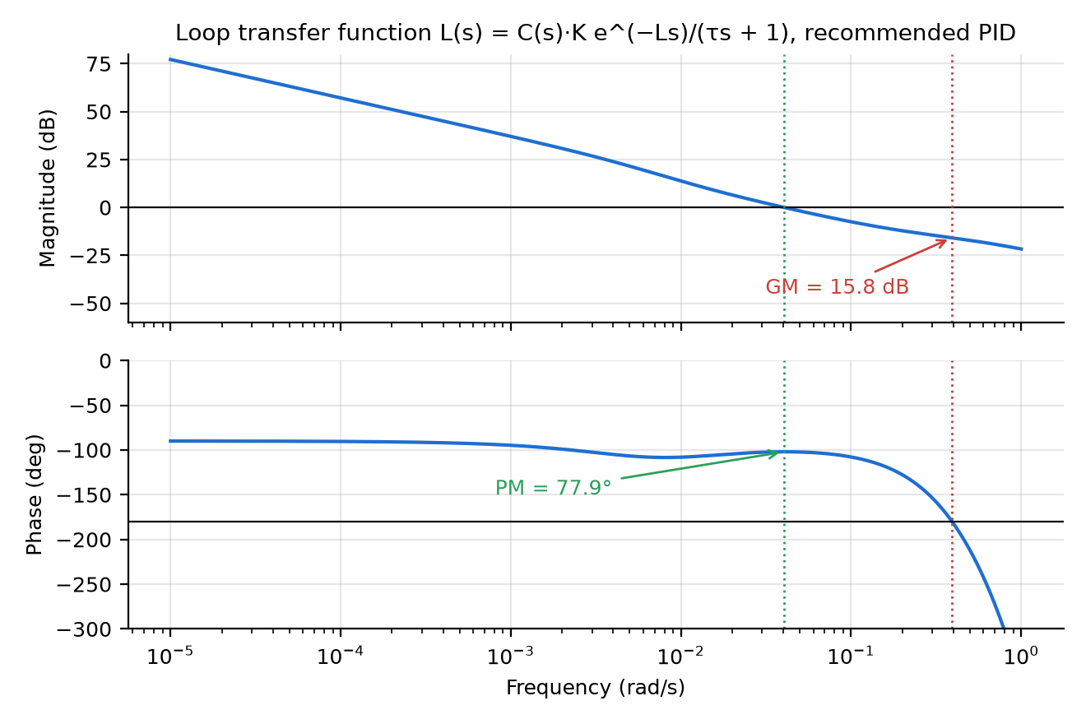
Figure 7. Loop Bode plot with the recommended PID: phase margin 77.9° at 0.040 rad/s and gain margin 15.8 dB at 0.39 rad/s.

8.3 Comparison of tuning methods
Standard test: 25 → 15 °C, then a 0.2 duty load at 1200 s. Margins are continuous-time; the 1 s sampling adds roughly 0.5 s more effective delay. Duty std. dev. is measured with 0.05 °C rms sensor noise added.
Design | Kp | Ki | Kd | Phase margin (°) | Gain margin (dB) | Delay margin (s) | Rise time (s) | Settling 2 % (s) | Overshoot (%) | Load peak (°C) | Load recovery (s) | Duty std. dev.
PI, SIMC λ = 90 s (conservative) | 0.126 | 0.00070 | 0 | 87.0 | 29.5 | 144 | 264 | 519 | 0 | 0.80 | 486 | 0.007
PI, SIMC λ = 20 s | 0.48 | 0.0048 | 0 | 72.3 | 17.8 | 31 | 164 | 304 | 0 | 0.30 | 97 | 0.028
PID, recommended | 0.48 | 0.0048 | 1.2 | 77.9 | 15.8 | 34 | 165 | 294 | 0 | 0.30 | 103 | 0.052
PID, IMC (Rivera) λ = 30 s | 0.374 | 0.00205 | 0.92 | 85.6 | 18.0 | 48 | 200 | 503 | 0 | 0.38 | 221 | 0.039
PID, Ziegler–Nichols reaction curve | 2.88 | 0.288 | 7.2 | 4.4 | 0.2 | 0.2 | 152 | limit cycle | 0.96 | 0.17 | — | 0.303
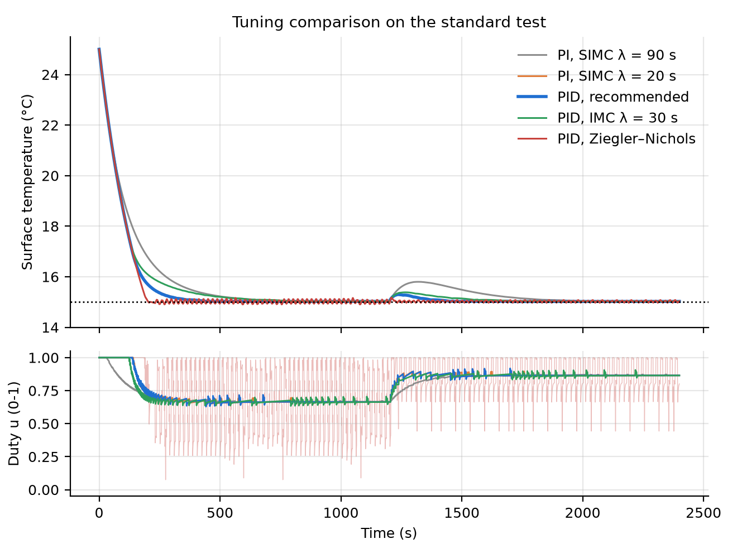
Figure 8. Tuning comparison on the standard test. Ziegler–Nichols (red) limit-cycles, with its duty switching between 0 and 1 (drawn faint). The PI with λ = 20 s lies almost under the recommended PID.
Ziegler–Nichols fails here. It targets quarter-amplitude decay, and with a dominant lag and saturation that leaves 4° of phase margin. In simulation it limit-cycles ±0.13 °C with the duty slamming between 0 and 1. Its apparently good load figures come from that oscillation.
The derivative term buys little. It adds 6° of phase margin and shaves 9 s off settling, but it doubles duty noise. For a dominant first-order plant this is expected; PI with λ = 20 s is an equally valid final choice. D is kept small because the assignment asks for a full PID.

8.4 Effect of changing Kp, Ki and Kd
One gain is changed at a time from the recommended set (s04_gain_sweep.m). A recovery of 0 s means the temperature never left the ±0.2 °C band.
Change | Gain value | Overshoot (%) | Settling 2 % (s) | Load peak (°C) | Load recovery (s) | Phase margin (°) | Gain margin (dB) | Duty std. dev.
Baseline | — | 0 | 294 | 0.30 | 103 | 77.9 | 15.8 | 0.052
Kp × 0.5 | 0.24 | 3.60 | 331 | 0.42 | 126 | 60.8 | 19.0 | 0.038
Kp × 2 | 0.96 | 0 | 412 | 0.19 | 0 | 72.8 | 11.2 | 0.078
Kp × 4 | 1.92 | 0 | 399 | 0.18 | 0 | 48.9 | 5.7 | 0.146
Ki × 0.25 | 0.0012 | 0 | 952 | 0.42 | 451 | 88.6 | 15.8 | 0.050
Ki × 4 | 0.0192 | 2.18 | 248 | 0.24 | 41 | 47.9 | 15.8 | 0.051
Ki × 10 | 0.048 | 2.74 | 236 | 0.21 | 27 | 23.1 | 15.8 | 0.052
Kd = 0 | 0 | 0 | 304 | 0.30 | 97 | 72.3 | 17.8 | 0.028
Kd × 4 | 4.8 | 0.06 | 266 | 0.29 | 120 | 95.2 | 8.8 | 0.127
- Kp sets how hard the loop pushes back. Raising it cuts the load peak (0.30 → 0.18 °C) but lowers the gain margin (15.8 → 5.7 dB) and nearly triples duty noise. Settling got slower at ×2 because, with Ki fixed, the integral time τ_{I} = Kp/Ki doubled and left a slow tail. Halving Kp gave overshoot for the opposite reason. Kp and Ki interact, and their ratio sets the damping.
- Ki removes steady-state error and sets how fast a load is cancelled. More Ki speeds recovery (103 → 27 s) but erodes phase margin (78° → 23°) and adds overshoot. Too little leaves a 952 s crawl.
- Kd adds phase lead, which damps the loop, but it raises high-frequency gain. At ×4 the gain margin halves and duty noise is 4.5 times the PI value.
- Rise time hardly changes (152–166 s) for any gain. The duty is saturated at 1 for most of the 10 °C pull-down, so the actuator, not the tuning, sets it.
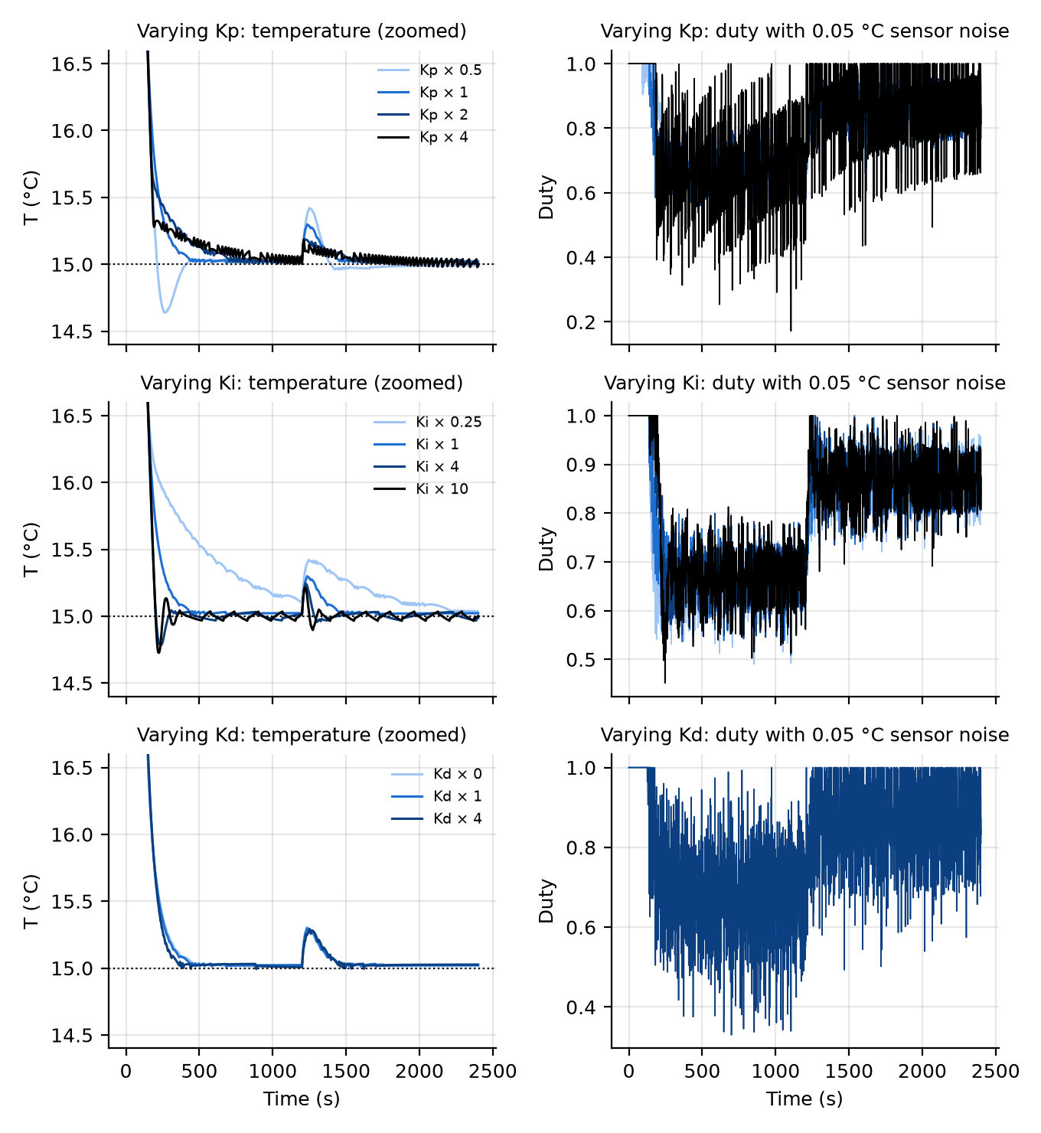
Figure 9. Varying one gain at a time about the recommended set. Left: surface temperature (zoomed). Right: duty with 0.05 °C rms sensor noise added.

8.5 Robustness to parameter uncertainty
The gains stay fixed while the plant changes (s07_robustness.m). The setpoint is raised when K shrinks, so that it stays reachable.
Plant | Setpoint (°C) | Phase margin (°) | Gain margin (dB) | Overshoot (%) | Settling (s) | Load peak (°C)
Nominal | 15.0 | 77.9 | 15.8 | 0 | 294 | 0.30
K × 0.7 | 16.6 | 77.3 | 18.9 | 0.13 | 356 | 0.26
K × 1.3 | 15.0 | 77.6 | 13.5 | 0 | 226 | 0.31
τ × 0.7 | 15.0 | 79.6 | 12.7 | 0 | 271 | 0.31
τ × 1.3 | 15.0 | 75.3 | 18.1 | 0 | 326 | 0.29
L = 10 s | 15.0 | 66.4 | 11.9 | 0 | 299 | 0.32
L = 20 s | 15.0 | 43.3 | 6.3 | 0.32 | 310 | 0.45
K × 1.3 and L = 20 s | 15.0 | 32.4 | 4.1 | 0.38 | 271 | 0.55
The design tolerates ±30 % errors in K and τ with almost no change. Dead time is the parameter to measure first: at 20 s the margins fall below the usual 45° and 6 dB targets. If identification finds L > 10 s, re-tune with λ = 4L by re-running s03 with the measured values.
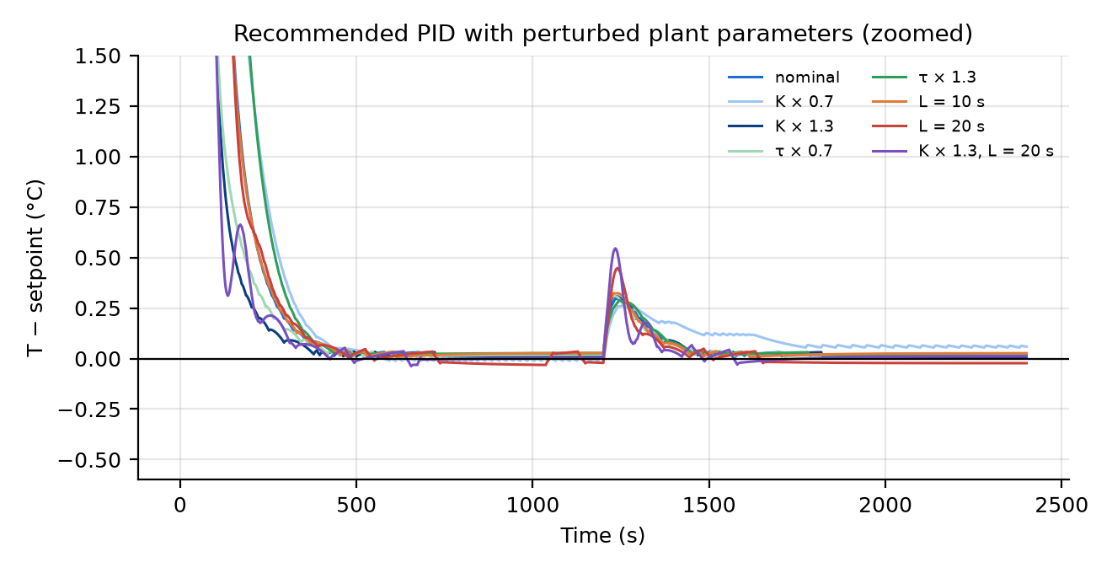
Figure 10. Error from the setpoint with the recommended gains held fixed while the plant parameters are perturbed.

9. Hardware design and implementation
The prototype has the five parts the assignment lists:
- Plant: the cold plate on the Peltier module.
- Sensor: a DS18B20 on the plate.
- Controller: an Arduino Uno running the PID at 1 s.
- Actuator: the module itself, switched by a logic-level MOSFET at 25 kHz.
- Feedback: the sensor reading returned to the controller every second.
A second DS18B20 on the heat sink is used only as a safety trip. A switched resistor provides a repeatable heat-load disturbance.

9.1 Components
Item | Suggested part | Purpose | Key rating / note
Peltier module | TEC1-12706, 40 × 40 mm | Actuator | 12 V, about 5.5–6 A, about 66 W input at full duty
Hot-side cooler | CPU tower or block cooler with 12 V fan | Rejects Q_{c} + P_{e} (about 70 W) | ≤ 0.15 °C/W to keep the hot side within about 10 °C of ambient
Cold plate | Aluminium, 40 × 40 × 3–5 mm | The controlled surface | Thermal paste both faces, closed-cell foam around the edges
Surface sensor | DS18B20, bare TO-92 | Feedback | 0.0625 °C resolution, ±0.5 °C, 750 ms conversion
Heat-sink sensor | DS18B20 | Over-temperature trip at 60 °C | Same bus
Controller | Arduino Uno or Nano | PID, PWM, logging | Timer1 25 kHz PWM on D9
Driver MOSFET | IRLB8721 (or IRLZ44N) | Low-side switch for the module | Logic-level, about 16 mΩ at 4.5 V gate, so about 0.5 W at 5.5 A: fit a small clip heat sink
Freewheel diode | 1N5822 / SR560 Schottky | Clamps wiring-inductance spikes | Across the module
Bulk capacitor | 2200 µF, 25 V, low ESR | Supplies 25 kHz current pulses | At the MOSFET
Load heater | 100 Ω, 5 W resistor + second MOSFET on D6 | Repeatable disturbance (1.4 W at 12 V) | Calibrate in section 10; 47 Ω gives about 3 W if more is needed
Power supply | 12 V, ≥ 10 A | Module + fan + heater | Fuse 8 A in the 12 V line
Passives | 4.7 kΩ (1-Wire pull-up), 2 × 100 Ω gate, 2 × 10 kΩ gate pull-down | Interfacing | —
Heat-sink sizing is the safety-critical calculation. At full duty the hot side must reject the pumped heat plus all of the electrical input, about 70 W. A small extruded heat sink of about 1 °C/W would let the hot side climb about 70 °C above the room. The module would stop cooling and could be damaged. A CPU-class cooler at about 0.15 °C/W keeps the rise near 10 °C. The fan is wired straight to 12 V so firmware can never switch it off.

9.2 Connections (basis for the schematic PDF)
From | To | Note
PSU +12 V | 8 A fuse, then module red (+), fan +, heater resistor | —
Module black (−) | Q1 drain | Low-side switching
Q1 source, Q2 source | PSU − (star ground) | Keep high-current return away from sensor ground
Arduino D9 | Q1 gate via 100 Ω; 10 kΩ gate to source | 10 kΩ keeps Q1 off during reset
Arduino D6 | Q2 gate via 100 Ω; 10 kΩ gate to source | Heater switch
Heater resistor other end | Q2 drain | Resistor bonded to the cold plate
Schottky diode | Cathode to +12 V, anode to Q1 drain | Across the module
2200 µF capacitor | +12 V to ground, at Q1 | —
DS18B20 (both) | VDD to 5 V, GND to GND, DQ to D2 | 4.7 kΩ from D2 to 5 V
Arduino GND | PSU − star point | Single connection
Arduino USB | Laptop | Power and data logging
Draw this in KiCad or Fritzing for the required schematics PDF. Before mounting, check the module's polarity with a 2 s test at DUTY 0.3: the plate side must get cold.

9.3 Design choices
- 25 kHz PWM. Timer1 in phase-correct mode with TOP = 320 gives 16 MHz / (2 × 320) = 25 kHz and 321 duty levels. This is inaudible and far above any thermal dynamics, so the module sees its average. Low-frequency PWM (for example the default 490 Hz) would thermally cycle the module's junctions.
- PWM vs smoothed DC. An LC filter (about 100 µH, ≥ 8 A, plus 2200 µF) would make the current smooth. That raises efficiency, because Joule loss scales with RMS current. It also makes cooling nonlinear in duty (section 5.2). Unfiltered PWM is kept so the linear model holds; the filter is listed as an improvement.
- Sensor mounting. Lay the flat face of the bare TO-92 on the plate with thermal paste, hold it with Kapton tape and cover it with foam. Place it on the plate above the module's centre, because that point is what gets controlled. A waterproof stainless sleeve adds seconds of lag and a dead-time margin cost (section 8.5).
- Cooling only. A single MOSFET cannot reverse current, so warming is passive. A BTS7960 H-bridge would allow active heating and faster warming steps (section 15).

9.4 Firmware
firmware/peltier_pid/peltier_pid.ino runs one control step per second:
- Read the DS18B20 conversion started one second earlier. Non-blocking conversion keeps the loop timing exact.
- Check for faults, then compute the PID exactly as in section 8.1.
- Set the 25 kHz PWM duty.
- Print one CSV line: t_s,T_surf,T_hot,T_ref,duty,load,mode.
Over the serial port (115200 baud) it accepts these commands, so every test in section 10 runs without reflashing:
Command | Effect
SP 15 | Setpoint, limited to 5–30 °C
KP 0.48, KI 0.0048, KD 1.2, TF 2 | Change gains live (gain-variation tests)
MODE OPEN, DUTY 0.6 | Open loop at a fixed duty (identification)
MODE AUTO | Closed loop, with bumpless transfer from open loop
LOAD 1 / LOAD 0 | Heater disturbance on / off
RESET | Clear a latched fault
? | Print gains and state
Safety. Duty goes to 0 and latches off if the surface sensor fails (it reads −127 °C or the power-on value of 85 °C), or if the heat sink exceeds 60 °C. log_serial.m records the stream to CSV with a live plot.
The sketch uses the OneWire and DallasTemperature libraries.

10. Experimental methodology
The experiments run in a fixed order: identify the real plant first, re-tune from it, then test the controller under the same scenarios that were simulated. This makes the simulation-vs-experiment comparison like for like.
Record for every run: room temperature, relative humidity (for the dew point), supply voltage at the module under load, the gains loaded (? command) and the file name. Start every closed-loop run from ambient with the module off for at least 10 min. Repeat each closed-loop test three times to show repeatability.
# | Test | Firmware commands | Duration | What it gives | Script
E0 | Commissioning | MODE OPEN, DUTY 0.3 for 2 s, then DUTY 0 | 5 min | Correct polarity, sensor order, fan running, fault trip works (temporarily lower T_HOT_MAX) | —
E1 | Ambient and noise | MODE OPEN, DUTY 0 | 10 min | T_{amb}, sensor noise std. dev., quantisation | —
E2 | Open-loop step | DUTY 0 until steady, then DUTY 0.6 | ≥ 20 min | K, τ, L (replaces provisional values) | s08
E3 | Linearity | Repeat E2 with DUTY 0.3 and DUTY 0.9 | 2 × 20 min | K at three duty levels | s08
E4 | Heater calibration | DUTY 0.5 until steady, LOAD 1 until steady, LOAD 0 | 40 min | Open-loop rise ΔT_{h}, so d_heater = ΔT_{h} / K | —
E5 | Re-tune | Put E2–E4 values in peltier_params.m, run s03, send KP/KI/KD | — | Final gains | s03
E6 | Setpoint step | MODE AUTO, SP 20 from ambient | 15 min | Rise, overshoot, settling, steady-state error | s09
E7 | Setpoint staircase | SP 20 → SP 15 (t = 900 s) → SP 18 (t = 2100 s) | 45 min | Tracking, cooling vs passive warming | s09
E8 | Load disturbance | At 15 °C steady: LOAD 1 for 10 min, then LOAD 0 | 25 min | Peak deviation, recovery time, duty headroom | s09
E9 | Gain variation | E6 repeated with Kp × 0.5, Kp × 2, Ki × 4, Kd = 0 | 4 × 15 min | Measured effect of each gain (discussion Q2–Q3) | s09
E10 | Actuator limit | SP set 2 °C below T_{amb} − K | 15 min | Saturation, and anti-windup recovery when SP is raised again | —
Metrics use the same definitions as the simulation (step_metrics.m, dist_metrics.m):
- Rise time: 10 % to 90 % of the step.
- Overshoot: % of the step size past the setpoint.
- 2 % settling time.
- Steady-state error: the mean over the last 60 s.
- Load disturbance: peak rise above the setpoint, and time until the temperature stays within ±0.2 °C.
The DS18B20's ±0.5 °C absolute accuracy limits accuracy. Its 0.0625 °C resolution limits steady-state error and repeatability. Report both, and check the surface sensor against a reference thermometer in an ice bath (0 °C) before E2.
Logging. Run log_serial("COM5", "../data/<test>_<run>.csv", <seconds>) from MATLAB. Save the open-loop step as data/openloop_step.csv and the main closed-loop run as data/closedloop_run.csv. s08 and s09 read those two names.
Safety during tests. Never run the module with the fan off or the heat sink removed. Keep water from condensation away from the Arduino and MOSFETs; a drip tray under the plate is enough. Stop the test if the heat-sink reading passes 50 °C.

11. Results
Each table sets the simulated prediction beside the measured result. Measured values are the mean of three repeats, with the spread in brackets. [FILL: measured columns. Also update the simulated columns after re-running s03–s07 with the identified K, τ and L, so both columns describe the same plant.]

11.1 Setpoint tracking (E6, E7)
These come from the s05 staircase (800 s per step).
Step | Simulated rise time (s) | Simulated overshoot (%) | Simulated settling 2 % (s) | Simulated steady-state error (°C) | Measured rise time (s) | Measured overshoot (%) | Measured settling (s) | Measured steady-state error (°C)
25 → 20 °C (cooling) | 74 | 0 | 130 | −0.01 | to measure
20 → 15 °C (cooling) | 114 | 0 | 222 | −0.02 | to measure
15 → 18 °C (passive warming) | 68 | 0 | 120 | +0.02 | to measure
18 → 22 °C (passive warming) | 135 | 0 | 272 | +0.02 | to measure
Warming is passive. During a warming step the controller can only switch the module off, so the plate warms at its natural rate toward ambient. Warming toward 22 °C is therefore slower than toward 18 °C: the driving difference T_{amb} − T shrinks as the plate approaches ambient.
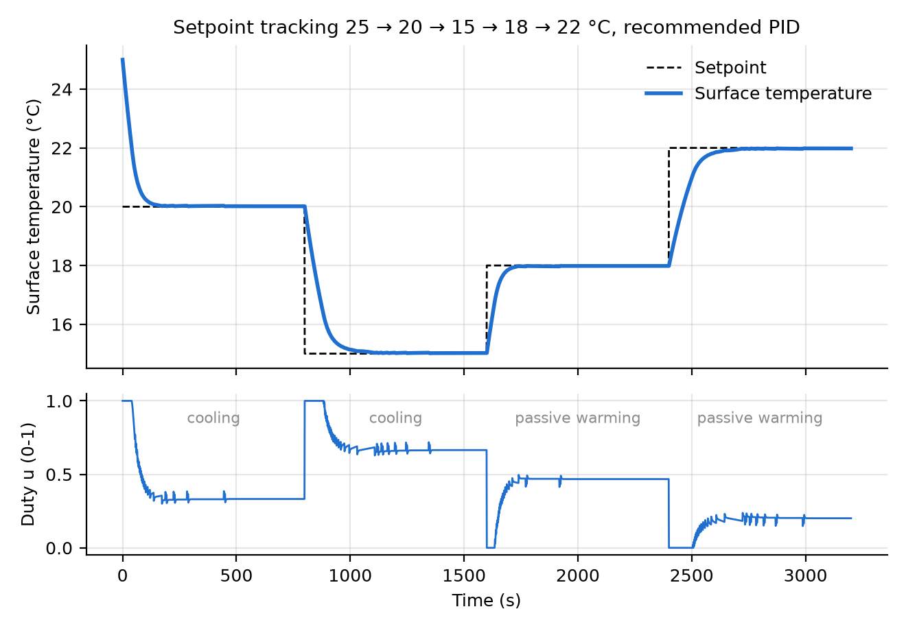
Figure 11. Simulated setpoint tracking 25 → 20 → 15 → 18 → 22 °C. Cooling steps are actively driven; warming steps are passive, with the duty at 0.

11.2 Load disturbance (E8)
Quantity | Simulation (d_{u} = 0.2) | Experiment
Peak rise above 15 °C | 0.30 °C | to measure
Recovery to within ±0.2 °C | 103 s | to measure
Duty before / after load | 0.67 / 0.87 | to measure
Error after recovery | 0.02 °C | to measure
Scale the simulated values by the heater's measured d_heater from E4. To first order, the peak scales linearly with load size.

11.3 Stability
No sustained oscillation is predicted for any recommended or SIMC design. The Ziegler–Nichols set limit-cycles at ±0.13 °C. In E9, note whether any gain set oscillates, and its period. A period of roughly 2π/ω₁₈₀ ≈ 16 s confirms that the measured dead time is close to the model's.

12. Results comparison — simulation vs experiment
s09_sim_vs_experiment.m replays the logged setpoint and heater signals through the model, using the identified parameters and the firmware's gains. It then overlays measured and simulated temperature and duty, and prints RMSE plus the metric table below for every setpoint change. Because the inputs are identical, any difference is model error.
Metric | Simulation | Experiment | Difference | Main cause
RMSE of T over the whole run | — | — | to measure
Settling time 20 → 15 °C | 222 s | to measure
Overshoot 20 → 15 °C | 0 % | to measure
Load peak | 0.30 °C | to measure
Steady-state duty at 15 °C | 0.67 | to measure
[FILL: Figure 12 — paste the s09_sim_vs_experiment.png overlay of measured and simulated temperature and duty for test E7, caption "Figure 12. Measured vs simulated response, test E7".]
What to look for when explaining differences:
- Steady-state duty higher than simulated. The real K is lower than 15: the heat sink is warmer, or there is condensation load. This is the most likely difference.
- Response slows or creeps after the first minutes. Heat-sink warming, the second slow mode from section 6.3. It appears as a trend in the s09 error plot.
- More overshoot or ringing than simulated. The real dead time is longer: sensor bonding, plate thickness, or the sensor placed away from the module's centre.
- Constant offset. The sensor's ±0.5 °C absolute accuracy. The loop holds the reading exactly, and a reference thermometer shows the true error.
- Noise on the duty trace. Sensor noise amplified by Kp and Kd (section 8.4). Compare the measured duty std. dev. with the simulated 0.05.
- Asymmetric warming. Expected from the cooling-only actuator, so it is not a model error.

13. Discussion
The answers draw on the simulation (sections 7–8) and the experiments (sections 11–12).
- How effectively does the PID achieve the setpoint? Within the feasible range (13–22 °C at 25 °C ambient) it reaches the setpoint without overshoot and settles in 130–294 s depending on step size. The remaining error is about 0.02 °C, which is the sensor's quantisation. Outside that range no controller can help, because the actuator is saturated. [FILL: measured steady-state error and overshoot from section 11.1.]
- How do Kp, Ki and Kd affect the response?
  - Kp sets the immediate push-back: a smaller load peak, at the cost of noise and gain margin.
  - Ki removes steady-state error and sets load-recovery speed, at the cost of phase margin and overshoot.
  - Kd adds damping through phase lead, but amplifies sensor noise.
  - For this plant Kp and Ki dominate; Kd changes settling by only 3 %.
- What happens when they are increased or decreased? See the table in 8.4.
  - Kp × 4 cuts the load peak 40 % but drops the gain margin to 5.7 dB and triples duty noise.
  - Ki × 10 recovers loads 4 times faster but leaves 23° of phase margin; Ki × 0.25 takes 952 s to settle.
  - Kd × 4 halves the gain margin.
  - Halving Kp increased overshoot, because Ki was left unchanged and the integral became relatively stronger. The gains interact.
- Does the practical system behave like the simulation? [FILL from section 12: RMSE between measured and simulated temperature, and the main differences.] Expect the shape to match, and the steady-state duty to be higher than predicted if the heat sink warms. Expect more lag if the sensor bonding is poor.
- Main sources of error in practice:
  - Sensor absolute accuracy (±0.5 °C) and placement, so the reading may not be the true surface temperature.
  - Quantisation (0.0625 °C).
  - Heat-sink temperature drift, which changes K.
  - Room drafts and ambient drift.
  - Condensation load below the dew point.
  - Supply-voltage sag under 5.5 A, which reduces pumping power.
  - Thermal-paste and contact variation between assemblies.
- Response to disturbances. A 3 °C-equivalent heat load raises the surface 0.30 °C, and the controller recovers within ±0.2 °C in 103 s by raising the duty from 0.67 to 0.87. Disturbances are rejected only while duty headroom remains. At 13 °C the same load uses all of it, and below that the error stays.
- Limitations encountered — see section 14.
- Improvements to the control system — see section 15.
- Industrial prototype.
  - An RTD (PT100/PT1000) with a 24-bit converter instead of the DS18B20.
  - A bidirectional H-bridge, or a linear current-source driver.
  - A rated heat sink, with T_{h} feedforward.
  - Sealed insulation with a dew-point monitor.
  - Interlocked over-temperature and fan-fail cut-outs in hardware, not only firmware.
  - Stored, versioned calibration.
  - An enclosure meeting IP and EMC requirements.
- Is PID the right technique? Yes, for this plant. It is a stable first-order lag with modest dead time. PI with anti-windup achieves almost all the achievable performance, the gains have physical meaning, and PID runs on an 8-bit MCU. Model predictive control would earn its complexity only with hard constraints to plan around, such as staying above the dew point while holding a ramp, or with multiple coupled zones. Feedforward from a measured heat-sink temperature is the cheapest next step beyond PID. A Smith predictor would help only if the dead time turned out to be a large fraction of τ, and the analysis suggests it is not.

14. Limitations
- Parameter uncertainty. K, τ and L come from a single open-loop step test and change with ambient and heat-sink temperature. The design tolerates ±30 % in K and τ, but is less tolerant of dead time above 10 s.
- Cooling only. u ∈ [0, 1] means no active heating. Warming steps are passive and slower, and the plate cannot be held above ambient.
- Limited range. The reachable range is T_{amb} − K to T_{amb} and shifts with the room. Setpoints of 5 and 10 °C were not achievable with this hardware.
- The model is first order. It ignores heat-sink dynamics, operating-point dependence of K and condensation.
- The sensor limits accuracy. Resolution of 0.0625 °C and accuracy of ±0.5 °C cap steady-state accuracy.
- The Simulink model differs slightly from the firmware. The standard Simulink PID block differentiates the error, not the measurement, so setpoint steps produce a short derivative kick there.
- Experimental scope. [FILL: limitations met during testing, e.g. number of repeats, ambient conditions, sensor calibration, condensation.]

15. Proposed improvements
Improvement | Expected benefit | Effort
Measure K, τ, L and re-tune with λ = 4L | Margins checked on the real plant | Low (s08, s03)
Setpoint ramp, or setpoint weighting b < 1 on P | Gentler duty during large steps, less thermal stress | Low
Feedforward u_{ff} = (T_{amb} − r)/K on top of PID | Faster setpoint response; PID only corrects model error | Low
H-bridge (BTS7960) for bidirectional drive | Active warming, symmetric response, setpoints above ambient | Medium
LC filter on the module current | Higher efficiency (less RMS Joule loss); needs gain scheduling because cooling becomes nonlinear | Medium
Heat-sink temperature feedforward | Cancels the slow drift before it reaches the plate | Medium
PT1000 + ADS1220 sensor | About 0.01 °C resolution and better accuracy | Medium
Dew-point limit on the setpoint (humidity sensor) | Prevents condensation and the latent-heat load | Medium
Gain scheduling on setpoint | Consistent response if K varies with operating point (E3) | Medium

16. Conclusion
An energy balance on the cold plate gives the first-order model −K/(τs + 1), so the supplied transfer function is physically justified. It also shows that a heat load enters through the thermal lag, not as an output step. With the provisional plant (K = 15 °C, τ = 180 s, L = 5 s), a reverse-acting PID tuned by SIMC achieves the following:
- Kp = 0.48, Ki = 0.0048, Kd = 1.2, with clamping anti-windup.
- No overshoot, and 2 % settling in 294 s for a 10 °C step.
- A 0.30 °C peak under a 3 °C-equivalent load.
- 78° / 15.8 dB stability margins, and tolerance of ±30 % errors in K and τ.
The main engineering constraint is the actuator, not the tuning. A cooling-only module reaches only T_{amb} − K, which is why 5 °C and 10 °C cannot be held and the demonstration should use 15–22 °C. [FILL: two sentences on the measured performance and how closely it matched the simulation.]

17. References
- K. Ogata, Modern Control Engineering, 5th ed., Prentice Hall, 2010.
- N. S. Nise, Control Systems Engineering, 7th ed., Wiley, 2015.
- K. J. Åström and T. Hägglund, Advanced PID Control, ISA, 2006 (anti-windup, derivative filtering, setpoint weighting).
- S. Skogestad, "Simple analytic rules for model reduction and PID controller tuning," Journal of Process Control, vol. 13, pp. 291–309, 2003 (SIMC rules).
- D. E. Rivera, M. Morari and S. Skogestad, "Internal model control: PID controller design," Ind. Eng. Chem. Process Des. Dev., vol. 25, pp. 252–265, 1986.
- J. G. Ziegler and N. B. Nichols, "Optimum settings for automatic controllers," Trans. ASME, vol. 64, pp. 759–768, 1942.
- C. L. Smith, Digital Computer Process Control, Intext, 1972 (two-point FOPDT identification).
- D. M. Rowe (ed.), Thermoelectrics Handbook: Macro to Nano, CRC Press, 2006 (Peltier heat-balance equations).
- Maxim Integrated (Analog Devices), DS18B20 Programmable Resolution 1-Wire Digital Thermometer, datasheet.
- Hebei I.T., TEC1-12706 Thermoelectric Cooler, datasheet.
- Infineon, IRLB8721PbF HEXFET Power MOSFET, datasheet.
- MathWorks, PID Controller and Discrete PID Controller block reference; pidtune documentation.

Appendix A — Review of the supplied material
The supplied transfer function is sound and is kept. The block diagram and the plots built from it contain errors that would either cool the wrong signal or overstate disturbances. Each is listed with the minimum fix.

A.1 Signal trace of the supplied diagram
From the screenshot:
- Plant → Delay → DistSum (+ Delay, − Disturb).
- DistSum output to TempSum (+ Tamb, − DistSum), whose output goes to the Scope.
- DistSum output also to Err (+ Ref, − DistSum) → PID (configured as PI, with an output limit) → Plant.
Near the junction above Err, the PID output line and the TempSum-to-Scope line cross. The image alone cannot show which one feeds the Plant and the Scope's second input. Check it in Simulink with Highlight Signal to Source; rebuilding with build_simulink_model.m removes the question.
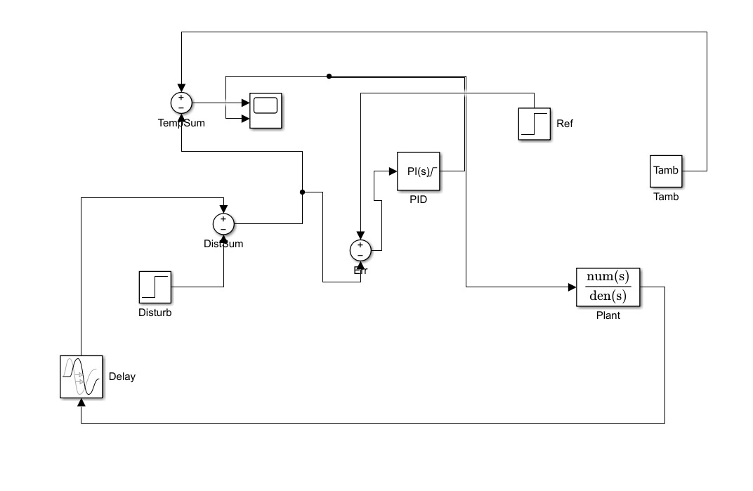
Figure A1. The supplied Simulink block diagram, before correction.
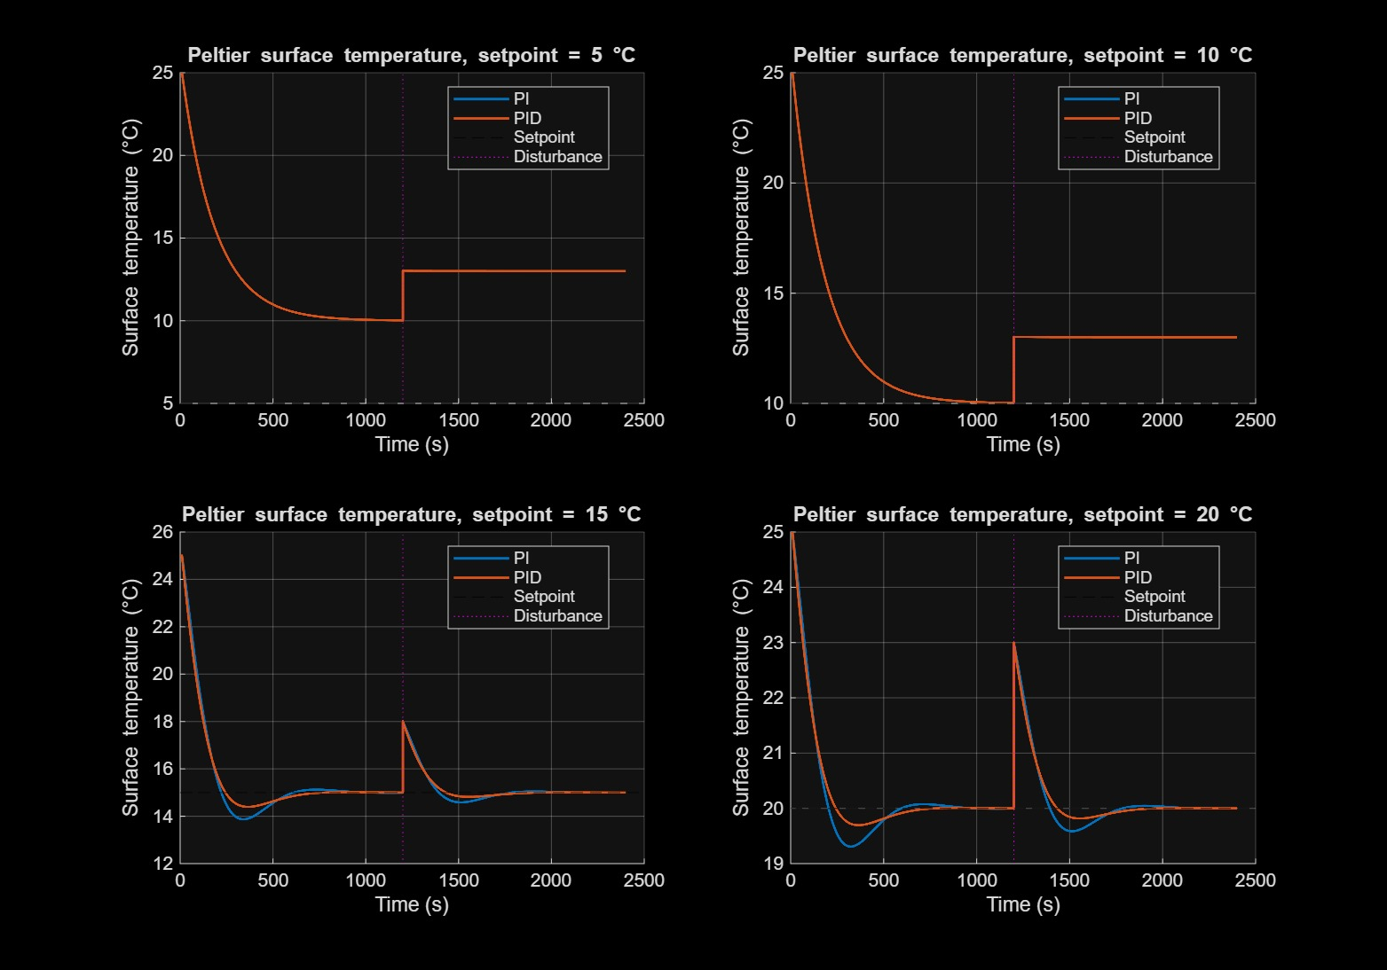
Figure A2. The supplied PI/PID simulation results, before correction. The 5 °C and 10 °C cases saturate, and the disturbance appears as an instant +3 °C step.

A.2 Problems found
# | Where | Problem | Consequence | Minimum correction
1 | TempSum signs vs plant gain | TempSum computes T_{amb} − (plant path), which assumes the plant outputs a positive temperature drop. The supplied plant −K/(τs + 1) outputs a negative change. | Using both gives a double negative: T = T_{amb} + K·u, so more duty would heat. | Keep the supplied −K plant and set TempSum to ++ (T_{s} = T_{amb} + ΔT).
2 | Err input | Err compares Ref, an absolute °C, with the DistSum output, a change from ambient. | The loop would drive the change to 15, giving T ≈ 10 °C, not 15 °C. | Feed Err from the measured absolute temperature (after TempSum and the sensor).
3 | Err sign | With a negative-gain plant, e = Ref − T and positive gains form a positive-feedback loop. | Runaway to a duty limit. | Reverse-acting error e = T_{meas} − T_{ref} (Err signs: + T_{meas}, − Ref), or keep e = Ref − T and make all gains negative.
4 | Disturbance location | Disturb is subtracted after the plant and delay, as an instantaneous step on the temperature. | Plots show a vertical 3 °C jump at 1200 s. That overstates the peak tenfold (3.02 vs 0.30 °C), and the controller sees the disturbance before the dead time. | Move DistSum to the plant input: u − d_{u} (§5.2).
5 | Delay location | The delay sits between the plant and every other signal, so the plotted "surface temperature" is the delayed one. | Actual and measured temperature cannot be compared. | Place the delay only in the feedback (measurement) path, and log both signals.
6 | PID block | Shows "PI(s)" with a limit; anti-windup and sample time are not visible. | Integrator windup during the long saturated pull-down; no match to the 1 s firmware. | Discrete PID, Ts = 1 s, limits [0, 1], clamping anti-windup, N = 1/Tf.
7 | Setpoints 5 and 10 °C | Below or at T_{amb} − K = 10 °C. | Duty pinned at 1, no regulation, and the load leaves a permanent +3 °C error. The 5 °C trace is hidden under the 10 °C one in the all-setpoints plot. | Test at 13–22 °C; show one infeasible setpoint as an actuator-limit case.
8 | Supplied script | step(G_surface) plots the change (final value −15 °C) under the label "Surface Temperature Change", which is correct. K and τ are marked illustrative. | None, as long as the values are not presented as measured. | Used as provisional values; replaced via s08.

A.3 How the conflict was resolved
The diagram and the transfer function cannot both be used unchanged. The diagram assumes a positive temperature-drop plant and compares it against an absolute reference. The transfer function has a negative gain acting on a temperature change.
The transfer function was kept, because section 5 derives it from physics and it matches the variable definitions supplied with it. The diagram was corrected with four rewires: TempSum signs, the Err input, the Err sign, and the DistSum position. All the block names were kept, so the corrected model is recognisably the same architecture (§4, Appendix B).
The plots' PI-vs-PID shapes at 15 and 20 °C are plausible, but the gains that produced them were not supplied. They should be regenerated with the corrected model and the gains in §8.

Appendix B — Simulink construction guide
build_simulink_model.m builds and runs this model automatically, and saves peltier_pid_model.slx. To build it by hand, first run P = peltier_params(); S = pid_designs(P); g = S(3); so the block parameters can refer to P.* and g.*. Then add the blocks below.
Block name | Library block | Parameters | Input ports (port ← source) | Role
Ref | Sources / Step | Step time 0, Initial P.Tamb, Final P.T_{ref} | — | Setpoint, absolute °C
Err | Math Operations / Sum | List of signs +- | 1 ← Quantizer (T_{meas}), 2 ← Ref | e = T_{meas} − T_{ref} (reverse acting)
PID | Discrete / Discrete PID Controller | Controller PID, Form Parallel, P g.Kp, I g.Ki, D g.Kd, N 1/g.Tf, Sample time P.Ts, Integrator and Filter methods Backward Euler, Limit output on [P.umin, P.umax], Anti-windup clamping | 1 ← Err | Duty command u
Disturb | Sources / Step | Step time P.t_{load}, Initial 0, Final P.d_{load} | — | Heat load in duty units
DistSum | Math Operations / Sum | Signs +- | 1 ← PID, 2 ← Disturb | Net cooling command u − d_{u}
Plant | Continuous / Transfer Fcn | Numerator [-P.K], Denominator [P.tau 1], initial state 0 | 1 ← DistSum | ΔT_{surface} (negative when cooling)
Tamb | Sources / Constant | P.Tamb | — | Ambient temperature
TempSum | Math Operations / Sum | Signs ++ | 1 ← Tamb, 2 ← Plant | T_{surface} = T_{amb} + ΔT (absolute)
Delay | Continuous / Transport Delay | Time delay P.L, Initial output P.Tamb | 1 ← TempSum | Sensor and contact dead time
Sample | Discrete / Zero-Order Hold | Sample time P.Ts | 1 ← Delay | 1 s sensor reading
Quantizer | Discontinuities / Quantizer | Interval P.q (0.0625) | 1 ← Sample | DS18B20 resolution; output = T_{meas}
Mux + Scope | Signal Routing / Mux (3); Sinks / Scope (2 inputs) | — | Mux ← TempSum, Quantizer, Ref; Scope 2 ← PID | Temperatures and duty
log_* | Sinks / To Workspace | Save format Timeseries; names T_{surface}, T_{meas}, duty, T_{ref} | From TempSum, Quantizer, PID, Ref | Logged for plots and metrics
Solver. Fixed-step ode4 with step P.dt = 0.1 s, stop time P.t_end = 2400 s. A variable-step solver also works; set Max step to 1 s so the 1 s controller and the 1200 s load step are not stepped over.
Initial conditions. Plant state 0 and Delay initial output P.Tamb, so the plate starts at ambient. The PID integrator starts at 0.
Saturation and anti-windup. The output is limited to [0, 1] inside the PID block, so the clamping logic sees it. A separate Saturation block after the PID would not stop windup.
Check after building. build_simulink_model overlays the Simulink output on simulate_loop.m. The curves should coincide except for a brief derivative kick at setpoint changes: the standard block differentiates the error, while the firmware differentiates the measurement. Use the PID Controller (2DOF) block with c = 0 to remove that difference.
Variants. For a staircase setpoint, replace Ref with Repeating Sequence Stair or Signal Editor. For the original disturbance model (comparison only), add the 3 °C step after TempSum instead of at DistSum.

Appendix C — MATLAB package and firmware
Run run_all from the matlab folder. It runs s01–s09 in order, writes every figure to figures/ as PNG and FIG, and builds the Simulink model if Simulink is installed. It needs MATLAB with the Control System Toolbox; simulate_loop.m itself needs no toolbox.
File | What it does | Report section
peltier_params.m | Every parameter, tagged provisional, design or datasheet | 6.1
peltier_plant.m | Transfer functions (with and without delay, load path) and state space | 5–6
pid_designs.m | SIMC PI, recommended PID, IMC-PID, Ziegler–Nichols gain sets | 8.2–8.3
simulate_loop.m | Closed-loop simulation with saturation, anti-windup, dead time, quantisation, noise; same law as the firmware | 7–8, 11
step_metrics.m, dist_metrics.m | Rise, overshoot, settling, steady-state error; load peak, recovery, IAE | 8, 10–12
loop_margins.m | Gain, phase and delay margins | 8.3, 8.5
s01_model_analysis.m | Model display, open-loop steps, Bode, reachable range | 6, 7.1
s02_before_after.m | Open loop vs P-only vs on/off vs PID | 7.3
s03_pid_design.m | Tuning comparison, margins, pidtune cross-check | 8.3
s04_gain_sweep.m | Effect of Kp, Ki, Kd up and down | 8.4
s05_setpoint_tracking.m | Feasibility table and staircase test | 7.2, 11.1
s06_disturbance_rejection.m | Physical load vs supplied output-step model | 7.4, 11.2
s07_robustness.m | K, τ, L perturbations | 8.5
s08_identify_plant.m | K, τ, L from an open-loop step log (two-point + least squares) | 6.2, 10
s09_sim_vs_experiment.m | Replays a logged run through the model; overlay, RMSE, metric table | 12
build_simulink_model.m | Builds, runs and checks peltier_pid_model.slx | 7, App. B
log_serial.m | Logs the Arduino CSV stream with a live plot | 10
make_synthetic_data.m | Writes files named SYNTHETIC_* so s08/s09 can run before hardware exists; never report them | —
firmware/peltier_pid/peltier_pid.ino | Arduino PID, 25 kHz PWM, safety trips, serial commands, CSV log | 9.4
verification/verify_sim.py | Python copy of simulate_loop.m that produced the numbers in this report | 7–8, 11
Verification. verification/verify_sim.py is an independent Python implementation of simulate_loop.m. Its output, verification/results.json, reproduces every simulated number in sections 7–11, and verification/make_figures.py draws Figures 2–11 from the same model.

