**Brainstorm Ideas:**

1. Water bodies Waste Management

Problem:

Solution:

1. De-crystallization of honey

Problem:

Solution:

1. Intimate washes

Problem:

Solution:

1. .

Problem:

Solution:

1. .

Problem:

Solution:

**Working Idea:**

Problem Statement:

* Intimate washes are too harsh and irritating for the skin, which can result in issues like dryness, itching, and Odor.
* The natural pH balance of the vagina might be upset by the synthetic components found in intimate washes such as SLS.
* Sodium laureth sulfate (SLS), a specific ingredient included in intimate wash solutions, is what causes the pH change.
* SLS is a surfactant found in a variety of personal care products.
* Despite the fact that it is a very powerful cleanser, it can be harsh on the skin and mucous membranes.
* SLS functions by dissolving oils and dirt this can be beneficial for washing sweat and dirt off the skin, but it can also upset the vagina's normal pH balance.
* The pH of the vagina is somewhat acidic, which aids in preventing infection.
* When SLS is used to wash the vagina, the pH balance may be raised, increasing the risk of infection.

Dataset:

Strategies to resolve the problem:

A new herbal intimate lotion that is affordable for a wide range of consumers, makes use of natural components that are beneficial and safe for the intimate area and is effective and pleasant to use on skin that is sensitive, due to the product having a smooth, gel-like structure that penetrates the dermal layer effectively and comfortably. It also contains relaxing and soothing natural aromatic components, and

Benefits of new herbal intimate lotion:

* on skin that is sensitive, gentle, and effective
* Safe and helpful natural substances for the intimate area
* Widely available and reasonably priced for customers
* reduces the impact of intimate issues like dryness, itching, and Odor

Usage:

* After using an intimate wash
* Apply on a dry area
* Avoid using it during periods

Wants and needs of society:

Visualization:

**User Persona:**

Paper Card:

User- Kavya

Age- 30

Occupation- Software Engineer

Demographic- Single, lives in a city

Goal- Maintain proper intimate hygiene so that you can feel confident and fresh all day.

Problems: (Itching, irritability, and dryness are felt after using V-Wash)

* after using V-Wash, there may occasionally be itching, irritation, and dryness.
* Worried that using V-Wash excessively would upset the delicate equilibrium in her private space
* Uncertain of the effectiveness of V-Wash in preventing infection

User Narrative:

I want to use a solution that is gentle on my skin and successful at preventing infection as a V-Wash user with difficulties so that I can feel confident and fresh throughout the day. I also want to have a positive experience around using such a product, and feel healed and comfortable after its application.

Acceptance Criteria:

* The product must be pH-balanced to preserve the intimate area's natural pH.
* The product must not contain any harsh chemicals or irritating fragrances.
* Clinical studies must show that the product is effective at preventing infections.
* Product must provide a welcome and refreshing contrast to the harsh chemical-esqe feeling evoked by a product like V-wash and evoke a feeling of nourishment and vitality. This is accomplished through the use of natural aromatics which have soothing properties and also the smoothness of the product itself which has a pleasing and cooling gel-like feel and a deep forest green color reminiscent of the botanicals it contains.

**Wireframe:**

Project goals-

* To develop an innovative herbal intimate lotion that lessens the impact of intimate wash problems, and which provides an excellent customer experience during application and after, which helps the user feel a sense of relaxation and confidence about their intimate health.

Objective-

* To develop a lotion for fragile skin that is both mild , cooling and effective.
* To employ natural components that are advantageous and safe for the intimate area, increasing user comfort.
* To create a lotion that is accessible and cheap to a variety of customers.
* To ensure a positive and rejuvenating customer experience around the use of our herbal product which also carries a pleasant botanical scent created naturally, anchoring the customer to the product and adding to user experience, making it a positive ending to a possibly worrying use of a pH imbalance product which often acts harshly.
* To inform them of the advantages of utilizing herbal intimate lotion and the correct way to use it.

Target audience-

* Concerned women of all ages over their sexual health.
* women who have issues with Odor, dryness, or irritation in their intimate areas.
* women looking for a secure and natural solution to take care of their private areas.
* Women who have a tendency to view natural/herbal products as a viable and harmless method of solving problems of irritation/infection caused by the use of chemical products, and are seeking a helpful and reassuring product for the same.

Desired outcomes-

* To create a lotion that is highly welcomed by customers and lessens the impact of personal issues, which provides a solution for their issues accompanying intimate wash use, while also creating a positive state of mind which evokes a feeling of well-being.
* To inform them of the advantages of utilizing herbal intimate lotion and the correct way to use it.
* To create awareness amongst consumers of the existence of the problem of pH imbalance caused by the use of intimate washes composed of chemicals and the right way to remedy the issue.
* To expand the market for herbal intimate lotion and increase customer access to it.

Key Ingredient: Lactic Acid 1.2% w/v

Ingredients: Purified Water, Triethanolamine Lauryl Sulphate, Ammonium Lauryl Sulphate, Cocamidopropyl Betaine, PEG-7 Glyceryl Cocoate, Lactic Acid, Phenoxyethanol (and) Benzoic Acid (and) Dehydroacetic Acid, Sorbitol, Hydroxypropyl Cellulose, Polyquaternium-7, Fragrance, Hippophae Rhamnoides (Sea buckthorn) Fruit Oil, Sodium Hydroxide, Tea Tree Oil (Melaleuca Alternifolia), perfume

**Wireframe**





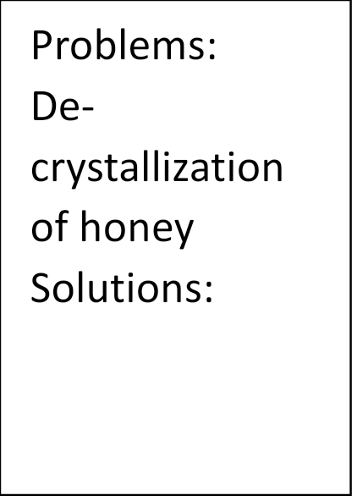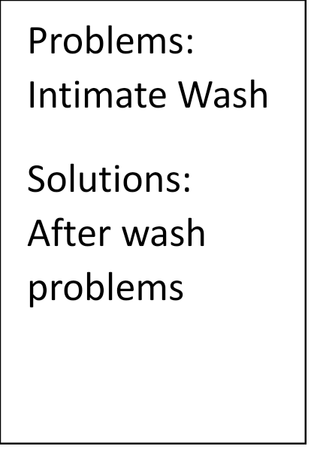



* Intimate