1. y = 2x3 − x

2. y = x3 − 4x

3. x − y2 = 1

4. y=|x|+|x−16|

5. y = x3 + 4x2 − 3

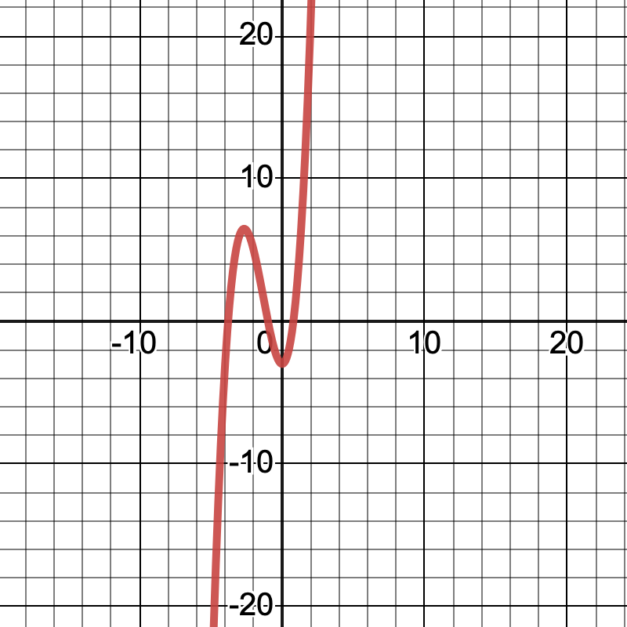

6. y=cos(πx)+9

7.

Mean(x_1) = 17.5

Min(x_1) = 5

Max(x_1) = 30

Sample Standard Deviation(x_1) = 9.35

Population Standard Deviation(x_1) = 8.54

Mean(y_1) = 67.33

Min(y_1) = 43

Max(y_1) = 85

Sample Standard Deviation(y_1) = 16.57

Population Standard Deviation(y_1) = 15.13

Correlation Coefficient; r = -0.35