STANDARD CHARTERED BANK
Anti-Money Laundering (AML) Platform
End-to-End Architecture & Technical Deep Dive
Including Lucid Search Application

PREM VISHNOI
Big Data Consultant | Standard Chartered Bank, Singapore
February 2016 – July 2018

Core Banking • Retail Banking • CIB • Hadoop/Hive • Spark • Elasticsearch

1. Project Overview
Company | Standard Chartered Bank (SCB) — Singapore HQ
Role | Big Data Consultant
Duration | February 2016 – July 2018 (~2.5 years)
Division | Group Financial Crime Compliance (GFCC)
Coverage | 15 countries: SG, HK, MY, TH, IN, KR, TW, UK, US, AE, KE, NG, PK, BD, CN
Tech Stack | Hadoop, HDFS, Hive, Apache Spark, Sqoop, Kafka, Elasticsearch, Oozie
Banking Lines | Core Banking, Retail Banking, Corporate & Institutional Banking (CIB)
Key Deliverables | AML Data Platform + Lucid Search Application
Regulatory | MAS (Singapore), FCA (UK), FinCEN (US), HKMA, RBI + 10 local regulators

1.1 Business Context
Standard Chartered Bank operates across 60+ markets with a strong presence in Asia, Africa, and the Middle East. The Group Financial Crime Compliance (GFCC) division needed a unified data platform to detect suspicious transactions, screen entities against sanctions lists, and generate regulatory reports across all 15 priority countries. Before this project, each country operated its own siloed AML system with different data formats, screening vendors, and no cross-border visibility. An entity flagged as high-risk in Singapore could remain undetected in Hong Kong.
1.2 My Role & Responsibilities
- Led design and implementation of the Hadoop-based AML data platform for 15 countries
- Built data ingestion pipelines from Core Banking, Retail, and CIB source systems using Sqoop and Kafka
- Designed the Hive data warehouse (ODS → CDM → ADS) with per-country schemas for data sovereignty
- Developed Apache Spark jobs for entity resolution, transaction aggregation, and 200+ feature engineering
- Built the "Lucid Search" application on Elasticsearch for high-risk entity identification
- Ensured MAS regulatory compliance: 7-year retention, audit trails, T+1 processing SLA

2. End-to-End Architecture
The following diagram shows the complete AML platform architecture from source systems to compliance output:

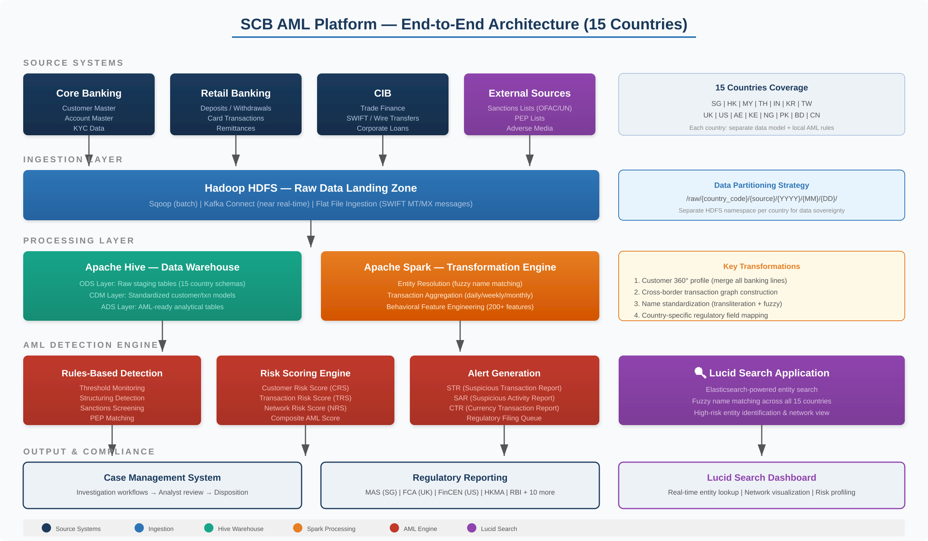

Figure 1: SCB AML Platform — End-to-End Architecture (15 Countries)

2.1 Source Systems Detail
Core Banking: Customer master data, account information, KYC records. Sourced from Oracle/DB2 databases. Includes demographics (name, DOB, nationality), account details (number, type, status), KYC documents (ID verification, risk rating, PEP classification), and beneficial ownership structures.
Retail Banking: Transaction systems covering deposits, withdrawals, card transactions (credit/debit), remittances, and ATM/teller cash transactions. Highest-volume source at 30–50 million transactions/day across all countries.
CIB (Corporate & Institutional Banking): Trade finance (Letters of Credit, Bank Guarantees), SWIFT wire transfers (MT103, MT202), corporate loans, and treasury operations. Lower volume but significantly higher value — critical for detecting trade-based money laundering.
External Sources: OFAC SDN List, UN Consolidated List, EU Sanctions, PEP databases, and adverse media feeds. Updated daily and screened against the entire customer base.

3. Data Pipeline Detail
The detailed data flow from source extraction through Hive staging, Spark transformations, to AML-ready tables:

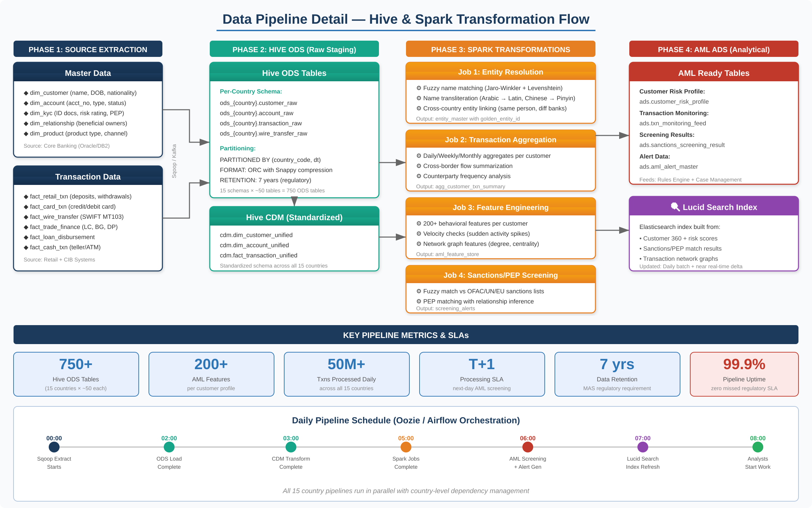

Figure 2: Data Pipeline — Hive & Spark Transformation Flow with Daily Schedule

3.1 Phase 1: Source Extraction
- Sqoop (Batch): Incremental imports from Oracle/DB2. Country-specific connection configs with character encoding handling (UTF-8 for Latin, UTF-16 for Chinese/Arabic). Timestamp-based incremental pulls on last_modified_date.
- Kafka Connect (Near Real-Time): High-priority streams (wire transfers, large cash deposits). Topics partitioned by country_code for ordered processing.
- Flat File: SWIFT MT/MX message files and sanctions list updates. Custom Python parser for SWIFT formats to structured records.
3.2 Phase 2: Hive Data Warehouse
ODS Layer (Raw Staging)
- Per-country schemas: ods_sg, ods_hk, ods_my, ods_th, etc. (15 schemas)
- ~50 tables per country = 750+ total ODS tables
- PARTITIONED BY (country_code STRING, dt STRING)
- ORC format with Snappy compression; 7-year retention

Sample ODS Table DDL
CREATE EXTERNAL TABLE ods_sg.customer_raw (
customer_id STRING,
customer_name STRING,
name_local_script STRING, -- Thai/Chinese/Arabic
date_of_birth STRING,
nationality STRING,
id_type STRING, -- passport/nric
id_number STRING,
risk_rating STRING, -- low/medium/high
pep_flag STRING, -- Y/N
source_system STRING
)
PARTITIONED BY (country_code STRING, dt STRING)
STORED AS ORC
TBLPROPERTIES ('orc.compress'='SNAPPY');

CDM Layer (Standardized)
Transforms per-country raw data into a unified schema across all 15 countries:
- Name standardization: transliterate Arabic/Chinese/Thai to Latin script
- Date format unification: DD/MM/YYYY, MM/DD/YYYY → YYYY-MM-DD
- Currency normalization: all amounts converted to USD using daily FX rates
- Customer 360: merge Core Banking + Retail + CIB into one profile per entity

-- Key CDM tables:
cdm.dim_customer_unified -- golden profile per entity
cdm.dim_account_unified -- all accounts across banking lines
cdm.fact_transaction_unified -- all txns standardized

3.3 Phase 3: Spark Transformations
Job 1: Entity Resolution (Most Complex)
Identifies when the same person/entity exists across multiple countries or banking lines with different name spellings. Multi-pass approach:
- Pass 1: Exact match on ID numbers (passport, national ID) across countries
- Pass 2: Fuzzy name matching using Jaro-Winkler distance (threshold > 0.85) with transliteration
- Pass 3: Phonetic matching using Double Metaphone for English and custom algorithms for Arabic/Chinese
- Output: golden_entity_id linking all representations across 15 countries

Entity Resolution PySpark Code
from pyspark.sql import functions as F
from pyspark.sql.types import DoubleType
import jellyfish

@F.udf(DoubleType())
def jaro_winkler_score(name1, name2):
if name1 is None or name2 is None: return 0.0
return jellyfish.jaro_winkler_similarity(
name1.upper().strip(), name2.upper().strip())

# Cross-country entity matching
cross_match = (customer_sg.alias('sg')
.crossJoin(customer_hk.alias('hk'))
.withColumn('name_score',
jaro_winkler_score(
F.col('sg.name_latin'),
F.col('hk.name_latin')))
.withColumn('id_match',
F.col('sg.passport_no') == F.col('hk.passport_no'))
.filter((F.col('name_score') > 0.85) |
(F.col('id_match') == True)))

Job 2: Transaction Aggregation
- Daily/Weekly/Monthly aggregates per customer: volume, count, avg size, max single txn
- Cross-border flow analysis: money-in vs money-out by country pair (e.g., SG→HK)
- Counterparty frequency analysis and channel distribution

Job 3: AML Feature Engineering (200+ Features)
Category | Example Features | AML Signal
Velocity | txn_count_7d, volume_change_pct | Sudden activity spikes
Structuring | count_just_below_threshold | Breaking txns to avoid reporting
Cross-Border | unique_countries_30d, high_risk_vol | Unusual international flows
Network | degree_centrality, betweenness | Hub in suspicious network
Behavioral | avg_txn_size_change, dormancy_days | Deviation from normal pattern
KYC Risk | kyc_age_days, risk_rating_changes | Stale KYC or PEP connections

Job 4: Sanctions & PEP Screening
- Fuzzy match entire customer base vs OFAC SDN, UN, EU + 10 local sanctions lists daily
- PEP matching with relationship inference (spouse/child of PEP is also flagged)
- Match confidence scoring (0–100) based on name similarity, DOB, country overlap
- False positive management: previously dismissed matches auto-dismissed if score unchanged

4. Lucid Search Application
Lucid Search was the user-facing application I designed and built for AML analysts to identify and investigate high-risk entities across all 15 countries in sub-second response times.

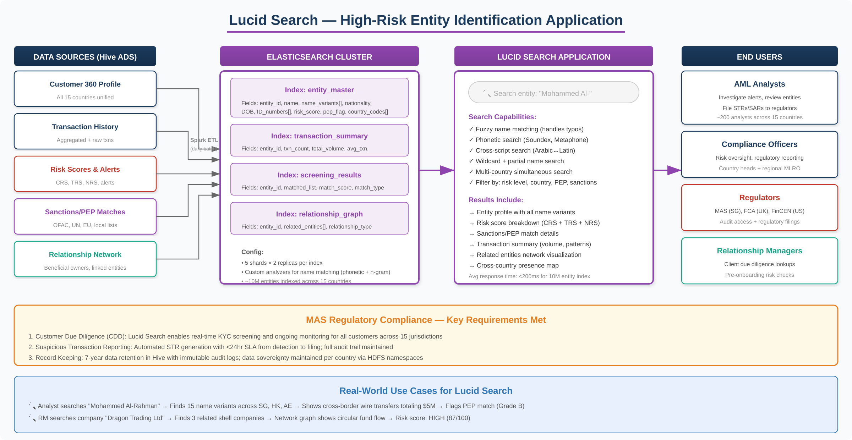

Figure 3: Lucid Search — High-Risk Entity Identification Application

4.1 Why We Built Lucid Search
Before Lucid Search, AML analysts investigating a cross-border case had to manually request data from each country team, wait days for a response, and manually correlate information. Lucid Search provided a single search interface across all 15 countries with sub-second response times, fundamentally changing how investigations were conducted.
4.2 Elasticsearch Index Design
- entity_master: Golden entity profile. Fields: entity_id, all name variants (Latin + local script), DOB, nationalities, ID numbers, risk score, PEP flag. Custom analyzers: phonetic (Double Metaphone) + n-gram tokenization.
- transaction_summary: Aggregated metrics per entity. Total volume, count, cross-border flows, top counterparties, channel distribution.
- screening_results: Sanctions/PEP match results with scores, match types, and analyst dispositions.
- relationship_graph: Entity relationships with type (beneficial owner, director, spouse) and link strength for network investigation.

Custom Elasticsearch Analyzer Configuration
{
"settings": {
"analysis": {
"analyzer": {
"name_analyzer": {
"type": "custom",
"tokenizer": "standard",
"filter": ["lowercase", "asciifolding",
"phonetic_filter", "ngram_filter"]
}
},
"filter": {
"phonetic_filter": {
"type": "phonetic",
"encoder": "double_metaphone",
"replace": false
},
"ngram_filter": {
"type": "ngram",
"min_gram": 3, "max_gram": 5
}
}
}
}
}

4.3 Search Capabilities
Search Mode | How It Works | Use Case
Fuzzy Name | Jaro-Winkler + edit distance | "Mohamad" finds "Mohammed"
Phonetic | Double Metaphone encoding | "Chen" finds "Chan"
Cross-Script | Transliterated + original script | Arabic ↔ Latin, Chinese ↔ Pinyin
Wildcard | N-gram partial matching | "Al-Rah*" finds all variants
Multi-Country | Federated search across 15 indices | One search = all jurisdictions
Filtered | Combine with risk/country filters | Name + HIGH risk + UAE

4.4 Real-World Use Cases
Use Case 1: Cross-Border Money Laundering Detection
• Analyst searches "Mohammed Al-Rahman" in Lucid Search
• Returns 15 name variants across Singapore, Hong Kong, and UAE
• Transaction summary: $5M cross-border wires in 90 days
• Network graph: linked shell companies in 3 jurisdictions
• PEP match: Grade B (close associate of foreign official)
• Result: STR filed with MAS within 24 hours

Use Case 2: Trade-Based Money Laundering
• RM searches "Dragon Trading Ltd" for pre-onboarding CDD
• Finds 3 related companies across HK, SG, BVI
• Relationship graph shows circular fund flows
• Risk score: 87/100 (HIGH) — onboarding rejected
• Referral to GFCC for full investigation

5. Interview Talking Points
Q: Walk me through the SCB AML project end-to-end.
"At Standard Chartered, I was a Big Data Consultant in Group Financial Crime Compliance, building the AML data platform for 15 countries. Each country had its own banking systems with no cross-border visibility. I designed a Hadoop solution with three layers: Hive for data warehousing with per-country schemas (750+ tables), Spark for entity resolution and feature engineering (200+ features), and Elasticsearch for Lucid Search. The pipeline processed 50M+ transactions daily with T+1 SLA — yesterday's data ready by 8 AM."

Q: What was the hardest technical challenge?
"Entity resolution across 15 countries with multiple scripts. The same person could be 'Mohammed Al-Rahman' in Singapore and 'محمد' in UAE. I built a multi-pass Spark job: exact-match on passport numbers, then fuzzy name matching with Jaro-Winkler after transliteration, then phonetic matching. We achieved 95%+ recall with under 5% false positive rate. The golden_entity_id was the foundation for all cross-border AML detection."

Q: Tell me about Lucid Search.
"I designed Lucid Search on Elasticsearch so analysts could search 10M+ entities across 15 countries in under 200ms. Four indices: entity master, transaction summary, screening results, and relationship graph. Custom analyzers handled phonetic matching and n-gram tokenization. It supported fuzzy, phonetic, cross-script (Arabic↔Latin), and filtered search. Used by 200+ analysts daily, it reduced investigation time from days to hours."

Q: How did you handle 15 countries' data sovereignty?
"Separate HDFS namespaces and Hive schemas per country (ods_sg, ods_hk, etc.). Schema-level access controls — Singapore team could only query ods_sg directly. CDM/ADS layers had unified views with row-level security and audit logging. Every query was logged with analyst ID, timestamp, and accessed entity — MAS requirement."

Q: What about regulatory compliance?
"MAS was primary regulator plus 14 others simultaneously. I ensured: 7-year immutable data retention in ORC, full audit trails, T+1 SLA, daily sanctions list updates, and country-level data sovereignty. Automated regulatory report generation — STRs for MAS, SARs for FinCEN, equivalent for each local regulator. Zero missed regulatory SLAs during my tenure."

6. Quick Reference — Key Numbers

Metric | Value | Context
15 | Countries | SG, HK, MY, TH, IN, KR, TW, UK, US, AE, KE, NG, PK, BD, CN
750+ | Hive ODS Tables | 15 countries × ~50 tables each
50M+ | Daily Transactions | Processed across all banking lines
10M+ | Entities Indexed | In Elasticsearch for Lucid Search
200+ | AML Features | Behavioral features per customer
200+ | Analysts | Using Lucid Search daily
<200ms | Search Latency | Lucid Search avg response
T+1 | Processing SLA | Yesterday data ready by 8 AM
7 years | Data Retention | MAS regulatory requirement
99.9% | Pipeline Uptime | Zero missed regulatory SLAs
95%+ | Entity Match Recall | Cross-country resolution accuracy
<5% | False Positive Rate | Entity resolution matching

— End of Document —

