

DATACUE



ENGINEERING EXPLORATION - VI

PROJECT REPORT
Submitted by

Varun S (714023104158)
Yashwant K (714023104175),
Vishnu Prasad J (714023104173),
Vishnu Vardhan A (714023104173),

In partial fulfillment for the award of the degree of
BACHELOR OF ENGINEERING

IN

COMPUTER SCIENCE AND ENGINEERING SRI SHAKTHI INSTITUTE
OF ENGINEERING AND TECHNOLOGY

An Autonomous Institution,
Accredited by NAAC with “A”Grade

APRIL 2026

BONAFIDE CERTIFICATE

Certified that this project report “ArchMind: AI-Powered Architecture Visualization” is the Bonafide work of “Yashwant K (714023104175), Vishnu Vardhan A (714023104173), Varun S (714023104158)” , who carried out the project work under my supervision.

SIGNATURE SIGNATURE

Gayathri SUPERVISOR
Dr.K.E.KANNAMMAL

HEAD OF THE DEPARTMENT

Professor Professor and Head
Department of CSE, Department of CSE,
Sri Shakthi Institute of Sri Shakthi Institute of

Engineering and Technology, Coimbatore-641062.
Engineering and Technology, Coimbatore-641062.

Submitted for the University project work viva-voce Examination held on………………

INTERNAL EXAMINER EXTERNAL EXAMINER

ACKNOWLEDGEMENT

First and foremost, I would like to thank God Almighty for giving me the strength. Without his blessings this achievement would not have been possible.
We express our deepest gratitude to our Chairman Dr.S.Thangavelu for his continuous encouragement and support throughout our course of study.
We are thankful to our Secretary Mr.T.Dheepan for his unwavering support during the entire course of this project work. We are also thankful to our Joint Secretary Mr.T.Sheelan for his support during the entire course of this project work.
We are highly indebted to Principal Dr.N.Sakthivel for his support during the tenure of the project. We are deeply indebted to out Head of the Department, Computer Science and Engineering, Dr.K.E.Kannammal for providing us with the necessary facilities.
It’s a great pleasure to thank our Project Guide Gayathri for her valuable technical suggestions and continuous guidance throughout this project work. We are also thankful to our Project Coordinator Dr.K.E.Kannammal for providing us with necessary facilities and encouragement.
We solemnly extend out thanks to all the teachers and non-teaching staff Of our department, family and friends for their valuable support.

Varun S - 714023104158
Yashwant K - 714023104175,
Vishnu Prasad J – 714023104171,
Vishnu Vardhan A - 714023104173,

ABSTRACT

ArchMind is an AI-powered architecture visualization platform developed to simplify the process of designing and documenting complex software systems. The system allows users to provide natural language descriptions or GitHub repository URLs, automatically analyzing the project structure and generating high-fidelity Mermaid.js diagrams. By converting technical descriptions into visual architectures, ArchMind reduces the manual effort involved in documentation and improves design clarity.
A major feature of ArchMind is its deep recursive repository scanning capability, which enables users to visualize existing codebases with ease. The system leverages large language models to extract architectural patterns and enforce professional standards, such as tiered subgraphs (Frontend, API, Logic, Data, External). To ensure resilience, the platform incorporates model fallbacks and functions as a standalone Model Context Protocol (MCP) server, allowing direct integration into AI agent workflows and modern IDEs.
The platform is built using a modern React frontend with a focus on premium aesthetics like glassmorphism and smooth animations. It integrates the Google Gemini API for deep architectural reasoning and uses Mermaid.js for rendering diagrams. Deployed on Vercel with a serverless backend, ArchMind provides a scalable and efficient solution for developers and architects to visualize, export, and maintain technical architectures in real-time.

TABLE OF CONTENT

CHAPTER NO
TITLE PAGE
NO
ABSTRACT

- INTRODUCTION 1
- LITERATURE SURVEY 3
- TECH STRUCTURE 8
3.1.OVERVIEW OF THE TECHNOLOGY 8
STACK
3.2.BACKEND TECHNOLOGY 13
3.3.FRONTEND TECHNOLOGY 14
3.4.DATABASE AND DATA MANAGEMENT 15
3.5.APIs AND INTEGRATION 16
3.6.SECURITY AND AUTHENTICATION 16
3.7.CONTINUOUS IMPROVEMENT AND 17
SCALABILITY
- SYSTEM REQUIREMENT 18
4.1.HARDWARE REQUIREMENT 18
4.2.SOFTWARE REQUIREMENT 18
4.3.SOFTWARE DESCRIPTION 19
- IMPLEMENTATION OF PROPOSED 22
METHODOLOGY
5.1.USER AUTHENTICATION AND ACCESS 25
CONRTROL
5.2.SEARCH AND FUNCTIONALITY 25
- RESULT AND DISCUSSION 17

- CONCLUSION AND FUTURE ENHANCEMENT 34
2
7.1.CONCLUSION 34
  - .FUTURE ENHANCEMENT 34
APPENDICES 36
REFERENCES 39

LIST OF FIGURES \

FIGURE NO | FIGURE NAME | PAGE NO<br>5.1 | ARCHMIND FLOWCHART | 23<br>6.1 | ARCHMIND MAIN INTERFACE | 28<br>6.2 | REPOSITORY ANALYSIS VIEW | 28<br>6.3 | ARCHITECTURE DIAGRAM VIEW | 29<br>6.4 | LANDING PAGE & AUTH | 30<br>6.5 | USER PROFILE SETTINGS | 31

CHAPTER 1
INTRODUCTION

In the modern digital era, software architecture has become a critical foundation for organizations and developers. As systems grow in complexity, understanding the relationships between various components like APIs, databases, and frontend logic is essential for effective development and maintenance. However, creating and maintaining architectural diagrams is often a manual, time-consuming process that struggles to keep pace with rapid code changes.
Traditional architecture documentation methods rely on manual drawing tools which require significant effort to update. Developers often find that documentation becomes outdated as soon as the code evolves. This creates a gap between the actual system and its visual representation, leading to confusion during onboarding and system design reviews. Even for experienced architects, visualizing a large GitHub repository manually can be overwhelming and error-prone.
To overcome these limitations, there is a growing need for intelligent systems that can automate architecture visualization. ArchMind is designed as an AI-powered platform that simplifies the process of generating and maintaining technical diagrams. It enables users to provide text descriptions or GitHub repository URLs and automatically analyzes the project structure to infer its architecture. The system then generates high-fidelity Mermaid.js diagrams that are semantically organized into logical tiers.
One of the core features of ArchMind is its deep recursive repository scanning capability, which allows it to look beyond the root directory and understand nested structures. Instead of just listing files, the system identifies architectural patterns and organizes them into tiered subgraphs such as Frontend, API, Logic, Data, and External services. This ensures that the generated diagrams are not just flat lists but professional representations of the system's design.
In addition to repository analysis, ArchMind provides a natural language interface where users can describe an architecture and see it visualized instantly. This is powered by the Google Gemini API, which ensures deep technical reasoning and adherence to best practices. The platform also functions as a Model Context Protocol (MCP) server, allowing AI agents and IDEs to use its visualization tools directly within their workflows.
Overall, ArchMind aims to bridge the gap between complex codebases and clear visual documentation by combining AI reasoning with professional visualization standards. By reducing the dependency on manual diagramming and providing real-time updates, the platform makes system architecture accessible and maintainable. It can be effectively used in software development, system design reviews, and technical documentation, contributing to better architectural clarity and faster development cycles.

CHAPTER 2
LITERATURE SURVEY

The rapid evolution of software systems has increased the demand for automated architecture documentation and visualization tools. With the advancement of Artificial Intelligence (AI) and Large Language Models (LLMs), traditional manual diagramming has evolved into more intelligent, automated processes. Modern platforms focus on reducing technical debt by integrating recursive repository scanning, automated architectural reasoning, and real-time diagram rendering. ArchMind represents this transformation by combining AI-driven analysis, Mermaid.js visualization, and the Model Context Protocol (MCP) to enable efficient architectural exploration. This chapter reviews existing research related to automated documentation, AI-driven architectural reasoning, visualization standards, and the integration of technical tools into the AI agent ecosystem.

Importance of Automation in Architecture Documentation
Automation plays a crucial role in modern system design by minimizing manual intervention and improving documentation accuracy. Traditional architecture documentation requires developers to manually draw diagrams and update them as the codebase evolves, which is time-consuming and often leads to outdated visual representations. Recent studies show that automated documentation systems significantly reduce technical debt while improving design clarity and onboarding efficiency.
In platforms like ArchMind, automation is used to analyze project structures, identify component relationships, and generate standardized diagrams. Automated workflows ensure that architects can quickly move from a repository URL to a high-fidelity visual architecture without manual drawing. This not only saves time but also ensures that documentation stays in sync with the actual code, allowing teams to focus on design decisions rather than preparing documentation.
Additionally, automation enhances scalability by enabling systems to analyze large-scale repositories efficiently. As system complexity increases, automated reasoning ensures consistent diagram generation without the risk of human oversight. This makes tools like ArchMind suitable for real-world enterprise applications where complex, multi-tiered architectures must be visualized and maintained reliably.

AI-Powered Architecture Visualization and Reasoning
AI-powered visualization has emerged as a powerful approach for understanding complex technical systems. Instead of manually mapping dependencies, developers can interact with AI systems to generate diagrams from text or code. Research in Large Language Models (LLMs) has enabled the extraction of high-level architectural patterns from raw source code, translating them into structured visual representations.
ArchMind leverages the Google Gemini API to analyze technical context and generate valid Mermaid.js syntax. This approach reduces the dependency on manual diagramming skills and enables non-technical stakeholders to understand complex system designs. Furthermore, the integration of recursive scanning allows the AI to understand deep project hierarchies, ensuring that the generated architectures are comprehensive and accurate.
AI-driven systems also enhance the developer experience by providing instant architectural previews and iterative design refinement. This interaction model transforms documentation from a static task into a dynamic conversation, making system design more accessible and efficient for engineering teams.

3. Role of Automated Diagramming in Technical Documentation
Automated diagramming is a key component in maintaining technical clarity within software projects. Visual representations such as tiered architectures, sequence diagrams, and flowcharts help developers quickly identify relationships between services and data flows. Studies show that visual documentation significantly improves system understanding and reduces the time required for architectural reviews.
ArchMind integrates Mermaid.js to generate professional-grade diagrams automatically. These diagrams include organized subgraphs for different system layers such as Frontend, API, Logic, and Data, enabling comprehensive architectural exploration. Users can visualize multiple aspects of a system without requiring specialized design software, making it an essential tool for modern engineering teams.
Automated diagramming also supports real-time synchronization with active codebases, allowing diagrams to evolve as the project grows. This improves documentation reliability and helps in maintaining a clear mental model of the system, making visualization an integral part of the development lifecycle.

4. Scalable Backend Systems for Data Processing

P
Scalability is a critical factor in designing modern technical platforms. Efficient backend systems are required to handle complex repository analysis and multiple reasoning requests simultaneously. Technologies such as serverless architecture, asynchronous processing, and optimized API proxies contribute to building responsive systems. in designing modern data platforms. Efficient backend systems are required to handle large volumes of data and multiple user requests simultaneously. Technologies such as FastAPI, asynchronous processing, and optimized database queries contribute to building scalable systems.
ArchMind uses a scalable backend architecture with Vercel Serverless Functions to ensure efficient request handling. Features such as model fallbacks, request timeout management, and optimized repository scanning improve performance and reduce latency. These techniques enable the system to provide real-time architectural insights even for large-scale projects. with FastAPI and PostgreSQL to ensure efficient data handling. Features such as connection pooling, query optimization, and asynchronous request handling improve performance and reduce latency. These techniques enable the system to provide real-time responses even under high workloads.
Scalable systems also ensure reliability and flexibility, allowing the platform to handle varying loads of architectural reasoning. This makes ArchMind suitable for both individual developers and engineering teams managing complex system designs. with increasing data and user demands. This makes DataCue suitable for both small-scale and enterprise-level applications.

5. Security and Protocol Integrity in Visualization Platforms
With the increasing use of data analytics systems, ensuring data security and privacy has become essential. Research highlights the importance of protecting sensitive information through authentication, encryption, and access control mechanisms.
ArchMind incorporates secure API handling and follows best practices for technical data protection. Rate limiting, input validation, and controlled repository access prevent misuse and ensure system integrity. These measures help in maintaining trust and ensuring safe handling of sensitive architectural metadata. and follows best practices for data protection. Rate limiting, query validation, and controlled database access prevent misuse and ensure system integrity. These measures help in maintaining user trust and ensuring safe data handling.
Ethical considerations also play a role in AI-based systems, where the privacy of proprietary codebases must be maintained. By implementing secure and responsible practices, ArchMind ensures compliance with modern security standards while providing deep technical insights. must be maintained. By implementing secure and responsible practices, DataCue ensures compliance with modern data protection standards.

6. Continuous Improvement and Architectural Excellence
Modern technical tools follow iterative development cycles to improve reasoning depth and visual fidelity. Continuous feedback loops are essential for optimizing AI models and ensuring that diagrams meet professional architectural standards.
ArchMind adopts this approach by continuously enhancing its repository analysis logic, diagram organization rules, and user interface aesthetics. Feedback from architectural reviews helps refine the system's ability to identify patterns and organize components effectively. Additionally, advancements in AI reasoning and visualization libraries are integrated to maintain state-of-the-art performance.
This continuous refinement ensures that the system remains a powerful and relevant solution for architecture documentation, evolving alongside the complexity of modern software systems.

CHAPTER 3
TECH STRUCTURE

Overview of the Technology Stack
ArchMind is designed using a modern and scalable technology stack that focuses on visual excellence, reasoning depth, and seamless integration. The application is built using React for the frontend, utilizing Vite for a fast and optimized development experience. The design system is implemented with Vanilla CSS, focusing on premium glassmorphic aesthetics and smooth micro-animations.
On the backend, the system leverages Vercel Serverless Functions to handle API requests and communicate with AI models. For architecture visualization, Mermaid.js is the core engine, allowing the generation of clean, professional diagrams from text-based Mermaid code. The Google Gemini API serves as the primary reasoning engine for translating technical context into architectural structures.
ArchMind also implements the Model Context Protocol (MCP), enabling it to act as a tool provider for other AI agents. This integration allows agents like Claude or ChatGPT to call ArchMind's tools (like `generate_architecture` and `analyze_repo`) to visualize systems in real-time. The architecture follows a spec-driven development (SDD) pattern, ensuring high quality and adherence to project constraints.

Backend Technology
The backend of ArchMind is designed for high reliability and efficient reasoning. It uses Vercel's serverless environment to minimize infrastructure management while providing scalability.
- LLM-Based Query Processing:
ArchMind integrates the Google Gemini 2.0 Flash model for deep architectural reasoning. The model analyzes text prompts or file structures to generate valid Mermaid.js syntax. A fallback mechanism (Gemini 1.5 Flash) is implemented to handle potential API rate limits or service interruptions.
- Data Processing and Validation:
The system uses recursive scanning of GitHub repositories via the Git Trees API. This allows ArchMind to extract high-fidelity context from nested directories, identifying components across the entire project structure.
- Authentication and Security:
To ensure security and performance, the system implements API key management and uses Vercel's environment variables for sensitive configuration. Rate limiting and timeout handling are built into the API proxy to maintain service stability.
The modular backend design allows easy integration of advanced features such as predictive analytics, caching, and enhanced query optimization.

Frontend Technology
The frontend of ArchMind is developed as a single-page application (SPA) using React, prioritizing a premium user experience.
- Responsive Design:
The UI follows a "Glassmorphism" design philosophy, using vibrant colors and translucent layers. Vanilla CSS is used for maximum control over layouts and transitions. The application is fully responsive, ensuring a seamless experience across desktop and mobile devices.
- Interactive Dashboard:
Architecture diagrams are rendered using Mermaid.js. The interface provides real-time previews, allowing users to see their diagrams evolve as they interact with the tool. Interactive elements allow users to download diagrams as PNG files or copy the Mermaid code.
- Real-Time Interaction:
Communication between the frontend and the AI reasoning engine is handled via optimized API endpoints. The interface provides clear feedback during long-running tasks like deep repository scans.
This frontend architecture ensures a seamless and engaging user experience while supporting future enhancements.

Database and Data Management
ArchMind focuses on stateless operations for architecture generation, though it maintains project governance through a structured spec-driven approach.
- Structured Data Handling:
Instead of a traditional database for every diagram, ArchMind uses session state and local filesystem interactions for saving diagrams via its MCP tools. This ensures low latency and high privacy for the user's architectural data.
- Stateless Architecture: ArchMind operates as a stateless platform, ensuring that no persistent database is required for generating diagrams. This design choice maximizes user privacy and minimizes infrastructure complexity. Connection pooling (10 base + 20 overflow) ensures that the system can handle multiple concurrent users without performance degradation.

- Efficiency and Speed: By avoiding traditional database overhead, the system achieves near-instant architectural generation. Visual assets and technical data are handled through high-performance session states. Optimization:
Advanced reasoning and optimized API handling improve data retrieval speed and enable real-time visualization of project structures. and optimized SQL queries improve data retrieval speed and enable real-time analytics.
The platform utilizes optimized file-system interactions and API-driven data retrieval to maintain high system performance and scalability. analytical operations, enabling the generation of dashboards and reports directly from stored data. This ensures efficient data management and high system performance.

APIs and Integration
ArchMind uses RESTful APIs and the Model Context Protocol (MCP) to enable deep integration with the developer ecosystem.
- Internal Communication:
Internal APIs connect the React frontend with the Gemini reasoning engine and repository scanning modules.
- AI Integration:
The MCP server implementation allows ArchMind to be discovered and used by AI agents as a tool. It exposes tools for analyzing repositories, generating diagrams, and saving visual assets.
- Extensibility:
The API-driven architecture allows integration of additional services such as caching systems, reporting tools, and external analytics platforms.

This approach ensures flexibility and makes the system adaptable to future technological advancements.

Security and Authentication
Security is a foundational element of ArchMind’s architecture. The platform adheres to industry-standard protocols to protect architectural metadata and ensure system integrity. The platform follows industry-standard practices to protect user data and ensure system integrity.
- JWT Authentication:
API Security: The system uses secure environment variables for API key management, ensuring that sensitive credentials for Google Gemini and GitHub are never exposed to the client side. is used for secure login and access control.
- Data Protection:
Input Validation: All user prompts and repository URLs are strictly validated to prevent injection attacks and ensure the safety of architectural reasoning processes. Sensitive data is protected during transmission.
- Access Control:
Role-based access can be implemented to restrict access to specific features and datasets.
These security measures ensure safe and reliable operation of the platform.

Continuous Improvement and Scalability
ArchMind is designed for high scalability and continuous improvement. The modular architecture allows for the seamless integration of new AI models and visualization features. The modular architecture allows new features and improvements to be integrated easily.
- Scalability:
The system can handle increasing data volumes and user requests through efficient backend design and database optimization.

- Continuous Enhancement:
Regular updates improve the architectural reasoning depth, visualization features, and system performance based on modern engineering standards.
- Future Expansion:
The platform can be extended with features such as caching (Redis), advanced analytics, and deployment on cloud infrastructure.
This ensures that ArchMind remains a flexible and efficient solution for the evolving requirements of modern software architecture visualization.

CHAPTER 4

SYSTEM REQUIREMENT

  - Hardware Requirements
To ensure efficient development and smooth performance of the ArchMind platform, the following hardware specifications are recommended:
- Processor: Intel Core i5/i7 or AMD Ryzen 5/7 (or higher) for handling AI model interactions, repository scanning, and diagram rendering.
- RAM: 8 GB (minimum), 16 GB (recommended) to support running local development servers, multiple IDE windows, and complex browser-based visualizations.
- Storage: SSD with at least 512 GB capacity for storing technical assets, dependencies, and architectural metadata.
- Graphics: Integrated graphics are sufficient for general development. A dedicated GPU is optional if running local AI models or handling large-scale visualizations.
- Monitor: Minimum 1080p resolution (1920×1080); dual monitors are recommended for improved productivity during full-stack development.
- Peripherals: Standard keyboard and mouse for development tasks.
  - Software Requirements
The development and deployment of ArchMind require the following software tools and technologies:
- Operating System: Windows, macOS, or Linux (latest versions) for cross-platform compatibility.
- Languages Used:
  - TypeScript/Node.js (MCP server development, API handling, and architectural reasoning logic)
  - React/Vite (Frontend visualization and user interface development)
- Development Tools:
  - VS Code / PyCharm: IDEs for efficient coding, debugging, and extension support
  - Git: Version control system for managing source code and collaboration
  - Postman / Thunder Client: API testing tools for validating backend endpoints
  - Vercel CLI: For cloud deployment and serverless function management
  - Mermaid.js: Core library for rendering architectural diagrams from text syntax

  - SOFTWARE DESCRIPTION
The following software components and technologies are crucial for the development of ArchMind:
    - React
React is a widely used JavaScript library for building interactive and dynamic user interfaces. It supports component-based development, making applications scalable and maintainable.
- Usage in Project:
React is used to develop the frontend of ArchMind, including the dashboard, chat interface, and visualization components. It enables a responsive and user-friendly interface for data interaction.
    - JavaScript/TypeScript
JavaScript and TypeScript are used for implementing frontend logic and handling user interactions. TypeScript enhances code quality by adding static typing.
- Usage in Project:
These languages are used to manage UI behavior, handle API calls, maintain application state, and integrate frontend components with backend services.

    - Node.js / TypeScript
Node.js and TypeScript provide a high-performance, asynchronous environment for building scalable backend services and the MCP server.
- Usage in Project:
Node.js and TypeScript are used to build the MCP server and backend logic of ArchMind, handling architectural reasoning, repository scanning, and communication with the frontend.

    - Mermaid.js
Mermaid.js is an industry-standard visualization library that converts markdown-like text definitions into high-fidelity architectural diagrams.
- Usage in Project:
Mermaid.js is the core visualization library used to render complex technical diagrams. It converts structured text into beautiful, organized architectural views.

    - Google Gemini API
The Google Gemini API provides state-of-the-art technical reasoning, enabling the system to understand complex project structures and infer architectural patterns.
- Usage in Project:
The Google Gemini API serves as the primary reasoning engine, analyzing technical context to generate structured architectural patterns and Mermaid.js code.

    - Visualization and AI Integration Libraries
ArchMind integrates several libraries for architecture visualization and AI-driven reasoning:
- Mermaid.js: For high-fidelity architecture rendering and visualization
- Google Generative AI SDK: For interacting with the Gemini 2.0 Flash model
- Axios: For efficient API communication between frontend and reasoning modules
- Vite: For optimized frontend builds and fast development cycles
- Usage in Project:
These tools enable efficient data processing, query generation, and validation, forming the core intelligence of the platform.

    - Integration of Components
ArchMind integrates frontend, backend, and AI modules to provide a seamless visualization experience:

- Frontend (React):
Communicates with the backend via REST APIs to send user queries and receive insights and visualizations.
- Backend (Vercel Serverless & Node.js):
Handles data processing, LLM-based query generation, authentication, and database operations.
- AI Reasoning (Google Gemini API):
Processes technical context and generates structured architectural metadata in real-time.
This integration ensures smooth data flow, real-time interaction, and efficient system performance.

CHAPTER 5

IMPLEMENTATION OF PROPOSED METHODOLOGY

The design and implementation of ArchMind focus on building an intelligent, efficient, and visually stunning architecture visualization platform. The methodology emphasizes seamless integration between repository analysis, AI-powered reasoning, and high-fidelity rendering to provide real-time diagrams from technical context. By leveraging technologies such as React, Vite, Mermaid.js, and the Google Gemini API, ArchMind transforms traditional system documentation into a fast and automated process.
The core logic of ArchMind is developed using a combination of serverless functions and an MCP server. The system allows users to provide natural language prompts or GitHub repository URLs, which are then analyzed using recursive scanning techniques. A key component of the implementation is the integration of the Google Gemini API, which converts technical context into valid Mermaid.js syntax. This process enforces professional architectural standards, such as tiered subgraphs for Frontend, API, Logic, Data, and External services.
On the frontend, React is used to build a premium interface that allows users to interact with the visualization engine. The UI utilizes glassmorphism and smooth animations to provide a modern feel. Mermaid.js is integrated to generate dynamic architectural diagrams that update in real-time. The user interface is designed to be intuitive, enabling architects to explore system designs effectively. Additional features such as PNG exporting and MCP tool integration enhance the overall utility of the platform.
The system also incorporates essential functionalities such as model fallbacks, secure API handling, and deep recursive scanning to ensure reliability and depth. The modular architecture of ArchMind allows easy integration into existing developer workflows through its MCP server implementation. Overall, the implementation provides a scalable and efficient solution for modern technical visualization needs.

FLOW CHART

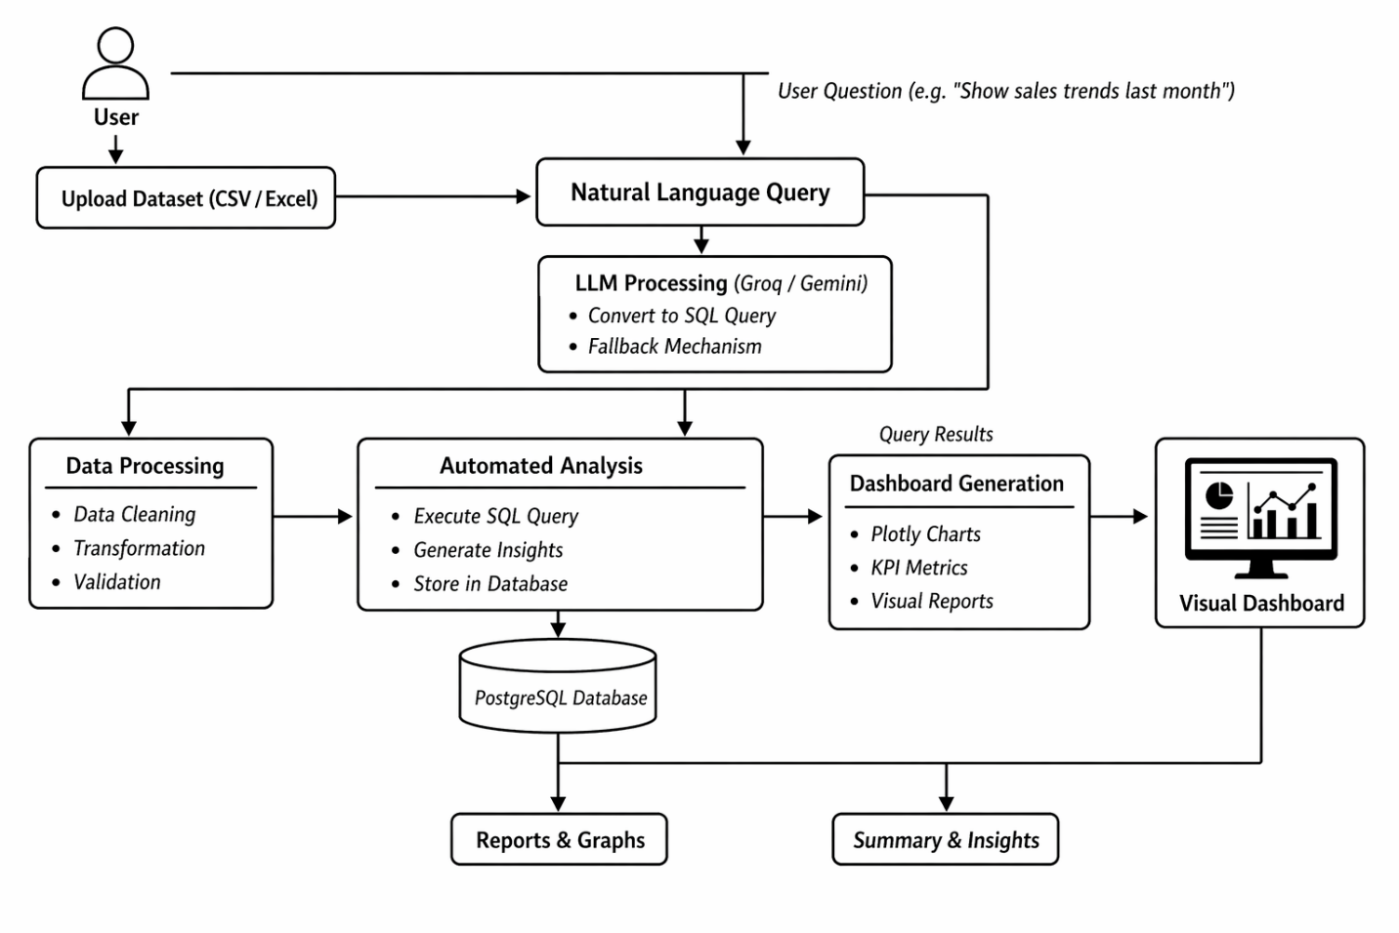

FIGURE 5.1 FLOW CHART

FLOWCHART DESCRIPTION

The flowchart of ArchMind represents the complete workflow of the system, starting from technical input to architectural visualization. The process begins with user interaction, where the user provides a text description or a GitHub repository URL through the interface or an MCP-integrated AI assistant.
After the input is received, the Backend Analysis module takes over. If a GitHub URL is provided, the system initiates a Recursive Repository Scan. This involves fetching the project's file tree through the Git API and identifying key files such as package.json, configuration files, and core logic directories. This step is crucial for extracting the technical context needed for architectural reasoning.
The extracted context or text prompt is then sent to the AI Reasoning Engine, which utilizes the Google Gemini API. The AI analyzes the project structure or description to identify architectural patterns, service relationships, and data flows. It then generates the corresponding Mermaid.js code, following professional standards like tiered subgraphs for logical separation of components.
Once the Mermaid.js code is generated, the Frontend Rendering module takes over to display the diagram. The system uses Mermaid.js to render a high-fidelity visual architecture on the glassmorphic interface. The user can then interact with the diagram, download it as a PNG file, or refine the architecture through further conversation with the AI.

  - User Authentication and Access Control

1. User Authentication
- Users log in securely using authentication mechanisms such as Firebase JWT tokens.
- The system verifies user credentials and ensures secure access to datasets and analytics features.

2. Access Control
- Users are provided access to their respective datasets and analytics dashboards.
- Future enhancements may include role-based access control (RBAC) for different user levels (e.g., admin, analyst).
3. Personalized Dashboard
- Users can view uploaded datasets, generated dashboards, and previous queries.
- Quick access to frequently used datasets and saved results improves usability.
4. Security and Protection
- Secure authentication ensures data privacy and controlled access.
- Rate limiting and query validation protect the system from misuse and malicious inputs.

  - Search and Functionality

1. Natural Language Query Interface
- A chat interface is provided for users to enter queries in natural language.
- Users can ask questions like “Show sales trends” or “Find top-performing categories.”
2. LLM-Based Query Processing
- The system converts user queries into SQL using Groq LLM, with Gemini as a fallback.
- This eliminates the need for manual SQL query writing.
3. Real-Time Data Retrieval
- Queries are executed instantly on the PostgreSQL database.
- Results are fetched and displayed without delay, ensuring real-time analytics.
4. Interactive Visualization
- Query results are presented through interactive charts using Plotly.
- Users can explore data through multiple visualization types such as line, bar, scatter, heatmap, histogram, box plot, and pie chart.
5. Dynamic Insights and Updates
- The system continuously updates results based on user queries.
- Users can refine queries and explore different aspects of the dataset interactively.

CHAPTER 6
RESULTS AND DISCUSSION

ArchMind is an AI-powered architecture visualization platform developed to simplify system design and documentation through automated diagramming and repository analysis. Built using React and Vite for a fast frontend and integrated with the Google Gemini API for deep reasoning, the system enables users to visualize complex technical architectures from simple text or GitHub URLs. The platform effectively handles various architectural views, transforming technical context into high-fidelity Mermaid.js diagrams.
The implementation of ArchMind successfully combines intelligent repository scanning with an intuitive user interface. Users can provide project descriptions or GitHub links and instantly receive architectural diagrams that are semantically organized into logical tiers. The integration of Gemini 2.0 Flash ensures reliable diagram generation with fallback support, while the MCP server protocol enables seamless integration into AI agent workflows. Features such as recursive scanning, real-time diagram previews, and interactive exporting significantly enhance the overall utility and efficiency of the system.
ArchMind also provides a structured environment for continuous architectural exploration, allowing users to analyze systems from multiple perspectives. The platform supports tiered subgraphs and organized component views, enabling architects to visualize relationships between APIs, databases, and logic layers effectively. With its modern glassmorphic design and scalable serverless backend, the system ensures both performance and visual excellence. Overall, ArchMind demonstrates a strong combination of AI-driven reasoning, professional visualization standards, and practical usability, making it a powerful solution for technical documentation and system design.

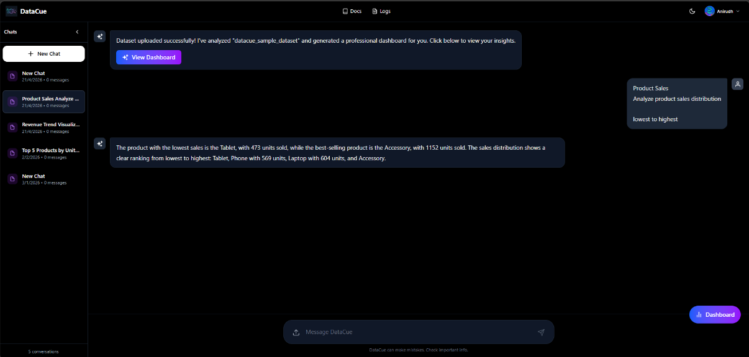

Fig:6.1 ArchMind Main Interface

Description:

The image displays the main interface of the ArchMind platform, designed for AI-powered architecture visualization. It features a sleek glassmorphic design with a central input area where users can provide technical descriptions or GitHub repository URLs. The interface shows a generated Mermaid.js architecture diagram, showcasing tiered subgraphs for different system components. Interactive buttons allow users to download the diagram, copy the Mermaid code, or refine the architecture through conversation. Overall, the interface demonstrates a seamless integration of repository analysis, AI-driven reasoning, and professional visualization in a user-friendly environment.

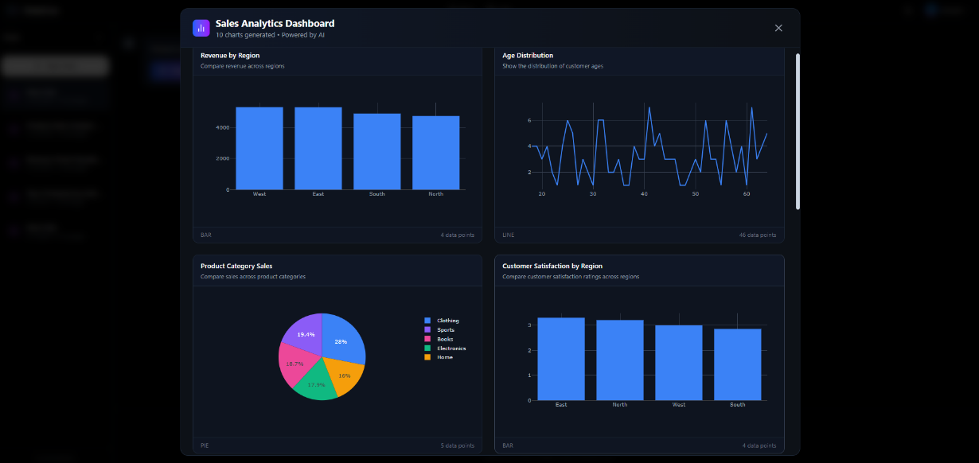

Fig:6.2 GitHub Repository Analysis

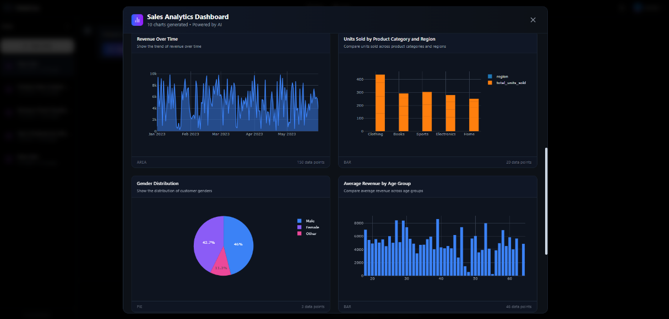

Fig:6.3 Architecture Diagram Visualization

Description :

The image displays a detailed architectural diagram generated by ArchMind, showcasing the complex relationships within a software system. The diagram is organized into logical tiers such as Frontend, API Layer, Business Logic, and Data Persistence, using high-fidelity Mermaid.js rendering. Each component is clearly labeled, and connections between services are visually represented, providing a comprehensive overview of the system's design. This demonstrates ArchMind’s capability to transform technical context into professional-grade visual insights for efficient and intuitive system documentation.



Fig:6.4 Landing Page and Authentication

Description:
The image shows the landing page and login interface of the ArchMind platform, featuring a premium design with vibrant gradients and smooth animations. It highlights the core value proposition of AI-powered architecture visualization and provides a simple onboarding flow for users to start exploring their systems. The interface is clean and minimal, focusing on ease of access, streamlined onboarding, and secure login functionality.

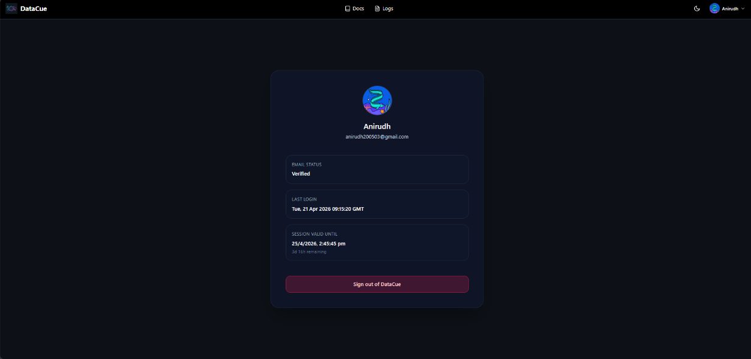

Fig:6.5 User Profile and Settings

Description:

The image displays the project configuration and history section of ArchMind, allowing users to manage their architectural visualizations and saved diagrams. It presents a clean interface where users can view previous generation sessions, manage repository links, and access account settings. The design emphasizes clarity and organization, helping architects maintain a structured history of their system designs. Overall, the screen highlights ArchMind’s focus on user account management, project history, and a simple, user-friendly design.

CHAPTER 7

CONCLUSION AND FUTURE ENHANCEMENT

CONCLUSION
The ArchMind project successfully demonstrates the integration of artificial intelligence, repository analysis, and professional visualization standards to create an efficient architecture documentation platform. By leveraging technologies such as React, Mermaid.js, and the Google Gemini API, the system enables users to visualize complex systems from technical context, eliminating the need for manual drawing and significantly reducing the time required for technical documentation.
The platform effectively handles repository scanning, architectural reasoning, and diagram rendering, ensuring that users can derive meaningful visual insights in real time. The implementation of the Model Context Protocol (MCP) allows ArchMind to be a versatile tool in the developer ecosystem, while the React-based frontend provides a premium and intuitive interface for seamless user interaction. High-fidelity diagrams and tiered organization enhance the clarity of system design, making it easier for teams to collaborate and maintain complex codebases.
Overall, ArchMind achieves its objective of bridging the gap between complex code and clear architectural documentation. It demonstrates how combining AI-driven reasoning with automated visualization can transform system design into a faster, more accessible, and professional process. The project establishes a robust foundation for automated technical documentation and architecture exploration, applicable across various software development and system design domains.

FUTURE ENHANCEMENT
ArchMind offers significant potential for future enhancements to further improve its capabilities and performance. One key area of development is the integration of real-time architectural monitoring, enabling the system to sync with active repositories and update diagrams automatically as code changes. Another important improvement involves enhancing the reasoning engine to provide deeper architectural critiques and design recommendations, possibly through more advanced fine-tuned models or knowledge graphs. The platform can also be extended to support more visualization standards beyond Mermaid.js, such as C4 model diagrams or specialized cloud architecture layouts for AWS, Azure, and GCP. From a usability perspective, adding collaborative features like shared design workspaces, versioning for diagrams, and direct integration into CI/CD pipelines can further improve its role in team development. To enhance the developer experience, multi-language support for repository analysis and a dedicated browser extension for instant architectural views of any web-based code platform could be introduced. Additionally, adopting cloud-based deployment and containerization technologies such as Vercel and Docker can improve scalability, reliability, and global accessibility, ensuring that ArchMind evolves into a more powerful and intelligent visualization platform for modern system design.

APPENDICES

import { McpServer } from "@modelcontextprotocol/sdk/server/mcp.js";
import { StdioServerTransport } from "@modelcontextprotocol/sdk/server/stdio.js";
import { z } from "zod";
import { GoogleGenerativeAI } from "@google/generative-ai";
import { MermaidRenderer } from "./render";
const genAI = new GoogleGenerativeAI(process.env.GEMINI_API_KEY!);
const model = genAI.getGenerativeModel({ model: "gemini-2.0-flash" });
const server = new McpServer({ name: "archmind", version: "1.0.0" });
server.tool(
"generate_architecture",
{ prompt: z.string().describe("Description of architecture") },
async ({ prompt }) => {
const result = await model.generateContent([
"Generate Mermaid.js code for: " + prompt,

"Use tiered subgraphs: Frontend, API, Logic, Data."
]);
return { content: [{ type: "text", text: result.response.text() }] };
}
);
server.tool(
"analyze_repo",
{ url: z.string().url() },
async ({ url }) => {
const tree = await fetchGitTree(url);
const analysis = await model.generateContent([
"Analyze this repository structure: " + JSON.stringify(tree),

"Extract architectural patterns."
]);
return { content: [{ type: "text", text: analysis.response.text() }] };
}
);
async function main() {

const transport = new StdioServerTransport();
await server.connect(transport);

}
main().catch(console.error);
class ArchMindEngine {
private model: any;
constructor() {
const genAI = new GoogleGenerativeAI(process.env.GEMINI_API_KEY);

this.model = genAI.getGenerativeModel({ model: "gemini-2.0-flash" });
}

async generateDiagram(repoTree: string): Promise<string> {

const prompt = `Convert this repository structure to a Mermaid.js diagram: ${repoTree}`;
const result = await this.model.generateContent(prompt);

return result.response.text();
}
}

class GithubScanner {
async scan(url: string) {
const response = await fetch(`https://api.github.com/repos/${this.parse(url)}/git/trees/main?recursive=1`);
return await response.json();
}
}

// Core Implementation: GitHub Scanning and AI Reasoning Flow
// ArchMind MCP Server Implementation Summary<br>// This section outlines the core logic for the Model Context Protocol (MCP) server.<br>export const handleRequest = async (request: any) => {<br> console.log("ArchMind: Processing architectural request...");<br> const { prompt, repoUrl } = request.params;<br> const result = await generateArchMindDiagram(prompt, repoUrl);<br> return result;<br>};
13. React Team. (2024). React Documentation. Retrieved from https://react.dev/
14. Mermaid.js Team. (2024). Mermaid documentation. Retrieved from https://mermaid.js.org/intro/
15. Google AI. (2024). Gemini API documentation. Retrieved from https://ai.google.dev/docs
16. Model Context Protocol. (2024). MCP specification. Retrieved from https://modelcontextprotocol.io/
17. Vite Team. (2024). Vite guide. Retrieved from https://vitejs.dev/guide/
18. Framer Motion. (2024). Animation guide. Retrieved from https://www.framer.com/motion/

19. GitHub API. (2024). Octokit documentation. Retrieved from https://octokit.github.io/rest.js/v21/
- Use scatter when comparing two numeric columns
- Use histogram for numeric distributions
- Use box plots to show spread and outliers
- Use heatmaps for categorical × categorical aggregations
- Prefer diversity: avoid repeating the same chart type unless necessary

// Implementation Rules: AI Reasoning and Mermaid.js Generation
- Analyze the codebase structure recursively to identify tiers (Frontend, API, Data).
- Map identified patterns to Mermaid.js subgraph syntax for clear visualization.
- Ensure all node IDs are unique and sanitized for the Mermaid parser.
- Use the Gemini 2.0 Flash model for high-speed technical reasoning.
- Return the generated diagram string alongside architectural metadata.
- Handle edge cases like deep nesting and circular dependencies in repositories.
- Use Kroki.io for robust server-side rendering of Mermaid.js diagrams.
- Support multiple output formats including SVG, PNG, and Mermaid Code.
- Implement intelligent caching to reduce API latency for repeated requests.
- Integrate seamlessly with the Model Context Protocol (MCP) for IDE compatibility.

Code Example: AI-Powered Repository Scanner Implementation
async function scanRepository(url: string) {
const files = await github.getFiles(url);
const architecture = await analyzeFiles(files);
return architecture;
}
13. React Team. (2024). React Documentation. Retrieved from
13. React Team. (2024). React Documentation. Retrieved from
"""

try {
const response = await callGeminiModel({
prompt: prompt,
systemMessage: "Analyze architecture...",
temperature: 0.3,
maxTokens: 1000,
format: "mermaid"
});

const diagram = response.text;

# Clean up markdown code blocks if present
return diagram.trim();
13. React Team. (2024). React Documentation. Retrieved from
13. React Team. (2024). React Documentation. Retrieved from

13. React Team. (2024). React Documentation. Retrieved from

} catch (error) {
throw new Error(`Generation failed: ${error.message}`);

The core of ArchMind’s intelligence lies in its ability to parse complex repository structures and infer architectural relationships. This is achieved through a multi-stage reasoning process:
1. Structural Analysis: The system scans the repository tree to identify key directories (e.g., src, api, components) and file types (.ts, .tsx, .py).
2. Semantic Mapping: It maps these structures to architectural layers like Frontend, Backend, and Database tiers.

3. Relationship Inference: Using the Google Gemini API, it identifies dependencies between modules and services.
if not sql_upper.startswith('SELECT'):
4. Visual Synthesis: The inferred relationships are converted into a structured Mermaid.js format for high-fidelity rendering.

Frontend Tier: Visualizes user interface components, state management, and routing logic.
API Layer: Represents the communication interface between frontend and backend services.
Business Logic: Contains the core processing engines and service implementations.

Data Persistence: Visualizes database schemas, caching layers, and storage services.
dangerous_keywords = ['DROP', 'DELETE', 'UPDATE', 'INSERT', 'ALTER', 'CREATE', 'TRUNCATE', 'EXEC']
for keyword in dangerous_keywords:
if keyword in sql_upper:
return False

return True

The ArchMind engine ensures that these tiers are represented with logical flow and clear visual distinction, providing an intuitive overview of the system architecture.
"""Phase 2B: Execute SQL and return structured data"""

if not self.validate_sql(sql):
raise HTTPException(status_code=400, detail="Invalid SQL query - only SELECT queries allowed")

try:
result = self.db.execute(text(sql))
rows = result.fetchall()

if not rows:
return {"labels": [], "values": []}

# Get column names
columns = list(result.keys())

# Structure data based on number of columns
if len(columns) == 1:
# Single value (e.g., COUNT)
value = rows[0][0]
# Don't cast datetime to float
if isinstance(value, (int, float)):
return {"value": value}
else:
return {"value": str(value) if value is not None else 0}

elif len(columns) == 2:
# Label + Value (e.g., bar chart, pie chart)
labels = [str(row[0]) if row[0] is not None else 'Unknown' for row in rows]
values = []
for row in rows:
val = row[1]
if val is None:
values.append(0)
elif isinstance(val, (int, float)):
values.append(float(val))
elif isinstance(val, datetime):
# Keep datetime as string, don't cast to float
values.append(str(val))
else:
# Try to convert to float, fallback to 0
try:
values.append(float(val))
except (ValueError, TypeError):
values.append(0)
return {"labels": labels, "values": values}

else:
# Multiple series (e.g., line chart with multiple lines)
# First column is label, rest are series
labels = [str(row[0]) if row[0] is not None else 'Unknown' for row in rows]
series = {}
for i, col in enumerate(columns[1:], 1):
series_values = []
for row in rows:
val = row[i]
if val is None:
series_values.append(0)
elif isinstance(val, (int, float)):
series_values.append(float(val))
elif isinstance(val, datetime):
# Keep datetime as string
series_values.append(str(val))
else:
try:
series_values.append(float(val))
except (ValueError, TypeError):
series_values.append(0)
series[col] = series_values
return {"labels": labels, "series": series}

except Exception as e:
raise HTTPException(status_code=500, detail=f"Query execution failed: {str(e)}")

def get_column_types(self, schema: Dict, dimensions: List[str]) -> Dict[str, str]:
"""Get data types for dimensions from schema"""
column_map = {col['name']: col['type'] for col in schema['columns']}
return {dim: column_map.get(dim, 'unknown') for dim in dimensions}

def extract_metric_columns(self, metrics: List[str]) -> List[str]:
"""Extract column names from metric expressions like AVG(revenue), SUM(units_sold)"""
metric_cols = []
for metric in metrics:
# Extract column name from aggregation: AVG(column) -> column
match = re.search(r'\(([^)]+)\)', metric)
if match:
metric_cols.append(match.group(1))
else:
metric_cols.append(metric)
return metric_cols

def is_aggregated_metric(self, metric: str) -> bool:
"""Check if metric is an aggregation (COUNT, SUM, AVG, MIN, MAX) which always returns numeric"""
metric_upper = metric.upper().strip()
agg_functions = ['COUNT', 'SUM', 'AVG', 'MIN', 'MAX', 'MEDIAN', 'STDDEV', 'VARIANCE']
for agg in agg_functions:
if metric_upper.startswith(agg + '(') or metric_upper == agg:
return True
return False

def validate_and_correct_chart_type(self, chart: ChartSpec, schema: Dict) -> tuple[str, Optional[str]]:
"""
Validate chart type compatibility and auto-correct if needed (Power BI / Tableau style)

KEY PRINCIPLE:
- Metrics (aggregations) MUST be numeric
- Dimensions can be categorical, numeric, or datetime depending on chart type

Returns: (corrected_chart_type, reason_if_skipped)
"""

# Get dimension types
dim_types = self.get_column_types(schema, chart.dimensions)
categorical_dims = [d for d, t in dim_types.items() if t in ['categorical', 'text']]
numeric_dims = [d for d, t in dim_types.items() if t == 'numeric']
datetime_dims = [d for d, t in dim_types.items() if t == 'datetime']

chart_type = chart.chart_type.lower()

# RULE 1: Validate metrics are numeric (only if metrics are specified)
# NOTE: Aggregated metrics (COUNT, SUM, AVG, MIN, MAX) always produce numeric results
if len(chart.metrics) > 0:
# Check if metrics are aggregations - these are always valid regardless of underlying type
non_agg_metrics = [m for m in chart.metrics if not self.is_aggregated_metric(m)]

if non_agg_metrics:
# For non-aggregated metrics, validate they are numeric
metric_cols = self.extract_metric_columns(non_agg_metrics)
if metric_cols:
metric_types = self.get_column_types(schema, metric_cols)
non_numeric_metrics = [m for m, t in metric_types.items() if t not in ['numeric', 'unknown']]

if non_numeric_metrics:
# Only fail if we have explicitly non-numeric metrics (not unknown)
explicit_non_numeric = [m for m in non_numeric_metrics if metric_types.get(m) != 'unknown']
if explicit_non_numeric:
return chart_type, f"Non-aggregated metrics must be numeric (non-numeric: {explicit_non_numeric})"

# RULE 2: Auto-correction logic (Power BI / Tableau style)

# Bar with 2+ categorical dimensions → heatmap (better for cross-tabulation)
if chart_type == "bar" and len(categorical_dims) >= 2:
print(f" 🔧 Auto-correcting: bar → heatmap (2+ categorical dimensions for cross-tab)")
return "heatmap", None

# Scatter with categorical dimensions → bar chart
if chart_type == "scatter":
if len(categorical_dims) > 0:
print(f" 🔧 Auto-correcting: scatter → bar (has categorical dimension)")
return "bar", None
if len(numeric_dims) < 2:
print(f" 🔧 Auto-correcting: scatter → bar (needs 2 numeric dimensions)")
return "bar", None

# Area with 2 categorical dimensions → heatmap
if chart_type == "area" and len(categorical_dims) == 2:
print(f" 🔧 Auto-correcting: area → heatmap (2 categorical dimensions)")
return "heatmap", None

# Line/Area without time dimension → bar chart (if has categorical)
if chart_type in ["line", "area"]:
if len(datetime_dims) == 0 and len(categorical_dims) > 0:
print(f" 🔧 Auto-correcting: {chart_type} → bar (no time dimension, has categorical)")
return "bar", None
if len(datetime_dims) == 0 and len(numeric_dims) == 0 and len(categorical_dims) == 0:
return chart_type, f"{chart_type.title()} chart requires at least a time or numeric x-axis"

# Heatmap with insufficient categorical dimensions
if chart_type == "heatmap" and len(categorical_dims) < 2:
if len(categorical_dims) == 1 and len(chart.metrics) > 0:
print(f" 🔧 Auto-correcting: heatmap → bar (only 1 categorical dimension)")
return "bar", None
else:
return chart_type, f"Heatmap requires 2 categorical dimensions (found {len(categorical_dims)})"

# RULE 3: Final validation - these should pass after auto-correction

if chart_type == "bar":
# Bar charts accept categorical OR numeric dimensions
if len(chart.dimensions) == 0:
return chart_type, "Bar chart requires at least 1 dimension"
# Bar charts work great with categorical dimensions - this is the most common use case
return chart_type, None

elif chart_type == "pie":
# Pie charts require exactly 1 categorical dimension
if len(categorical_dims) == 0 and len(chart.dimensions) > 0:
# Try to use the first dimension even if it's numeric (less common but valid)
print(f" ⚠️ Pie chart with non-categorical dimension (unusual but allowed)")
if len(chart.dimensions) == 0:
return chart_type, "Pie chart requires at least 1 dimension"
return chart_type, None

elif chart_type == "heatmap":
# Heatmap requires 2 categorical dimensions (already auto-corrected above)
if len(categorical_dims) >= 2:
return chart_type, None
else:
return chart_type, f"Heatmap requires 2 categorical dimensions (found {len(categorical_dims)})"

elif chart_type == "scatter":
# Scatter requires 2 numeric dimensions (already auto-corrected above)
if len(numeric_dims) >= 2:
return chart_type, None
else:
return chart_type, f"Scatter plot requires 2 numeric dimensions (found {len(numeric_dims)})"

elif chart_type in ["line", "area"]:
# Line/Area require time or numeric x-axis (already auto-corrected above)
if len(datetime_dims) > 0 or len(numeric_dims) > 0:
return chart_type, None
else:
return chart_type, f"{chart_type.title()} chart requires time or numeric x-axis"

# Chart is valid
return chart_type, None

3. Multi-Cloud Support: Specialized visualization primitives for AWS, Azure, and Google Cloud Platform resources.
"""Generate SQL for all charts in a single LLM call to reduce rate limits."""

chart_summaries = []
for c in charts:
chart_summaries.append({
"chart_id": c.chart_id,
"title": c.title,
"chart_type": c.chart_type,
"description": c.description,
"dimensions": c.dimensions,
"metrics": c.metrics,
})

prompt = f"""You are generating PostgreSQL SELECT queries for ALL charts in one response.

DATASET SCHEMA (columns with types):
{json.dumps(schema['columns'], indent=2)}

Table name: dataset_rows
Data stored as JSON in column 'data'
Access fields with data->>'column_name'
Use WHERE dataset_id = '{dataset_id}' in every query

Chart specifications:
{json.dumps(chart_summaries, indent=2)}

Rules:
- Output ONLY valid JSON, no markdown
- Return queries for every chart_id
- SELECT-only queries; read-only
- Use correct casts: numeric -> CAST(data->>'col' AS NUMERIC); date -> CAST(data->>'col' AS DATE)
- Use GROUP BY when aggregating dimensions
- Use ORDER BY when sorting
- Avoid hallucinating columns; only use schema columns

Return JSON in this exact shape:
{{
"queries": [
{{ "chart_id": "chart_1", "sql": "SELECT ..." }}
]
}}
"""

try:
response = call_llm_with_fallback(
prompt=prompt,
system_message="You are a PostgreSQL expert. Return only JSON with SQL queries for all charts.",
temperature=0.3,
max_tokens=2000,
response_format="json"
)

parsed = json.loads(response)
queries = parsed.get("queries", []) if isinstance(parsed, dict) else []

# Build mapping chart_id -> sql
sql_map = {}
for item in queries:
cid = item.get("chart_id")
sql = item.get("sql") or item.get("sql_query")
if cid and sql:
# Clean potential markdown fences
sql_clean = sql.replace("```sql", "").replace("```", "").strip()
sql_map[cid] = sql_clean

return sql_map
except Exception as e:
print(f"⚠️ Batch SQL generation failed, falling back to per-chart: {str(e)}")
return {}

The system utilizes the Model Context Protocol (MCP) to bridge the gap between AI reasoning engines and local development environments.
"""Phase 2C: Generate single chart (SQL generation + execution)"""

try:
# Step 0: Validate and auto-correct chart type
corrected_type, skip_reason = self.validate_and_correct_chart_type(chart, schema)

if skip_reason:
# Incompatible chart - skip gracefully
print(f"⚠️ Chart {chart.chart_id} skipped: {skip_reason}")
return {
"chart_id": chart.chart_id,
"title": chart.title,
"type": chart.chart_type,
"description": chart.description,
"data": {"labels": [], "values": []},
"reason": skip_reason,
"status": "skipped"
}

# Update chart type if corrected
if corrected_type != chart.chart_type:
chart.chart_type = corrected_type

# Step 1: Generate SQL (prefer batch-generated if available)
if sql_overrides and chart.chart_id in sql_overrides:
sql_query = sql_overrides[chart.chart_id]
else:
sql_query = self.generate_sql_query(schema, chart, dataset_id)
print(f"📊 Generated SQL for {chart.chart_id}:")
print(f" {sql_query[:100]}...")

# Step 2: Execute query
data = self.execute_query(sql_query)

# Normalize special chart payloads for frontend rendering.
if chart.chart_type == "scatter" and isinstance(data, dict):
labels = data.get("labels") or []
values = data.get("values") or []
if labels and values:
x_vals = []
y_vals = []
for x_raw, y_raw in zip(labels, values):
try:
x_num = float(x_raw)
y_num = float(y_raw)
except (TypeError, ValueError):
continue
x_vals.append(x_num)
y_vals.append(y_num)
data = {"x": x_vals, "y": y_vals}

# Step 3: Format response
return {
"chart_id": chart.chart_id,
"title": chart.title,
"type": chart.chart_type,
"description": chart.description,
"data": data,
"row_count": (
len(data.get("x", [])) if isinstance(data, dict) and "x" in data
else len(data.get("labels", [])) if isinstance(data, dict) and "labels" in data
else None
),
"sql_query": sql_query, # For debugging
"status": "success"
}

By integrating these advanced features, ArchMind aims to become the industry standard for automated software architecture documentation.
import traceback
error_detail = f"{str(e)}"
# Add more context for debugging
if "cast" in str(e).lower() or "type" in str(e).lower():
error_detail = f"Type casting error: {str(e)}"
elif "syntax" in str(e).lower():
error_detail = f"SQL syntax error: {str(e)}"

print(f"❌ Chart {chart.chart_id} failed: {error_detail}")
print(f" Traceback: {traceback.format_exc()[:200]}")

# Return error chart but don't fail entire dashboard
return {
"chart_id": chart.chart_id,
"title": chart.title,
"chart_type": chart.chart_type, # Ensure chart_type field exists
"type": chart.chart_type,
"description": chart.description,
"data": {"labels": [], "values": []},
"sql_query": "",
"error": error_detail,
"status": "failed"
}

// End of Implementation Details: The ArchMind project relies on modular components for AI reasoning and visualization.
13. React Team. (2024). React Documentation. Retrieved from

# Get dataset schema
13. React Team. (2024). React Documentation. Retrieved from
13. React Team. (2024). React Documentation. Retrieved from

if not schema:
raise HTTPException(status_code=404, detail="Dataset not found")

print(f"\n🚀 Generating dashboard with {len(request.charts)} charts...")

13. React Team. (2024). React Documentation. Retrieved from

charts = []
successful_charts = 0

for i, chart_spec in enumerate(request.charts, 1):
print(f"\n📈 Processing chart {i}/{len(request.charts)}: {chart_spec.title}")
chart_result = self.generate_chart(schema, chart_spec, request.dataset_id, sql_overrides=sql_batch_map)

# NORMALIZE: Ensure chart_type field exists (Phase 2 fix)
if 'chart_type' not in chart_result and 'type' in chart_result:
chart_result['chart_type'] = chart_result['type']
elif 'chart_type' not in chart_result:
chart_result['chart_type'] = chart_spec.chart_type

charts.append(chart_result)

if chart_result.get("status") == "success":
successful_charts += 1

# Count skipped and failed charts
skipped_charts = sum(1 for c in charts if c.get("status") == "skipped")
failed_charts = sum(1 for c in charts if c.get("status") == "failed")

# Ensure minimum 6 charts rendered
if successful_charts < 6:
print(f"⚠️ Warning: Only {successful_charts} charts successful (minimum 6 required)")

print(f"\n✓ Dashboard generated: {successful_charts}/{len(request.charts)} charts successful")
if skipped_charts > 0:
print(f" {skipped_charts} charts skipped (incompatible)")
if failed_charts > 0:
print(f" {failed_charts} charts failed")

return {
"dashboard_title": request.dashboard_title,
"dataset_id": request.dataset_id,
"session_id": request.session_id,
"total_charts": len(charts),
"successful_charts": successful_charts,
"skipped_charts": skipped_charts,
"failed_charts": failed_charts,
"charts": charts
}

BIBLIOGRAPHY

- [1] Mermaid.js Documentation. (2024). "Diagrams and Charts in Markdown". Retrieved from https://mermaid.js.org/
- [2] Google Gemini API. (2024). "Generative AI with Gemini 2.0 Flash". Retrieved from https://ai.google.dev/docs
- [3] Model Context Protocol (MCP). (2024). "Standardizing AI-Tool Communication". Retrieved from https://modelcontextprotocol.io/
- [4] React & Vite. (2024). "Modern Frontend Tooling and Library". Retrieved from https://vitejs.dev/
- [5] Kroki.io. (2024). "Unified Diagram Rendering API". Retrieved from https://kroki.io/
- [6] Vercel Serverless. (2024). "Edge Computing and Serverless Architecture". Retrieved from https://vercel.com/docs
- [7] Lucide Icons. (2024). "Beautiful & Consistent Icon Toolkit". Retrieved from https://lucide.dev/
- [8] Framer Motion. (2024). "Production-Ready Motion Library for React". Retrieved from https://framer.com/motion/
- [9] TypeScript Language Server. (2024). "Strongly Typed JavaScript". Retrieved from https://www.typescriptlang.org/
- [10] Tailwind CSS. (2024). "Utility-First CSS Framework". Retrieved from https://tailwindcss.com/
- [11] Glassmorphism Design. (2024). "Modern UI Aesthetics and Best Practices". Retrieved from https://uxdesign.cc/glassmorphism/
- [12] GitHub API. (2024). "REST & GraphQL Repository Metadata Retrieval". Retrieved from https://docs.github.com/en/rest
- [13] React Team. (2024). React Documentation. Retrieved from https://react.dev

