

Industry Embedded Systems

KGiSL INSTITUTE OF TECHNOLOGY

(Approvedby AICTE And Affiliated to Anna University, Chennai)

Saravanampatti, Coimbatore - 641035

Academic Year 2022-2023

DEPARTMENT OF ELECTRONICS AND COMMUNICATION ENGINEERING

SMART PUBLIC RESTROOM USING IoT

Submitted By

PRANAV.R (711721106076)

MOURIS.V (711721106067)

VISHNU.M (711721106314)

NAVEEN KUMAR.S (711721106070)

CONTENTS

|  |  |  |  |
| --- | --- | --- | --- |
| **CHAPTER** | | **TITLE** | **PAGE NO.** |
|  |  | Abstract |  |
| 1 |  | Introduction |  |
|  | 1.1 | Project Definition |  |
|  | 1.2 | Project Objectives |  |
|  | 1.3 | Project Specifications |  |
| 2 |  | Literature Survey |  |
| 3 |  | System Study |  |
| 4 |  | System Environment |  |
|  | 4.1 | Hardware Requirements |  |
|  | 4.2 | Software Requirements |  |
| 5 |  | System Design |  |
| 6 |  | Results and Discussion |  |
|  |  | Conclusion |  |
|  |  | Appendix |  |
|  |  | References |  |

+

ABSTRACT

- In 21st century, technologies are increasing day by day, and at the same time our major task is cleanliness. From this paper we spread the message of hygiene and cleanliness of our surrounding. We need to maintain the hygiene or cleanliness in publics place or toilets. In cities government provides many facilities to make our surrounding clean. This paper is helpful to keep the India clean called as “Swachh Bharat”. In this system, we are targeting only on, how to maintain the hygiene in washrooms, and observing to the workers activities and also stopping the public to use the dirty washrooms. IOT is a relatively new technology and is getting very popular very rapidly. The main aim of IOT is to connect electronic or mecha-electronic devices together with the help of a network. By using IOT, we will be designing a monitoring system for public toilets so that managing them becomes easy for higher authorities. IOT devices will be used, namely microcontrollers analogue sensors along with a front end for UI and a backend for future analysis purposes.

Chapter 1

INTRODUCTION

IOT is the technology of the future. It is getting very popular due to its vast application possibilities. A general idea behind IOT is a network of various devices being electronic or mechanical connected together to perform a certain task in unison. These tasks can be repetitive and can be effectively handled by IOT. Based on the functionality of the IOT system, they are divided into tiers, and each tier represents a level of the IOT system. We will be designing an IOT system for monitoring the hygiene of public toilets by various using various sensors.

These sensors will be connected to a microcontroller which will send the data to the backend, where it will be stored and processed. This data can be fetched and monitored by using a frontend, either an android app or a website. The objective of this system is to keep track of all cleaning activities so that the toilets are kept clean and hygienic at all times. The technical working of the system starts with parameters used to identify the hygiene of the toilet. Various sensors are available, like ammonia sensor, H2S gas sensor, turbidity sensor, etc. can be used. Depending upon the complexity of the system, microcontrollers can be used.

1.1Project Definition

In this project, The Smart Public Restroom System aims to enhance the overall experience of using public restrooms by integrating cutting-edge technology to provide real-time information on restroom availability and cleanliness. This system will revolutionize the way people interact with public facilities, ensuring that users have access to clean and available restrooms whenever they need them.

1.2Project Objectives

This project aims to set new standards in public restroom facilities, offering users a convenient and hygienic experience while providing management teams with valuable insights to optimize cleaning schedules and resources.

1.3Project Specifications

1.Detects the bad odour

2.Occupancy Sensor

3.Alerts and Notifications

4.Data processing and transmission

5.Compliance and Safety

Chapter 2

LITERATURE SURVEY

In terms of global research, many developed countries have already developed fully automated smart toilets which are capable of handling all the tasks from data gathering to automatic cleaning of the toilets without any human interaction except for the system maintenance. This fully automated system requires a lot of capital and can’t be applied to all public toilets. In developing countries, a system that can auto flush is in place. For monitoring purposes, it is done by old fashion on paper methods which track activities of the toilet usage and cleaning process. For many regions, the toilets are neglected completely.

Chapter 3

SYSTEM STUDY

* 1. PROPOSED SYSTEM

In this proposed system will trying to create awareness among the people about the proper hygiene or sanitation of using washrooms by using internet of things. It is a rapidly emerging technology. Our proposed system will make everyone to strictly follow the cleanliness and proper sanitation in the toilets and to produce disease free toilets. It prevents from many diseases that spread due to improper sanitation of the washroom. So, by using IOT technologies in the smarter way, we can maintain the proper cleanliness which is next to godliness. Be clean Be safe.

In below system first phase is, IR sensor which is used to detect person present in the washroom. If person present is present in the washroom it will sense. After using the toilet, the flush system will start automatically. Then there are two sensors first is Ammonia sensor and another one is odour sensor measure odour into the washroom.If odour is present more than natural odour then room freshener system will ON automatically it maintain good smell in washroom.If number of person use washroom and then odour level increase more than nature odour, then system send signal automatically to receiver hub station.

**3.**1.1 ARCHITECTURE OF PROPOSED SYSTEM

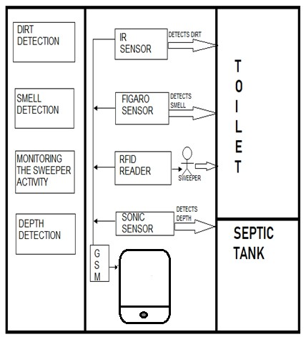

Chapter4

SYSTEM ENVIRONMENT

4.1 Hardware Requirement

Hardware tools are required:

• Microcontroller PIC 16F877

* LCD Display
* Power supply
* Buzzer
* Infrared sensor
* Sonic sensor
* Gas sensor
* RFID
* GSM modem

4.2Software Requirement

* Embedded C programming

Chapter 5

SYSTEM DESIGN

5.1 IOT SYSTEM DESIGN:

**5.1.1Microcontroller**

A microcontroller is a small computer on a single combined circuit holding a processor core, memory and programmable input/output peripherals. Program memory in the form of Ferroelectric RAM, NOR flash or OTP ROM is also often included on chip, as well as a typically small amount of RAM. Microcontrollers are designed for embedded applications, in contrast to the microprocessors used in personal computers or other general-purpose applications.

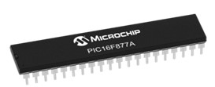

### **Figure 2: Microcontroller**

PIC 16F877 is one of the most advanced microcontroller from Microchip. This controller is commonly used for experimental and modern applications because of its low price, wide range of requests, high quality, and ease of obtainability. It is ideal for applications such as machine control applications, measurement devices, study purpose, and so on. The PIC 16F877 features all the mechanisms which present microcontrollers usually have.

### **5.1.2 LCD**

LCD stands for Liquid Crystal Display. By using the LCD, all the outputs are displayed. LCD doesn’t know about the content (data or commands) supplied to its data bus. It is the user who has to specify whether the content at its data pins are data or commands.

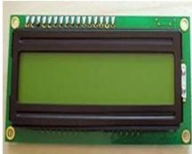

### **Figure 3: LCD Display**

For this, if a command is inputted then a certain arrangement of 0’s and 1’s has to be applied to the Control lines so as to specify it is a command on the other hand if a data is inputted at the data lines then an another combination of 0s and 1s has to be applied to the control lines to require it is Data.

# **5.1.3 BUZZER**

Buzzer is also called as Beeper. It is a sound signalling mechanical device.

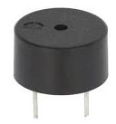

**Figure 4: Buzzer**

# **5.1.4 INFRARED SENSOR**

The IR sensor is used to detect the dirt present in the toilet. Here we nourish the image models into the sensor. It can perceive the dirt by comparing the images we feed into it, after using the toilet. If it can detect the dirt, it raises the alarm, and the users may get embraced and they clean it. This system can create the responsiveness among the people.

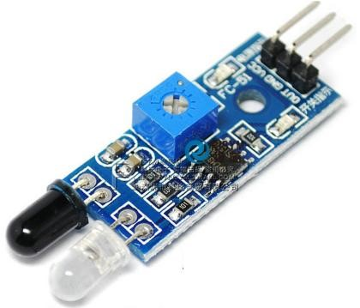

**Figure 5: IR sensor**

# **5.1.5 SMELL SENSOR**

The Smell Sensor is used to detect the unwanted smell and gases in the toilet. For this purpose, we are going to use the sensor called **Figaro** sensor.

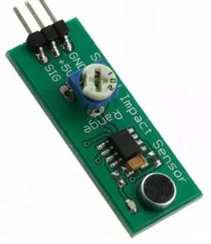

## Figure 6: Smell Sensor

It can intellect the dry gases present in the toilets such as NH3, CO2, CH4, H2S, etc. By taking those gases leads to Nausea, Drowsiness, instant loss of awareness, etc. After sensing the unwanted gases, it can blink the red light. Then the sweeper can clean it by using particular Cleaning Agents.

# **5.1.6 RFID READER**

The RFID stands for Radio Frequency Identification. It can be used for monitoring the Sweeper. The Organization wishes to provide the identity tag for the Sweeper. The Sweeper desires to show the tag before the cleaning process is going to start and after it is finished.

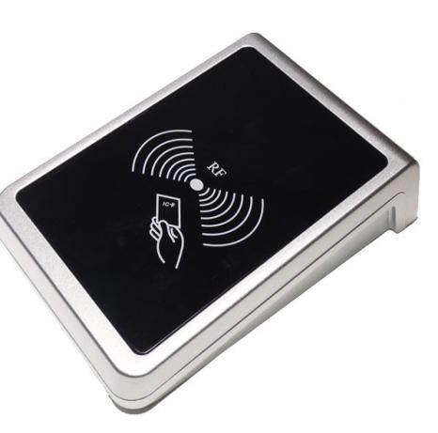

**Figure 7: RFID Reader**

Then the CR4 sensor can spot the presence of dirt. If it is present, it can blink the red light. If it is clean, it can blink the blue light. It assistances to understand the responsibilities of sweeper by his/her own. If Sweeper is not clean the toilets for period of time, his/her absence in cleaning the toilet also reported to the dependable organization. These all the details are stored in the database.

## 5.1.7 SONIC SENSOR

The Sonic Sensor is used for computing the depth. Here it is used to measure the depth of the septic tank. The Sonic Sensor is fixed into the Septic tank. Then the Septic tank get filled means, it can sends the communications to particular organization. Then they will allot persons to clean the septic tank. Then septic tank cleaners will clean the tank. After cleaning it, the sensor can detect the level, and send messages to consistent organization.

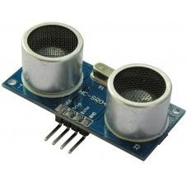

## Figure 8: Sonic sensor

This ultrasonic sensor can be used for measuring distance, object sensor, motion sensors etc. High sensitive module can be used with microcontroller to integrate with motion circuits to measure the distance, position & motion sensitive products.

In a nutshell, water depth sensing is using a sensor to measure the depth of water in a tank or container. Although various sensors can be used for this application, we will talk about ultrasonic sensor application.With ultrasonic sensors, we can find the water depth calculation by finding the distance between the transceiver and the surface of the water. The sensor will transmit a short ultrasonic pulse, and we can measure the travel time of that pulse to the liquid and back. We can then subtract that distance from the total depth of the tank to determine the water depth.

## 2.3.1GSM

GSM stands for Global System for Mobile communication. It establishes the mobile communication from one place to another place.

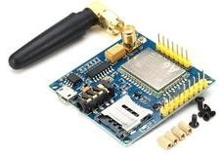 **Figure 10: GSM Module**

It transfers the information from main circuit to operator. It uses Time Division Multiple Access (TDMA).

GSM is mainly used for communicating and transferring message from one person to concerned organisation. GSM module is used to establish communication between a computer and a GSM and GPRS system.

Here we are using GSM LT-2 communication module makes it possible to use GSM paths to provide monitoring and messaging functions in alarm systems. It facilitates cooperation with SATEL and third party control panel diallers or correctly configured outputs.

He GSM LT-2 module makes it possible to implement monitoring as well as text and voice messaging functions. The caller ID retransmission function creates it likely to present the incoming callers number on telecommunication stations armed with this functionality. GSM alarm system built-in GSM communication module inside, work as a mobile handset. After purchased the GSM alarm system, people need to acquisition the SIM card, and select the mobile service package. GSM alarm system can program several phone numbers for alarm receiving. When any abnormal event happens, the system will response, then inform the owner via voice call and short message (SMS).

GSM will check the messaging activities for sweepers and also need to check with their cleanliness duty for their work. The sweepers need to check with particular activity of its work by their sensors.

**BLOCK DIAGRAM OF PROPOSED SYSTEM:**

### 

**Figure11:Block diagram of proposed system**

Chapter 6

Results and Discussion

The Smart public restroom project using IoT is proposed to create an awareness among the people about the proper toilet management

It can prevents the many contagious diseases like malaria, typhoid, cholera, streptococcus, asthma, etc..

It can promotes the “Swachhbharat” scheme.

**CONCLUSION**

Our proposed project will create awareness among the people about the proper sanitation. It makes use of Internet of things, which is a rapidly growing technology. Our proposed system will make everyone to strictly follow the cleanliness and proper sanitation in the toilets. It prevents the many new contagious diseases that spread due to improper sanitation of the toilets. Thus by using technologies in the smarter way, we can maintain the cleanliness which is next to the godliness. Keep Clean, Be Safe.

#### **APPENDIX**

Source code

#include <Servo.h>

const int buttonPin = 7;

const int ledPin = 2;

const int servoPin = 9;  // Digital pin for the servo

int buttonState = 0;

Servo doorServo;

void setup() {

  pinMode(ledPin, OUTPUT);

  pinMode(buttonPin, INPUT);

  doorServo.attach(servoPin);  // Attaching the servo to the pin

}

void loop() {

  buttonState = digitalRead(buttonPin);

  if (buttonState == HIGH) {

    // Restroom is occupied

    digitalWrite(ledPin, HIGH);

    // Open the door (rotate the servo)

    doorServo.write(90);  // Angle to open the door

  } else {

    // Restroom is vacant

    digitalWrite(ledPin, LOW);

    // Close the door (return the servo to its initial position)

    doorServo.write(0);  // Angle to close the door

  }

}

#### **REFERENCES**

1. Xavier Gibert, Vishal M Patel, and Rama Chellappa, in their IEEE paper titled as “Deep Multi-Task Learning for Railway Track Inspection” Volume 18, Issue 1, Jan 2017, pp 153 – 167.
2. S Mohamed Ashiq, K Karthikeyan, S

Karthikeyan. “Fabrication of Semi-

Automated Pressurized Flushing System in Indian Railway Toilet”, International Journal of Engineering and Advanced Technology (IJEAT), Volume-2, Issue-3, February2013.

1. Dr. ManojHedaoo, Dr. SuchitaHirde ,Ms.

Arshi Khan “Sanitation In Indian Railway Premises: A Great Cause Of Concern”, International Journal of Advanced Engineering Technology, Mar 2012,

Volume 3, Issue 1, pp 50 -55.

1. Dhanajay G Dange, Dattaprakash G Vernekar, Sagar D Kurhade, Prashant D

Agwane, “Methodology for Design and Fabrication of Human Waste Disposal

System for Indian Railway”, International Journal of Science Technology & Engineering, Volume 2, Issue 07,

January2016, pp 14 – 19. [5] Mesch, F., Puente Le´on, F.

&Engelberg, T., Train-based location by detecting rail switches. Computers in Railways VII, eds. J. Allen, R.J. Hill, C.A. Brebbia, G. Sciutto & S. Sone,

WIT Press, Southampton, pp. 1251– 1260, 2000.

1. K. Osathanunkul, K. Hantarkul, P. Pramokchon, P. Khoenkaw and N.

Tantitharanukul, “Design and Implementation of an Automatic Smart Urinal

Flusher”,International Computer Science and Engineering Conference (ICSEC2016), Chiang Mai, Thailand, Dec,2016, pp 14-17.

1. J. Shah and B. Mishra, “IoT enabled Environmental Monitoring System for Smart Cities”, International Conference on Internet of Things and Applications (IOTA), Maharashtra Institue of Technology, Pune, India, Volume 3, Issue 2, Jan 2016, pp383388.
2. A.Zanella,S.Member,N.Bui,A.Castellani,L.Va ngelistaandM.Zorzi,

“InternetofThingsforSmartCities,”IEEEIntern etofThings,Vol.1,no. 1, pp. 22-32,2014.

1. K. Hantrakul, P. Pramokchon, P. Khoenkaw, N. Tantitharanukul, and K. Osathanunkul,

“Automatic Faucet with Changeable Flow based on MQTT protocol”,International Computer Science and Engineering

Conference (ICSEC2016), Chiang Mai, Thailand, 14-17 Dec,2016.

1. C. H. Tsai, Y. W. Bai, M. B. Lin, R. J. R. Jhang and Y. W. Lin, "Design and implementation of an auto flushing device with ultra-low standby power," 2013 IEEE International Symposium on Consumer Electronics (ISCE), Hsinchu, 2013, pp.183184.
2. KitisakOsathanunkul, KittikornHantrakul, Part Pramokchon, PaweenKhoenkaw and

NasiTantitharanukul “Configurable Automatic Smart Urinal Flusher based on MQTT Protocol”,IEEE 2017.

1. A. D. Kadge, A. K. Varute, P. G. Patil, P. R.

Belukhi “Automatic Sewage Disposal System for Train”,International Journal of Emerging Research in Management &Technology

(Volume-5, Issue-5), May 2016.

1. PandyaChintan, YadavJatin, KareliyaSanket, DarshanAdeshara

“AUTOMETIC WORKING BIO-TOILET

TANK FOR RAILWAY

COACHES”,International Journal of

Advance Engineering and Research Development Volume 2,Issue 10,October 2015.

1. E.Elakiya,K.Elavarasi,R.P.Kaaviyapriya,

“Implementation of Smart Toilet (Swachh Shithouse) Using IOT Embedded Sensor Devices”, International Journal of Technical Innovation in Modern Engineering & Science (IJTIMES), Volume 4, Issue 4, April-2018, pp 65 – 74.

1. K.Dhanalakshmi,P.Hemalatha,

”Development of IOT Enabled Voice Recognition Robotic Guide Dog For Visually Impaired People to enhance the guiding and interacting experience”, Journal of Advanced Research in Dynamical and Control Systems, Vol 3, Issue 1, pp 262-272.