Layout for Voizfonica software

Home page

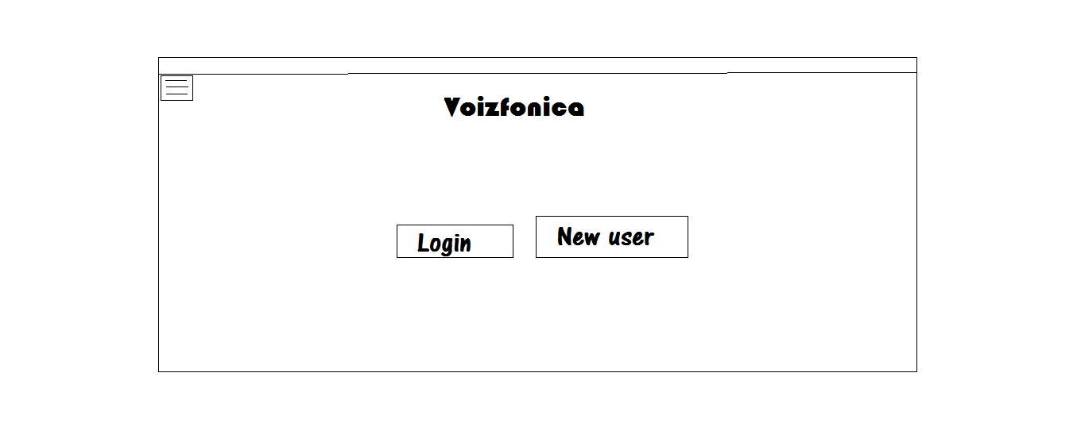

Menus

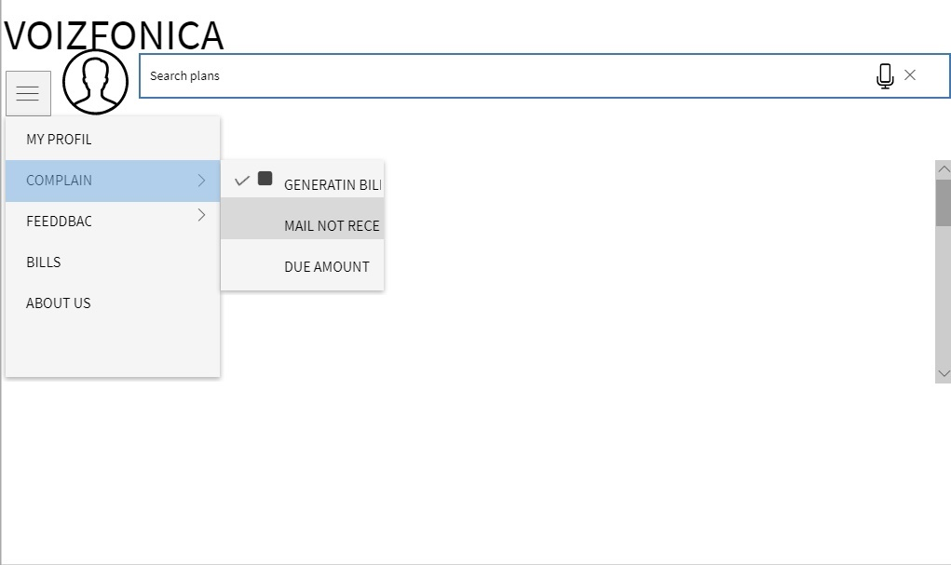

Existing user login



Create new account

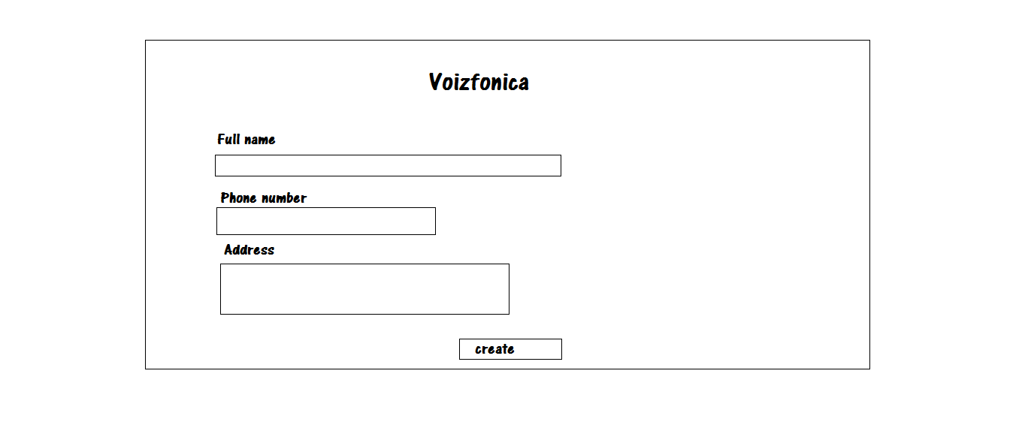

User profile:

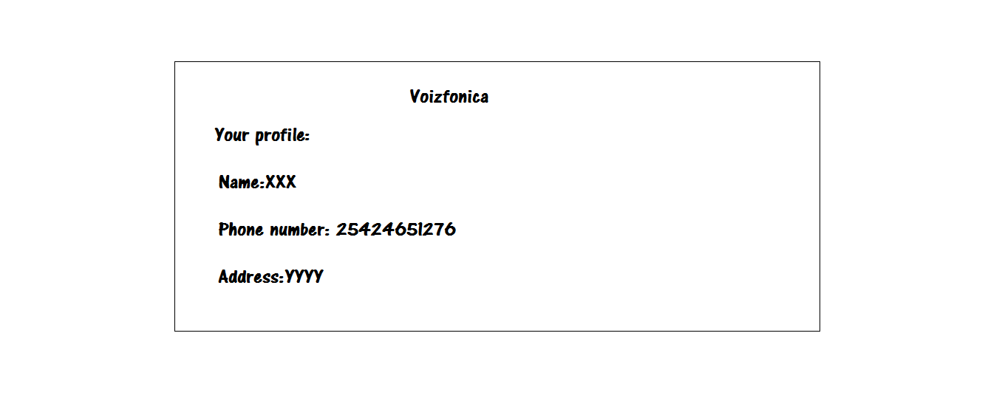

Complaints:

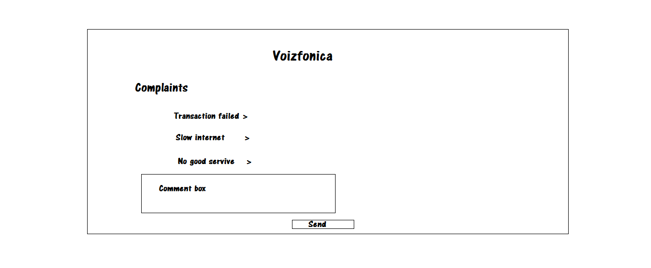

Bills:

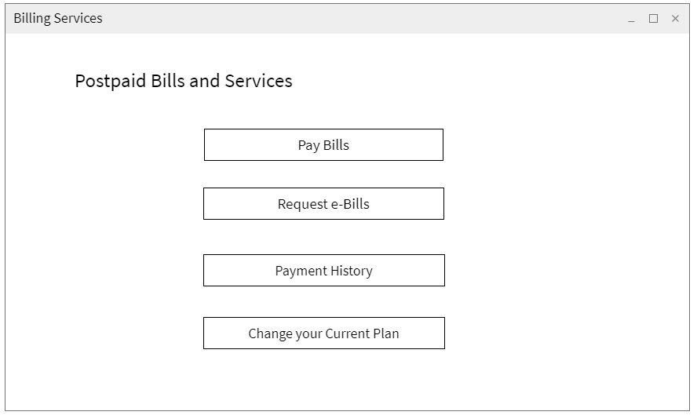

Feedback:

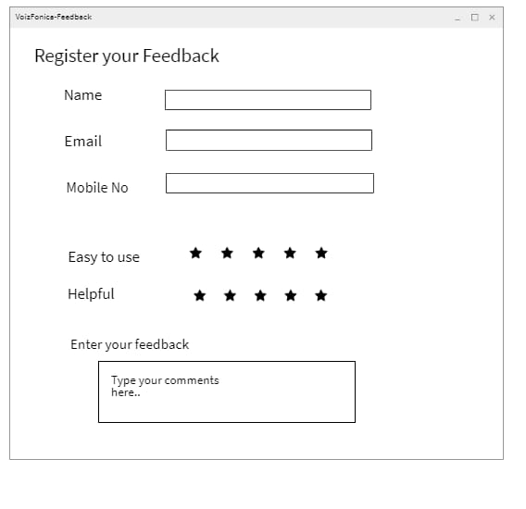

Software requirements:

Front end:

HTML,CSS,AngualrJS,Bootstrap.

Back end:

Java framework.

Spring.

SQL Database.

Hardware Requirements:

Operting System:Windows.

* Processor (CPU) with 2 gigahertz (GHz) frequency or above.
* A 2 GB of RAM.
* Monitor Resolution 1024 X 768 or higher.
* A minimum of 20 GB of available space on the hard disk.
* Internet connection with a speed of 4 Mbps or higher.